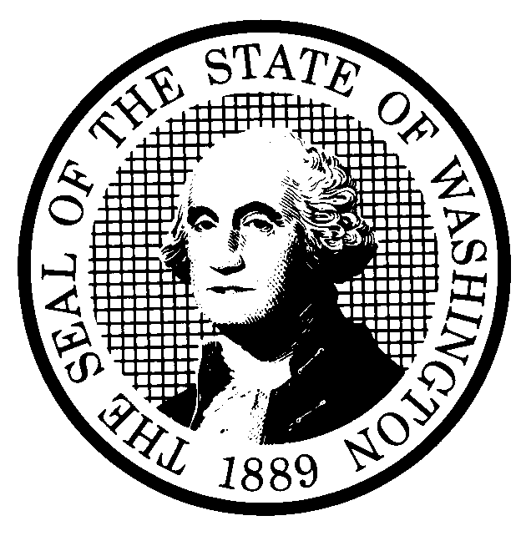 | PREPROPOSAL STATEMENT OF INQUIRY |  | CR-101 (June 2004)  (Implements RCW 34.05.310)  Do NOT use for expedited rule making
Agency: Washington Utilities and Transportation Commission

Subject of possible rule making: This rulemaking would consider expanding payment options and allowing solid waste/refuse companies to issue electronic billing to customers on request, by amending WAC 480-70-401 (Payment option), and WAC 480-70-396 (Billing). Docket No. TG-041349.
Statutes authorizing the agency to adopt rules on this subject: RCW 80.01.040; RCW 81.04.160
Reasons why rules on this subject may be needed and what they might accomplish: Since the March 2001 effective date for the rules in chapter 480-70 WAC, Solid Waste and/or Refuse Collection Companies, five companies have requested exemptions to the payment rule, WAC 480-70-401, to allow customers the option to pay bills by using Electronic Fund Transfer, which provides for electronic payments over the Internet. In addition, WAC 480-70-396 could be modified to allow companies, with the customer’s consent, to send bills to customers in electronic form.
Identify other federal and state agencies that regulate this subject and the process coordinating the rule with these agencies: N/A
Process for developing new rule (check all that apply):
Negotiated rule making
Pilot rule making
X Agency study
X Other (describe) The Commission will ask for initial comments, and provide an opportunity for additional comments.
How interested parties can participate in the decision to adopt the new rule and formulation of the proposed rule before publication:
(List names, addresses, telephone, fax numbers, and e-mail of persons to contact; describe meetings, other exchanges of information, etc.)
Interested persons may file comments with the Secretary, Washington Utilities and Transportation Commission, referencing docket number TG-041349, P.O. Box 47250, 1300 S. Evergreen Park Drive, S.W., Olympia, Washington, 98504-7250; Telephone (360) 664-1234; Facsimile (360) 586-1150. Comments may also be provided by e-mail to <records@wutc.wa.gov>. Commission Staff will post on the Commission’s web site (www.wutc.wa.gov/041349) those comments that are provided in electronic format. If there are any questions about how to participate in this rulemaking please contact Ms. Penny Hansen at 360-664-1242, or phansen@wutc.wa.gov. For specific information regarding opportunities for written comment and to ensure receipt of further information concerning this rulemaking, please see the attachment to this form.

DATE  August 4, 2004 |  | CODE REVISER USE ONLY  Filed with the Code Reviser's Office  August 4, 2004, 10:26 a.m.
NAME (TYPE OR PRINT)  Carole J. Washburn |  | WSR# 04-16-120
SIGNATURE
TITLE

Executive Secretary

WASHINGTON UTILITIES AND TRANSPORTATION COMMISSION

CR-101 - ATTACHMENT
DOCKET NO. TG-041349

(e) Interested persons may contact the Secretary, Washington Utilities and Transportation Commission, P. O. Box 47250, Olympia, Washington, 98504-7250, 360-664-1174 (Fax: 360-586-1150).

WRITTEN COMMENTS
Written comments may be submitted to the Commission at the address given above and should be filed with the Commission no later than August 25, 2004.
Electronic copies. The Commission requests that comments be provided in electronic format to enhance public access, for ease of providing comments, to reduce the need for paper copies, and to facilitate quotations from the comments. Comments may be submitted by electronic mail to the Commission’s Records Center at records@wutc.wa.gov. Please include:

- The docket number of this proceeding (TG-041349)
- The commenting party’s name
- The title and date of the comment or comments

An alternative method for submitting comments may be by mailing/delivering an electronic copy on a 3 ½ inch, IBM-formatted, high-density disk, in .pdf Adobe Acrobat format or in Word 97 or later. Include all of the information requested above. The Commission will post on the Commission’s web site all comments that are provided in electronic format. The web site is located at http://www.wutc.wa.gov/041349. If you are unable to file your comments electronically or to submit them on a disk, the Commission will always accept a paper document.

Opportunity for further comment is anticipated. Information about the schedule and other aspects of the rulemaking, including comments, will be posted on the Commission’s web site as it becomes available. If you wish to receive further information on this rulemaking you may (1) call the Commission’s Records Center at 360-664-1234, (2) e-mail the Commission at <records@wutc.wa.gov>, or (3) mail written comments to the address above to the attention of Carole J. Washburn, Secretary. When contacting the Commission, please refer to Docket No. TG-041349 to ensure that you are placed on the appropriate service list. Questions may be addressed to Penny Hansen (360) 664-1242 or e-mail at phansen@wutc.wa.gov.

NOTICE

TO CONTINUE RECEIVING NOTICES AND INFORMATION ABOUT THIS RULEMAKING -- The Commission wants to ensure its mailings are sent to persons who are interested in the topic and want to receive that information. ANY PERSON WHO COMMENTS will continue to receive notices and information. If you do not submit comments but wish to remain on the mailing list for this rulemaking, please advise the Records Center by any one of the following methods: (1) send a note with your name, address (or a copy of your mailing label), and telephone and fax numbers referencing Docket No. TG-041349, and the words "Please keep me on the mailing list"; or (2) E-mail your name, address, telephone and fax numbers, referencing Docket No. TG-041349, and the words "Please keep me on the mailing list" to <records@wutc.wa.gov>. Please note that all information in the mailings will be accessible through the Commission's Internet web site at <http://www.wutc.wa.gov/041349>. THOSE PARTIES WHO DO NOT RESPOND MAY NOT RECEIVE FURTHER MAILINGS OR INFORMATION ON THE RULEMAKING.

