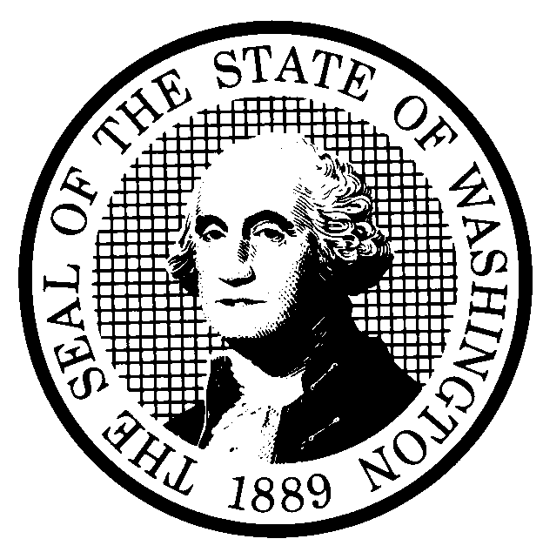 | PREPROPOSAL STATEMENT OF INQUIRY  (RCW 34.05.310) |  |  | CR-101 (7/22/01)  Do NOT use for expedited rule making
Agency: WASHINGTON UTILITIES AND TRANSPORTATION COMMISSION

Subject of possible rule making: This rulemaking would consider whether to adopt rules in Chapter 480-62 WAC, Railroad Companies - Operations, relating to point protection for train movements. The rulemaking may also address rules related to public and railroad employee safety, and the protection of property from damage associated with general train operations.

Docket No. TR-040151
(a) Statutes authorizing the agency to adopt rules on this subject: RCW 80.01.040 – General; RCW 81.04.160 Transportation.
(b) Reasons why rules on this subject may be needed and what they might accomplish: During the Commission’s rulemaking in Docket No. TR-021465 addressing remote control operations, it became apparent that adequate protection of the leading end of the train is a general safety concern, not one that is limited to remote control operations. Information provided during the remote control operations rulemaking indicated that the greatest need for point protection occurs at grade crossings and where trains may enter mainline tracks. This information also indicated that the safety concerns involved were present in all types of moves, not just moves made by remote control trains. General rules addressing point protection may improve public and railroad employee safety, and prevent property damage associated with train operations.
(c) Identify other federal and state agencies that regulate this subject and the process coordinating the rule with these agencies:
The Federal Railroad Administration (FRA) requires railroads to adopt operating rules. Almost all of the railroad companies operating in Washington State have signed the General Code of Operating Rules, which are filed with the FRA. The FRA, however, does not enforce these operating rules. The General Code of Operating Rules includes rules concerning point protection. Commission staff will seek to ensure that any rule proposed in this rulemaking is consistent with any rule in the General Code of Operating Rules, as well as other internal safety rules adopted by the railroads.
(d) Process for developing new rule (check all that apply):
Negotiated rule making
Pilot rule making
X Agency study
X Other (describe)

The Commission will consider pertinent information provided during workshops and from written comments in Docket No.
TR-021465, and will request written comments in this rulemaking to assist the Commission in determining whether state rules are needed, as well as the language and content of any rules.
(e) How interested parties can participate in the decision to adopt the new rule and formulation of the proposed rule before publication:

Interested persons may file comments with the Secretary, Washington Utilities and Transportation Commission, P.O. Box 47250, 1300 S. Evergreen Park Drive, S.W., Olympia, Washington, 98504-7250; Telephone (360) 664-1174; Facsimile (360) 586-1150, by March 19, 2004.
For specific information regarding opportunities for written comments and to ensure
receipt of further information concerning this rulemaking, please see the attachment to this form.

Please refer to Docket No. TR-040151 on all correspondence. |  |  | CODE REVISER USE ONLY

Filed with the Code Reviser's Office
February 18, 2004, 9:24 a.m.
NAME (TYPE OR PRINT)  CAROLE J. WASHBURN |  |  | WSR# 04-05-103
SIGNATURE
TITLE  EXECUTIVE SECRETARY |  | DATE  FEB. 18, 2004

WASHINGTON UTILITIES AND TRANSPORTATION COMMISSION
CR-101 - ATTACHMENT
DOCKET NO. TR-040151

WRITTEN COMMENTS
Written comments may be submitted to the Commission at the address given above and should be filed with the Commission no later than Friday, March 19, 2004.
Electronic copies. The Commission requests that comments be provided in electronic format to enhance public access, for ease of providing comments, to reduce the need for paper copies, and to facilitate quotations from the comments. Comments may be submitted by electronic mail to the Commission’s Records Center at records@wutc.wa.gov. Please include:

- The docket number of this proceeding (TR-040151)
- The commenting party’s name
- The title and date of the comment or comments

An alternative method for submitting comments may be by mailing/delivering an electronic copy on a 3 ½ inch, IBM-formatted, high-density disk, in .pdf Adobe Acrobat format or in Word 97 or later. Include all of the information requested above. The Commission will post on the Commission’s web site all comments that are provided in electronic format. The web site is located at http://www.wutc.wa.gov/040151. If you are unable to file your comments electronically or to submit them on a disk, the Commission will always accept a paper document.

Opportunity for further comment is anticipated. Information about the schedule and other aspects of the rulemaking, including comments, will be posted on the Commission’s web site as it becomes available. If you wish to receive further information on this rulemaking you may (1) call the Commission’s Records Center at 360-664-1234, (2) e-mail the Commission at <records@wutc.wa.gov> or (3) mail written comments to the address above to the attention of Carole J. Washburn, Secretary. When contacting the Commission, please refer to Docket No. TR-040151 to ensure that you are placed on the appropriate service list. Questions may be addressed to Mike Rowswell (360) 664-1265 or e-mail at <mrowswel@wutc.wa.gov>.
NOTICE:

TO CONTINUE RECEIVING NOTICES AND INFORMATION ABOUT THIS RULEMAKING -- The Commission wants to ensure its mailings are sent to persons who are interested in the topic and want to receive that information. ANY PERSON WHO COMMENTS will continue to receive notices and information. If you do not submit comments but wish to remain on the mailing list for this rulemaking, please advise the Records Center by any one of the following methods: (1) send a note with your name, address (or a copy of your mailing label), and telephone and fax numbers referencing Docket No. TR-040151, and the words "Please keep me on the mailing list"; or (2) E-mail your name, address, telephone and fax numbers, referencing Docket No. TR-040151 and the words "Please keep me on the mailing list" to <records@wutc.wa.gov>. Please note that all information in the mailings will be accessible through the Commission's Internet web site at <http://www.wutc.wa.gov/040151>. THOSE PARTIES WHO DO NOT RESPOND MAY NOT RECEIVE FURTHER MAILINGS OR INFORMATION ON THE RULEMAKING.

