BEFORE THE WASHINGTON
UTILITIES & TRANSPORTATION COMMISSION

IN THE MATTER OF THE PETITION OF FRONTIER COMMUNICATIONS NORTHWEST INC., TO BE REGULATED AS A COMPETITIVE TELECOMMUNICATIONS CO. PURSUANT TO RCW 80.36.320
DOCKET NO. UT-121994
DIRECT TESTIMONY OF TREVOR R. ROYCROFT, PH.D. (TRR-1T)
ON BEHALF OF
PUBLIC COUNSEL

April 25, 2013
REDACTED VERSION
DIRECT TESTIMONY OF TREVOR R. ROYCROFT, PH.D. (TRR-1T)
DOCKET UT-121994

TABLE OF CONTENTS
PAGE
I. INTRODUCTION / SUMMARY . . . . . . . . . . . . . . . . . . . . . . . . . . . . . . . . . . 1

II. OVERVIEW . . . . . . . . . . . . . . . . . . . . . . . . . . . . . . . . . . . . . . . . . . . . . . . . . . 3
A. Approach for Analysis . . . . . . . . . . . . . . . . . . . . . . . . . . . . . . . . . . . . . . . . 4
B. Summary of Findings and Recommendation . . . . . . . . . . . . . . . . . . . . . . . 8

III. RESIDENTIAL MARKET ANALYSIS . . . . . . . . . . . . . . . . . . . . . . . . . . . . . 9
A. Overview of Residential Markets . . . . . . . . . . . . . . . . . . . . . . . . . . . . . . . 9
1. Ongoing Important of Wire Voice Services . . . . . . . . . . . . . . . . . . . . . 11
2. Residential Wireline Subscribers . . . . . . . . . . . . . . . . . . . . . . . . . . . . . . 12
B. Alternatives to Frontier . . . . . . . . . . . . . . . . . . . . . . . . . . . . . . . . . . . . . . . . 14
1. Wireline Alternatives . . . . . . . . . . . . . . . . . . . . . . . . . . . . . . . . . . . . . . . 14
2. Wireless Alternatives . . . . . . . . . . . . . . . . . . . . . . . . . . . . . . . . . . . . . . . 23
3. Summary of Alternatives . . . . . . . . . . . . . . . . . . . . . . . . . . . . . . . . . . . . 27
C. Port-Out Study . . . . . . . . . . . . . . . . . . . . . . . . . . . . . . . . . . . . . . . . . . . . . . . . 27
D. Results of Analysis . . . . . . . . . . . . . . . . . . . . . . . . . . . . . . . . . . . . . . . . . . . . 31
1. Summary of Alternatives Analysis . . . . . . . . . . . . . . . . . . . . . . . . . . . . . 31
2. Additional Analyses of the Residential Market. . . . . . . . . . . . . . . . . . . . . 33 a. Captive Customers . . . . . . . . . . . . . . . . . . . . . . . . . . . . . . . . . . . . . . . 33
b. Market Share and Concentration . . . . . . . . . . . . . . . . . . . . . . . . . . . . . 34

IV. OTHE ISSUES RAISED BY FRONTIER . . . . . . . . . . . . . . . . . . . . . . . . . . . . . . 37

V. CONCLUSION . . . . . . . . . . . . . . . . . . . . . . . . . . . . . . . . . . . . . . . . . . . . . . . . . . . 42

TABLES

Table 1: Residential Port-Outs by Technology . . . . . . . . . . . . . . . . . . . . . . . . . . . . . . . . . 28
Table 2: Residential Port-Outs by Carrier . . . . . . . . . . . . . . . . . . . . . . . . . . . . . . . . . . . . . 29
Table 3: States where Frontier is Required to Maintain Tariffs . . . . . . . . . . . . . . . . . . . . 40

i
DIRECT TESTIMONY OF TREVOR R. ROYCROFT, PH.D. (TRR-1T)
DOCKET UT-121994

TABLE OF CONTENTS - CONTINUATION
PAGE

FIGURES

Figure 1: Wireline Telephone Service by Age Group . . . . . . . . . . . . . . . . . . . . . . . . . . 12
Figure 2: Overlay of Frontier Exchange Boundaries and Cable Service Areas . . . . . . 16
Figure 3: Percent of Frontier Port-outs by Wire Center to Cable Companies . . . . . . . 19
Figure 4: Comcast service areas and Frontier exchanges in around Everett . . . . . . . . 20
Figure 5: Overlay of households per Census Block . . . . . . . . . . . . . . . . . . . . . . . . . . 21
Figure 6: Overlay of Frontier Exchanges and AT&T Wireless Coverage . . . . . . . . . . 25
Figure 7: AT&T Wireless coverage and Census Block household counts . . . . . . . . . . 26

EXHIBIT LIST

Exhibit No TRR-2 Qualifications

Exhibit No. TRR-3 Regression Analysis of Port-outs and Density

ii
- INTRODUCTION / SUMMARY
Q: Please state your name and business address.
A: My name is Trevor R. Roycroft. My business address is 51 Sea Meadow Lane, Brewster, MA, 02631.
Q: By whom are you employed and in what capacity?
A: I am an independent consultant providing economic and policy analysis related to telecommunications, public utility, and information technology industries.
Q: On whose behalf are you testifying?
A: I am testifying on behalf of the Public Counsel Section of the Washington Attorney General’s Office (Public Counsel).
Q: Please describe your professional qualifications.
A: I have twenty-two years of experience in the public utility field. With regard to my educational background, I hold three degrees. I received the Bachelor of Arts degree in Economics with a minor in Statistics from California State University, Sacramento. The degree was awarded with honors. I also hold the Masters and Doctor of Philosophy in Economics from the University of California, Davis. My Ph.D. fields of specialization are Economic Theory, Industrial Organization, Public Sector Economics, and Economic History.
My experience in the telecommunications field began with my employment at the Indiana Office of Utility Consumer Counselor (OUCC) during the years 1991 to 1994. For most of my tenure at the OUCC I was Chief Economist. My primary areas of analytical responsibility at the OUCC related to telecommunications regulation and policy, including incentive regulation plans. I was also involved in natural gas, electric, and water utility cases, and filed testimony and supervised staff involved in these areas.
I have been involved in higher education related to the telecommunications field. From 1994 to 2004, I was a professor in the J. Warren McClure School of Communication Systems Management at Ohio University. At Ohio University I was granted tenure and promoted to Associate Professor in the spring of 2000. My primary areas of teaching responsibility were graduate and undergraduate courses covering regulatory policy, the economics of the telecommunications industry, consumer issues with telecommunications markets, and telecommunications technology. I left Ohio University to pursue consulting on a full-time basis at the end of 2004.
I have published research in refereed journals including The Journal of Regulatory Economics, Contemporary Economic Policy, and Telecommunications Policy. I have contributed chapters that have been published in book volumes related to the telecommunications field. I have provided referee service to various academic journals including: The Journal of Regulatory Economics, Telecommunications Policy, Social Science Computer Review, Utilities Policy, Journal of Economic Studies, and Communications of the Association for Information Systems.
I have provided analysis and testimony as an independent consultant since 1994. In my role as a consultant, I have addressed a wide variety of issues including: competition, incentive regulation plans, cost-of-service studies, cost modeling, service quality, and merger review. I have filed testimony, reports, and
affidavits before state regulatory commissions, before the Federal Communications Commission (FCC), and before the Canadian Radio-Television and Telecommunications Commission. I have also provided expert services in class action lawsuits associated with the public utility field. Attached hereto, as Exhibit No. TRR-2, is a true and correct copy of my most recent curriculum vitae.
Q: What exhibits are you sponsoring in this proceeding?
A: Exhibit No. TRR-2 is a copy of my curriculum vitae. Exhibit No. TRR-3 contains the results of a regression analysis that I discuss later in this testimony.
Q: What have you done to prepare your testimony?
A: I reviewed Frontier’s Petition and associated exhibits. I also reviewed the supporting testimonies of Jack D. Phillips and Billy Jack Gregg, along with their associated exhibits. I prepared discovery that was served on Frontier, and reviewed the responses to that discovery. I have reviewed Frontier’s responses to Staff discovery, and responses of other parties to Staff discovery. I also utilized Census data and data on the geographic availability of cable and wireless mobility services. I reviewed advertised offers of service providers operating in Frontier’s Washington service area.
II. OVERVIEW
Q: What is the purpose of your testimony?
A: I was asked by Public Counsel to review Frontier’s Petition, and to evaluate, from an economic and public policy perspective, whether the proposed request for competitive classification is in the public interest.
A. Approach for Analysis.
Q: What approach have you taken when evaluating Frontier’s request?
A: Frontier has requested that the Commission classify the company as “competitive.” RCW 80.36.320(1) states:
The commission shall classify a telecommunications company as a competitive telecommunications company if the services it offers are subject to effective competition. Effective competition means that the company’s customers have reasonably available alternatives and that the company does not have a significant captive customer base. In determining whether a company is competitive, factors the commission shall consider include but are not limited to:
(a) The number and sizes of alternative providers of service;
(b) The extent to which services are available from alternative providers in the relevant market;
(c) The ability of alternative providers to make functionally equivalent or substitute services readily available at competitive rates, terms, and conditions; and
(d) Other indicators of market power which may include market share, growth in market share, ease of entry, and the affiliation of providers of services.
The commission shall conduct the initial classification and any subsequent review of the classification in accordance with such procedures as the commission may establish by rule.
The underlined sentence provides the statute’s definition of effective competition, and I have used this definition, along with the factors specified in subparts (a)-(d) of RCW 80.36.320(1), when considering Frontier’s request.
Because Frontier has chosen to request statewide competitive classification of all services, rather than by service or geographical area, I believe that Frontier has the burden of proof to show that it is subject to effective competition throughout its entire service territory for every service that is covered by its request. The evaluation of the “relevant market” in subsection (b) must consider all areas within Frontier’s service territory, and the analysis must account for the fact that the specific geographic location of a consumer’s residence will influence the extent to which services are available from alternative providers. In addition, the Commission must determine that captive customers are not present in any of Frontier’s service territory. Otherwise, under competitive classification, Frontier could selectively raise rates in areas where captive customers reside.
Q: The statutory provisions indicate that the Commission should consider the “relevant market.” What is the relevant market?
A: Residential telecommunications markets have distinct characteristics. Residential consumers purchase telecommunications services based on their geographic location, which means residential services (as opposed to mobility services) must be capable of delivering telecommunications to a specific location—in the consumer’s residence. For consumers to choose a service provider other than Frontier for residential service, it must be the case that the alternative provider has operations in the consumer’s geographic location and can deliver service in the consumer’s residence. Thus, when considering the relevant market, it is important to evaluate the presence of alternative providers, especially facilities-based providers, in the various geographic areas associated with Frontier’s service area.
Frontier is requesting competitive classification for all of its residential services in its statewide service territory. Frontier’s residential voice services have traditionally been anchored by local exchange telephone service—a service that enables voice calling in a geographically bounded exchange area. Frontier’s
local exchange service also serves as a gateway to other voice services—Frontier’s customers are required to purchase local exchange telephone service to be able to utilize long distance services or vertical features that may be purchased along with local exchange service. However, local exchange service also plays a critical role as a stand-alone product—affordable stand-alone residential local service promotes universal service objectives.
Providers other than Frontier may offer services that can substitute for Frontier’s local exchange service. To the extent that consumers are observed to replace Frontier’s services with these alternatives, the services offered by these providers may also be part of the relevant market. Thus, the relevant market should include the sellers of voice services that enable calling in the local exchange that can deliver service to a consumer’s residence.
It is also important to consider whether alternatives to Frontier’s local exchange service are available as an individual service, or on a combined basis, i.e., if alternative services that provide local exchange service are only available as a package of voice and non-voice services, consumers’ ability to substitute for Frontier’s local exchange service may be negatively affected.
Q: Does broadband Internet access service affect the analysis of the residential market?
A: Yes. Interpreting market trends for residential voice services is complicated by the fact that broadband Internet access is becoming a primary driver of wireline telecommunications purchase decisions for many households. With regard to broadband services, Frontier has fallen behind its cable rivals in technology performance. Thus, while there is substantial evidence that consumers are leaving Frontier for cable alternatives, voice services are likely “following” consumer preferences for cable’s superior broadband. As will be discussed below, in areas where cable operations are limited, Frontier has retained larger market shares.
With regard to Frontier’s broadband market performance, data provided by Frontier indicates a troubling trend. [Begin Highly Confidential] XXXXX XXXXXXXXXXXXXXXXXXXXXXXXXXXXXXXXXXXXXXXXXXXXXXXXXXXXXXXXXXXXXXXXXXXXXXXXXXXXXXXXX. [End Highly Confidential] This trend suggests that Frontier’s financial viability in Washington will face increased pressure, which is likely to increase Frontier’s incentives to geographically discriminate in a way that would unfairly disadvantage customers in areas where Frontier faces lower levels of competition. Granting Frontier the regulatory relief that it requests would enable such discrimination.
In the balance of this testimony I will consider whether reasonably available alternatives to Frontier’s residential voice services exist, and whether the Company has a significant captive customer base. In conducting this evaluation I will consider:
- the number and sizes of alternative providers of service;
- the extent to which services are available from alternative providers in the relevant market;
- the ability of alternative providers to make functionally equivalent or substitute services readily available at competitive rates, terms, and conditions; and
- other indicators of market power which may include market share, growth in market share, ease of entry, and the affiliation of providers of services.
B. Summary of Findings and Recommendation.
Q: Please summarize your findings and recommendation.
A: Frontier has requested that the Commission grant the Company state-wide competitive classification. I have evaluated competition in Frontier’s service territory and found the following:
- Frontier has lost a significant number of its switched access lines. However, there is substantial variation in line loss from wire center to wire center. This variation in line loss indicates that competitive forces are not uniform across Frontier’s service area.

  - Regulatory impediments are not responsible for Frontier’s loss of access lines and market share. Frontier has failed to invest in a manner that would allow it to compete for residential customers, especially those who value high-quality broadband.
- Wireline voice services continue to be a popular choice, with about 65 percent of households continuing to purchase wireline voice services.
- Wireless service is a suitable residential service for some households, but others will not find “cord cutting” to be a reasonable alternative. Cord cutting is observed to be highly correlated with age—younger households are more likely to find cord cutting attractive.
- The market for residential services is geographically segmented, consumers face different choices depending on their geographic location.
  - Cable voice alternatives are a popular alternative to Frontier’s residential voice services, however, there are geographic limitations on the availability of cable voice services—a substantial number of consumers in Frontier’s service area cannot choose a cable voice alternative.
  - Wireless services, in addition to functional limitations, have geographic variation in coverage and signal strength that will prevent consumers from substituting wireless for wireline.
- The residential CLEC sector has dramatically curtailed operations. Evidence points to a very limited residential CLEC presence.
- Over-the-top VoIP alternatives have not been widely adopted, and over-the-top VoIP providers also face strong competition from cable bundles.
- Frontier has lost substantial market share in some wire centers, while maintaining near-monopoly market share in others.
- Residential markets continue to be highly concentrated—a large number of consumers in Frontier’s service territory face a highly concentrated market for residential voice services.
- Frontier still has captive customers—consumers who have little choice but to take residential voice services from Frontier.
- Frontier has not presented credible evidence of the availability of stand-alone voice services, either statewide or on a more narrow geographic designation.
- Frontier’s request for relief should be denied.
- Frontier should consider refiling its request for relief with a focus on residential packages and bundles on a wire-center basis, if that level of relief is permissible under RCW 80.36.320(1). If it is not, then Frontier may want to consider a request for relief using the AFOR approach.

III. RESIDENTIAL MARKET ANALYSIS
- Overview of Residential Markets.
Q: What trends are apparent in residential markets?
A: Technical transformation, evolving consumer preferences, and the ongoing economic downturn have all impacted the market for residential telecommunications services. With regard to voice services, companies like Frontier have experienced declines in switched access line counts. In recent years, consistent with national trends, Frontier has faced switched line losses. According to Frontier witness Mr. Phillips, Frontier now sells about 60 percent fewer switched access lines in Washington than it did in 2000.
Switched line losses reflect the impact of the growing availability of cable voice services, which have proved to be attractive to some consumers. However, as discussed earlier, broadband is rapidly becoming the “leader” service in some households’ decisions among alternative sources of residential services. Frontier has not kept pace with the broadband capability of its cable rivals, which does not bode well for Frontier’s ability to compete for these customers.
In addition, some consumers in Frontier’s Washington service area have cut the cord and gone “wireless only.” As will be discussed below in more detail, the growth of wireless-only households has a strong correlation to age. However, declining consumer incomes are also pressuring consumer decisions regarding wireline services.
Declines in switched access lines increase the risks for wireline operators as they must recover the largely fixed costs of their operations from a shrinking customer base. It is possible that this confluence of factors will test the proposition that the local telecommunications industry is subject to destructive competition. Given the growth of cable voice and superior broadband in some areas, whether two wireline facilities-based providers will be sustainable is a key point of policy evaluation, and one which this Commission should keep in mind as it considers Frontier’s request for competitive classification. If Frontier is facing significant financial pressure due to declining switched access lines and [Begin Highly Confidential] XXXXXXXXXXXXXX [End Highly Confidential], granting competitive classification will further increase risks for those Frontier customers who face few competitive alternatives.
- Ongoing Importance of Wireline Voice Services.
Q: While there have been substantial declines in switched access lines sold by Frontier, do consumers still value wireline voice services?
A: Yes. Regardless of the service provider, wireline voice services have characteristics that are attractive to many consumers, including the following:
- wireline service is available inside the home;

- local usage is typically unmetered, and use of “toll free” numbers is also provided on an unmetered basis, which can enable access to governmental and business services at low cost;
- service quality is generally superior to wireless calling; and
- access to emergency services is provided through 911 service which is often enhanced to provide emergency responders with detailed information about customer location, and potentially previous emergency situations at the residence.
Recent evidence from the Centers for Disease Control’s National Health Interview Survey (NHIS) points to the ongoing importance of wireline services. In 2012 about 64 percent of households nationwide maintained a wireline telephone. The most recent state-level data from the NHIS, from 2011, shows that about 66 percent of Washington adults reside in a household with a wireline telephone.
- Residential Wireline Subscribers.
Q: Does the popularity of wireline telephone service vary by the age of consumers?
A: Yes. Figure 1 shows data from the National Health Interview Survey on wireline service adoption by age. The data on wireline services in Figure 1 includes all wireline services (both traditional telephone service and VoIP services).
Figure 1: Wireline Telephone Service by Age Group
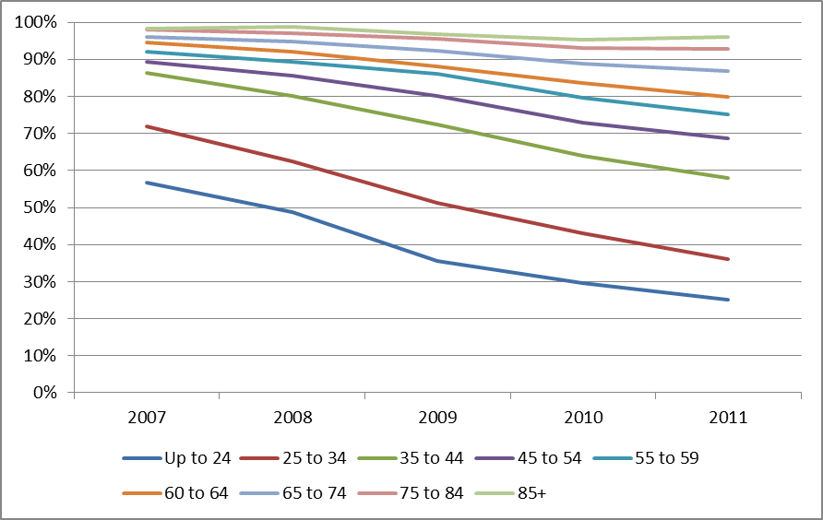
It is clear from Figure 1 that consumers show different preferences for wireline services based on their age. While all age demographics show a decline in use of wireline services, the younger age demographics (below age 35) show a much sharper decline. Large numbers of households with heads aged 45 and above continue to purchase wireline services. This suggests that wireless-only service is not a reasonable alternative for many of these households.
Q: Are there geographic differences associated with wireline service subscription?
A: Yes. Data from the NHIS also points to geographic differences in wireline service adoption. Nationwide, non-metropolitan areas exhibit cord cutting rates 8.6 percentage points lower than metropolitan areas (27.1 percent vs. 35.7 percent). This indicates that approximately 73 percent of all households nationwide in non-metropolitan areas continue to rely on wireline voice services, and given the more limited reach of cable voice services outside of metropolitan areas, a substantial portion of these wireline voice services are provided by ILECs like Frontier. The national data corresponds with the experience in Washington. The most recent state level-data from the NHIS shows that wireline telephones are more popular in Eastern Washington Counties and other areas outside of King County. In these areas about 70 percent of adults reside in households with a wireline telephone. As will be discussed further below, the higher popularity of wireline service in these areas is likely the result of inferior wireless coverage in lower density, rural, and insular areas. When considering Frontier’s request, the Commission should not ignore consumer preferences for wireline services. While cord cutting is an option for some, there is little evidence that all households are willing or able to cut the cord.
B. Alternatives to Frontier.
Q: The statute indicates that the Commission should consider “reasonably available alternatives” when determining whether or not effective competition exists. Did you evaluate alternatives to Frontier’s services?
A: Yes.
Q: What are the primary sources of residential telephone services in Frontier’s Washington service area?
A: The evidence indicates that consumers are choosing from among wireline alternatives and wireless mobility services to deliver telephone services to their residences. I will first address wireline alternatives and then turn to wireless mobility options.
- Wireline Alternatives.
Q: What wireline choices are available in Frontier’s service area?
A: In addition to Frontier, wireline services are available from cable providers like Comcast, Charter, Time Warner, and Astound Broadband. These companies provide service over their own facilities, and promote bundled service offerings that include voice, broadband, and video offerings. In addition, there is still some limited CLEC activity in the residential market. Alternatively, if a consumer has a broadband connection, they can purchase service from a third-party “over-the-top” provider like Vonage or Magic Jack.
Q: From a consumer’s perspective, are there limits on the choice of a wireline alternative to Frontier?
A: Yes. As will be discussed further below, evidence indicates that cable providers like Comcast have been the most successful in attracting Frontier customers. However, there are geographic limitations associated with cable voice alternatives. If a consumer resides in an area without a cable voice provider, they will not be able to choose that wireline alternative. Figure 2, below, is a map that overlays data available from the Federal Communications Commission regarding the service areas for the largest cable companies operating in Washington (Comcast, Charter, and Time Warner) with Frontier’s Washington exchange boundaries.
/ /
/ / /
/ / / /
/ / / /
/ / / / /
/ / / / / /
/ / / / / / /
/ / / / / / / /
Figure 2: Overlay of Frontier Exchange Boundaries and Cable Service Areas
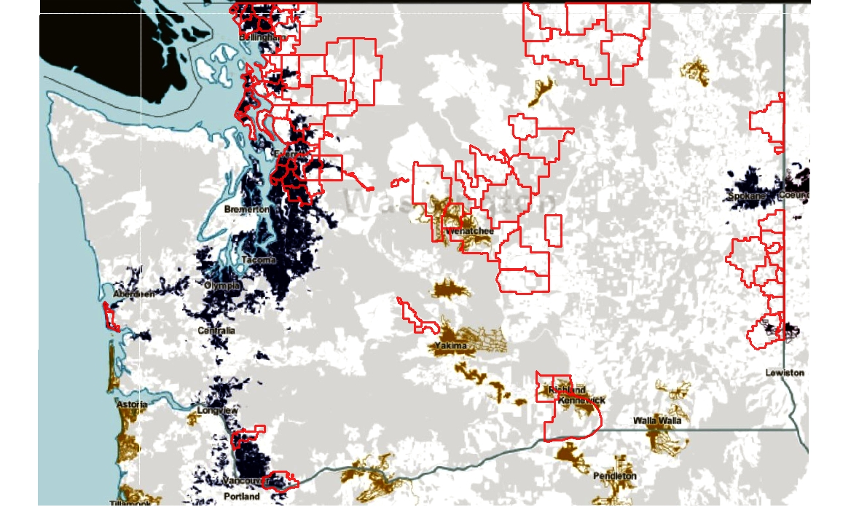

Frontier’s service area boundaries are shown as the red outlines in Figure 2. The dark blue areas are Comcast’s service area, the light brown area is Charter service territory, and the small darker brown area shown to the north of Lewiston on the map (i.e., Pullman) is Time Warner’s service area. Figure 2 clearly shows that for some households located in Frontier’s service area, cable voice alternatives are not available from these service providers. Moreover, while Mr. Phillips presents a list of cable operators in his Exhibit No. JP-5 that identifies 23 cable companies that operate in Frontier’s Washington service area, other evidence provided by Frontier indicates that they do not all offer voice services. In addition, Frontier provided data on residential telephone number port-outs. Frontier reports that of its 102 wire centers in Washington, 35 wire centers had no telephone number port-outs to cable providers in the March – December 2012 period. Absence of port-out activity in a wire center suggests that alternative cable voice services are not available.
Q: Can you further discuss your findings from the port-out analysis that you conducted ?
A: Because residential telephone numbers are important contact points, it is commonplace for consumers to take advantage of number portability when switching their home telephone service provider. A consumer’s choice to take their number with them results in a “port-out” event for Frontier, i.e., Frontier ports the number to the new service provider selected by the consumer. According to Frontier port-out data, among those wire centers that did have cable port-outs during the March-December 2012 period, only Astound, Comcast, Charter, and Time Warner had residential numbers ported from Frontier. This suggests a lower level of cable voice activity than identified by Mr. Phillips in his
Exhibit No. JP-5.
To see the frequency of porting to cable companies by wire center, refer to Figure 3, below. Figure 3 shows the distribution of port-outs to cable/broadband providers during the period March-December 2012, stated as a percentage of residential access line counts at year-end 2011. Figure 3 also shows that a substantial number of wire centers had either no porting-to-cable activity, or ported a very small percentage of numbers to cable. The variation in porting activity reflects not only the absolute presence of a cable voice alternative, but also the coverage of cable voice facilities within wire centers, i.e., a wire center might have a cable company operating in only a portion of the wire center.
/ /
/ / /
/ / / /
/ / / / /
/ / / / / /
/ / / / / / /
/ / / / / / / /
/ / / / / / / / /
/ / / / / / / / / /
/ / / / / / / / / / /
Figure 3: Percent of Frontier Port-outs by Wire Center to Cable Companies
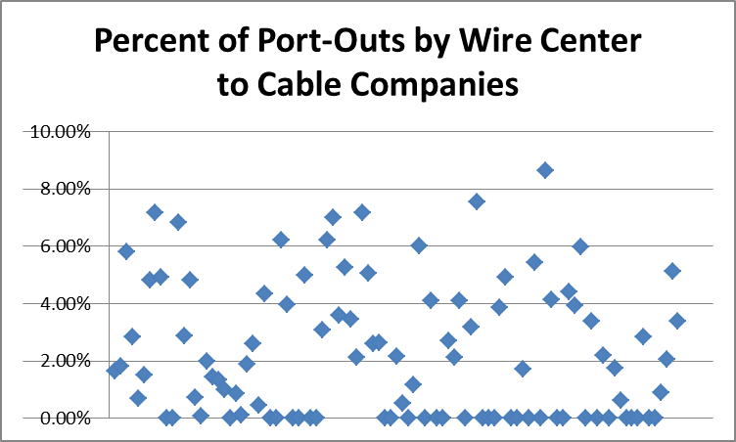
While a precise estimate of the number of households in Frontier’s service area that have no cable voice access is not available, it appears that there are over 42,000 households in Frontier’s service area are not in a cable voice provider’s footprint.
Q: Did you use Census data on household location at the Census Block level to illustrate the lack of cable alternatives for some Washington consumers?
A: Yes. Figure 4 enlarges the portion of Figure 2 surrounding Everett. Figure 4 shows Frontier exchange boundaries in purple and Comcast’s service area in dark blue.
Figure 4: Comcast service areas and Frontier exchanges in and around Everett
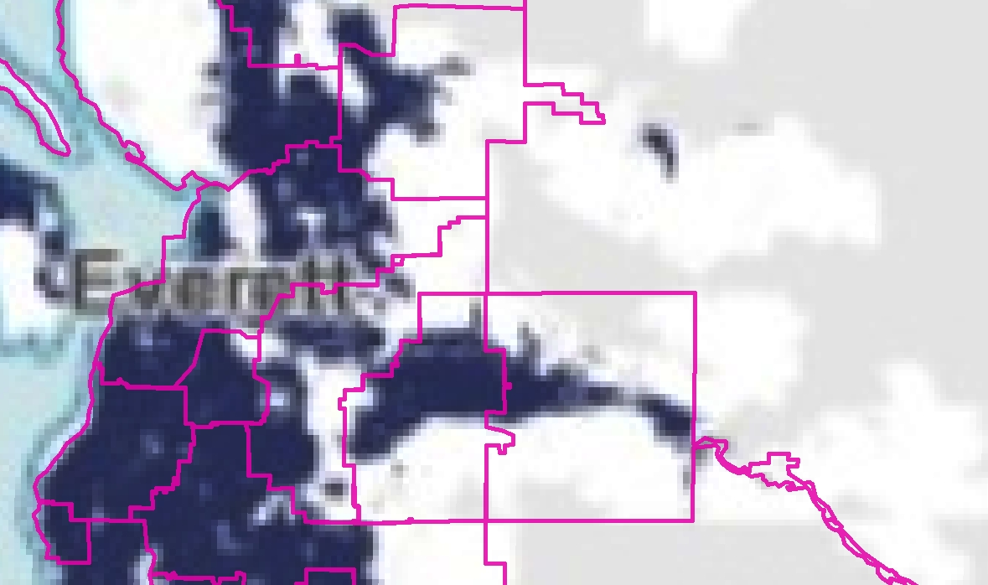

I then utilized data from the Census Bureau on the number of households in each Census Block to illustrate household locations on this map, which is shown in Figure 5.
/ /
/ / /
/ / / /
/ / / / /
/ / / / / /
/ / / / / / /
/ / / / / / / /
Figure 5: Overlay of households per Census Block
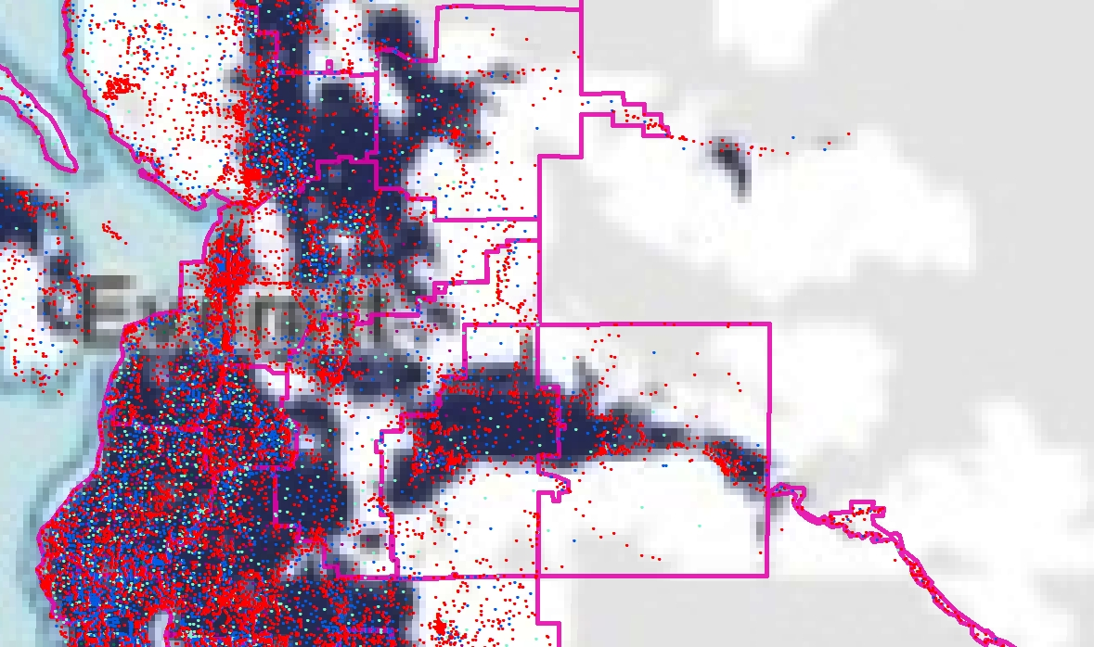
Up to
18
19-67
68-169
170-381
382 and
up
Each red dot in Figure 5 represents a Census block with up to 18 households. The other colors represent Census blocks with higher numbers of households, as shown in the key. It is clear from Figure 5 that a substantial number of households in Frontier exchanges in the Everett area are outside of Comcast’s service area. This information illustrates the limits of choice for Washington households—some consumers do not have a cable voice alternative. Cable voice is not a reasonably available statewide alternative.
Q: Did you assess consumer’s ability to choose conventional CLEC services?
A: Yes. In theory, conventional CLECs, which rely on unbundled network element or resale arrangements, may provide service anywhere in Frontier’s service area. Mr. Phillips presents data on CLEC activity, however, his information mixes business and residential markets, and is of little use when considering residential markets alone. There is no question that Frontier faces a much higher degree of competition from business-oriented CLECs. However, the residential CLEC industry has undergone a substantial contraction, and the choices afforded by the CLEC industry for residential customers have largely disappeared. Port-out data provided by Frontier identified port-out activity that could reasonably be associated with a residential CLEC in only 26 of Frontier’s 102 wire centers. As will be discussed in more detail below, other data from the port-out analysis shows a very limited residential CLEC presence in Frontier’s service area. As a result, I do not believe that the evidence supports classifying CLECs as a reasonably available statewide alternative.
Q: Did you assess consumers’ ability to choose an over-the-top voice provider?
A: Yes. In theory, any consumer with a broadband connection should have access to over-the-top voice providers like Vonage or Magic Jack, however, over-the-top VoIP service has not been widely adopted. For example, Vonage, the nation’s largest over-the-top provider, has seen its customer base in the U.S. decline from 2.375 million in 2007 to 2.232 million in 2012. Like Frontier, Vonage and other over-the-top providers have faced competitive pressure from managed VoIP products offered by cable and telephone companies. As noted by Vonage:
For example, they [cable companies] bundle Internet access, cable television, and home phone service with an implied price for the phone service that may be significantly below ours. In addition, such competitors may in the future require new customers or existing customers making changes to their service to purchase voice services when purchasing high speed Internet access.
As will be discussed below in more detail, port-out data indicates that over-the-top alternatives are not being widely adopted. A relatively small amount of over-the-top port-out activity was reported by Frontier in 66 of 102 Frontier wire centers. I do not believe that the evidence supports over-the-top voice services as being a reasonably available statewide alternative to Frontier’s residential local exchange services.
- Wireless Alternatives.
Q: Frontier raises the issue of wireless cord cutting as an alternative to Frontier’s residential services. Are there limits on a consumer’s ability to replace wireline service with wireless mobility services?
A: Yes, there are a number of limitations associated with wireless service that may restrict a consumer’s ability to replace residential wireline service. For example, some technologies are incompatible with wireless mobility services, or may require expensive upgrades to deliver the same functionality that can be delivered using a wireline connection. Fax machines, alarm systems, medical and personal monitoring devices frequently require wireline service availability. Other factors may influence consumer decisions regarding the potential to go wireless only. For example, wireless services are measured rate (even for calling 800 numbers) and may be more expensive than wireline services. Wireless services are not guaranteed to work anywhere, especially indoors. As recently noted by the California Public Utilities Commission in its consideration of a technology-neutral definition of basic service, the ability of a consumer to receive service within their premises is critical:
We disagree with parties’ claims that customers do not require a voice grade connection within their homes as long as they have access to the mobility advantage offered by wireless. This argument ignores the essential nature of basic service as a residentially-based service. While we recognize that wireless phones offer mobility advantages, those advantages do not negate the essential basic service need to be able to communicate within the customer’s own residence.

Q: Did you evaluate variation in wireless signal strength that could affect a consumer’s ability to receive service in their home?
A: Yes. Figure 6, below, shows an overlay of a coverage indicator map from AT&T Wireless with Frontier exchanges (outlined in yellow) near Everett. In AT&T Wireless’ coverage map, according to AT&T, the darkest orange areas provide “Best” coverage that is “sufficient for most in-building coverage.” AT&T notes:
However, in-building coverage can and will be adversely affected by the thickness/construction type of walls, or your location in the building (i.e., in the basement, in the middle of the building with multiple walls, etc.)
The next lightest shade of orange is described by AT&T as an area with “Good” coverage. AT&T describes “Good” coverage as “sufficient for on-street or in-the-open coverage, most in-vehicle coverage and possibly some in-building coverage.” The lightest orange is described as “Moderate,” which is described by AT&T as “sufficient signal strength for on-street or in-the-open coverage, but may not have it for in-vehicle coverage or in-building coverage.”
Figure 6: Overlay of Frontier Exchanges and AT&T Wireless Coverage
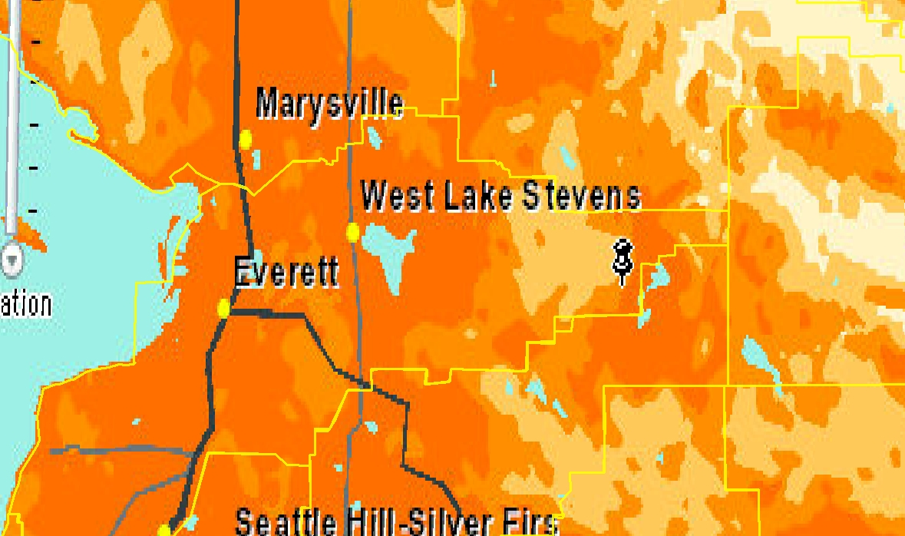
AT&T Wireless’ service description is consistent with the long-standing wireless mobility service quality model which delivers the strongest signals in high density areas and along major roads. As a result, some consumers that have a usage profile that is consistent with consideration of wireless-only may find their
wireless service provides in-building coverage sufficient for their needs. Others will not, and will not find wireless to be a reasonable substitute for that reason. As a result, the availability of wireless mobility services does not deliver a competitive alternative to all customers who could cut the cord, and certainly does not deliver an alternative to consumers who prefer a landline for the reasons discussed earlier.
Q: Were you able to utilize Census data to identify customer locations with reference to AT&T’s coverage depiction?
A: Yes. To more precisely illustrate AT&T’s coverage depictions and household locations, I overlaid Census data on household counts at the Census block level, which is shown in Figure 7.
Figure 7: AT&T Wireless coverage and Census Block household counts.
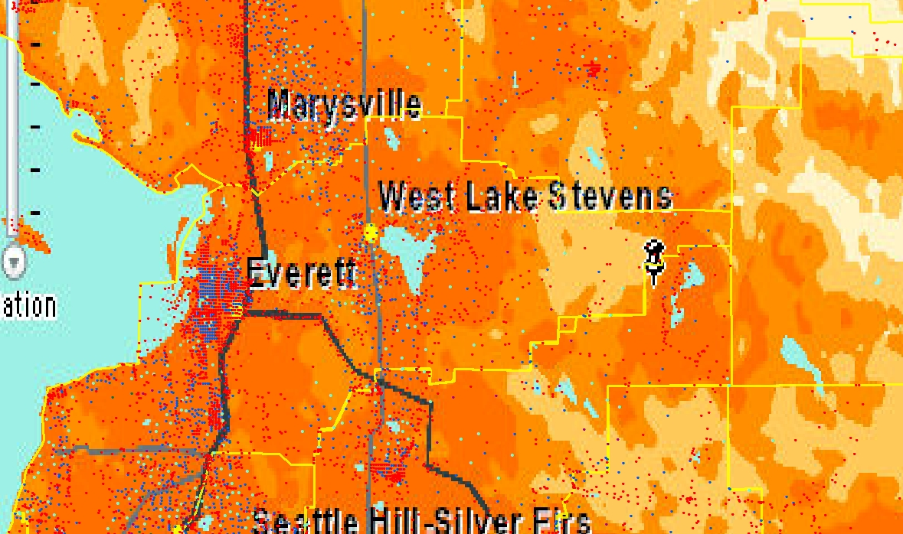
Up to
18
19-67
68-169
170-381
382 and
up
The information on household counts by Census block indicates that a substantial number of households reside in areas where there are lower levels of AT&T signal strength, making it less likely that a consumer could receive a signal indoors. However, it should be kept in mind that the depiction of wireless signal strength and the location of households is not as robust a representation as was the case for cable. Wireless signal reception is affected by a number of factors, and it is possible that some households in the dark orange area of the map will not be able to receive an adequate indoor signal. Thus, even for those households that can live without a wireline, their ability to choose the wireless-only option will be influenced by the vagaries of wireless signal strength.
- Summary of Alternatives.
Q: Can you summarize this portion of your testimony?
A: Yes. With regard to the statutory provisions regarding the reasonable availability of alternatives, there is substantial evidence that geographic variation in service availability from both wireline and wireless alternatives has not resulted in a uniform market environment. A substantial number of households do not have the same ability to choose from alternative providers as others who reside in high-density areas where cable voice services may be available and wireless signal strength is likely to be stronger. Frontier requests for statewide relief is not consistent with this evidence.
C. Port-Out Study.
Q: With regard to consumer choices of telephone service alternatives to Frontier, what does data on port-outs indicate?
A: The port-out data allows for an evaluation of consumer decisions regarding residential telephone services. Porting data is well suited for understanding consumer behavior as residential telephone service provides a point of contact associated with a household’s occupants. As a result, the home telephone number will have been incorporated into a variety of records (e.g., schools, doctors, dentists, contractors, friends, family, etc.), that will increase the desirability of keeping the number. Thus, port-out data provides a reasonable means to identify consumer perspectives on the reasonableness of various alternatives to Frontier’s residential services. The study that I conducted is based on all Frontier port-outs that occurred from March to December 2012. This data provides a window for viewing actual consumer behavior when choosing an alternative to Frontier.
With regard to the port-out data, Table 1 provides a summary of port-outs by technology.
Table 1: Residential Port-Outs by Technology
[Begin Confidential]
Technology | Number of Residential Port-Outs by Technology | Percent of all Residential Port-Outs
Cable | XXXX | XXXX
Wireless Mobility | XXXX | XXXX
CLEC | XXX | XXX
Over-the-Top VoIP | XXX | XXX
[End Confidential]
The data in Table 1 shows that the overwhelming majority of port-outs in the study period were to cable providers, with wireless port-outs a distant second. CLEC and over-the-top providers are a small fraction of all port-out activity.
Q: With regard to specific providers, what does the data show?
A: The data shows that among alternatives to Frontier, [Begin Confidential] XXXXXX [End Confidential] has been the most successful in attracting consumers to switch—the majority of port-outs during that period are to that company. Table 2 below summarizes port-outs by carrier.
Table 2: Residential Port-Outs by Carrier
(Begin Confidential)
Carrier | Residential Port-Outs | Percent of Res. Port-Outs
Astound Broadband | XXX | XXXX
AT&T | XXX | XXXX
AT&T Mobility | XXX | XXXX
Charter Fiberlink LLC | XXX | XXXX
Comcast | XXXX | XXXXX
Inland Cellular | X | XXXX
LocalTel | XX | XXXX
Qwest | XX | XXXX
Sprint PCS | XXX | XXXX
Time Warner | XX | XXXX
T-Mobile | XXX | XXXX
Verizon Wireless | XXXX | XXXXX
YMAX Communications | XXX | XXXX
Total | XXXXXX
(End Confidential)
It is important to recognize that while [Begin Confidential] XXXXX [End Confidential] has proved to be a popular alternative, consumers’ ability to choose [Begin Confidential] XXXXX [End Confidential] will depend on their specific
geographic location (as shown in Figure 2, above). Table 2 also shows the other wireline alternatives, such as the CLECs [Begin Confidential] XXXXXXXXX XXXXXX [End Confidential] have a much lower profile than cable alternatives. The over-the-top alternative [Begin Confidential] XXXXX XXXXX [End Confidential] also has a much more muted presence than the
cable alternatives.
Q: Did the port-out data shed light on geographic factors that helps to explain customer choices regarding alternatives to Frontier?
A: Yes. I utilized density information provided in response to Staff discovery and the port-out data to analyze the influence of density on port-outs. I performed a linear regression that used port-outs in a wire center as the dependent variable, and density as the explanatory variable. I conducted separate regressions for port-outs associated with cable, wireless, over-the-top, and CLECs, and on a combined basis. As shown in Exhibit No. TRR-3C, in each case the regression results showed a positive and statistically significant relationship between port-outs and density. In other words, the data shows that port-outs occurred more frequently in higher density areas. This analysis provides evidence of the limits of choice in lower density areas.
D. Results of Analysis.
- Summary of Alternatives Analysis.
Q: Please summarize your analysis and findings discussed above.
A: The statutory provisions define “effective competition” to mean that “the company’s customers have reasonably available alternatives and that the company does not have a significant captive customer base.” The discussion above illustrates that some Washington consumers who reside in Frontier’s service area do have alternatives for residential services. Cable companies provide the most popular alternative to Frontier’s residential service. Wireless mobility providers offer another alternative for some consumers. It is important to note that the alternative that is offered by cable and wireless providers is predominantly a service package, as opposed to a stand-alone local exchange service offering.
There is also substantial evidence that geographic limitations prevent a substantial number of Washington customers from choosing a cable alternative. Likewise, the technical limitations of wireless mobility services deter other consumers from choosing this alternative, and even for consumers who might like to go wireless-only, geographic coverage limitations may prevent consumers from choosing to go wireless only. The market evidence indicates that conventional CLECs and over-the-top providers are not viewed as reasonable alternatives by most consumers in Frontier’s service area.
With regard to the number and sizes of alternative providers of service, and the extent to which services are available, the evidence indicates that consumers face a much smaller number of alternatives than is depicted by Frontier’s Mr. Phillips. Geographic limitations on availability of cable alternatives offer consumers who reside in voice-service-offering cable company service areas one (1) wireline alternative. Conventional CLECs do not appear to be much of a factor in the residential market, thus giving much weight to their market impact is not reasonable. Similarly, over-the-top alternatives appear to appeal to a small number of consumers, and Frontier provides evidence that a small number of these providers are being considered by Washington consumers.
With regard to the functional equivalency issue, it is clear that some consumers are finding functional equivalency in cable voice and wireless offerings. However, cable and wireless voice services are generally sold as part of a bundle. The functional equivalency of stand-alone local exchange service is not readily available from these alternative providers.
With regard to stand-alone offerings, I do not find Frontier’s claims that alternatives are readily available to be convincing. The stand-alone cable voice offers identified by Frontier are promotions that revert to much higher rates after a short period of time. For example, after an introductory period, the Comcast $29.99 introductory rate reverts to either $39.99 or $44.99 per month. Similarly, wireless service is sold as a bundle, and generally requires a long-term contract. Likewise, stand-alone voice service is not available from over-the-top providers, as a consumer must purchase a broadband connection. Frontier has not
demonstrated that stand-alone voice services are subject to effective competition.
2. Additional Analyses of the Residential Market.
Q: In addition to the above analysis, did you look at any other indicators of competition in the residential market?
A: Yes. I also looked at whether Frontier has captive customers, as well as Frontier’s market share. These two items provide additional insight on whether Frontier faces competition throughout its service territory.
- Captive Customers.
Q: What is a captive customer?
A: The statute does not define the term “captive customer.” In the parlance of public utility regulation, the term “captive customer” means that a customer has little choice other than to take service from a single firm.
Q: Is it reasonable to conclude that Frontier still has “captive customers”?
A: As discussed above, wireline services still provide features that the majority of households find important enough to purchase, even with the availability of wireless mobility services. For a substantial number of households in Frontier’s service area, Frontier remains the only choice of wireline residential services. In other areas where wireline services are available from cable providers, Frontier is the only choice of stand-alone local exchange service. As a result, I believe that it is reasonable to conclude that Frontier has captive customers.
b. Market Share and Concentration.
Q: The statutory provisions identify market share as a factor that the Commission can evaluate when considering requests for competitive classification. Have you examined Frontier’s share of the market for voice telephone services?
A: Yes. To estimate Frontier’s residential market share I utilized Census data in combination with information provided by Frontier. In response to discovery, Frontier provided information on the number of residential households, based on Census counts, in each Frontier wire center. Frontier also provided information on the number of residential access lines it sold in each Frontier wire center. With data on the number of households and number of Frontier residential access lines in each wire center, Frontier’s market share of residential households, in each wire center, and an overall average, can be calculated.
The results of that analysis revealed a range of Frontier market shares within Frontier’s wire centers ranging from over 95 percent to as little as 17 percent. Thus, Frontier’s market share remains at near-monopoly levels in some wire centers, while in others it appears that Frontier no longer holds the largest market share in some other wire centers. The median Frontier market share in Frontier wire centers is about 40 percent and the household-weighted average of
market share is about 32 percent. Over 37,000 households in Frontier’s service area are located in wire centers with a Frontier market share of 50 percent or greater.
Q: Is the 50 percent market share important?
A: Yes. Market share information can be utilized to evaluate market concentration. Market concentration can provide information regarding the strength of competition in a market. If a market is highly concentrated, then market forces are less likely to deliver outcomes that are economically efficient, and consumers are more likely to pay prices that are in excess of cost, or to face price discrimination. When evaluating market concentration, economists and policy makers often utilize a tool known as the Herfindahl-Hirschman Index (HHI). The HHI is an economic tool utilized to assess market concentration. The HHI is calculated by summing the squared market shares of all firms in any given market. Based on the HHI value, antitrust authorities in the United States generally classify markets into three types: Unconcentrated (HHI < 1500), Moderately Concentrated (1500 < HHI < 2500), and Highly Concentrated (HHI > 2500).
If one firm in a market has a market share of 50 percent, this indicates that that market is highly concentrated. Based on Frontier’s market share alone, it is reasonable to conclude that a large number of consumers reside in Frontier market
areas with HHI values greater than 2,500—highly concentrated by the
Department of Justice’s benchmark. Of course, the actual HHI value in these market areas is higher, as summing the squares of the market shares of the other service providers would only increase the 2,500 value. Furthermore, many other consumers are likely to reside in highly concentrated markets, even if Frontier has a market share below 50 percent. For example, if Frontier has a market share of 40 percent, a cable provider has a market share of 25 percent, wireless providers have a combined market share of 30 percent, and CLECs and VoIP providers have a share of 2 percent each, the HHI value would still exceed 2,500.
Q: What is the impact of these high levels of concentration on a finding of “effective competition”?
A: If a market is highly concentrated it is unlikely that effective competition will exist. Firms are less likely to engage in price competition, and it is less likely that “market forces” will protect consumers.
Q: Can you summarize your discussion of market share?
A: Yes. Given the evidence that I presented regarding geographic differences in market entry, and the role of customer density in determining where competitors are likely to enter markets, it is not surprising that Frontier exhibits a range of market shares, with some indicating less evidence of market power than others. The evidence does not support Frontier’s request for statewide competitive classification, as Frontier assumes that competition is uniform throughout the state. The evidence indicates that market concentration remains high in some areas of the state, and that granting Frontier’s request would not comport with the statutory criteria.
- OTHER ISSUES RAISED BY FRONTIER
Q: Frontier witness Mr. Phillips offers an extensive discussion of Frontier access line loss. Mr. Phillips asserts that unless the Commission relieves Frontier of regulatory constraints this line loss will continue. Is the line loss described by Mr. Phillips occurring because of regulation?
A: No. As discussed earlier, changes in consumer preferences and technological change are the key factors leading to the decline in Frontier’s switched access lines. Frontier has provided no evidence that there are regulatory impediments to its ability to compete. Rather, I believe that investment decisions made by Frontier have limited its ability to compete in light of changing consumer preferences and technological change. For example, with regard to triple-play competition from cable operators, Frontier cannot match cable offerings in terms of broadband speeds and access to television programming. According to data provided by Frontier, [Begin Highly Confidential] XXXXXXXX [End Highly Confidential] households in Frontier’s service area do not have broadband download speeds available from Frontier that provide 20 MBPS, and [Begin Highly Confidential] XXXXXXXX [End Highly Confidential] do not have broadband download speeds available from Frontier that provide 12 MBPS. Cable companies are offering services of 50 Mbps and up. Consumers that value advanced broadband applications will likely find cable offerings to be more attractive, and the regulatory relief requested by Frontier will not correct this competitive disadvantage.
Q: Does Frontier identify specific regulatory impediments that are preventing Frontier from offering services in a manner similar to its competitors?
A: Mr. Phillips discusses the regulatory constraints that Frontier believes are preventing the Company from effectively competing, and points to the following provisions in Washington Code and Administrative rules:
The specific impediments include, but are not restricted to, regulations governed by state statues RCW 80.04.30, 80.04.310, 80.04.320, 80.04.330, 80.04.360, 80.04.460, 80.04.520, 80.36.100, 80.36.110, 80.08 (except 80.08.140), 80.12, 80.16 and state rules WAC 480-80-101-143, 480-140, 480-143, 480-120-102, 480-120-344, 480-120-369, 480-120-375, 480-120-389, and 480-120-395.
Other than making this assertion, Frontier provides no evidence to link these sections of code to its loss of access lines. I have reviewed these sections of the Revised Code of Washington and Washington Administrative Code and do not believe that Frontier’s claims are credible. These sections do not interfere with Frontier’s ability to attract or retain customers. Rather, Frontier’s technological limitations are to blame. Frontier has failed to invest in a manner that enables it to compete—namely, Frontier has not upgraded its plant to offer a competitive broadband service. For example, focusing on the residential market in Everett, Frontier offers packages that include satellite television, digital voice, and data speeds up to 6 MBPS. Comcast offers packages which offer similar voice and channel line-ups, and data speeds starting at 20 MBPS. The difference here reflects Frontier’s investment decisions, not the code sections identified by Frontier.
Q: Could the alleged regulatory impediments that Frontier has identified be responsible for Frontier’s lack of investment in wireless and broadband?
A: No, I do not believe that regulation is the culprit. Other ILECs have pursued wireless investment, and have also pursued more aggressive broadband deployment. Frontier has not employed similar strategies.
Q: Mr. Phillips states that consumers have reasonable alternatives “across Frontier’s service area” and that Frontier does not have a “significant captive customer base.” Is this correct?
A: No. The evidence reviewed above points to an environment where there are geographic differences in the ability of consumers to substitute for Frontier services. Some consumers reside in areas where cable voice is available, others do not. Furthermore, not all consumers will find cable bundles to be desirable, making the ability to switch more difficult. Wireless cord cutting may not be a reasonable alternative for many households.
While Mr. Phillips points to a captive customer base that is not “significant,” there are limits on consumer choice that result in Frontier
retaining market power for large numbers of Washington households. Given the importance of telephone service, granting Frontier’s request would result in the potential for abuse.
Q: Part of Frontier’s request involves detariffing all services, including basic local exchange service. Is Frontier required to maintain tariffs in other states?
A: Yes. In response to discovery, Frontier identified the following states as requiring Frontier to file tariffs:
Table 3: States where Frontier is Required to Maintain Tariffs
Alabama | New Mexico
Arizona | New York
California | Ohio
Georgia | Oregon
Illinois | Pennsylvania
Minnesota | South Carolina
Mississippi | Tennessee
Montana | Utah
Nebraska | West Virginia
Nevada

This list indicates that Frontier’s request for detariffing of local exchange service is premature.
Q: Absent tariffs, how does Frontier believe that prices should be established?
A: According to Mr. Phillips “In the competitive market which Frontier now operates, economically efficient prices should be driven by consumer demand, not the underlying product costs or a company’s return on investment.” Mr. Phillip’s perspective is important for this Commission to note. In a competitive market, firms do not have market power. As a result, market forces will drive prices to reflect their underlying costs of production, including the return on investment. That is why regulation has traditionally focused on costs and return
on investment when setting regulated rates.
Mr. Phillips, however, describes an outcome that is different from a competitive market outcome as he points to consumer demand as determining prices without regard to the underlying costs. This type of market outcome is associated with the presence of market power. When market power exists, firms will set prices based on what they believe “the market will bear,” which is another way of saying based on consumer demand. The outcome of the type of pricing that Mr. Phillips describes is not economically efficient. Rather, firms may raise prices above costs and engage in price discrimination, based on demand conditions. In areas where competition is weak, the outcome will be prices well above cost.
Q: Frontier’s petition states that the request for relief has no impact on carrier of last resort (COLR) obligations. Does Frontier reasonably support this assertion?
A: No. If a company serves as a COLR, there are two key elements associated with that responsibility—(1) the availability of service upon reasonable request, and (2) the price at which that service is offered. Frontier’s proposal, while possibly leaving the availability of service issue unchanged, would result in the lifting of price regulation, and also introduce the potential for rate deaveraging. The absence of price constraints could undermine COLR outcomes. As a result, should the Commission grant Frontier’s request, it should require that tariffed basic local service continue to be offered at a reasonable rate.
Q: Could granting Frontier’s petition result in the elimination of stand-alone basic service?
A: Yes. Frontier could eliminate stand-alone service, or raise stand-alone service prices in an effort to migrate consumers to service bundles. I believe that such an outcome, should it occur, would result in unreasonable harms to residential consumers. Stand-alone basic service is an important alternative for consumers, and is linked to the COLR concept. Elimination of stand-alone service would also have a potentially negative impact on universal service objectives.
- CONCLUSION
Q: Can you summarize your testimony and recommendations?
A: Frontier’s request for statewide competitive classification should not be granted. Frontier has not demonstrated that the statutory criteria have been satisfied throughout its service area. The evidence that I have presented shows that for a substantial number of households located in Frontier’s service area, effective competition is absent.
Q: Do you have an alternative solution or proposal?
A: Given the statutory provisions, it is not clear whether competitive classification on less than company-wide basis can be considered by the Commission. To the extent that it can, I recommend that Frontier refine its request for competitive classification. Rather than requesting state-wide competitive classification, I believe that the evidence is more likely to support Frontier’s request for relief for service packages or bundles on a wire-center-specific basis.
If less-than company-wide classification is not possible under RCW 80.36.320, then Frontier may want to consider an AFOR filing under RCW 80.36.135.
Q: Does this conclude your testimony at this time?
A: Yes.

Underline added.
Frontier Response to Public Counsel Data Request No. 5.
Direct Testimony of Jack D. Phillips, Exhibit No. JP-1T, p. 5, l. 3.
Cable companies promote the “triple play” of voice, broadband, and video services.
According to results of the NHIS, lower income households are more likely to abandon wireline service. See “Wireless Substitution: Early Release of Estimates From the National Health Interview Survey, January-June 2012,” December 19, 2012, available at: http://www.cdc.gov/nchs/data/nhis/earlyrelease/wireless201212.PDF .
Destructive competition has been described as a market that is not a natural monopoly, but that nonetheless does not have a stable equilibrium, resulting in bankruptcies and unstable supply. Thus, even though consumers have a limited number of alternatives, “competition” may lead to even fewer choices. Tendencies toward destructive competition are typically associated with industries that have high fixed and/or sunk costs. See e.g., Eldad Ben-Yosef, Evolution of the U.S. Airline Industry: Theory, Strategy, and Policy, Chapter 3 (Springer 2005).
Stephen J. Blumberg, Ph.D., and Julian V. Luke, "Wireless Substitution: Early Release of Estimates From the National Health Interview Survey, January-June 2012," Division of Health Interview Statistics, National Center for Health Statistics, December 19, 2012, Table 2, p. 9. http://www.cdc.gov/nchs/nhis/releases.htm#wireless
Stephen J. Blumberg, Ph.D., Julian V. Luke, Nadarajasundaram Ganesh, Ph.D., Michael E. Davern, Ph.D., and Michel H. Boudreaux, M.S. “Wireless Substitution: State-level Estimates From the National Health Interview Survey, 2010–2011,” October 12, 2012, Table 2. http://www.cdc.gov/nchs/data/nhsr/nhsr061.pdf
Data in Figure 1was compiled from the microdata associated with the NHIS, for the years 2007-2011. Available at: http://www.cdc.gov/nchs/nhis/quest_data_related_1997_forward.htm . Data for 2012 has not yet been released.
Stephen J. Blumberg, Ph.D., and Julian V. Luke, "Wireless Substitution: Early Release of Estimates From the National Health Interview Survey, January-June 2012," Division of Health Interview Statistics, National Center for Health Statistics, December 19, 2012, Table 2, p. 9. http://www.cdc.gov/nchs/nhis/releases.htm#wireless
Adams, Asotin, Benton, Chelan, Columbia, Douglas, Ferry, Franklin, Garfield, Grant, Kittitas, Klickitat, Lincoln, Okanogan, Pend Oreille, Spokane, Stevens, Walla Walla, Whitman, and Yakima.
Stephen J. Blumberg, Ph.D., Julian V. Luke, Nadarajasundaram Ganesh, Ph.D., Michael E. Davern, Ph.D., and Michel H. Boudreaux, M.S. “Wireless Substitution: State-level Estimates From the National Health Interview Survey, 2010–2011,” October 12, 2012, Table 2. http://www.cdc.gov/nchs/data/nhsr/nhsr061.pdf
http://wwwb.comcast.com/ ; http://www.charter.com/ ; http://www.timewarnercable.com/en/gateway.html
Data used to create Figure 2 is from http://tiles.mapbox.com/fcc/map/connect2compete#7.00/47.087/-119.116 and http://www.arcgis.com/home/item.html?id=10d2a1606cf24d94a6a0b2ea33a2391c . ArcGIS software was used to create the overlay.
Exhibit No. JP-5.
Exhibit No. JP-23 identifies voice offers from only Comcast, Charter, and Wave Broadband.
Frontier’s Petition indicates that it has 102 wire centers. In response to discovery, Frontier identified 101 wire centers in Frontier Response to Staff Data Request No. 109. Frontier identified 103 wire centers in Frontier Response to Staff Data Request No. 94.
Frontier Response to Staff Data Request No.111. Those wire centers are: Brewster, Bridgeport, Coupeville, Edison, Entiat, Everett Casino, Everson, Fairfield, Farmington, Garfield, George, Lake Wenatchee, Latah, Loomis, Malden, Mansfield, Manson, Molson-Chesaw, Naches, Newport, Nile, Oakesdale, Palouse, Quincy, Republic, Rockford, Rosalia, Sedro Woolley GTE, Skykomish, Soap Lake, Stevens Pass, Tekoa, Thornton, Tonasket, Washougal River, and Waterville. Frontier identified 102 wire centers in its Petition.
Similar impetus is associated with small business customers—contact with customers depends on continuity of the telephone number.
Frontier Response to Staff Data Request No. 111.
For example, a value of 5 percent indicates that of the residential access lines reported by Frontier at year-end 2011, 5 percent of those access lines were ported to cable companies.
Frontier Responses to Public Counsel Data Request No. 12.
The 42,000 count is based on wire centers that have no cable port-out activity presence (provided in Frontier Response to Staff Data Request No. 111), and Census household counts provided by Frontier (provided in Frontier Response to Staff Data Request No. 94). Within any wire center there are likely to be some households that are not passed by cable, especially in rural and suburban areas. These households are not counted as part of the 42,000, thus the actual number without cable is likely much higher.
Because the cable service area of the map is based on a jpeg image, the close-up view causes the edges of Comcast’s service area to become pixilated. However, the general boundaries of Comcast’s service area are still visible. Because Frontier’s exchange boundaries are available in an ArcGIS-compatible shapefile, they scale without pixilation.
Census Blocks are the smallest geographic area associated with Census tabulation. Census Block are typically bounded by roads, but may also be bounded by geographic features like rivers, or political boundaries.
For example, see the discussion at Exhibit No. JP-1T, page 25, ll. 7-13.
Because Frontier does not distinguish between business and residential port-outs, I counted AT&T and Qwest as serving residential customers, based on low port-out numbers for some wire centers. It is possible that these port-outs were associated with small business service providers.
Vonage 10-K reports for the years ending 2007 and 2012. http://www.sec.gov/Archives/edgar/data/1272830/000127283013000018/a10-k2012.htm http://www.sec.gov/Archives/edgar/data/1272830/000119312508059036/d10k.htm
Vonage 10-K for the year ending December 31, 2012, p. 6. http://www.sec.gov/Archives/edgar/data/1272830/000127283013000018/a10-k2012.htm
Exhibit No. JDP-1T, p. 20, ll. 7-16.
For example, AT&T Wireless offers the following explanation of its wireless coverage depictions as contained in their coverage maps: “Actual coverage may differ from map graphics and may be affected by terrain, weather, foliage, buildings and other construction, signal strength, high-usage periods, customer equipment and other factors. AT&T does not guarantee coverage and our coverage maps are not intended to show actual customer performance on the network, nor are they intended to show future network needs or build requirements inside or outside of AT&T’s existing coverage areas.” http://www.wireless.att.com/coverageviewer/popUp_legal.jsp
California Public Utilities Commission, D.12-12-038, December 24, 2012, pp. 21-22.
AT&T Wireless coverage maps provide more detail over a larger area than some other wireless carrier coverage maps. Verizon and Sprint coverage maps do not illustrate gradations of signal strength. T-Mobile coverage maps show signal strength projections, but generally show a smaller service footprint than AT&T Wireless.
http://www.wireless.att.com/coverageviewer/popUp_legend.jsp
http://www.wireless.att.com/coverageviewer/popUp_legend.jsp
http://www.wireless.att.com/coverageviewer/popUp_legend.jsp
A “port-out” occurs when a carrier transfers a telephone number to another carrier. Frontier tracks port-outs by carrier, which allows the tracking of where consumers that leave Frontier’s service choose to take service. Port-outs provide a reasonable reference point for evaluating competition, but will miss consumers who leave Frontier and choose not to take their number to the new provider.
Because Frontier could not provide data regarding the number of residential port-outs by any individual CLEC, it is likely that CLEC ports shown in Tables 1 and 2 contain some small-business port-outs.
Data regarding port-outs was obtained from Frontier Response to Staff Data Request No.111.
Because Frontier does not classify port-outs by customer class, I conservatively counted any small number of ports in a wire center as being associated with residential customers. It is likely that some small business port-outs are included in these numbers.
Frontier Response to Staff Data Request No. 94.
Exhibit No. JP-1T, p. 25, ll. 19-22 and p. 41, l. 11.
See, Exhibit No. JP-16, which identifies the introductory rate period as six months.
Exhibit No. JP-16.
According to the online version of Black’s Law Dictionary, in the context of electric power markets, a captive customer is a customer “who does not have realistic alternatives to buying power from the local utility, even if that customer had the legal right to buy from competitors.” http://thelawdictionary.org/captive-customer/
Frontier Response to Staff Data Request No. 94.
Frontier Response to Staff Data Request No. 91.
The resulting fractional value is then typically multiplied by 10,000 to provide a whole number result.
HHI = sum of squared market shares. Knowing that one firm has a 50 percent market share results in an HHI of at least 2,500: (.50)² * 10,000 =2,500.
This example assumes that wireless providers divide their combined 30 percent market share in the same proportion as reported by the FCC in their most recent report to Congress on competition in the wireless market, i.e., nationwide, AT&T has about 37 percent of customers, Verizon has 35 percent of customers, Sprint has about 17 percent of customers, and T-Mobile has about 11 percent of customers.
Exhibit No. JP-1T, pp. 23, 30.
Exhibit No. JP-1T, p. 5, ll. 4-7.
Exhibit No. JP-1T, p. 9, l. 16 to p. 14, l. 20. Frontier Response to Public Counsel Data Request No.10 provides the same list of alleged impediments.
Unlike AT&T and Verizon, Frontier has no wireless affiliate. As a result, the loss of a subscriber due to wireless cord cutting has a more substantial impact on Frontier—when cord cutting occurs AT&T and Verizon are much more likely to continue their business relationship with former wireline customers than is Frontier.
See, for example, http://www.frontier.com/dynamicproductpage?Productpath=/personal/bundles/triple-play-offers/tv-plus-broadband-max-plus-digital-phone-unlimited/dp-unlimited-broadband-max-america-s-top-120-1491 and http://www.comcast.com/corporate/shop/products/local/washington/wa/everett.html
Exhibit No. JP-1T, p. 6, ll.18-20.
Exhibit No. JP-1T, p. 23, l. 17.
Frontier Response to Public Counsel Data Request No.11.
Only terms and conditions are required to be in the tariff. Prices are in a nontariffed price catalog.
Stand-alone residential basic service is required to be tariffed but it not price-regulated, except for a cap on rates for areas in which state high-cost support is received.
Only for stand-alone residential service and only until transaction commitments are fulfilled.
Only for companies that have not elected market regulation and only for “safe harbor service” for companies that have elected market regulation.
Only stand-alone services are tariffed.
Exhibit No. JP-1T, p. 8, ll. 13-16.

