 | 
David S. Valdez
Vice President
Public Policy & External Affairs
WA0101RA
1800 41st Street
P.O. Box 1003
Everett, WA 98201
March 1, 2006 |  | WA0101RA  1800 41st Street  P.O. Box 1003  Everett, WA 98201
Ms. Carole Washburn, Executive Secretary
Washington Utilities and
Transportation Commission
1300 S. Evergreen Park Drive S.W.
Olympia, Washington 98504-7250

Dear Ms. Washburn:

Subject: Verizon Northwest Inc. Response Testimony – Docket No. UT-050778

Pursuant to Paragraph 12 of Order No. 01 dated August 4, 2005 in the above referenced docket, please find enclosed for filing an original and six (6) copies of the response testimony of 1) Dr. Carl R. Danner and 2) Keith Binney.

One of the exhibits is designated confidential pursuant to WAC 480-07-160, and the Protective Order in this matter. Therefore, this document is being provided on canary yellow paper in a separate, sealed envelope.

If you have any questions please call Robert Millar at (360) 236-9727.

Very truly yours,

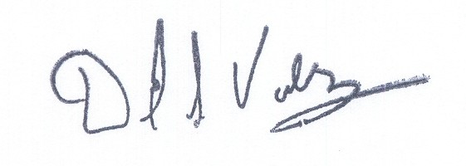

David S. Valdez

DSV:kad
Enclosures

c: Service List

