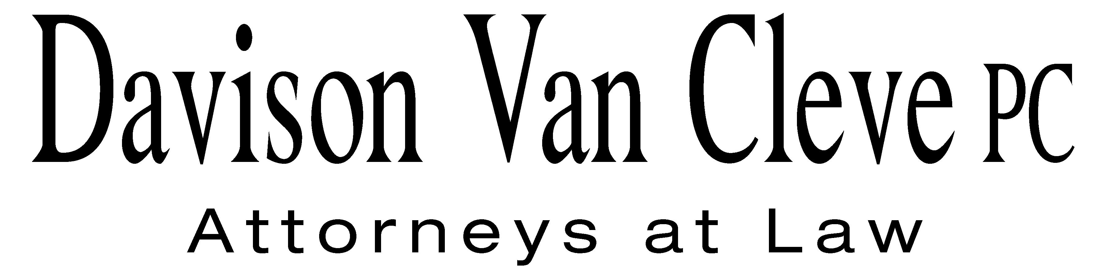
TEL (503) 241-7242 ● FAX (503) 241-8160 ● mail@dvclaw.com
Suite 400
333 SW Taylor
Portland, OR 97204

March 29, 2010

Via Email and Federal Express

Carole J. Washburn
Secretary
Washington Utilities and Transportation Commission
PO Box 47250
1300 S Evergreen Park Drive SW
Olympia, WA 98504-7250

Re: In the Matter of the Ten-year Achievable Potential and Biennial Conservation Target Report

Docket No. UE-100177

Dear Ms. Washburn:

Enclosed please find an original and twelve (12) copies of the Petition to Intervene of the Industrial Customers of Northwest Utilities.

Additionally, please find an original and twelve (12) copies of the Notice of Appearance of S. Bradley Van Cleve and Irion Sanger on behalf of the Industrial Customers of Northwest Utilities.

Thank you for your assistance.

Sincerely yours,

/s/ Martin H. Patail
Martin H. Patail
Enclosures

cc: Service List

CERTIFICATE OF SERVICE

I hereby certify that I have this day served the foregoing documents upon all parties of record in this proceeding by mailing a copy thereof in a sealed, first-class postage prepaid envelope to each individual’s last-known address, as listed below.
DATED this 29th day of March, 2010.
Davison Van Cleve, P.C.

/s/ Martin H. Patail
Martin H. Patail

PUGET SOUND ENERGY  TOM DEBOER  PO BOX 97034 PSE-08N  BELLEVUE WA 98009-9734  tom.deboer@pse.com | PERKINS COIE  SHEREE CARSON  Donna Barnett  10885 N.E. FOURTH STREET STE 700 BELLEVUE WA 98004-5579  scarson@perkinscoie.com
PUGET SOUND ENERGY  CAL SHIRLEY  200000 N. CREEK PRKWAY  BOT-O1H  BOTHELL, WA 98011  cal.shirley@pse.com | PUBLIC COUNSEL  SIMON FFITCH  800 FIFTH AVENUE STE 2000  SEATTLE, WA 98104-3188  simonf@atg.wa.gov
FRONDA WOODS  WASHINGTON UTILITIES & TRANSPORTATION COMMISSION  ATTORNEY GENERAL SECTION  STATE MAIL STOP 40128  fwoods@utc.wa.gov | DANIELLE DIXON  NW ENERGY COALITION  811 1ST AVE STE 305  SEATTLE, WA 98104  danielle@nwenergy.com

