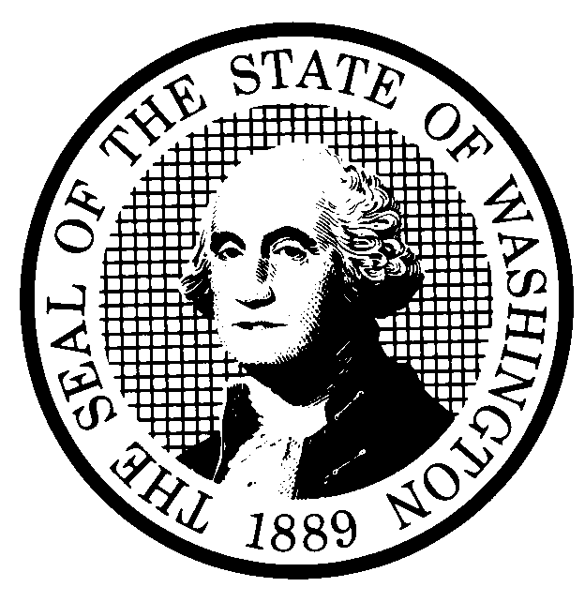 | PROPOSED RULE MAKING |  |  |  |  | CR-102 (June 2004)  (Implements RCW 34.05.320)  Do NOT use for expedited rule making
Agency: Washington Utilities and Transportation Commission
X Preproposal Statement of Inquiry was filed as WSR 04-08-132; or  Expedited Rule Making--Proposed notice was filed as WSR ; or  Proposal is exempt under RCW 34.05.310(4). |  |  |  |  |  |  | X Original Notice  Supplemental Notice to WSR  Continuance of WSR
Title of rule and other identifying information:
WAC 480-110-255, Jurisdiction, and WAC 480-110-205, Application of rules, for water companies. The proposed amendments would increase the maximum average annual revenue per customer jurisdictional threshold for water companies to reflect the latest final implicit price deflator of the United States Department of Commerce at the time of adoption, pursuant to RCW 80.04.010. In addition, proposed changes to WAC 480-110-255 would clarify the accounting methodology in computing the revenue threshold.
Docket No. UW-040375
Hearing location(s):  Commission Hearing Room 206  Second Floor, Chandler Plaza Building  1300 S. Evergreen Park Drive S.W.  Olympia, WA 98504 |  |  |  | Submit written comments to:  Name: Carole J Washburn, Secretary  Address: PO Box 47250, Olympia, WA 98504  e-mail: Records@wutc.wa.gov Please include Docket No.UW-040375 in your communication.  fax: (360) 586-1150 by (date) February 23, 2005.
Date: March 16, 2005 Time: 9:30 am |  |  |  | Assistance for persons with disabilities: Contact  Ms. Mary DeYoung by March 9, 2005  TTY (360) 586-8203 or (360) 664-1133
Date of intended adoption: March 16, 2005
(Note: This is NOT the effective date)
Purpose of the proposal and its anticipated effects, including any changes in existing rules:
The proposal would raise the jurisdictional revenue threshold as provided in RCW 80.04.010 to reflect a threshold revenue level that uses the latest final index number at the time of adoption. The draft rules reflect the final 3rd quarter 2004 index number released December 22, 2004, which would result in a $468 threshold. This threshold may change at the time of the adoption based on the latest final implicit price deflator of the Department of Commerce. The proposal would allow nonregulated companies to increase revenue up to the threshold amount without becoming subject to Commission regulation.

Reasons supporting proposal: The proposal would update the current jurisdictional threshold of $429, set on December 31, 1999, clarify the accounting methodology for computing the revenue threshold, and allow unregulated companies to increase revenue up to the threshold amount and still remain outside the Commission’s jurisdiction.
Statutory authority for adoption: RCW 80.01.040;  RCW 80.04.160, and RCW 80.04.010. |  |  |  | Statute being implemented: N/A
Is rule necessary because of a:  Federal Law?  Federal Court Decision?  State Court Decision?  If yes, CITATION: |  | Yes  Yes  Yes | X No  X No  X No |  | CODE REVISER USE ONLY  Filed with the Code Reviser’s Office  January 31, 2005, 10:48 a.m.  WSR 05-04-063
DATE
January 31, 2005

NAME (type or print)
CAROLE J. WASHBURN
SIGNATURE

TITLE
EXECUTIVE SECRETARY

(COMPLETE REVERSE SIDE)
Agency comments or recommendations, if any, as to statutory language, implementation, enforcement, and fiscal matters: None.

Name of proponent: Washington Utilities and Transportation Commission |  |  | Private  Public  X Governmental
Name of agency personnel responsible for:
 | Name | Office Location | Phone
Drafting............... Danny Kermode, Reg. Analyst |  | 1300 S. Evergreen Park Dr, Olympia, WA 98504 | (360) 664-1253
Implementation.... Carole J. Washburn, Secretary |  | 1300 S. Evergreen Park Dr, Olympia, WA 98504 | (360) 664-1174
Enforcement........Carole J. Washburn, Secretary |  | 1300 S. Evergreen Park Dr, Olympia, WA 98504 | (360) 664-1174
Has a small business economic impact statement been prepared under chapter 19.85 RCW?
Yes. Attach copy of small business economic impact statement.

A copy of the statement may be obtained by contacting:
Name:
Address:

phone ( )
fax ( )
e-mail
X No. Explain why no statement was prepared.

The proposed corrections and changes to rules will not result in or impose an increase in costs to water companies. Because there will not be any increase in costs resulting from the proposed rule changes, an SBEIS is not required under RCW 19.85.030(1)

Is a cost-benefit analysis required under RCW 34.05.328?

Yes A preliminary cost-benefit analysis may be obtained by contacting:
Name:
Address:

phone ( )
fax ( )
e-mail

X No: Please explain: The Commission is not an agency to which RCW 34.05.328 applies. The proposed rule is not a significant legislative rule of the sort referenced in RCW 34.05.328(5).

