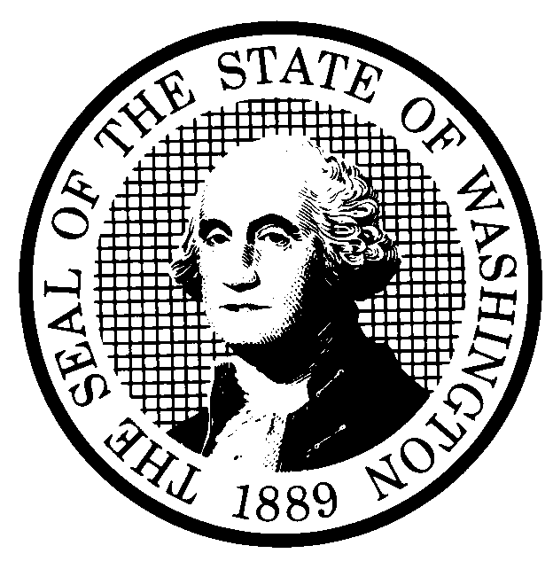 | PROPOSED RULE MAKING  (RCW 34.05.320) |  |  |  |  |  |  |  |  | CR-102 (7/22/01)  Do NOT use for expedited  rule making
Agency: Washington Utilities & Transportation Commission |  |  |  |  |  |  |  |  |  | x Original Notice
x Preproposal Statement of Inquiry was filed as WSR 02-10-055 ; or  Expedited Rule Making -- Proposed notice was filed as WSR ; or  Proposal is exempt under RCW 34.05.310(4). |  |  |  |  |  |  |  |  |  | Supplemental Notice  to WSR  Continuance of WSR
(a) Title of rule: (Describe Subject)
The proposed rules would establish a new standard for calculating the interest on customer deposits in WAC chapters 480-70 Solid Waste, 480-90 Gas Operations, 480-100 Electric Operations, and 480-110 Water Companies. In addition, the proposed rules would amend
WAC 480-100-148, Service responsibility, to clarify current language that may unintentionally prevent electric utilities from suspending service for reasonable periods in order to repair meters.
Purpose: See (j) below.

Other identifying information: Docket No. A-020405

(b) Statutory authority for adoption: RCW 80.01.040 and RCW 80.04.160 |  |  |  |  |  |  |  |  | Statute being implemented:
(c) Summary: See (j) below.
Reasons supporting proposal:
(d) Name of Agency Personnel Responsible for: |  |  |  |  | Office Location |  |  |  |  |  | Telephone
1. Drafting............... Sharyn Bate, 1300 S. Evergreen Park Drive S.W., Olympia, WA 98504 360-664-1295

2. Implementation....Carole J. Washburn, Secretary, 1300 S. Evergreen Park Drive S.W., Olympia, WA 98504 360-664-1174

3. Enforcement........Carole J. Washburn, Secretary, 1300 S. Evergreen Park Drive S.W., Olympia, WA 98504 360-664-1174

(e) Name of proponent (person or organization):  Washington Utilities and Transportation Commission |  |  |  |  |  |  |  |  |  |  | Private  Public  x Governmental
(f) Agency comments or recommendations, if any, as to statutory language, implementation, enforcement and fiscal matters:
None

(g) Is rule necessary because of:  Federal Law?  Federal Court Decision?  State Court Decision? |  | Yes  Yes  Yes |  | x No  x No  x No |  | If yes, ATTACH COPY OF TEXT  Citation:
(h) HEARING LOCATION: |  |  |  |  |  |  | Submit written comments to:
Commission Hearing Room 206  Second Floor, Chandler Plaza Building  1300 S. Evergreen Park Drive S.W.  Olympia, WA 98504 |  |  |  |  |  |  | Carole J. Washburn, Secretary, P. O. Box 47250, Olympia, WA 98504 or  E-mail to <records@wutc.wa.gov>. Please include Docket No. A-020405 in your communication  FAX (360) 586-1150 By September 11, 2002
Date: September 25, 2002 Time: 9:30 AM |  |  |  |  |  |  | DATE OF INTENDED ADOPTION: September 25, 2002
Assistance for persons with disabilities: Contact  Mary DeYoung by Monday, September 23, 2002 |  |  |  |  |  |  | CODE REVISER USE ONLY
TDD (360) 586-8203 or (360) 664-1133
NAME (TYPE OR PRINT)
CAROLE J. WASHBURN
SIGNATURE

TITLE  SECRETARY |  |  | DATE  8/20/02
(COMPLETE REVERSE SIDE)
(j) Short explanation of rule, its purpose, and anticipated effects:

The proposal would adopt the one-year Treasury Constant Maturity calculated by the U.S. Treasury, and published in the Federal Reserve’s Statistical Release H.15 on January 15 of each year as the standard for calculating the interest on deposits of solid waste, gas, electric and water customers.

The proposal would also amend WAC 480-100-148, Service responsibility, by deleting the language “other than meters” to clarify utility liability if changes or repairs to meters are necessary.

The proposal would streamline the process for calculating the interest on customer deposits by utilities since the interest rate can automatically be determined. It would eliminate the need to await notice from the Commission authorizing the interest rate change, and it would eliminate the need for Commission staff to administer the process.
Does proposal change existing rules? | x YES NO | If yes, describe changes:
The affected WACs are:

- WAC 480-70-411 (Solid Waste), Establishing credit and deposits.
- WAC 480-90-113 (Gas), Residential deposit requirements.
- WAC 480-90-118 (Gas), Nonresidential deposit requirements.
- WAC 480-100-113 (Electric), Residential deposit requirements.
- WAC 480-100-118 (Electric), Nonresidential deposit requirements.
- WAC 480-110-335 (Water), Establishment of credit and deposits.

The current rules use the interest rate of the 52-week Treasury Bill that has been discontinued. The proposed rules use the one-year Treasury Constant Maturity calculated by the U.S. Treasury, as published in the Federal Reserve’s Statistical Release H.15 on January 15 of each year as the rate. Additionally, the proposed rules remove the requirement that the Commission will advise the utilities each year of the specific rate by mail because under the proposal the new rate will be a reference rather than a calculation. Language in the above rules has been redrafted to parallel language across the four industries. These revisions do not change the substance of the rules.

- WAC 480-100-148(2)(d), Service responsibility.

The draft language revises WAC 480-100-148(2)(d), Service responsibility by deleting the language “other than meters.”
(k) Has a small business economic impact statement been prepared under chapter 19.85 RCW?
Yes. Attach copy of small business economic impact statement.
A copy of the statement may be obtained by writing to:

telephoning: ( )
faxing: ( )
x No. Explain why no statement was prepared

The proposed rules streamline the process for determining the yearly interest rate to be applied to customer deposits. In addition, the proposed rules eliminate the need for Commission Staff to administer the process. Because there will not be any increase in cost resulting from the proposed rules, an SBEIS is not required.

(l) Does RCW 34.05.328 apply to this rule adoption? Yes x No
Please explain:
The Commission is not an agency to which RCW 34.05.328 applies. The proposed rules are not significant legislative rules of the sort referenced in RCW 34.05.328(5).

