FILED
MAR 26 2010
NOT FOR PUBLICATION
MOLLY C. DWYER, CLERK
UNITED STATES COURT OF APPEALS

U.S. COURT OF APPEALS

FOR THE NINTH CIRCUIT

QWEST CORPORATION, Plaintiff - Appellee,
v. ARIZONA CORPORATION COMMISSION, Defendant, MIKE GLEASON et al., Defendants - Appellees, LEVEL 3 COMMUNICATIONS, LLC, Defendant - Appellant, and
PAC-WEST TELECOMM, INC., Defendant,
No. 08-15887
D.C.

No. 2:06-CV-02130-SRB MEMORANDUM

*

Appeal from the United States District Court for the District of Arizona Susan R. Bolton, District Judge, Presiding
* This disposition is not appropriate for publication and is not precedent except as provided by 9th Cir. R. 36-3.

Argued November 4, 2009; Resubmitted February 19, 2010 San Francisco, California Before: B. FLETCHER, CANBY, and GRABER, Circuit Judges. Level 3 Communications, LLC ("Level 3"), and Qwest Corporation ("Qwest") entered into an Interconnection Agreement to provide for the exchange of Internet Service Provider ("ISP")-bound traffic pursuant to the Telecommunications Act of 1996 ("the Act"). The parties agreed to exchange "ISP-bound traffic (as that term is used in the FCC [Federal Communications Commission] ISP [Remand] Order) at the FCC ordered rate, pursuant to the FCC ISP [Remand] Order." Level 3 filed a complaint with the Arizona Corporation Commission ("Commission"), claiming that this provision required Qwest to pay intercarrier compensation to Level 3 for virtual NXX calls (calls to a customer whose area code bears no relation to its physical location). The Commission ruled in favor of Level 3, and Qwest appealed to the district court. Level 3 now appeals an order from the district court that remanded the case to the Commission.

We dismiss the appeal as being from a non-final order. A remand order
is considered final where (1) the district court conclusively resolves a
separable legal issue, (2) the remand order forces the agency to apply
a potentially erroneous rule which may result in a wasted proceeding,
and (3) review would, as a practical matter, be foreclosed if an
immediate appeal were unavailable.
2

Chugach Alaska Corp. v. Lujan
, 915 F.2d 454, 457 (9th Cir. 1990). Here, the remand order fails the third prong because denying an appeal now would not foreclose review in the future. The district court in this case did not resolve Qwest
’
s claims for relief, and it did not enter a final judgment. In fact, the district court did not enter judgment on any of the issues presented by Qwest.

Our precedent instructs that a remand order may be considered a final, appealable order only when "review would, as a practical matter, be foreclosed if an immediate appeal were unavailable." Alsea Valley Alliance v. Dep’t of Commerce, 358 F.3d 1181, 1184 (9th Cir. 2004) (internal quotation marks omitted). Neither party is foreclosed from seeking appellate review, in the future, of any legal determination made in the district court’s final order. Because the remand order is not a final, appealable order, we must dismiss the appeal. See Williamson v. UNUM Life Ins. Co. of Am., 160 F.3d 1247 (9th Cir. 1998) (holding that a remand order was not a final order); Alsea Valley Alliance, 358 F.3d at 1184 (same).
DISMISSED.
3

United States Court of Appeals for the Ninth Circuit

Office of the Clerk
95 Seventh Street San Francisco, CA 94103
Information Regarding Judgment and Post-Judgment Proceedings
(December 2009)
Judgment
• This Court has filed and entered the attached judgment in your case. Fed. R. App. P. 36. Please note the filed date on the attached decision because all of the dates described below run from that date, not from the date you receive this notice.
Mandate (Fed. R. App. P. 41; 9th Cir. R. 41-1 & -2)
• The mandate will issue 7 days after the expiration of the time for filing a petition for rehearing or 7 days from the denial of a petition for rehearing, unless the Court directs otherwise. To file a motion to stay the mandate, file it electronically via the appellate ECF system or, if you are a pro se litigant or an attorney with an exemption from using appellate ECF, file one original motion on paper.
Petition for Panel Rehearing (Fed. R. App. P. 40; 9th Cir. R. 40-1) Petition for Rehearing En Banc (Fed. R. App. P. 35; 9th Cir. R. 35-1 to -3)

(1) A. Purpose (Panel Rehearing):

• A party should seek panel rehearing only if one or more of the following grounds exist:
      - A material point of fact or law was overlooked in the decision;
      - A change in the law occurred after the case was submitted which appears to have been overlooked by the panel; or
      - An apparent conflict with another decision of the Court was not addressed in the opinion.
    - Do not file a petition for panel rehearing merely to reargue the case.

B. Purpose (Rehearing En Banc)

• A party should seek en banc rehearing only if one or more of the following grounds exist:
      - Consideration by the full Court is necessary to secure or maintain uniformity of the Court’s decisions; or
      - The proceeding involves a question of exceptional importance; or
      - The opinion directly conflicts with an existing opinion by another court of appeals or the Supreme Court and substantially affects a rule of national application in which there is an overriding need for national uniformity.

(2) Deadlines for Filing:
    - A petition for rehearing may be filed within 14 days after entry of judgment. Fed. R. App. P. 40(a)(1).
    - If the United States or an agency or officer thereof is a party in a civil case, the time for filing a petition for rehearing is 45 days after entry of judgment. Fed. R. App. P. 40(a)(1).
    - If the mandate has issued, the petition for rehearing should be accompanied by a motion to recall the mandate.
    - See Advisory Note to 9th Cir. R. 40-1 (petitions must be received on the due date).
    - An order to publish a previously unpublished memorandum disposition extends the time to file a petition for rehearing to 14 days after the date of the order of publication or, in all civil cases in which the United States or an agency or officer thereof is a party, 45 days after the date of the order of publication. 9th Cir. R. 40-2.

(3) Statement of Counsel

• A petition should contain an introduction stating that, in counsel’s judgment, one or more of the situations described in the “purpose” section above exist. The points to be raised must be stated clearly.

(4) Form & Number of Copies (9th Cir. R. 40-1; Fed. R. App. P. 32(c)(2))

• The petition shall not exceed 15 pages unless it complies with the alternative length limitations of 4,200 words or 390 lines of text.
• The petition must be accompanied by a copy of the panel’s decision being challenged.
• An answer, when ordered by the Court, shall comply with the same length limitations as the petition.
• If a pro se litigant elects to file a form brief pursuant to Circuit Rule 28-1, a petition for panel rehearing or for rehearing en banc need not comply with Fed. R. App. P. 32.

•

The petition or answer must be accompanied by a Certificate of Compliance found at Form 11, available on our website at under
Forms.

• You may file a petition electronically via the appellate ECF system. No paper copies are required unless the Court orders otherwise. If you are a pro se litigant or an attorney exempted from using the appellate ECF system, file one original petition on paper. No additional paper copies are required unless the Court orders otherwise.

Post Judgment Form - Rev. 12/2009

Post Judgment Form - Rev. 12/2009

Bill of Costs (Fed. R. App. P. 39, 9th Cir. R. 39-1)

- The Bill of Costs must be filed within 14 days after entry of judgment.
- See Form 10 for additional information, available on our website at under

Forms.
Attorneys Fees
- Ninth Circuit Rule 39-1 describes the content and due dates for attorneys fees applications.
- All relevant forms are available on our website at under Forms or by telephoning (415) 355-7806.

Petition for a Writ of Certiorari
• Please refer to the Rules of the United States Supreme Court at
Counsel Listing in Published Opinions
- Please check counsel listing on the attached decision.

• If there are any errors in a published opinion, please send a letter in writing within 10 days to:
    - West Publishing Company; 610 Opperman Drive; PO Box 64526; St. Paul, MN 55164-0526 (Attn: Kathy Blesener, Senior Editor);
    - and electronically file a copy of the letter via the appellate ECF system by using “File Correspondence to Court,” or if you are an attorney exempted from using the appellate ECF system, mail the Court one copy of the letter.

Post Judgment Form - Rev. 12/2009

United States Court of Appeals for the Ninth Circuit

BILL OF COSTS
Note: If you wish to file a bill of costs, it MUST be submitted on this form and filed, with the clerk, with proof of service, within 14 days of the date of entry of judgment, and in accordance with 9th Circuit Rule 39-1. A late bill of costs must be accompanied by a motion showing good cause. Please refer to FRAP 39, 28
U.S.C. § 1920, and 9th Circuit Rule 39-1 when preparing your bill of costs.
9th Cir. No.
v.
The Clerk is requested to tax the following costs against:
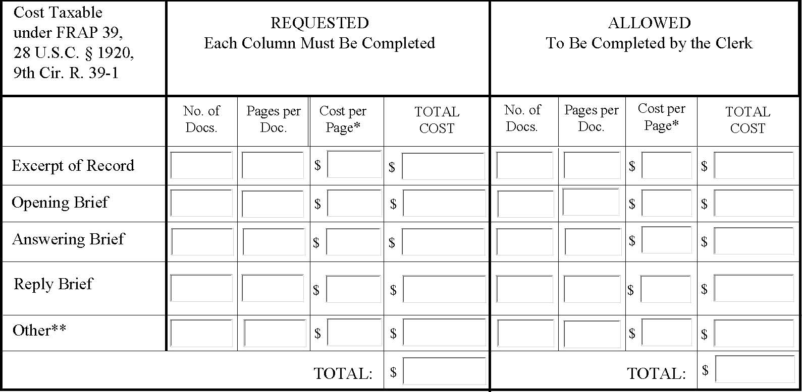

* Costs per page may not exceed .10 or actual cost, whichever is less. 9th Circuit Rule 39-1.
** Other: Any other requests must be accompanied by a statement explaining why the item(s) should be taxed pursuant to 9th Circuit Rule 39-1. Additional items without such supporting statements will not be considered.
Attorneys' fees cannot be requested on this form.
Continue to next page.

, swear under penalty of perjury that the services for which costs are taxed were actually and necessarily performed, and that the requested costs were actually expended as listed.

Signature ("s/" plus attorney's name if submitted electronically) Date Name of Counsel:
Attorney for:
I,

Date (To Be Completed by the Clerk) | Costs are taxed in the amount of $
 | Clerk of Court By: | , Deputy Clerk

