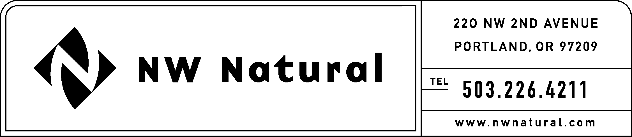
GAIL HAMMER
Rates and Regulatory Affairs
Phone: 503.226.4211 ext. 5865
Fax: 503.721.2516
gail.hammer@nwnatural.com

September 9, 2016

VIA ELECTRONIC FILING

Steven King, Executive Director and Secretary
Washington Utilities and Transportation Commission
1300 S. Evergreen Park Drive, S.W.
P.O. Box 47250
Olympia, Washington 98504-7250

RE: UG-151776 - NW Natural’s 2016 Integrated Resource Plan
ERRATA FILING – DO NOT REDOCKET

NW Natural Gas, dba NW Natural (“NW Natural” or the “Company”), herein files a correction to the Integrated Resource Plan in the above-referenced docket originally filed on August 26, 2016. The errata changes the language on page 1.16 to read “from $5,275 million to $5,293 million” rather than “from $5,275 million to $5.293 million.”

Please contact me should you have questions or require additional information.

Sincerely,
/s/ Gail Hammer
Gail Hammer
NW Natural

Enclosure

