March 22, 2010

BY Web Portal & Federal Express

David W. Danner
Executive Director and Secretary
Washington Utilities and Transportation Commission
1300 S. Evergreen Park Drive S.W.
Post Office Box 47250
Olympia, Washington 98504-7250
Subject: In re Application of Shuttle Express, Inc., For Extension of Certificate No. C-975, Shuttle Express, Inc. d/b/a Shuttle Express
Docket No. TC-091931
Dear Mr. Danner:
Enclosed, for filing, is the original and two copies of the Answer Of Shuttle Express To Petition For Administrative Review.
If you have any questions, please do not hesitate to contact the undersigned.
Very truly yours,
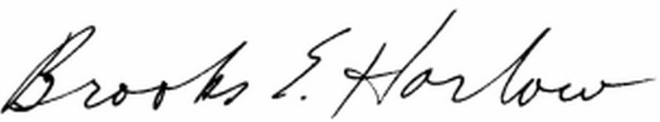
Brooks E. Harlow, P.C.

cc w/encs.: Service List

