
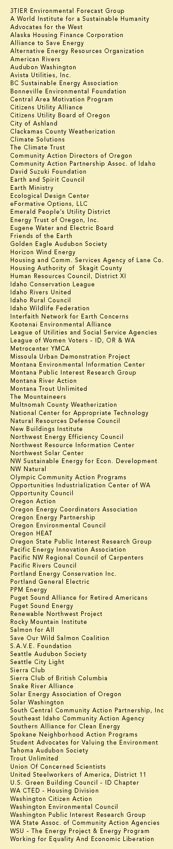

June 11, 2009

BY ELECTRONIC FILING AND FIRST CLASS MAIL

Mr. David Danner, Executive Director and Secretary
Washington Utilities and Transportation Commission
P.O. Box 47250
1300 S. Evergreen Park Drive SW
Olympia, WA 98504-7250

RE: WUTC vs. Puget Sound Energy, Docket Nos. UE-090704 & UG-090705

Dear Mr. Danner:

Attached please find the NW Energy Coalition's Petition to Intervene and Notice of Appearance for Puget Sound Energy's General Rate Case, Docket Nos. UE-090704 and UG-090705. The originals and 12 copies are being sent to the Records Department via First Class Mail. They have also been sent via electronic mail and first class mail to the attached service list.

Sincerely,

Danielle Dixon
Senior Policy Associate

