 May 5, 2005

Ms Carole J Washburn, Executive Secretary
Washington Utilities and Transportation Commission
1300 South Evergreen Park Drive SW
Olympia, WA 98504-7250

Re: Inland Telephone Company ( Prescott Telephone & Telegraph Company )
Third Revision of Sheet No. 386 Canceling Second Revision of Sheet No. 386

Dear Ms Washburn:

ICS would like to formally protest the file tariff sheets filed by Inland Telephone Company (UT-050606) modifying the service area map of the Roslyn, WA exchange.

ICS has contacted Inland Telephone Company (Julie) on 04/12/05 & 04/19/05 to request telecommunication service from Inland.

ICS has requested monthly pricing from Inland Telephone Company and will be ordering service as soon as pricing is made available to ICS from Inland Telephone Company.

In the event of Inland Telephone Company’s tariff sheet to modify the Roslyn, WA service area map be enacted, ICS would be unable to conduct business in the Roslyn, WA exchange area.

Sincerely,

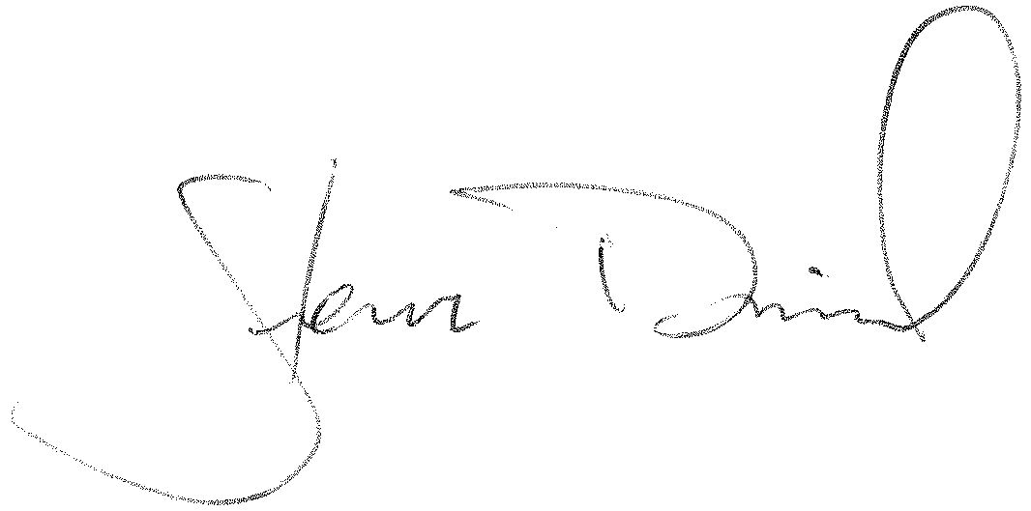

Steven M Daniels
Intelligent Community Services

