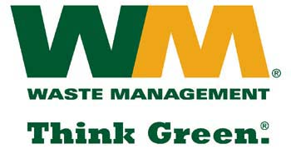

July 29, 2026

Steven King, Executive Director and Secretary
Washington Utilities & Transportation Commission
1300 South Evergreen Park Drive SW
P.O. Box 47250
Olympia, Washington 98504-7250

Re: TG-151382 (Waste Management – North Sound and Waste Management – Marysville, divisions of Waste Management of Washington, Inc. (G-237); Tariff No. 19)
Dear Secretary King:
Enclosed please find replacement pages 18, 19, 21, 22, 23, 24, 25, 27, 28, 29, 30, 31, 32, 34, 35, 37, 38, 40, 41, 42, 43, 44, 45, and 46 for the above-referenced docket. These pages are being replaced in concurrence with WUTC Staff recommendations. Please do not re-docket.

If you have any questions or need additional information, please contact me at:

Address: 720 4th Avenue, Suite 400, Kirkland, WA 98033
Telephone /Fax #: (425) 814-7840 / (425) 814-7866
e-mail: mweinstein@wm.com
Thank you for your attention to this matter.

Respectfully,

Michael A. Weinstein
Senior Pricing Manager, Pacific Northwest Market Area

