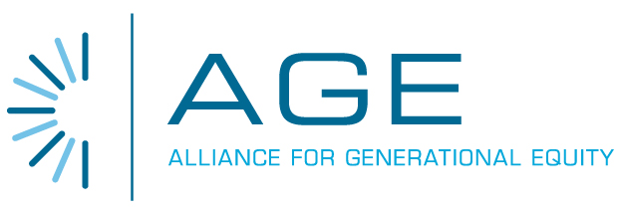

February 22, 2010

Mr. David Danner
Executive Director
Washington Utilities and Transportation Commission
P.O. Box 47250
1300 S. Evergreen Park Dr. SW
Olympia, WA 98504-7250

RE: Washington UTC -- Docket No. UT-093012

Dear Mr. Danner:

The Alliance for Generational Equity (AGE), representing Washington’s seniors and low-income families who will benefit from access to lifeline telecommunications services at rates that are fair, reasonable, and affordable to those populations, strongly endorses the referenced application for TracFone Wireless Inc. for designation as an eligible telecommunications carrier in Washington. AGE believes that this program offers a fiscally responsible model to support economically fragile seniors who can use wireless technology as a safety tool and for low-income families who need access to the lifeline program to enhance employability and the health of their families.

AGE advocates public policies that protect the economic security and quality of life of each generation. Having access to basic telephone service is an essential tool for enhancing the economic security and quality of life of these impacted populations. We are writing to urge you to fully support the TracFone Wireless petition to provide Safelink Lifeline service in Washington. This approval will expand competition in the marketplace, provide seniors with a safety tool, and help low-income consumers gain economic opportunities with funding provided by the Federal Universal Service Fund and under program guidelines established for states to access this program.

Seniors and low-income families in Washington will join millions of other Safelink participants already qualified in twenty-two other states where Safelink is presently approved. By approving the TracFone application, low-income Washington seniors, boomer families and young consumers will gain access to essential wireless phone service. Safelink provides a free phone and monthly airtime to eligible consumers who are struggling to get by in today’s tough economic climate. Phone service, particularly mobile phone service, is vital tool in helping these families stay safe during emergencies, and is essential in helping participants seek and maintain employment and to stay connected with family.

We believe SafeLink will help Washington’s low-income residents contribute to a robust state economy without any drain on already scarce state revenues. It is, in our judgment, critical that TracFone’s application be approved as quickly as possible to allow these at-risk families in Washington to have access to this valuable program.

Sincerely,

//

Dave Herman
AGE National Spokesperson
770-329-6262
timewheel8@aol.com

