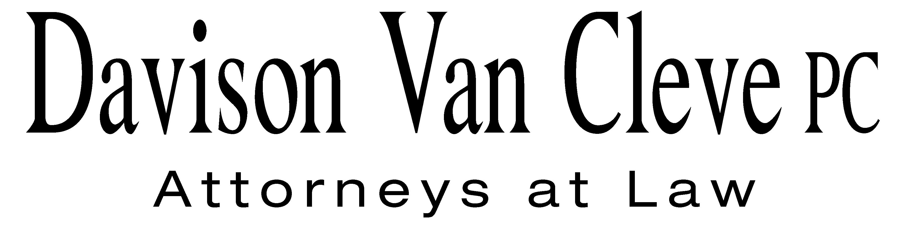
TEL (503) 241-7242 ● FAX (503) 241-8160 ● mail@dvclaw.com
Suite 400
333 SW Taylor
Portland, OR 97204

June 21, 2013

Via Email and Federal Express

Mr. Steven V. King
Acting Executive Director
Washington Utilities & Transportation Commission
1300 S. Evergreen Pk. Dr. S.W.
P. O. Box 47250
Olympia, WA 98504-7250

Re: In the matter of WUTC v. PacifiCorp.
Docket No. UE-130043

Dear Mr. King:

Enclosed please find an original and nineteen (19) copies of the Response Testimony and Exhibits of Paul Les Teel, David Reller and Scott Peters on behalf Columbia Rural Electric Association (“Columbia REA”).

Thank you for your assistance, and please do not hesitate to contact our office if you have any additional questions.

Sincerely yours,

/s/ Karen A. Zolka
Karen A. Zolka
Enclosures
cc: Service List

CERTIFICATE OF SERVICE

I hereby certify that I have this day served the foregoing Reply upon all parties of record in this proceeding by mailing a copy thereof in a sealed, first-class postage prepaid envelope to each individual’s last-known address, as listed below.
DATED this 21st day of June, 2013.
Davison Van Cleve, P.C.

/s/ Karen A. Zolka
Karen A. Zolka

WASHINGTON DOCKETS  PACIFICORP  825 NE MULTNOMAH, SUITE 2000  PORTLAND OR 97232  washingtondockets@pacificorp.com | SARAH WALLACE  SENIOR COUNSEL  PACIFICORP  825 NE MULTNOMAH, SUITE 1800  PORTLAND OR 97232  sarah.wallace@pacificorp.com
KATHERINE MCDOWELL  McDowell Rackner & Gibson PC  419 SW 11th Avenue STE 400  Portland, OR 97205  katherine@mcd-law.com | ROBERT CEDARBAUM  Assistant Attorney General  WUTC  PO Box 40128  Olympia, WA 98504-0128  bcedarba@utc.wa.gov
WILLIAM GRIFFITH  Vice President, Regulation  Pacific Power & Light Company  825 NE Multnomah STE 2000  Portland, OR 97232  Bill.Griffith@pacificorp.com | SIMON FFITCH  LISA GAFKEN  Office of the Attorney General  800 Fifth Avenue STE 2000  Seattle, WA 98104-3188  simonf@atg.wa.gov  lisa.gafken@atg.wa.gov
BRAD M. PURDY  Attorney at Law  2019 N. 17th St.  Boise, ID 83702  bmpurdy@hotmail.com | SCOTT PETERS  Manager of Marketing and Member Services  Columbia Rural Electric Association, Inc.  PO Box 46  Dayton, WA 99328  speters@columbiarea.com
BOISE WHITE PAPER, L.L.C.  Boise White Paper Holdings, L.L.C.  PO Box 50  Boise, ID 83728 | THE ENERGY PROJECT  The Energy Project  3406 Redwood Ave.  Bellingham, WA 98225

