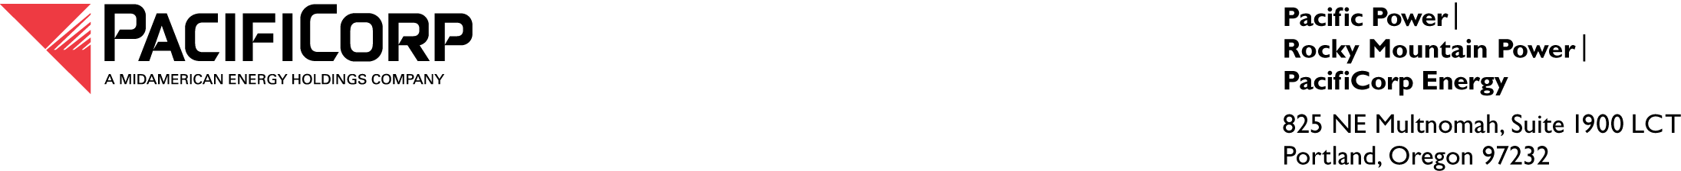

July 6, 2016

VIA ELECTRONIC FILING

Steven V. King
Executive Director and Secretary
Washington Utilities and Transportation Commission
1300 S. Evergreen Park Drive SW
P.O. Box 47250
Olympia, WA 98504-7250

Re: Docket UE-980404—Report of New Credit Agreement for Short-Term Debt

Pacific Power & Light Company (Pacific Power or Company), a division of PacifiCorp, submits to the Washington Utilities and Transportation Commission one verified confidential and redacted copy of the $400,000,000 Credit Agreement, dated June 30, 2016, among PacifiCorp, the Banks party thereto, and JPMorgan Chase Bank, N.A., as Administrative Agent. This credit agreement replaces the $600,000,000 Credit Agreement dated June 28, 2012, which was terminated on June 30, 2016. Commercially sensitive information has been redacted from the enclosed credit agreement. The Company has provided notices related to this credit agreement on May 10, 2016, and June 23, 2016, in Docket UE- 160490.

Because PacifiCorp has not made any new borrowing in connection with the referenced transaction, no Report of Securities Issued is enclosed.

Confidential material in support of this filing is being provided under WAC 480-07-160.

Under penalty of perjury, I declare that I know the contents of the enclosed documents, and they are true, correct and complete.

Please contact Ariel Son, Regulatory Projects Manager, at 503-813-5410, if you have any questions about this letter or the enclosed documents.

Sincerely,

Bruce N. Williams
Vice President and Treasurer

Enclosure

