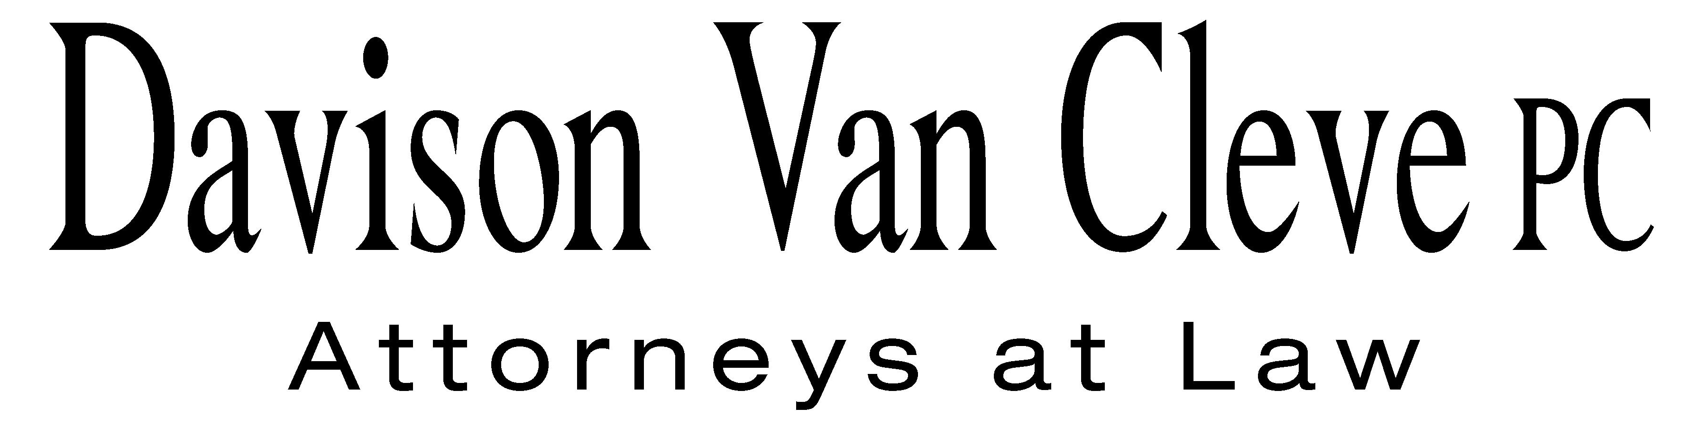
TEL (503) 241-7242 ● FAX (503) 241-8160 ● mail@dvclaw.com
Suite 400
333 SW Taylor
Portland, OR 97204

May 26, 2009

Via Email and Federal Express

Carole J. Washburn
Secretary
Washington Utilities and Transportation Commission
PO Box 47250
1300 S Evergreen Park Drive SW
Olympia, WA 98504-7250

Re: In the matter of the Puget Sound Energy, Inc.’s general rate increase.

Docket No. UE-090704/UG-090705

Dear Ms. Washburn:

Enclosed please find an original and twelve (12) copies each of the following documents for filing in the above-captioned matter:

- the Petition to Intervene of the Industrial Customers of Northwest Utilities; and

- the Notice of Appearance of S. Bradley Van Cleve and Irion Sanger on behalf of the Industrial Customers of Northwest Utilities.

Thank you for your assistance.

Sincerely yours,

/s/ Brendan E. Levenick
Brendan E. Levenick
Enclosures

cc: Service List

CERTIFICATE OF SERVICE

I hereby certify that I have this day served the foregoing documents upon all parties of record in this proceeding by mailing a copy thereof in a sealed, first-class postage prepaid envelope to each individual’s last-known address, as listed below.
DATED this 26th day of May, 2009.
Davison Van Cleve, P.C.

/s/ Brendan E. Levenick
Brendan E. Levenick

PUGET SOUND ENERGY  TOM DEBOER  PO BOX 97034 PSE-08N  BELLEVUE WA 98009-9734  tom.deboer@pse.com | PERKINS COIE  SHEREE CARSON  10885 N.E. FOURTH STREET STE 700 BELLEVUE WA 98004-5579  scarson@perkinscoie.com
WUTC  ROBERT D CEDARBAUM  ASSISTANT ATTORNEY GENERAL  ATTORNEY GENERAL OFFICE  STATE MAIL STOP 40128  bcedarba@wutc.wa.gov | WUTC  MICHAEL FASSIO  ASSISTANT ATTORNEY GENERAL  STATE MAIL STOP 40128  MFassio@utc.wa.gov
PERKINS COIE
DONNA BARNETT
10885 N.E. FOURTH STREET STE 700
BELLEVUE WA 98004
dbarnett@perkinscoie.com

