- Changes in Road Restoration Construction Practices
  - This series of comparative photographs illustrates the changes in road restoration construction practices that are often now required by some municipalities and counties where PSE constructs natural gas system projects.
    - Figure 3-1 represents an example of a project where PSE was able to work in the shoulder where restoration was minimal and less expensive.
Figure 3-1: Orting Phase I Project, 8-Inch Diameter Supply Pipeline, In-Service 2007
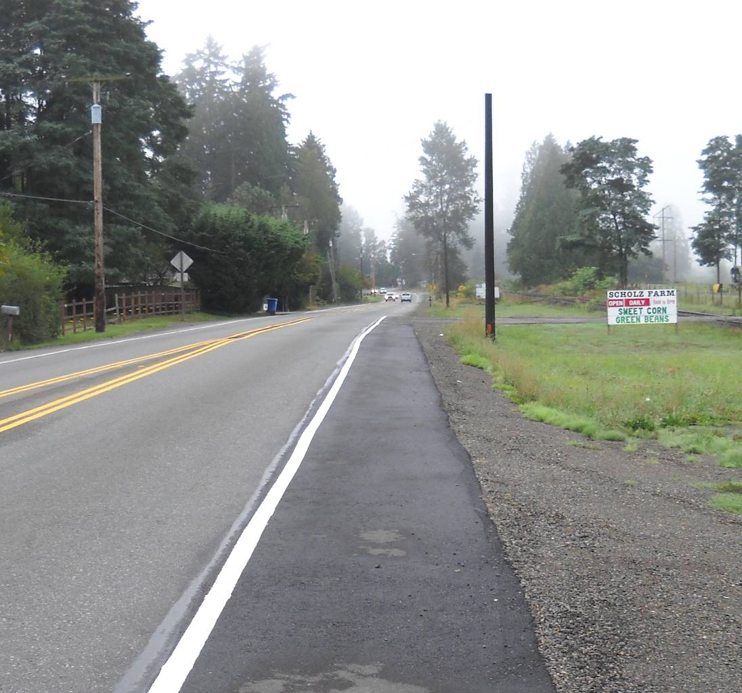

Continued on next page
    - Figure 3-2 shows an example of a project where PSE was required to work in the roadway and installed a temporary patch. PSE incurred approximately $2.5 million in costs to install this patch that is approximately five feet wide over a five mile length of roadway.
Historically, this patch would have been an acceptable final restoration practice. More recently and more frequently, as in this project, the Company was required to return to add roadway asphalt overlay which varied from one lane to five lanes, plus shoulders. This was at an additional cost of $2 million (yielding a total cost of $4.5 million for paving restoration).
Figure 3-2: Kent Black Diamond Phase II Project, 16-Inch Diameter Supply Pipeline,
In-Service October 2009
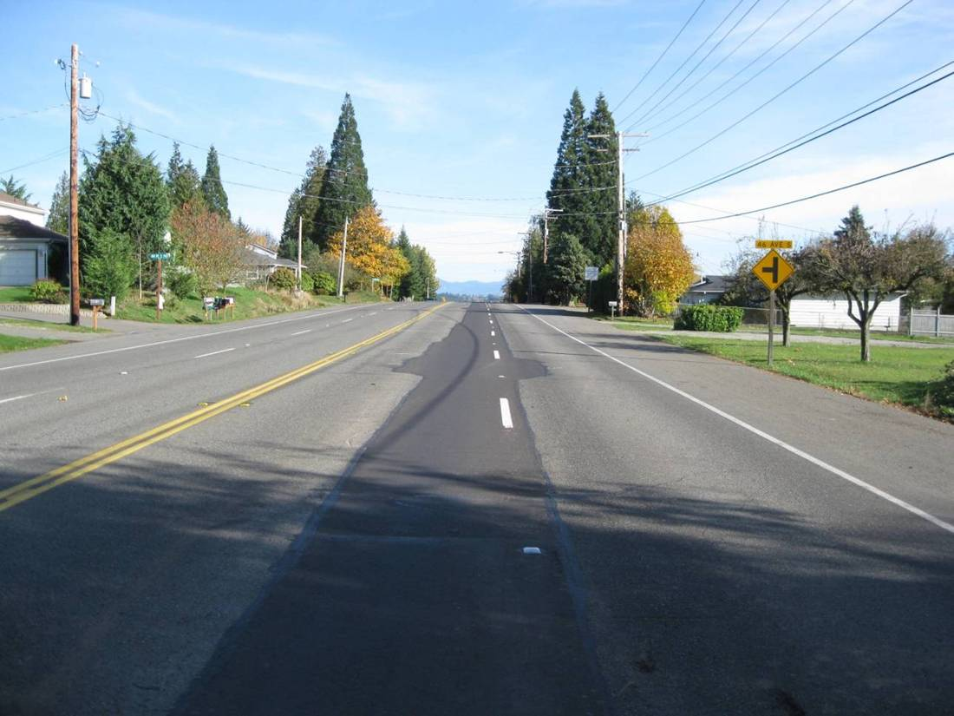

Continued on next page
    - Figure 3-3 depicts the required full roadway asphalt overlay on a section of the project where the road is a four-lane road. The photo was taken after the required full roadway overlay was completed, but before line striping.
Figure 3-3: Kent Black Diamond Phase II Project, 16-Inch Diameter Supply Pipeline,
In-Service October 2009
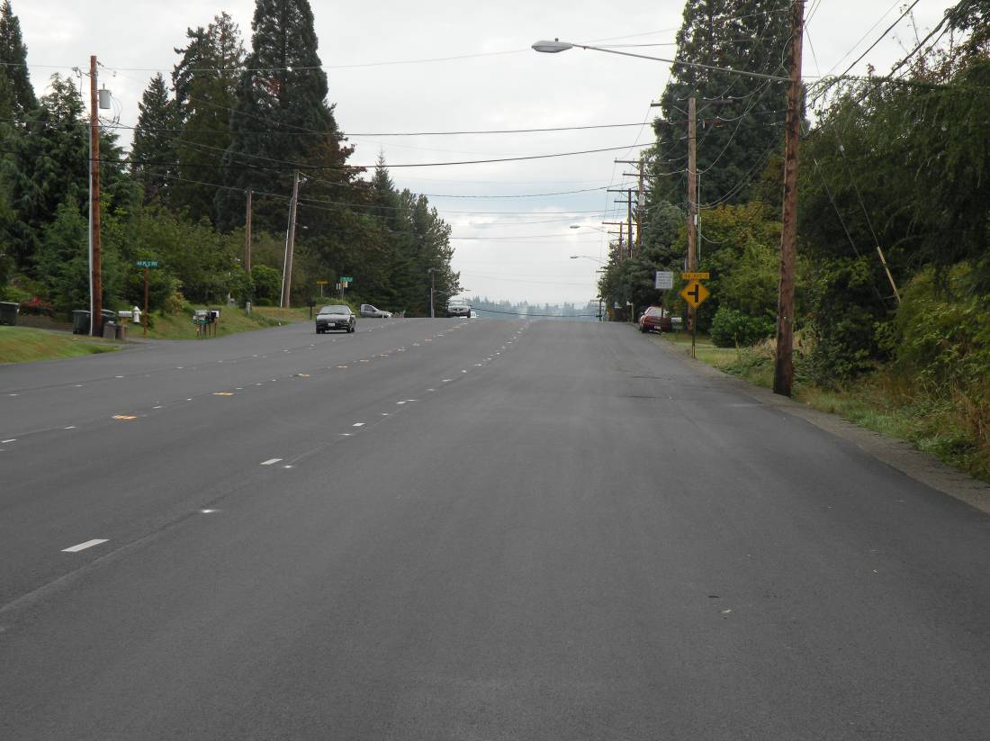

Continued on next page
    - Figure 3-4 shows a project where a soil spreading machine was used to install select material that was hauled in to meet backfill compaction permit requirements. Since specific backfill material had to be hauled in, the existing soils that had been removed had to be hauled away.
Figure 3-4: Kent Black Diamond Phase II Project, 16-Inch Diameter Supply Pipeline,
In-Service 2009
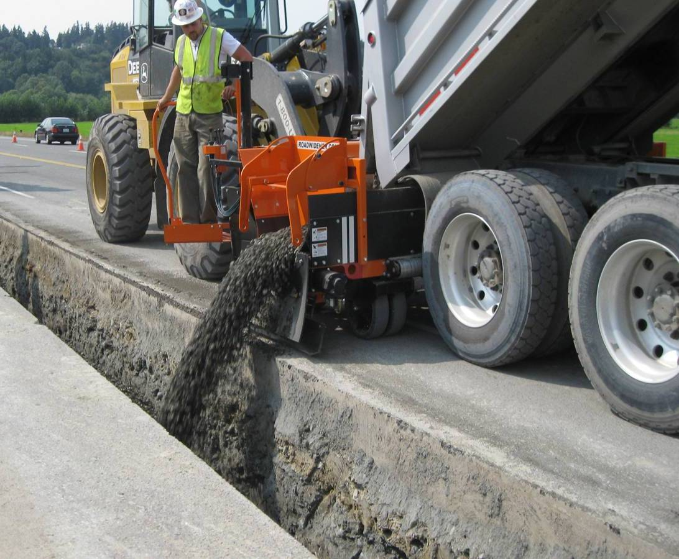

Continued on next page
    - Figure 3-5 illustrates the trench depth for six-inch PE pipe in accordance with PSE standards that require three feet of cover.
Figure 3-5: 6501 Beacon Ave S, 6-Inch Bare Steel Main Replacement, In-Service Expected 2010
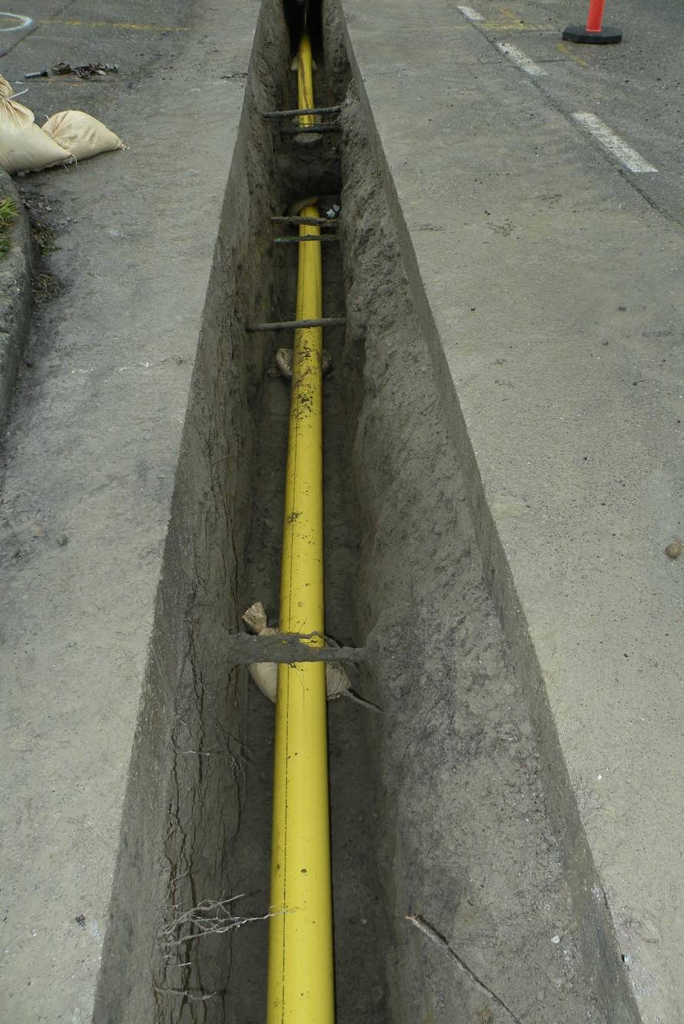
    - Figure 3-6 shows the trench depth for 12-inch high pressure pipeline where the permit required seven feet of cover although PSE standards would have required three feet of cover. The seven-foot trench depth mandated the use of additional worker safety protections, such as shoring.
Figure 3-6: Lacey-Fones Road, 12-Inch Diameter Supply Pipeline, In-Service 2009
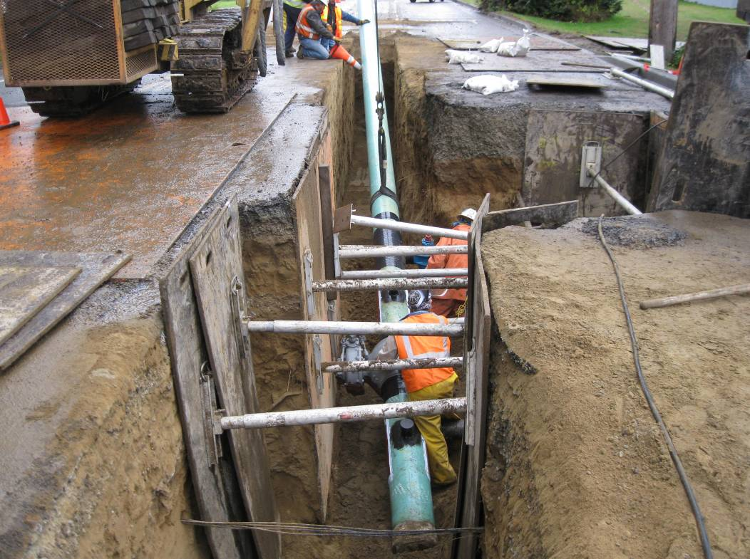

Continued on next page
    - In Figure 3-7, the required traffic control cameras which allowed the City to perform automated traffic control were installed prior to initiating construction and removed upon project completion. PSE incurred camera installation and removal costs of approximately $300,000.
Figure 3-7: Bellevue Lake Hills 12- and 16-Inch-Diameter Supply Pipeline, In-Service 2009
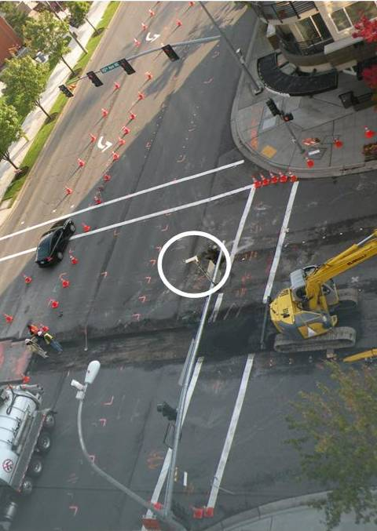
    - Figure 3-8 depicts work that had to be performed at night as a condition of the construction permit. This increased project costs for added traffic control (off-duty police), lighting, overtime or shift differential, and extended hours for concrete mixing batch plants to supply backfill material.
Figure 3-8: Lynnwood Valve Replacement, In-Service 2007
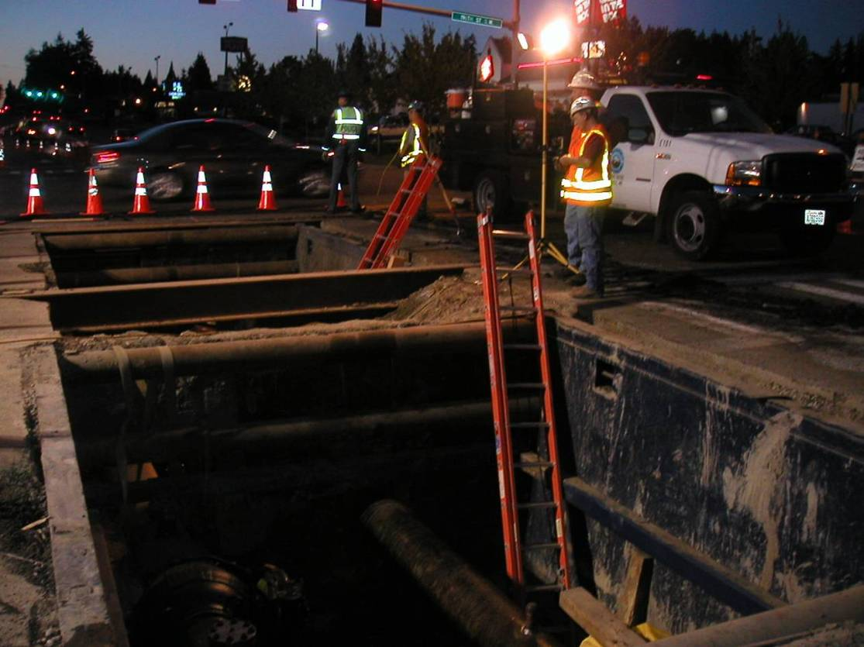

Continued on next page
    - In the past, an acceptable practice was to naturally filter water by discharge through a grass field or hillside. More recent regulations require a water quality treatment and monitoring system.

Figure 3-9 shows Clover Creek open cut crossing and the environmental protection steps that were required to preserve water quality and salmon migration. Geo-technical studies of soils indicated that conditions were not conducive to directional drill or traditional bore construction methods, therefore, PSE was required to open cut Clover Creek. Water that passed through the cut had to be filtered to meet water quality requirements. This was achieved by constructing upstream and downstream barriers – providing the water a place to settle before reentry to the creek.
Figure 3-9: Frederickson 16-Inch HP Supply Pipeline, In-Service 2008
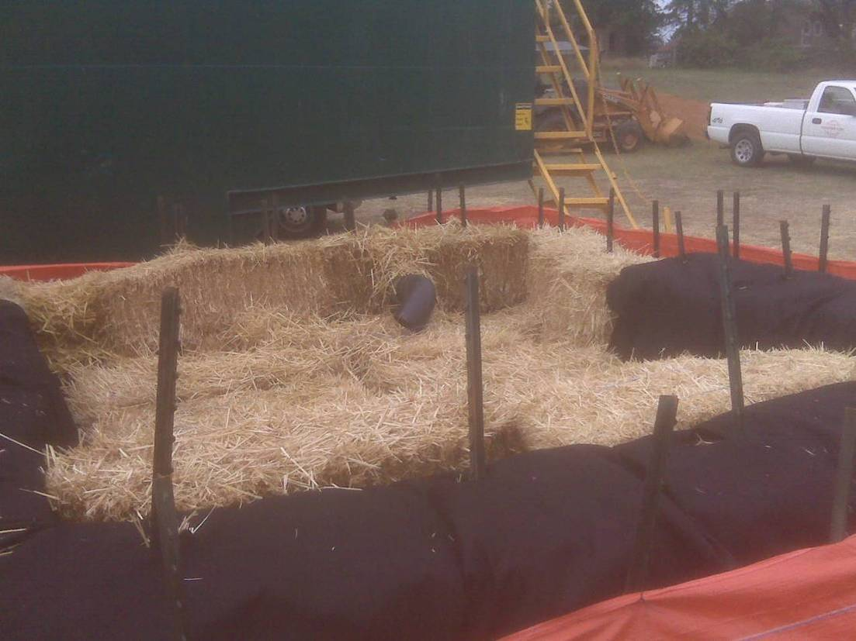
Sediment tank receiving creek water to drain between dams
Filtration System

