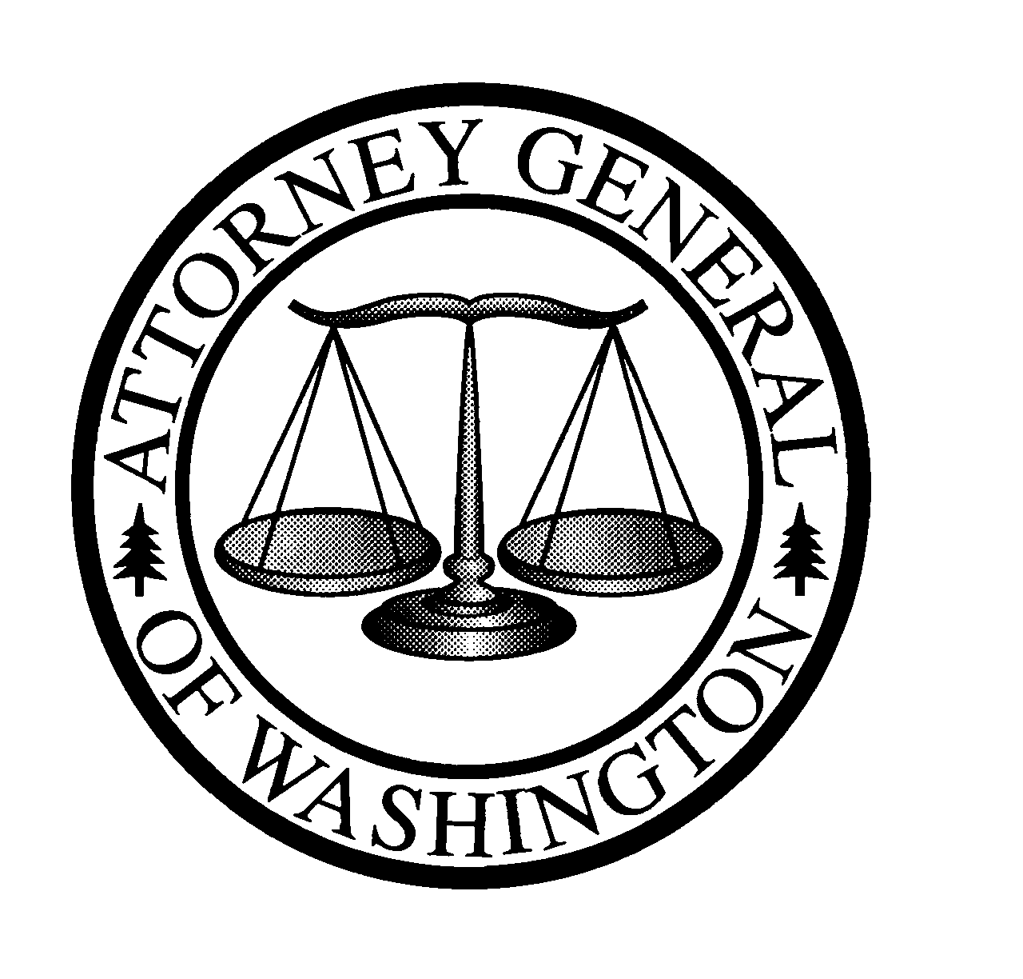
Christine O. Gregoire
ATTORNEY GENERAL OF WASHINGTON
900 Fourth Avenue, Suite 2000 • TB-14 • Seattle, Washington 98164-1012

July 31, 2026

VIA ELECTRONIC FILING & ABC/Legal messenger
Carole Washburn
Secretary
Washington Utilities and Transportation Commission
1300 S. Evergreen Pk. Dr. S.W.
PO Box 47250
Olympia, WA 98504-7250

Re: In the Matter of the Rule-Making Proceeding Related To Reporting of
Transactions Between Regulated Companies and Their Subsidiaries
Docket No. A-021178

Dear Ms. Washburn:

Enclosed please find an original copy of the Initial Comments of Public Counsel for filing in the above-entitled case. For confirmation of receipt, I have enclosed a copy to be date-stamped and sent back to us in the enclosed self-addressed, stamped envelope. A copy was also sent via e-mail on November 27, 2002.

Sincerely,

Simon ffitch
Assistant Attorney General
Public Counsel Section
(206) 389-2055

Sf:cjw

Enclosures

