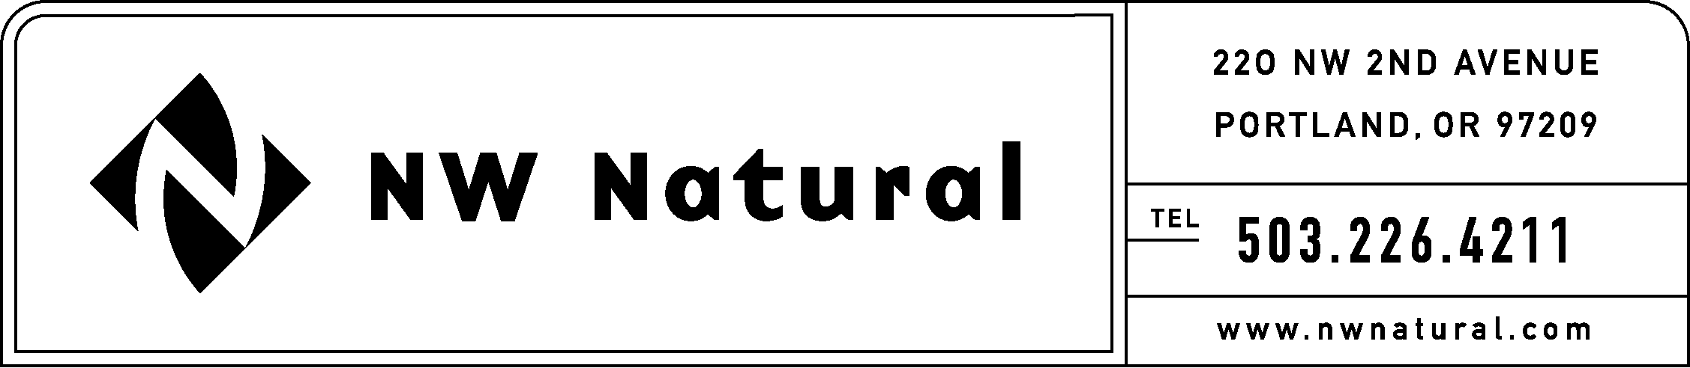

RATES AND REGULATORY AFFAIRS
Facsimile: (503) 721-2532

January 20, 2005

Ms. Carole J. Washburn
Executive Secretary
Washington Utilities & Transportation Commission
P.O. Box 47250
Olympia, Washington 98504-7250

Re: Docket Number A-021178
Financial Reporting Rules

NW Natural respectfully submits the following comments on the proposed rules in the above-referenced matter:

WAC 480-90-242 Issuing Securites.

NW Natural supports staff’s proposed changes to this section, and appreciates the effort that both staff and the Commissioners have expended in addressing earlier comments and concerns associated with earlier versions of this rule.

We do suggest one point of clarification:

There are two types of ratings issued – a secured rating and an unsecured rating. Most agencies will use the secured rating. For clarity, we believe that the rule should specify the type of rating that would apply for purposes of this rule. We recommend that the secured rating be used. As such, we suggest that the rule be clarified as follows:

“Investment grade” means a gas utility whose corporate credit/issuer secured rating is in one of the four highest rating categories of either Standard & Poor’s L.L.C. or Moody’s Investment Service Inc.”

WAC 480-90-224 Transferring cash or assuming obligations.

At Section (1)(b), second paragraph, of the proposed rule, there is a reference to the annual report filed pursuant to WAC 480-100-252 (FERC Form 1), which is an electric rule and reporting requirement. We believe the correct reference should be to WAC 480-90-252 (FERC Form 2).

WAC 480-90-245 Affiliated Interests – Contracts or arrangements.

The proposed rule requires the filing of a verified copy or verified summary (whichever applies) of any contract or arrangement described in RCW 80.16.020. Absent a materiality threshold, this would potentially impose reporting requirements for contracts that carry small dollar values. This could be burdensome on the utility and could inundate the Commission with unnecessary and unwanted filings.

One approach to managing this would be to add a materiality threshold similar to that used by the Securities and Exchange Commission. For example:

This requirement will not apply to contracts or arrangements for amounts that do not exceed 5% of the consolidated gross revenues of the affiliate.

WAC 480-90-257 Commission basis report.

We suggest the following clarification to Section (2)(b):

“Results of operations adjusted for any material out-of-period, nonoperating, nonrecurring, and extraordinary items or any other item that materially distorts reporting period earnings and rate base; and”

Thank you again for the opportunity to comment in this proceeding.

Sincerely,

NW NATURAL

Onita R. King, Manager
Tariffs and Regulatory Compliance

