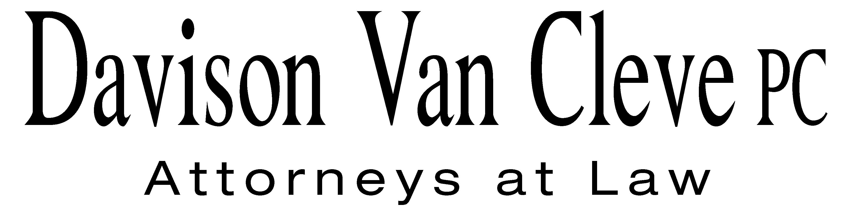
TEL (503) 241-7242 ● FAX (503) 241-8160 ● mail@dvclaw.com
Suite 400
333 SW Taylor
Portland, OR 97204

October10, 2008

Via Federal Express and Electronic Mail

Carole J. Washburn
Secretary
Washington Utilities & Transportation Commission
1300 S. Evergreen Park Drive S.W.
Olympia, WA 98504

Re: In the Matter of WUTC v. Avista Corporation

Docket Nos. UE-080416

Dear Ms. Washburn:

Enclosed please find the Petition for Review on behalf of the Industrial Customers of Northwest Utilities and Public Counsel in the above-referenced matter.

Thank you for your assistance.

Sincerely yours,

/s/ Brendan E. Levenick
Brendan E. Levenick

Enclosures
cc: Service List
CERTIFICATE OF SERVICE

I hereby certify that I have this day served a copy of the foregoing Petition for Review of the Industrial Customers of Northwest Utilities and Public Counsel upon the parties, shown below, listed on the official service list in Docket No. UE-080416 by causing the same to be mailed, postage-prepaid, via U.S. Mail.
DATED at Portland, Oregon, this 10th day of October, 2008.
Davison Van Cleve, P.C.

/s/ Brendan E. Levenick
Brendan E. Levenick

Kelly Norwood  Vice President  Avista Corporation  1411 E. Mission  Spokane, WA 99220 | David Meyer  Attorney  Avista Corporation  PO Box 3727  Spokane, WA 99220
Liz Andrews  Manager, Revenue Requirements  State & Federal Regulation  Avista Corporation  1411 E. Mission  Spokane, WA 99220 | Pat Ehrbar  Regulatory Analyst  State & Federal Regulation  Avista Corp.  1411 East mission  Spokane, WA 99220
Greg Trautman  Washington Utilities & Trans. Comm'n Attorney General Section  PO Box 40128  Olympia, WA 98504 | Simon ffitch  Office of the Attorney General  Public Counsel Section  800 5th Avenue, Suite 2000  Seattle, WA 98104
Stefanie Johnson  Public Counsel  800 5th Avenue, Suite 2000  Seattle, WA 98104-3188 | Tom Spinks  Public Counsel  800 5th Avenue, Suite 2000  Seattle, WA 98104-3188
Kathryn Zsoka  Public Counsel  800 5th Avenue, Suite 2000  Seattle, WA 98104-3188 | Ronald L. Roseman  Attorney at Law  2011 14th Avenue East  Seattle, WA 98112
Tommy A Brooks
Chad Stokes
CABLE HUSTON BENEDICT
1001 SW 5TH STE 2000
PORTLAND OR 97204-1136

