

Request for Proposals

For

The State of Washington
Department of Corrections

Offender Telephone System
And Recording/Monitoring

CRFP6446
Issued: August 1, 2005

TABLE OF CONTENTS

SECTION I 1
1. Introduction 1
1.1 Overview 1
1.2 Funding 1
1.3 Delegation of Authority to Acquiring Organization: Department of Corrections 1
1.4 Definitions 1
SECTION 2 2
2. General Requirements 2
2.1 General Background 2
2.2 Contract Term, Initiation of Services, and Payment of Commission 3
SECTION 3 4
3. RFP Rules and Procedures 4
3.1 Issuing Office, Contact with the State 4
3.2 RFP Coordinator 4
3.3 Conduct of Acquisition 4
3.4 Conditions 4
3.5 RFP Schedule 5
3.6 Vendor's Questions and State's Responses 5
3.7 Complaints 6
3.8 Cancellation or Reissuance of the RFP 6
3.9 RFP Amendments 6
3.10 Alternate or Multiple Proposals 7
3.11 Withdrawal of Proposals 7
3.12 Proposal Due Date 7
3.13 Proposal Delivery Location 7
3.14 Waiver of Minor Administrative Irregularities 7
3.15 Acceptance of Proposals 8
3.16 Proposal Evaluation 8
3.17 Selection of Apparent Successful Vendor 8
3.18 Contract Award 9
3.19 Incorporation Into Contract 9
3.20 Award Notice 9
3.21 Vendor Debriefing 9
3.22 Protest Procedures 9
3.23 Execution of the Written Contract 11
3.24 Insurance Coverage 11
3.25 Compliance with the Americans with Disabilities Act 12
3.26 Authority to Bind the Department 12
3.27 Proprietary Information/Public Disclosure 12
SECTION 4 12
4. Instructions for Proposal Preparation and Submittal 12
4.1 Proposal Organization and Number of Copies 12
4.2 Proposal Format 13
4.3 Submittal Envelope (1 copy) 13
4.4 Technical Proposal (4 copies) 14
4.5 Qualifications Proposal (4 copies) 14
4.6 Cost Proposal (4 copies) 14
4.7 Supplemental Material 14
4.8 Proposal Content, Order of Appearance 15
4.9 Responses to All Subsections Required 15
4.10 Mandatory Requirements 15
4.11 Scored Requirements 15
SECTION 5 16
5. Technical Proposal Requirements (22 Points) 16
5.1 Vendor Responses (MS): 16
5.2 Vendor Responses (MR) 17
SECTION 6 17
6. Qualifications Proposal Requirements (24 points) 17
6.1 Vendor Firm Information 17
6.2 Responsible Parties 18
6.3 (MR) Washington Business License/Federal Employer Identification Number 18
6.4 Past and Present Relationships with the State 19
6.5 (MR) Contract Performance 19
6.6 (MR) Subcontractors 20
6.7 Qualifications 20
SECTION 7 22
7. Cost Proposal Requirements (54 points) 22
7.1 Cost 22
SECTION 8 23
8. Proposal Evaluation Requirements 23
8.1 Evaluation Team 23
8.2 Basis for Evaluation 23
8.3 Evaluation Steps 23
8.4 Scoring 23
8.5 Scoring/Selection Approach/Apparent Successful Vendor 25
EXHIBIT A 1
CERTIFICATIONS AND ASSURANCES 1
EXHIBIT B 1
GENERAL TERMS AND CONDITIONS 1
EXHIBIT C 1
Scoring Example 1
EXHIBIT D 1
Examples of Vendor Cost Proposal: 1
EXHIBIT E 1
Vendor Cost Proposal Form: 1
Exhibit F 1
DOC Policy 450.200 1
DOC Policy 450.210 7
Exhibit G 1
RESPONSIVENESS CHECKLIST 1

SECTION I
  - Introduction
    - Overview
The Washington State Department of Corrections is soliciting a qualified vendor to provide telecommunication services and equipment, to ensure that offenders in prison, pre-release and work release facilities are provided access to public telephones subject to limitations and restrictions necessary to safeguard the security and order of the facility, and to protect the public from unwanted offender calls. This RFP will establish a single contract for the implementation and operation of a turnkey offender telephone system with integrated recording and monitoring capabilities to meet current and future legislative and programmatic requirements.
The Department intends to enter into a contract with a single vendor who will provide complete logistical support, ongoing operation, and maintenance of an offender telecommunications system/services for 15 correctional facilities and 15 work release facilities.
This Request for Proposals is expected to result in the award of a single contract with the vendor who best meets the stated requirements and provides competitive prices for offenders, offender families and friends. The proposed solution is for a turnkey system to include, among other things, installation, maintenance, telephones, enclosures, panel and such other equipment or materials necessary to replace the current offender telephone system/services.
Offender telephone services are currently provided by AT&T under a single contract as the prime contractor, with multiple vendors as subcontractors. The vendor awarded the contract will be expected to coordinate with AT&T and its subcontractors to allow for an uninterrupted transition and implementation of new services.
Vendors may submit only one proposal as a prime contractor, but may participate as a subcontractor with another prime contractor on more than one proposal. The prime contractor must provide a single point of contact for the Department
    - Funding
No state funding is provided for the services and equipment provided under any contract awarded as a result of this RFP. The Department bears no responsibility for any costs incurred by the vendor in providing the offender phone system and related services such as maintenance, monitoring and recording. The Department makes no guarantee of offender call minutes or the type of calls made during the term of the contract. No vendor selected as a provider of equipment or services by this acquisition is assured of receiving any minimum amount of business.
    - Delegation of Authority to Acquiring Organization: Department of Corrections
The Information Services Board (ISB) has authority and oversight over telecommunications acquisitions. The ISB has delegated to the Department of Information Services (DIS) the authority to approve releases of RFPs for telecommunication services. This RFP is released in accordance with state information technology (IT) investment policies and standards. The Department of Corrections is a cabinet-level agency. The Department is divided into the Prisons Division, Community Corrections Division, and the Administrative Division.
The Deputy Secretary, Prisons Division, or his/her delegate will administer the contract entered into as a result of this RFP.
    - Definitions
The following terms and abbreviations are defined as used herein:
Apparent Successful Vendor: Vendor ranked first as a result of the evaluation of proposals. The identification of a vendor as an Apparent Successful Vendor does not constitute an award of a contract under this RFP.
Calendar Year: A twelve-month period beginning on January 1st and ending on December 31^{st.}
Contractor: The vendor with whom a written contract is ultimately executed as a result of this procurement action.
Contract Award: The contract will be deemed awarded after selection and announcement of the apparent successful vendor, successful conclusion of any protest process(es) and execution of a mutually agreeable written contract between the Department and the selected vendor.
Date of Award: The date on which the agency and the successful bidder sign the contract.
DIS: The state of Washington, Department of Information Services.
DOC or Department: The state of Washington, Department of Corrections.
ISB: The Information Services Board. The governing body having oversight over telecommunication acquisitions, policies and standards.
RFP: Request for Proposals. A documented, formal acquisitions process providing an equal and open opportunity to submit a proposal.
RFP Coordinator: The individual noted in Section 3.2 or designee.
State: The government of the state of Washington, including all its organizational sub-parts.
Subcontractor: Any person not in the employ of the vendor, or any organization not owned by the vendor, performing work which is the responsibility of the vendor under a contract resulting from this RFP. The term applies to subcontractors at any tier.
Vendor: Any individual or organization that is a provider of goods and/or services as used herein, especially a provider of the goods and services being acquired through this RFP, whether or not the vendor elects to submit a proposal.

SECTION 2
  - General Requirements
This RFP is issued to procure the services of a single vendor to provide a turnkey offender telephone system including recording and monitoring equipment. A vendor may submit a proposal on behalf of a group of vendors who may serve as subcontractors, but the proposal must identify the primary vendor who will sign a contract if selected and will be responsible for any subcontractor’s services provided under the contract. The vendor must designate a single point of contact for the primary vendor and any subcontractors.
Section 2 defines how the services are expected to be utilized via the contract, and sets forth certain terms and conditions for the conduct and performance of the services to be contracted.
Except for Subsection 2.2.2, vendors are not to respond directly to Section 2 in their proposals. Information in Section 2 is intended to be helpful in completing the vendor’s response to the proposal requirements described in sections 5, 6, and 7 of this RFP.
    - General Background
The Department of Corrections, an executive-branch agency of the Washington State government, employs approximately 8,000 individuals who are responsible for approximately 17,000 offenders in the state prison system, and approximately 29,000 offenders under active community supervision. The Department operates 15 prison and pre-release facilities, 15 work release facilities, 89 community corrections offices, and a variety of offender and offender family support programs. Department facilities vary significantly in size and geographic location, with the largest employing nearly 1,500 staff members, and the smallest employing fewer than five staff members.
In 2003 (for the period of January 1, 2003 through December 31, 2003) offenders completed approximately:
579,171 local calls totaling 8,590,171 minutes
1,053,244 intraLata calls totaling 14,268,787 minutes
402,175 long distance (or interLata calls totaling 5,438,837 minutes
    - Contract Term, Initiation of Services, and Payment of Commission
      - Contract Term
The initial term of any contract resulting from this RFP will begin on March 1, 2006 and continue through December 31, 2007(“Initial Term”). Unless terminated earlier, at the end of the Initial Term and each one (1) year period thereafter until December 31, 2014, the Department may extend the term of the Contract for an additional one-year period under the same terms and conditions. The decision to extend the term of the contract shall be at the sole discretion of the Department.
      - Initiation of Services/Implementation Plan
One vendor will be selected to enter into a written convenience contract as a result of this RFP with the selected vendor to begin providing services no later than 120 days after execution of a written contract. The Proposal must include an implementation plan describing the tasks and activities to be completed and their timeframes/milestones prior to the start of services. The implementation plan is to detail how the vendor would satisfy the RFP's requirements regarding the installation, operation and maintenance of an offender phone system with monitoring and recording capabilities, such that each issue addressed would be complete and detailed enough to assure the Department of the vendor’s understanding and capability to perform the cited requirements, and to substantiate that the contract will be fully operational on the contract start date.
      - Commission
The Vendor selected and subsequently providing the services required by this RFP will pay a commission to the Department as set forth in Section 7 of this RFP. The commission paid to the Department will be based on a percentage of gross revenue generated by all offender calls. Commission payments shall be made by the twentieth day of each month.
      - Subcontracts
Vendors may use subcontractors to provide services required by this RFP. The intent to use certain parties as subcontractors must be stated in the vendor’s proposal. Vendor’s use of a subcontractor not included in the vendor’s proposal may be denied for any reason at the sole discretion of the Department.
      - Right of Ownership and Confidentiality
The Department shall own all data collected and stored, and other forms and reports produced in the performance of services rendered under contract from this RFP.
Much of the Department’s data relates to criminal justice issues. All data or documentation encountered by the contractor in performance of services requested will be considered confidential and, therefore, will not to be copied, shared, or transferred in any way without written permission of the DOC.

SECTION 3
  - RFP Rules and Procedures
    - Issuing Office, Contact with the State
The issuance of this RFP is in accordance with state of Washington IT investment policies and standards. The RFP Coordinator is the sole point of contact between vendors and the Department with regard to this RFP from the date of its release until the Apparent Successful Vendor has been announced. Any attempt by a vendor to contact the Department other than through the RFP Coordinator concerning this RFP during that time may be cause to disqualify the vendor from further consideration in this RFP. All requests for copies of the RFP, questions, and requests for clarification should be directed only to the designated RFP Coordinator identified below. Contact after announcement of the Apparent Successful Vendor is governed by the protest procedures outlined in this RFP
    - RFP Coordinator
The RFP Coordinator designated for this RFP is Kay Wilson-Kirby. In the event that the RFP Coordinator is not available, she or the Contracts Administrator shall designate another party to serve as RFP Coordinator in her absence.
All communications pertaining to this RFP must be directed only to the RFP Coordinator, or designee, as follows:
Department of Corrections
Attention: Kay Wilson-Kirby
Contracts, and Legal Affairs Section
Re: CRFP6446
410 West 5th Avenue
PO Box 41114
Olympia, WA 98504-1114
E-mail: kwilson-kirby@doc1.wa.gov
    - Conduct of Acquisition
This acquisition is being conducted in compliance with the policies and procedures of the Washington State Information Services Board as well as other applicable state laws and regulations.
    - Conditions
Proposals are invited and will be accepted subject to the following conditions and rights of the Department. The vendor is specifically notified that failure to comply with any part of the RFP may result in rejection of the entire proposal as non-responsive.
      - Only Source for Proposal Requirements
Proposals are to be based only on this RFP, subsequent amendments, if any, and the written questions and answers published to all vendors. Vendors are specifically instructed to disregard any previous materials, including previous RFPs or RFP drafts if any were issued, and any oral representations the vendor may have been given.
      - Proposal Preparation Costs
Neither the state of Washington nor the Department will be liable for any costs associated with the preparation of a proposal, a presentation by the vendor, or for any other activity conducted in response to this RFP. Vendor activity is voluntary on the part of the vendor and is done with the understanding that no costs incurred will be reimbursed by the state of Washington or DOC.
      - No Obligation to Contract or Buy
This RFP does not obligate the Department or the state of Washington to award or execute a contract for services specified herein. If a contract is executed as a result of this RFP, the Contractor is not assured of receiving any minimum amount of business from the state of Washington or from the Department. The Contractor is not assured of receiving a minimum amount of business as a result of offender or family telephone usage.
      - Third Party Vendor/Subcontractor
Proposals will be accepted from vendors who propose services provided by other parties, with the understanding that the vendor will remain solely responsible to the Department for the delivery and performance of all services to be provided under the contract.
    - RFP Schedule
All vendors must adhere to the following RFP schedule. The Department reserves the right to revise this schedule if necessary in accordance with Subsection 3.9.
Event Date
- Issue RFP August 1, 2005
- Written Complaints Due August 10, 2005
- Vendors’ Written Questions Due (FAX acceptable) August 12, 2005
- Issue Department’s Responses to Vendor Questions on or before August 19, 2005
- Proposals Due October 3, 2005 at 4:00 p.m. Local Time
- Evaluation Period October 4 –October 7, 2005
- Announcement of Apparently Successful Vendor October 10, 2005
(on or before)
- Execute a Written Contract (on or before) November 14, 2005
    - Vendor's Questions and State's Responses
Vendors may submit written questions and requests for clarification pertaining to this RFP to:
Department of Corrections
Attention: Kay Wilson-Kirby, RFP Coordinator
Re: CFP6446
410 West 5th Avenue
PO Box 41114
Olympia, WA 98504-1114
FAX: (360) 664-2009
E-mail: kwilson-kirby@doc1.wa.gov
Vendor's questions must be in writing and may be sent by mail, FAX, or electronic mail. Questions received after the deadline date stated in the RFP Schedule (Subsection 3.5) will not be answered. The Department will attempt to answer all questions received provided that the Department receives them no later than August 12, 2005.
The basic content of all vendors' questions and the Department's responses to the questions will be published and sent via mail, FAX, or electronic mail to each vendor. The vendor’s questions and the Department’s responses to the questions will also be published on the Department’s website at www.wa.gov/doc. The Department intends to provide the answers to all submitted written questions on or before August 19, 2005, in one single document. If a vendor does not receive the list of vendor questions and Department responses by close of business on August 19, 2005, then the vendor shall either contact the RFP Coordinator to request such list, or access the above listed website to review such list. Authors of questions will not be identified in this published document.
The Department's position as set forth in the published vendor's questions and the Department’s responses shall take precedence over the RFP, if a conflict exists between the two documents.
The only official answers and position of the state of Washington with regard to vendor's questions will be those stated in writing.
    - Complaints
Vendors may submit a complaint to the RFP Coordinator prior to responding to the RFP if a vendor believes the RFP unduly constrains competition or contains inadequate or improper criteria. The complaint shall be made in writing before the due date as shown in Subsection 3.5 of the RFP. The Department’s solicitation process may continue. The Department’s Contracts Administrator will review the complaint. A copy of the complaint will be forwarded to the Department of Information Services. The Department will reply to the vendor with a proposed solution, if deemed appropriate, and advise DIS of its reply. If the vendor believes the Department's proposed solution is unsatisfactory, the vendor may appeal to DIS. The vendor is to provide the written appeal to DIS at:
Deputy Director Department of Information Services/MOST
1110 Jefferson Street SE
Olympia, WA 98504-2445
The vendor must also send a copy of the written appeal to the RFP Coordinator. DIS may accept the Department's solution, or may direct modification of solicitation requirements or the schedule, direct withdrawal of the solicitation, or may take other steps that it finds appropriate. The resulting DIS decision is final with no further administrative appeal available.
    - Cancellation or Reissuance of the RFP
The Department reserves the right to cancel or reissue the RFP, in whole or in part, for any reason at the sole discretion of the Department at any time prior to the execution of a written contract. Canceling or reissuing the RFP acts as a rejection of all bids.
    - RFP Amendments
The Department reserves the right to amend this RFP. Amendments, if any are issued, will be sent to all vendors who request the RFP, and posted on the Department website at www.wa.gov/doc. If any vendor has reason to doubt whether the Department is aware of the vendor’s interest, it is incumbent on the vendor to either check the above listed website or to notify the Department to be sure that amendments are received. Notice to the RFP Coordinator may be sent by mail, telephone, e-mail, or FAX.
If a conflict exists or may exist between amendments or between an amendment and the RFP, the document having the latest date shall take precedence. For this purpose only, the published vendor's questions and the Department's responses shall be considered an amendment to the RFP.
    - Alternate or Multiple Proposals
Each vendor may submit only one proposal. Submission of multiple proposals is disallowed and will result in the rejection of all proposals submitted by the vendor.
    - Withdrawal of Proposals
Vendors may withdraw a proposal that has been submitted at any time up to the proposal due date and time. A written request signed by an authorized representative of the vendor must be submitted to the RFP Coordinator. After withdrawing a previously submitted proposal, the vendor may submit another proposal at any time up to the proposal due date and time.
All proposals submitted that are not withdrawn before the proposal due date and time shall remain valid for 180 days following the proposal due date. Proposals which specify expiration in less than 180 days will be considered non-responsive and will be rejected.
    - Proposal Due Date
All required copies of the proposal must be received at the RFP Coordinator’s office no later than 4:00 p.m. Pacific Standard Time (PST) on the date specified in the RFP Schedule in Subsection 3.5 above. No other distribution of the proposal is to be made by the vendor. Proposals received after that time and date will be considered non-responsive and will not be evaluated.
The proposals as delivered must include all parts and components as defined in the Instructions for Proposal Preparation and Submittal (RFP Section 4). The vendor can make no additions, deletions, corrections, or amendments after the due date. Incomplete proposals will be rejected as non-responsive.
The Department reserves the right to change the proposal due date to a later date, but will not change the date to an earlier date.
    - Proposal Delivery Location
All parts of the proposal must be mailed or delivered, by means of the vendor's own choosing, to the RFP Coordinator’s office at the address shown below:
Department of Corrections
Attention: Kay Wilson-Kirby
Contracts and Legal Affairs Section
Re: CRFP6446
First Floor
410 West 5th Avenue
PO Box 41114
Olympia, WA 98504-1114
When hand delivering proposals, please sign in with the security guard at the entrance. The proposal must be received at the above address not later than the due date and time for responses to this RFP as set forth herein. Late responses shall not be accepted and will be automatically disqualified from further consideration. The Department assumes no responsibility for timely delivery or receipt of proposals. Proposals submitted by FAX or e-mail will not be considered acceptable and will be rejected.
The method of delivery of proposals is at the discretion of the vendor and at the vendor's sole risk. The RFP Coordinator does not take responsibility for any problems with the mail, either within or outside the Department. Receipt by any other office or mailroom is not equivalent to receipt by the RFP Coordinator.
    - Waiver of Minor Administrative Irregularities
The Department reserves the right, at its sole discretion, to waive minor administrative irregularities in any proposal received. It shall be understood by the vendor that the proposal is predicated upon acceptance of all the terms and conditions contained in the RFP unless the vendor has obtained such waiver in writing from the Department prior to submission of the proposal. Such a waiver, if granted, will be applicable to all vendors.
    - Acceptance of Proposals
Proposals must be prepared and submitted in accordance with the Instructions for Proposal Preparation and Submittal (RFP Section 4). The Department reserves the right to reject any proposal that does not comply with the instructions.
    - Proposal Evaluation
A team or teams of evaluators selected by the Department will evaluate all proposals received by the due date and time that are not rejected during the pre-screening process, or the review for compliance with the mandatory requirements. The evaluation process is described briefly below with more specific information contained in Sections 7 and 8 and Exhibits C and D of this RFP.
      - Pre-screening
The RFP Coordinator shall first review each proposal for compliance with the requirements and instructions set forth in this RFP. Proposals found to be non-responsive will be rejected in the prescreening process and will not be forwarded to the evaluation team(s) for further review. A pre-screening checklist is attached as Exhibit G to this RFP.
      - Review for Compliance with Mandatory Requirements
Proposals will then be reviewed by the RFP Coordinator or designee(s) to ascertain that the requirements identified in this RFP as Mandatory Requirements (MR) are adequately addressed. Proposals found to be non-responsive will be rejected and will not be forwarded to the evaluation teams for further review.
      - Scoring
Proposals that meet the mandatory requirements will be reviewed and scored by an evaluation team(s) consisting of representatives of the Department and/or any other sources deemed necessary by the Department. The Department in its review of RFP requirements such as alternative calling plans may obtain input from stakeholders such as offender families, DIS, and the Washington Utilities and Transportation Commission. Requirements identified as scored by the appearance of Mandatory Scoring “(MS)” on the heading line will be reviewed using pre-established evaluation criteria as discussed in Section 8 of this RFP. Upon completion of this review, scores will be forwarded to the RFP Coordinator. See Exhibit C.
    - Selection of Apparent Successful Vendor
The RFP Coordinator, or designee, will compile the scores achieved on the evaluations of the Technical, Qualifications, and Cost proposal sections. The scores are added and the Apparent Successful Vendor will be identified on the basis of the final scores. Identification as an Apparent Successful Vendor does not give rise to a contract. No contract will exist as a result of this RFP unless, and until a written contract is executed between the Department and an Apparent Successful Vendor after resolution of any bid protests, and successful negotiation of contract terms.
The Department reserves the right to reject any and all proposals, for any reason, at any time, without penalty to the Department or state of Washington, and to issue no contract as a result of this RFP. All submissions accepted will be reviewed and the final selection, if any, will be the proposal, which, in the opinion of the Department, best meets the requirements set forth in this RFP and is in the best interest of the Department. Any proposal, which is rejected as non-responsive, will not be evaluated and no score will be assigned.
    - Contract Award
The Department reserves the right to make an award without further discussion of the proposal submitted. Therefore, the proposal should be initially submitted on the most favorable terms the vendor can offer. The proposal will become a part of the official file on this matter without obligation to the Department. The award of a contract, or selection of an Apparent Successful Vendor, does not give rise to a contract. The Department reserves the right to reject all proposals and not to award a contract as a result of this RFP at any time prior to the signing of a written contract.
    - Incorporation Into Contract
This RFP will be incorporated into any contract resulting from this RFP.
    - Award Notice
Vendors whose proposals have not been selected for further negotiation or award will be sent a notice of non-selection at the address, electronic mail address, or FAX number given in the Qualifications Proposal Requirements, Subsection 6.1.1.
    - Vendor Debriefing
Vendors who submitted a proposal may, within one business day of receipt of the notice of non-selection, request a meeting for debriefing and discussion of their proposals. The request must be submitted to the RFP Coordinator, in writing, by FAX or e-mail. Debriefings will be completed within the five business days following the receipt of the notice of non-selection. The Department will control the scheduling of debriefings.
Debriefing will not include any comparisons of the vendor’s proposal with other proposals. Discussion will be limited to a critique of the requesting vendor’s proposal.
    - Protest Procedures
Exhaustion of the protest procedure is a prerequisite to the vendor filing suit. Any lawsuit resulting from the RFP must be filed in Thurston County of the state of Washington.
      - First Level Protest Process
This procedure is available to vendors who submitted a response to this solicitation document and who have participated in a debriefing conference. Upon completing the debriefing conference, the vendor has five business days to file a protest of the acquisition with the Contracts Administrator; the protest must be received by the Department within five business days. Vendors protesting this procurement shall follow the procedures described herein. Protests that do not follow these procedures shall not be considered.
Upon receipt of a protest, the Department’s Contracts and Legal Affairs Section will perform a protest review. The Department will immediately notify DIS of the protest. The person conducting the protest review shall not have been involved in the acquisition being protested. If necessary to obtain review by a person not involved in the acquisition being protested, the protest review shall be conducted by someone from outside the Contracts and Legal Affairs Section selected at the sole discretion of the Department. All relevant facts known to the Department will be considered and the Department within five business days of receipt of the protest will issue a decision. If additional time is required, the protesting party will be notified of the delay.
In the event that a protest may affect the interest of another vendor that submitted a proposal, such vendor may be given an opportunity to submit views and any relevant information on the protest to the Contracts Administrator.
All protests must be in writing and signed by a person authorized to bind the vendor to a contractual relationship. Telegrams, e-mails, faxed documents, or similar transmittals will not be considered. The protest must state all facts and arguments reasonably known by the protesting party at the time of the protest, on which the protesting party is relying. All protests shall be addressed as follows:
Contracts Administrator
Department of Corrections
Administrative Division
Contracts and Legal Affairs Section
PO Box 41114
Olympia, Washington 98504-1114
      - Second Level Protest Process
The following protest procedure is available to vendors that have complied with the First Level Protest Procedures above. Protests are made:
To the Department of Information Services, (DIS) only after protesting first to the Department, if the Department’s resolution is not satisfactory to the protesting vendor. Protests to DIS shall be received, in writing, within five business days after a vendor has received notification of the Department's decision. Protests are to be sent to:
Deputy Director Department of Information Services/MOST
1110 Jefferson Street SE
Olympia, WA 98504-2445
      - DIS Review
The DIS review encompasses acquisitions approved by DIS and acquisitions within agency delegated authority. A vendor may protest to DIS in writing within five business days after the vendor has received notification of the Department's decision. DIS shall consider all the relevant facts, and issue a decision in writing within five business days after receipt of the protest, unless more time is needed. The protesting vendor shall be notified if additional time is necessary.
The DIS decision constitutes the final step of the protest process. The resulting decision is final with no further administrative appeal available.
      - Grounds for Protest
Grounds for protest are limited to specific criteria. Only protests based on the following criteria shall be considered:
- Arithmetic errors were made in computing the score;
- The Department failed to follow procedures established in the solicitation document, the IT Investment policy, the IT Investment Standards, or applicable state or federal laws or regulations; or
- Bias, discrimination, or conflict of interest on the part of an evaluator.
      - Form and Content
Vendors shall include in their written protest all facts and arguments upon which the protest is based. The minimum form and content that vendors are required to provide include:
- Information about the protesting vendor: name of firm, mailing address, phone number, and name of individual responsible for submission of the protest;
- Information about the acquisition, issuing agency, and acquisition method;
- Specific and complete statement of the Department action(s) protested and all supporting documentation;
- Specific reference to the grounds for the protest;
- Description of the relief or corrective action requested; and
- For protests appealed to DIS, a copy of the Department's written decision on the protest.
      - Available Remedies
The final determination shall:
- Find the protest lacking in merit and uphold the Department's action; or
- Find only technical or harmless errors in the Department's acquisition process, determine the Department to be in substantial compliance, and reject the protest; or
- Find merit in the protest and pursue other options, or in the case of a review by DIS, provide the Department with options, which may include:
- Correct errors and reevaluate all proposals; and/or
- Reissue the solicitation document; or
- Make other findings and determine other courses of action as appropriate.
      - Stay of Contract Execution During Protests
In the event of a timely protest, the Department will postpone further steps in the acquisition process until the protest is resolved. The Department may not execute a contract under this RFP or a work order until the protest is decided. The Department may execute a contract extension with the current contract provider(s) to continue services during this delay.
    - Execution of the Written Contract
At the sole option of the Department, any contract signed between a vendor and the Department as a result of this RFP will be subject to the Department’s General Terms and Conditions, attached hereto as Exhibit B. In no event is a vendor to submit its own standard contract terms and conditions as a response to this RFP. The vendor may submit exceptions or modifications to the proposed terms and conditions for consideration by the Department. Any such proposed exceptions or modifications to the contract terms must be included in the submittal envelope and must, if there are changes to existing wording, identify the contract section which is being proposed for modification. Modification requires Department approval.
Time is of the essence in the execution of any contract offered by the Department as a result of this RFP. The Department reserves the right to negotiate with the next highest ranked vendor and to contract with that vendor for an offender phone system, if a contract is not signed by the Apparent Successful Vendor within 20 days after a contract is presented by the Department to the Apparent Successful Vendor for signature.
    - Insurance Coverage
As a condition of the award of contract, the vendor will provide proof of insurance from the vendor’s insurance carrier, outlining the extent of vendor’s liability coverage. The vendor shall, at its own expense, obtain and keep in force commercial general liability insurance and business auto liability insurance during the term of the contract. The vendor's commercial general liability insurance shall cover risks of bodily injury (including death), property damage and personal injury, including coverage for contractual liability, with a limit of not less than $1 million per occurrence/$2 million general aggregate. The vendor's business auto liability insurance (owned, hired, or non-owned) shall cover risks of bodily injury (including death) and property damage, including coverage for contractual liability, with a limit of not less than $1 million per accident. The vendor shall furnish evidence of the required insurance by means of a Certificate of Insurance, a copy of which shall be forwarded to the Department within 15 days of receipt of notice of award.
    - Compliance with the Americans with Disabilities Act
Unless an individual or organization is exempt from compliance with the Americans with Disabilities Act, the Department will only contract with organizations or individuals that declare their intention to comply with the Americans with Disabilities Act.
    - Authority to Bind the Department
The Secretary of the Department or an appointed designee is the only individual who may legally commit the Department to the expenditure of public funds for this RFP. No cost chargeable to the proposed contract may be incurred before receipt of a fully executed written contract.
    - Proprietary Information/Public Disclosure
Materials submitted in response to this competitive RFP shall become the property of the Department.
All proposals received are public records under Chapter 42.17 RCW and shall be disclosed in accordance with the requirements of that chapter.
Any information in the proposal that the vendor desires to claim as proprietary and exempt from disclosure under the provisions of Chapter 42.17 RCW must be clearly designated. The page must be identified and the particular exemption from disclosure upon which the vendor is making the claim. Each page claimed to be exempt from disclosure must be clearly identified by the word “Confidential” printed on the lower right hand corner of the page.
The Department will consider a vendor’s request for exemption from disclosure; however, the Department will make a decision predicated upon applicable laws. Marking the entire proposal exempt from disclosure cannot be honored. The vendor must be reasonable in designating information as confidential. If any information is marked as proprietary in the proposal, such information will not be made available until the affected vendor has been given an opportunity to seek a court injunction against the requested disclosure, and either chooses not to seek an injunction, or fails to seek an injunction within ten days of receiving the notice of the request.
A charge will be made for copying and shipping, as outlined in RCW 42.17.300. No fee shall be charged for inspection of contract files, but 24 hours’ notice to the Department’s Contracts Administrator is required. Requests for information should be addressed to:
Department of Corrections
Contracts and Legal Affairs
Attn: Gary Banning, Administrator
410 West 5th Avenue
PO Box 41114
Olympia, WA 98504-1114

SECTION 4
  - Instructions for Proposal Preparation and Submittal
    - Proposal Organization and Number of Copies
Proposals must be submitted in five parts as follows:
a) Submittal Envelope (1 copy) – See section 4.3 for requirements
b) Implementation Plan (4 copies) – See subsection 2.2.2 for requirements
c) Technical Proposal (4 copies) – See section 4.4 for requirements
d) Qualifications Proposal (4 copies) – See section 4.5 for requirements
e) Cost Proposal (4 copies) – See section 4.6 for requirements
The required composition of each part is described in later paragraphs of this section.
    - Proposal Format
Each proposal part (Submittal Envelope, Implementation Plan, Technical, Qualifications, and Cost) must be separate units.
Proposals must be on standard 8.5" x 11" white paper, except that charts, diagrams and the like may be on foldouts which, when folded, fit within the 8.5" x 11" format. All pages, except for those in the submittal envelope, must be consecutively numbered, starting with page 1 in each of the proposals. The page number may be located at the top or bottom as the vendor prefers, but the location must be consistent throughout.
    - Submittal Envelope (1 copy)
The submittal envelope is to include:
a) Letter of submittal
b) Certifications and Assurances form (signed) See Exhibit A.
The outside of the Submittal Envelope must be labeled as follows:
Washington Department of Corrections
Submittal Envelope
Name of Vendor
CRFP6446
The envelope must be sealed when delivered. The person who takes delivery will execute a receipt, which will be signed by the delivering party with the date and time received. The required contents of the submittal envelope are specified below.
      - Letter of Submittal
The letter must be written on the vendor's official business letterhead stationery. It must include the following, in the order given:
a) An itemization of all materials and enclosures being forwarded collectively in response to the RFP;
b) A reference to all RFP amendments received by the vendor (by amendment issue date), to ensure the vendor is aware of all such amendments in the event there are any; if none have been received by the vendor, a statement to that effect should be included;
c) A statement that the vendor believes the proposal addresses all the mandatory requirements set forth in the RFP;
d) A statement which acknowledges and agrees to all of the rights of the Department including the procurement rules and procedures, terms and conditions, and all other rights and terms specified in this RFP;
e) An expression of the vendor’s willingness to enter into an agreement with the Department which includes the terms and conditions of the contract included as Exhibit B of this RFP; and
f) The vendor's guarantee that the proposal as submitted shall remain in full force and effect for a specified period of time, which must be at least 180 days from the proposal due date specified in this RFP.
The vendor may include any other topics or statements in the letter as the vendor deems appropriate and may wish to convey to the Department.
If the vendor wishes to propose alternate contract language, such proposal shall be made in the body of the submittal letter or, alternatively, in a separate document referenced from the body of the letter and enclosed in the Submittal Envelope. A person authorized to bind the vendor to a contractual relationship must sign the submittal letter.
      - Certifications and Assurances Form
A person authorized to bind the vendor in a contractual relationship must sign the Certifications and Assurances form, which must then be included in the Submittal Envelope.
The Certifications and Assurances form is included in this RFP as Exhibit A.
    - Technical Proposal (4 copies)
Four copies should be submitted.
The outside cover of the Technical Proposal is to be labeled as follows:
Washington State Department of Corrections
Technical Proposal
Name of Vendor
CRFP6446
The Technical Proposal is to contain the responses to the questions and requests for information, which appear in Section 5 of this RFP.
    - Qualifications Proposal (4 copies)
Four copies should be submitted.
The outside cover of the Qualifications Proposal is to be labeled as follows:
Washington State Department of Corrections
Qualifications Proposal
Name of Vendor
CRFP6446
The Qualifications Proposal is to contain the responses to the questions and requests for information, which appear in Section 6 of this RFP.
    - Cost Proposal (4 copies)
The outside cover of the Cost Proposal is to be labeled as follows:
Washington State Department of Corrections
Cost Proposal
Name of Vendor
CRFP6446
The Cost Proposal is to contain the responses to the questions and requests for information, which appear in Section 7 of this RFP and the completed Phone Cost Form (Exhibit E).
    - Supplemental Material
No supplemental material should be submitted.
    - Proposal Content, Order of Appearance
Responses to each question or request for information must appear in the order given in the RFP, numbered and headed the same way and with full text as each item appears in the RFP. A response for every numbered subsection (which should be identified as Mandatory Scored (MS-#) or Mandatory Requirement (MR-#) in Sections 5, 6 and 7 of this RFP) is required in the corresponding proposal except where:
a) The numbered item serves as a heading only, and there is no statement under the heading line; or
b) Otherwise stated within the numbered item.
The proposal evaluators will find it helpful, and the vendor will likely find it convenient during proposal preparation, if the vendor will repeat the number, heading, and full text of all subsections, including those which do not require a response. To assist vendors in developing their proposals this document is available in electronic format in Microsoft Word for Windows 97.
    - Responses to All Subsections Required
The vendor must provide the information requested in all mandatory subsections of the Technical, Qualifications, and Cost Proposal Sections (Sections 5, 6 and 7) without respect to whether a subsection states a mandatory or scored requirement. That is, the fact that a requirement is not scored does not mean that providing the requested information is optional. Failure to provide an adequate response to any mandatory subsection that requests information will cause the proposal to be deemed non-responsive and be disqualified from further consideration. A vendor response of “read, understood and will comply” without an adequate description of what the vendor proposes is not an acceptable response and will result in a zero score.
    - Mandatory Requirements
Mandatory Requirements (MR) - A Mandatory Requirement sets forth minimal information that must be considered, capabilities that must be provided or minimum performance levels that must be met by the vendor. Failure of the vendor to adequately meet any one Mandatory Requirement may render a proposal non-responsive and constitute grounds for proposal rejection. The Department reserves the right to waive non-material deviations if this is in the best interest of the Department.
Mandatory Requirements are denoted by (MR) on the heading line and will be evaluated on a pass/fail basis only. No score is credited for meeting Mandatory Requirements.
Failure to meet a Mandatory Requirement shall be established by any of the following conditions:
- The vendor states that a Mandatory Requirement cannot be met;
- The vendor fails to include required information in a Mandatory Requirement;
- The vendor fails to include sufficient information to substantiate that a given Mandatory Requirement is met; or
- The vendor fails to include requested references or documents.
If all vendors fail to meet the same Mandatory Requirement, the Department reserves the right to waive the Mandatory Requirement or to cancel the RFP.
    - Scored Requirements
Requirements which are not designated to be mandatory requirements "(MR)" are mandatory scored requirements, denoted by the appearance of (MS - #) (where # is a numeric indicator of the weight assigned to the item) on the heading line. These will be evaluated and a score will be assigned by each evaluator based on the merits of the proposed solution as described in the vendor’s response. It is in the vendor's best interest, therefore, to be as thorough as practical in its responses. A discussion of how the points will be awarded and how scores will be evaluated is contained in Section 8.

SECTION 5
  - Technical Proposal Requirements (22 Points)
    - Vendor Responses (MS):
The vendor must respond by identifying the technical requirement and providing sufficient narrative/written responses to allow the evaluators to fully understand and score how the phone system proposed by the vendor meets and/or furthers the following business/program needs. A vendor response of “Read, understand, and will comply” is not sufficient and will result in a score of zero without more description by the vendor of how they propose to meet the requirement.
      - (MS – 4.0) Protect the public from unwanted/unsolicited/fraudulent offender calls.
      - (MS – 4.0) Identify, document and record conversations affecting security of institutions and inappropriate/illegal activities. All calls from offender telephones will be processed and recorded through the offender calling system. All calls from designated attorney phones must be processed separately from the offender calling system and will not be recorded.
      - (MS – 2.0) Facilitate effective phone management and usage review by the Department through customized, standard and ad hoc reports.
      - (MS – 3.0) Available low-cost calling plans that promote/foster offender/family relationships, including a low cost alternative plan to collect calls (fully describe the implementation, management and billing processes as well as criteria for offender or others to use the plans). Fully describe any special features of the plans such as an across the board fixed rate for a 5 minute call or a free 5 minute call on an offender’s birthday.
      - (MS – 1.0) Facilitate offender, their families, and other public users ability to predict and monitor costs. Describe in detail the policy and procedures of handling customer complaints.
      - (MS – 1.0) System management including the ability to update offender call list and 4 to 15 digit personal identification number (PIN) number within one business day.
      - (MS – 1.0) Exist within current allocated physical space within the institutions and HQ.
      - (MS – 1.0) “24/7” (24 hours a day-7 days a week) availability of offender phones.
      - (MS – 1.0) Further DOC Policy Directives 450.200 and 450.210. (Attached as Exhibit F)
      - (MS – 4.0) Look, feel and ease of use. Vendor must provide a video of 60 minutes or less on VHS, CD or DVD demonstrating the proposed recording and monitoring equipment (what the system can do for Department investigative staff). Vendor must at a minimum demonstrate the following:
          - screens
          - reports
          - recording and monitoring features
          - ease of use

    - Vendor Responses (MR)
The vendor must respond by identifying the technical requirement and providing sufficient narrative/written responses to allow the evaluators to fully understand and assess how the phone system proposed by the vendor meets and/or furthers the following basic operational requirements. A vendor response of “Read, understand, and will comply” is not sufficient and may result in rejection of the proposal without more description by the vendor of how they propose to meet the requirement.
      - (MR) One-way, outgoing only service
      - (MR) Station-to-station operator announced calling
      - (MR) Prohibit direct dialed calls of any type
      - (MR) Prohibit access to live operators except as may be necessary for international calls
      - (MR) Secure playback on an unlimited number of workstations via Ethernet connection
      - (MR) Telephone station equipment powered by the telephone line and require no additional power source
      - (MR) Provide for the shutting down or inactivation of individual phones, phones in a housing unit or the total system
      - (MR) Use digital recording equipment capable of monitoring in real time and capable of capturing 100% of all calls placed from any of the offender phones including the ability to monitor other institutions’ offender calls from any institution’s networked monitoring stations, except attorney phones and the ability for investigators at HQ to also monitor and record selected facility calls. All prison facilities and HQ must be networked.
      - (MR) Provide and maintain attorney telephones which are not connected to the recording system
      - (MR) Provide Dictaphone playback machines at the 9 DOC facilities where they currently exist until no longer needed
      - (MR) Provide appropriate telephone equipment for hearing-impaired offenders
      - (MR) Installation is compliant with DOC IT infrastructure guidelines

SECTION 6
  - Qualifications Proposal Requirements (24 points)
    - Vendor Firm Information
      - (MR) Vendor Name and Address
State the proposing organization's full company or corporate name and give the official representative, address, telephone number, email address (if any) and FAX number of the vendor's office location responsible for performance under a contract with the state of Washington in the event the vendor becomes the Apparent Successful Vendor.
      - (MR) Organization
Specify how the proposing entity is organized (proprietorship, partnership, corporation).
      - (MR) Year of Organization
Specify the year in which the vendor was first organized to do business as substantially the entity which now exists, whether or not the form of organization has changed in the interim (such as by subsequent incorporation, merger, or other organizational change) and regardless of name changes. The intent of this requirement is to ascertain the longevity of continuous operation of the vendor, and the response should be formulated to provide that information as appropriate to the vendor's business circumstances.
      - (MR) Principal Officers
Give the name, office, address, and business telephone number of the principal officers of the vendor’s organization. At a minimum, include officers who hold the following functional positions, if applicable:
a) Board Chairman, if a corporation
b) President or other Chief Executive Officer
c) Corporate Secretary, if a corporation
d) Chief Financial Officer
      - (MR) Owners
Identify by name, business address and telephone number of all owners, partners or stockholders who own ten percent (10%) or more of the proposing organization. If any corporation owns ten percent (10%) or more of the proposing organization, identify the corporation and its chief executive officer and chief financial officer.
      - (MR) Change in Ownership
If any change in ownership or control of the proposing organization is anticipated during the twelve (12) months following the proposal due date, describe the circumstances of such change and indicate when the change will likely occur.
    - Responsible Parties
      - (MR) Management
Identify by name, title or position, and telephone number all management-level officers of the proposing organization's performing office who would have direct responsibility for the performance of a contract resulting from this RFP.
      - (MR) Contract Responsibility
Identify by name, title or position, and telephone number the individual who would have primary responsibility for initiating service resulting from this RFP; i.e., a manager or representative for this contract.
    - (MR) Washington Business License/Federal Employer Identification Number
Either (a) state that the vendor now holds a valid business license, Universal Business Identifier (UBI) issued by the state of Washington, and provide the license number; or (b) declare that the vendor will obtain such license if selected as the Apparent Successful Vendor, immediately upon such selection and before execution of a resulting contract. Also provide the Federal Employer Identification Number (FEIN) or Social Security Number.
Vendors who wish to obtain further information regarding a Washington Business License may write:
Department of Licensing
Master License Services
PO Box 9034
Olympia, WA 98507-9034
Or call:: (360) 664-1400
Or apply online at: www.dol.wa.gov
    - Past and Present Relationships with the State
      - (MR) Prior and Existing Contracts
If the proposing organization, its predecessor, or any party named in the preceding subsections has contracted with the Department or any other Washington State agency during the past 24 months, identify the contract number and/or any other information available to identify such contract(s).
If no such contracts exist, so declare.
      - (MR) Vendor's Employee Relationships to State
If any party named in the preceding subsections of this Section 6 is or was an employee of the state of Washington in the past 24 months, identify the individual(s) by name, social security number, state agency by which employed, job title of position held with the State, and separation date.
If no such relationship exists, so declare.
      - (MR) Persons Employed by Both State and Vendor
If any employee of any agency of the state of Washington is employed by the vendor, or sits on the governing board of the vendor, as of the due date for proposal submission specified herein, identify all such persons by name, position held with the vendor, and position held with the State (including job title and agency). Describe the responsibilities of such persons within the proposing organization. If, after review of this information by the Department, it is determined that a conflict of interest exists or may exist, the vendor may be disqualified from further consideration in this RFP.
If no such relationship exists, so declare.
    - (MR) Contract Performance
If the vendor or the subcontractor has had a contract terminated for default during the past five years, describe each termination in the format explained below. Termination for default is defined as notice to stop performance delivery due to the vendor's non-performance or poor performance and the issue was either (a) not litigated due to inaction on the part of the vendor; or (b) litigated and such litigation determined the vendor to be in default.
Submit full details of all terminations for default experienced by the vendor during the past five years including the other party's name, address and telephone number. Present the vendor's position on the matter. The Department will evaluate the facts and may, at it's sole discretion, reject the proposal if, based on the facts discovered, the Department believes that there is a risk that completion of a contract resulting from this RFP may be jeopardized by selection of the vendor.
If the vendor or subcontractor has experienced no such terminations for default in the past five years, so declare.
By providing the information required in this section, the vendor authorizes the Department to contact the entities with which the vendor/subcontractor has contracted regarding contract performance. The information received from these entities may be used for scoring purposes under the references section.
The Department will evaluate the facts and may, at its sole discretion, reject the vendor's proposal if, based on the facts discovered the Department believes that there is a risk that completion of a contract resulting from this RFP may be jeopardized by selection of the vendor.
    - (MR) Subcontractors
In order to achieve the best possible combination of equipment, service and rates, subcontractor arrangements may be proposed. Any and all such relationships must be in the context of a subcontractor(s) to the vendor. The proposing firm must be declared as the prime contractor.
If any subcontractor relationships are proposed, describe the subcontractor relationship with the proposing firm. Discuss the nature of the subcontractor organization and the management and reporting relationships between the vendor's firm and the subcontractor.
If no subcontracting is intended, so declare.
    - Qualifications
This paragraph explains the approach to determination of Qualifications. Do not respond to this paragraph. Responses to sections 6.7.1 through 6.7.1.5 will enable scores to be assigned to each vendor in each experience category. The experience categories to receive scores include:
- System-wide inmate telephone systems – Provision of inmate telephone systems and services statewide for a state correctional department or a countywide system and services for a county correctional department.
- Local inmate telephone systems – Provision of inmate telephone systems in a state or county that does not encompass all inmate facilities within the state or county. This would include federal facilities that are individually served.
Within the experience category, subcategories will be identified which are pertinent to the Department’s needs as described in Section 2 of this RFP.
- Responses will address vendor experience in providing services for each category.
- Vendors will also be required to specifically address their experiences in each subcategory.
- Vendors will be required to provide one-page résumés on individuals available to the vendor to provide services in each category that is to be included in the response.
- Vendors will be required to provide five references.
- Finally, vendors will be required to describe their ability to provide services in each subcategory.
The response will include relevant information to demonstrate the vendor’s experience. Experience should be correlated with the vendor’s contract references/prior contracts.
      - Offender Telephone Systems and Services
Experience in this category includes design and implementation of offender phone systems, billing/payments, customer relations, management of subcontractors, maintenance/repair/troubleshooting, and monitoring/recording integration.
        - (MS – 10.0) References/Experience
List at least three and no more than five vendor references for which the vendor has provided offender telephone systems similar to that sought through this RFP. Describe the specific experiences the vendor and subcontractors have had in providing inmate telephone systems and services. Clearly describe the scope and scale of the services provided for each experience, including whether the experience was that of the prime contractor or subcontractor. Limit the description of each experience to five pages or less. Each description can include either the Vendor or a subcontractor(s) or both. Describe how each experience applies to the following:
- Design and implementation of system wide or local offender phone systems
- Billing/payments
- Customer/public relations
- Management of subcontractors
- Maintenance/repair
- Troubleshooting/response
- Monitoring/recording integration
- Other
References must contain the firm’s name, contact’s name, and phone number. The score will be based on a review of the vendor’s response and the information obtained by the Department from the listed vendor references. The Department may, at its option, contact other vendor customers with whom the vendor has contracted and use such information obtained in scoring this item.
        - (MS – 6.0) Vendor Resources
Provide brief one-page résumés of the single point of contact and any other individual presently employed by the vendor or stated subcontractors who will be responsible to ensure vendor performance and customer (DOC, offender, and public users) satisfaction with the services provided. Provide documentation showing arrangements made with local exchange carriers to allow offenders to make collect calls. The score will be based on review of resumes provided, contact with references included within the resumes, and the extent of arrangements made with local exchange carriers.
Include the following information, at a minimum, for each person identified:
Name
Position, roles, and responsibilities served in past engagements
Description of key specialties and abilities
Description of education and training
References for the past engagements
        - (MS – 6.0) Added Value to DOC
Describe the resources vendor proposes to provide as added value in meeting the needs of the Department. Include resources to be provided the Department (including any dedicated staff that would reduce need for the Department to perform certain tasks), and demonstrated commitment to serving customers including state and local governments. Score will be based on the degree to which the vendor can be an available ongoing resource to the Department.
        - (MS – Pass/Fail) Vendor Financial Responsibility
Describe the proposing organization, including size, longevity, client base, areas of specialization and expertise, and any other pertinent information in such a manner that the proposal evaluators may reasonably formulate a determination about the stability and financial strength of the proposing organization.

Provide a copy of the vendor’s Dunn and Bradstreet, Equifax, TRW, or other appropriate credit rating. For sole proprietors, provide a copy of the appropriate credit rating for your sole proprietorship. If you are a sole proprietorship and have such a credit rating, so state. A credit report for the sole proprietorship will be required before contract execution.

Disclose any and all judgments, pending or expected litigation, or other real or potential financial or legal events that might materially affect the viability or stability of the proposing organization or warrant that no such condition is known to exist.

SECTION 7
  - Cost Proposal Requirements (54 points)
    - Cost
The evaluation of the Cost Proposal has been designed by the Department to award the most points to the vendor who best meets the legislative direction to select a contractor primarily based on the lowest rate charged to both the offender and the person paying for the telephone call and the lowest commission rates paid to the Department, while providing sufficient revenues for the activities funded from the Institutional Welfare Betterment Account. The Cost Proposal Score awards a maximum of 54 points and is comprised of four sub scores: lowest collect call cost to offenders and the persons paying for the calls, lowest alternative call cost to offenders and the persons paying for the calls, the lowest total cost of collect calls and calls under the proposed alternative calling plan, and the lowest commission rate paid to the Department. The maximum total is made up of a maximum of 28 points for the lowest collect call cost to the offender and the persons paying for the call, a maximum of 12 points for the lowest alternative call cost to the offender and the person paying for the call, a maximum of 10 points for the lowest total cost of collect calls and calls under the proposed alternative calling plan, and a maximum of 4 points for the lowest commission rate paid to the Department.
      - Cost Proposal Requirements
The vendor’s response to this RFP must identify a rate or rates for local, interLata, intraLata, interstate, and international offender calls. The rates may not be increased during the initial term of the contract. Rates must be proposed for collect calls and one alternative calling plan such as prepaid or debit and may be per minute, flat rate, a combination (hybrid) of flat rate and per minute rate or such other rate plan as the vendor may propose. Evaluation of costs uses twenty-minute call duration. The Cost Proposal will be submitted as a separately bound document. The alternative-calling plan proposed should not create higher costs to offender families for interLata or intraLata calls upon an offender’s transfer among state correctional facilities.
        - Commission (MR)
The vendor must guarantee a commission of 5.1 million dollars for the initial calendar year of the contract. The initial calendar year guaranteed commission payment will be prorated to reflect the actual start date of the contract. The guaranteed commission for each subsequent calendar year will be adjusted on January 1st of each year based on the fiscal year U.S.Implicit Price Deflator (IPD) published in the June volume of the Washington Economic and Revenue Forecast. The Department will provide this rate of adjustment to the vendor no later than August 1st of each calendar year.
No additional points will be awarded to vendors proposing to guarantee more than the required guaranteed commission amount stated above.
        - Phone Rates Bid by Call Type
Vendor must indicate the proposed rates for the initial term of the contract for all types of calls in a table/chart as shown in Exhibit E. Phone rates may not be increased for the initial term of the contract.
Adjustments in phone rates will be considered by the Department after initial term of the contract on a pass through basis only. By September 1, 2007 and each year thereafter the vendor will provide written notice of any phone rate increase requested and will provide sufficient documentation to justify the requested increase. Increases shall not exceed the rate of adjustment to the guaranteed commission under Section 7.1.1.1 above. Acceptance will be at the discretion of the Secretary and shall not produce a higher profit margin than that established on the original contract pricing. Approved price adjustments shall be implemented no sooner than January 1st of the following calendar year and remain unchanged during that calendar year.

SECTION 8
  - Proposal Evaluation Requirements
    - Evaluation Team
Department staff and others as may be selected in the sole discretion of the Department will perform the evaluation. Input from stakeholders may be requested by the evaluation team(s) in their sole discretion.
    - Basis for Evaluation
Proposals will be evaluated strictly in accordance with the requirements set forth in this RFP and any amendments issued.
    - Evaluation Steps
Proposals will be evaluated in three stages:
      - Preliminary screening
Proposals will first be reviewed for compliance with procedural instructions as set forth in the RFP. If a proposal is found to be non-responsive, it will be eliminated from further consideration.
      - Review of Mandatory Requirements
The Implementation Plan, Technical, Qualification and Cost proposals will then be reviewed by the RFP Coordinator or designees for adequacy of responses to the mandatory requirements, as indicated in the RFP by (MR) on the requirement heading line. If any mandatory requirement is not met, the proposal will be eliminated from further consideration. The Department reserves the right to waive non-material deviations if this is in the best interest of the Department.
If, in the opinion of the Department, the financial information provided by the vendor in the Qualification Proposal does not adequately demonstrate financial stability, the vendor's proposal may be rejected without further consideration.
      - Qualitative Review and Scoring
Proposals which pass the preliminary screening and mandatory requirements review will be evaluated and scored based on responses to requirements in the RFP which are denoted as scored by the appearance of (MS-#) on the requirement heading line. The evaluators will consider how well the vendor's proposed solution meets the needs of the Department, as described in the vendor's response to each requirement. Therefore, it is important that the responses be clear and complete, so that the evaluators can adequately understand all aspects of the proposal. A response of only “Read, understood, and will comply” will result in a zero score for the response.
    - Scoring
Each scored item will be given a score by each evaluator. Evaluators will be given an opportunity to discuss the proposals and results of references within them prior to final scoring. The evaluators will complete final scores independently of each other. The Department reserves the right to request clarification of any vendor’s proposal.
      - Technical/Qualification Points
Points will be assigned based on how the proposed technical response meets the expressed operating/programmatic need or the sufficiency of qualifications supporting each of the items being rated. A scale of zero to four will be used. This scale is defined as follows:
0 = The evaluator determines the technical response or qualifications are inadequate or unusable.
1 = The evaluator determines that the technical response or qualifications is substandard to that which is expected.
2 = The evaluator determines the technical response or qualifications are adequate and of average capability, availability and utility to the Department.
3 = The evaluator determines that the technical response or qualifications is better than which is average or expected.
4 = The evaluator determines the technical response or qualifications are clearly superior to that which is average and in the ability to meet the Department’s needs.
Each scored requirement is assigned a weight value factor as shown on the heading line for each scored subsection. The score given for each item will be multiplied by the value for that item to give the weighted score. The weighted scores will be added together to produce a total weighted score. This weighted score will be divided by the total possible score. For the Technical score the percentage derived will be multiplied by 22, the total points available for the Technical section. Each evaluator’s score will then be averaged. This will produce the total Technical points. For the Qualifications score the percentage derived will be multiplied by 24, the total points available for the Qualifications section. Each evaluator’s score will then be averaged. This will produce the total Qualifications points.
      - Cost Points
The Cost Proposal Score awards a maximum of 54 points and is comprised of four subscores: lowest collect call cost to offenders and the persons paying for the calls, lowest alternative call cost to offenders and the persons paying for the calls, lowest combined costs, and lowest commission rate. The maximum total is made up of a maximum of 28 points for the lowest collect call cost to the offender and the persons paying for the call, a maximum of 12 points for the lowest alternative call cost to the offender and the person paying for the call, a maximum of 10 points for lowest total cost of both collect and the proposed alternative calling plan, and a maximum of 4 points for the lowest commission rate paid to the Department.
Offender call costs will be calculated using 20-minute call duration using the number of calls for each call type identified in subsection 2.1. Interstate long distance and international calls rates proposed will not be used in the evaluation. For the purposes of evaluation a 70%-30% ratio of collect to alternative cost rates (i.e., pre-paid/debit) will be used. If the vendor proposed day and night rates, the lowest rates proposed will be used provided the rates are within 5% of each other, otherwise the rates will be averaged for evaluation purposes.
- Lowest collect call cost – The score for the lowest collect call cost is computed by dividing the lowest collect call amount calculated to be paid for phone calls by offenders and public users proposed by a vendor (Numerator) by the total amount calculated to be paid for phone calls by offenders and public users proposed submitted in the vendor’s proposal (Denominator) and multiplying by 28 (the weighting factor). See Exhibit C for an example.
- Lowest alternative call cost – The score for the lowest alternative call cost is computed by dividing the lowest alternative call amount calculated to be paid for phone calls by offenders and public users proposed by a vendor (Numerator) by the total amount calculated to be paid for phone calls by offenders and public users proposed submitted in the vendor’s proposal (Denominator) and multiplying by 12 (the weighting factor). See Exhibit C for an example.
- Lowest total offender call costs – The score for the lowest total offender call costs is computed by dividing the total cost of both collect calls and alternative call plan calls calculated to be paid for phone calls by offenders and public user proposed by a vendor (Numerator) by the total amount calculated to be paid for collect and alternative call plan phone calls by offenders and public users submitted in the vendor’s proposal (Denominator) and multiplying by 10 (the weighting factor). See Exhibit C for an example.
- Lowest commission rate – The score for the lowest commission rate is computed by dividing the lowest commission rate percentage proposed any vendor (Numerator) by the commission rate percentage submitted in the vendor’s proposal (Denominator) and multiplying by 4 (the weighting factor). See Exhibit C for an example.
    - Scoring/Selection Approach/Apparent Successful Vendor
The RFP Coordinator or designee will compile the scores from the Technical, Qualifications and Cost Proposals and rank the vendors based on final score. The highest scoring vendor will be notified that they are the Apparent Successful Vendor. A vendor tie results if the difference between the highest final score and the next highest score is less than one point. In the result of a tie, the Implementation Plan (See Section 2.2.2) will be assessed by the evaluation team(s) to determine the final vendor ranking.
The Implementation Plan will be scored on a scale of 0-10, 10 representing the highest score. The overarching considerations are to maintain connectivity, avoid disruption of telephone services to offenders and the Department’s need to monitor and/or rerecord offender calls and to minimize the concurrent use of the incumbent provider's and successor's services. The evaluators will consider the following in awarding a score:
- the tasks and activities to be completed and their timeframes/milestones prior to the start of services (e.g. set-up of facilities, hook-up of phone lines, hiring/training of personnel).
- the schedule or sequencing of the service installations at Department sites.
- the potential risks that might affect the changeover to a new phone provider, their possible impacts and any strategies or solutions that the vendor proposes to mitigate or prevent these impacts.
The evaluation process is designed to award a contract not necessarily to the vendor of least cost, but rather to that vendor with the best combination of attributes based upon the evaluation criteria.

EXHIBIT A

CERTIFICATIONS AND ASSURANCES

I/we make the following certifications and assurances as a required element of the proposal to which it is attached, understanding that the truthfulness of the facts affirmed here and the continuing compliance with these requirements are conditions precedent to the award or continuation of the related contract(s):

The prices and/or data have been determined independently, without consultation, communication, or agreement with others for the purpose of restricting competition. However, I/we may freely join with other persons or organizations for the purpose of presenting a single proposal.

The attached proposal is a firm offer for a period of 180 days following receipt and may be accepted by the Department without further negotiation (except where obviously required by lack of certainty in key terms) at any time within the 180 day period.

In preparing this proposal, I/we have not been assisted by any current or former employee of the state of Washington whose duties relate (or did relate) to this proposal, or prospective contract, and who was assisting in other than his or her official, public capacity. Neither does such a person nor any member of his or her immediate family have any financial interest in the outcome of this proposal. (Any exceptions to these assurances are described in full detail on a separate page and attached to this document.)

I/we understand that the Department of Corrections will not reimburse me/us for any costs incurred in the preparation of this proposal. All proposals or bids become the property of the Department and I/we claim no proprietary right to the ideas, writings, items, or samples.

I/we understand that, in connection with this acquisition:

The proposals will be evaluated and scored using the call data provided in this RFP only.

The rate data and prices that have been submitted are accurate and complete.

Unless otherwise required by law, the prices and/or rate data that have been submitted have not been knowingly disclosed by the vendor and will not knowingly be disclosed by him/her directly or indirectly to any other vendor or to any competitor prior to contract award.

No attempt has been made or will be made by the vendor to induce any other person or firm to submit or not to submit a proposal for the purpose of restricting competition.

The vendor certifies that it is not debarred, suspended, or otherwise excluded from or ineligible for participation in Federal Assistance programs under Executive Order 12579 "Debarment and Suspension."

This proposal is subject to disclosure as a public record under Chapter 42.17 RCW.

The vendor agrees to comply with the Americans with Disabilities Act (ADA).

The vendor grants permission to the Department to contact all references provided in the vendor's proposal, or identified in Section 6.7.1.1 of the RFP and understands that the Department may choose to only contact some of them as part of the evaluation process.
I/we understand that any contract awarded as a result of this RFP will incorporate General Terms and Conditions substantially similar to those attached as Exhibit B. I/we certify that I/we will comply with these or substantially similar General Terms and Conditions if selected as the Apparently Successful Vendor.

I/we acknowledge that the Department has the right to cancel the RFP for any reason, at any time, without penalty to the Department or the state of Washington.

I/we understand that exhaustion of the protest procedures set forth in this RFP is a prerequisite to filing suit. It is further understood and agreed that any lawsuit resulting from the RFP must be filed in Thurston County of the state of Washington.

I certify that I am the (Title) of the (organization) and am authorized to enter into a contractual relationship on behalf of my organization. The information submitted with this proposal is accurate and true to the best of my knowledge.

______________________________ ______________________________
Written Signature Typed Signature

______________________________ ______________________________
Title Date

______________________________

Company Name

EXHIBIT B

GENERAL TERMS AND CONDITIONS

- DEFINITIONS - As used throughout this Contract Agreement, the following terms shall have the meanings set forth below:

- “Contractor” shall mean that agency, firm, provider, organization, individual or other entity performing services under this Contract Agreement. It shall include any Subcontractor retained by the prime Contractor as permitted under the terms of this Contract Agreement.

- “Secretary” shall mean the Secretary of the Department of Corrections and delegates authorized in writing to act on Secretary’s behalf.

- “Department” shall mean the Department of Corrections (DOC) of the state of Washington, any division, section, office, unit or other entity of the Department, or any of the officers or other officials lawfully representing that Department.

- “Subcontractor” shall mean one not in the employment of the Contractor, who is performing all or part of those services under this Contract Agreement under a separate contract agreement with the Contractor. The terms “Subcontractor” and “Subcontractors” mean Subcontractor(s) in any tier.

- “Contract Administrator” shall mean the Administrator of the Department’s Office of Contracts and Regulations, or delegate.

- “OMWBE” means the Office of Minority and Women’s Business Enterprises of the state of Washington.

- “Minority Business Enterprise”, “Minority-Owned Business Enterprise”, or “MBE” means a business organized for profit, performing a commercially useful function, which is owned and controlled by one or more minority individuals and which is certified by the OMWBE.

- “Women’s Business Enterprise”, “Women-owned Business Enterprise”, or “WBE” means a business organized for profit, performing a commercially useful function, which is owned and controlled by one or more women and which is certified by the OMWBE.

- CONTRACTOR NOT EMPLOYEE OF DEPARTMENT - The Contractor, its employees or agents performing under this Contract Agreement are not employees or agents of the Department. The Contractor will not hold himself/herself out as, nor claim to be, an officer or employee of the Department or of the state of Washington by reason hereof, nor will he/she make any claim of right, privilege, or benefit which would accrue to a civil service employee under Chapter 41.06 RCW.

- NON-DISCRIMINATION - During the performance of this Contract Agreement, the Contractor shall comply with all requirements of federal, state, and local non-discrimination statutes and regulations. These requirements include, but are not limited to:

- Non-discrimination in employment. The Contractor shall not discriminate against any employee or applicant for employment because of race, color, sex, religion, national origin, creed, marital status, age, or the presence of any sensory, mental or physical handicap. This requirement does not apply, however, to a religious corporation, association, educational institution or society with respect to the employment of individuals of a particular religion to perform work connected with the carrying on by such corporation, association, educational institution, or society of its activities.

The Contractor shall take affirmative action to ensure that employees, including apprentices and volunteers, are employed and treated during employment without discrimination because of their race, color, religion, sex, national origin, creed, marital status, age, or the presence of any sensory, mental, or physical handicap. Such action shall include, but not be limited to, the following: Employment, upgrading, demotion, transfer, recruitment, and selection for training.

3.2 Non-discrimination in Client Services. The Contractor shall not, on grounds of race, color, sex, religion, national origin, creed, marital status, age, or the presence of any sensory, mental, or physical handicap:

- Deny an individual any services or other benefits provided under this Contract Agreement.
- Provide any service(s) or other benefits to an individual, which are different, or are provided in a different manner from those provided to others under this Contract Agreement.
- Subject any individual to segregation or separate treatment in any manner related to the receipt of any service(s) or other benefits provided under this Contract Agreement.
- Deny any individual an opportunity to participate in any program provided by this Contract Agreement through the provision of services or otherwise, or afford an opportunity to do so which is different from that afforded others under this Contract Agreement. The Contractor, in determining (a) the types of services or other benefits to be provided; (b) the class of individuals to whom, or the situation in which, such services or other benefits will be provided; or (c) the class of individuals to be afforded an opportunity to participate in any services or other benefits, will not utilize criteria, methods or administration which have the effect of subjecting individuals to discrimination because of their race, color, sex, religion, national origin, creed, marital status, age or the presence of any sensory, mental, or physical handicap.

- Americans with Disabilities Act, and any other Federal, State, or local regulations regarding the rights of individuals or groups shall be abided by in the performance of this Contract Agreement where appropriate.

- Non-compliance with Non-discrimination Requirements - In the event of the Contractor’s non-compliance or refusal to comply with the non-discrimination requirements, this Contract Agreement may be rescinded, canceled, or terminated, in whole or in part, and the Contractor may be declared ineligible for further contracts with the Department. The Contractor shall, however, be given a reasonable time in which to cure this non-compliance. Any dispute may be resolved in accordance with the “Disputes” procedure set forth herein.

- POLICIES AND PROCEDURES - In connection with such services rendered hereunder, the Contractor agrees to comply with applicable Department/ Institution policies and procedures relative to custody of inmates and security/operation of the institution such as, but not limited to, fingerprinting, photographs for identification purposes, and searches.

- UTILIZATION OF MINORITY-OWNED AND WOMEN-OWNED BUSINESSES - During the performance of this Contract Agreement, the Contractor shall comply with Chapter 39.19 RCW, as now existing or hereafter amended, any rule adopted under that Chapter by OMWBE and/or any policy or regulations adopted by the Department to effect agency compliance with that Chapter.

In the event that the Contractor fails to comply with any requirements set forth in the text of the contract instrument, relative to the utilization of minority and/or women-owned businesses, the Department may take such action or actions as are provided to the Department under Chapter 39.19 RCW.

If the Contractor prevents or interferes with any Subcontractor’s compliance with these provisions, or submits false or fraudulent information to the Department regarding compliance with this provision, the Contractor shall be subject to a fine not to exceed One Thousand Dollars ($1,000) in addition to any other penalties or sanctions prescribed by law.

- BILLING PROCEDURES - The Contractor’s compensation for goods and services rendered under this Contract Agreement shall be as set forth in the text of the contract instrument attached hereto. Any additional goods or services furnished by the Contractor in excess of that set forth in the text of the contract instrument attached hereto must have prior written approval of the Secretary.

At the intervals prescribed by the Department, the Contractor shall submit a state invoice voucher form prepared in triplicate (original and two signed copies) in the manner prescribed by the Department. Such vouchers shall contain a detailed statement of contract services performed for which the Contractor is seeking compensation. These vouchers shall also include such information as is necessary for the Department to determine the exact nature of all expenditures by Contractor for which reimbursement is sought and, as appropriate, identify all personnel for whom compensation is sought, the amount of hours each individual worked, and the rate of compensation for each.

The Contractor shall submit all travel expenses for which reimbursement is sought on a state travel expense voucher form, completed and signed by the Contractor. These expenses shall be submitted at the intervals and in the manner prescribed by the Department.

Payment shall be considered timely if made by the Department within 30 work days after the date of receipt. The Department may, in its sole discretion, withhold payments due the Contractor for services rendered if the Contractor fails to satisfactorily comply with any term or condition of this Contract Agreement.

- INDEMNIFICATION - The Contractor shall defend, protect, and hold harmless the state of Washington, the Department, or any employees thereof, from and against all claims, suits, or actions arising from any negligent or deliberate wrongful act or omission of the Contractor or Subcontractor, or agents of either, while performing under the terms of this Contract Agreement. The provisions of this paragraph shall not apply to any act or omission by the Contractor for which the Department, in the text of this Contract Agreement, has agreed to defend and hold the Contractor harmless. The provisions of this section shall survive any termination or the expiration of this Contract Agreement.

- COVENANT AGAINST CONTINGENT FEES - The Contractor warrants that no person or selling agency has been employed or retained to solicit or secure this Contract Agreement upon an agreement or understanding for a commission, percentage, brokerage, or contingent fee, excepting bona fide employees or bona fide established commercial or selling agency maintained by the Contractor for the purpose of securing business. The Department shall have the right, in the event of breach of this clause by the Contractor, to annul this Contract Agreement without liability or, in its discretion, to deduct from the contract price or consideration or otherwise recover the full amount of such commission, percentage, brokerage, or contingent fee. The provisions of this section shall survive any termination or the expiration of this Contract Agreement.

- CONFLICT OF INTEREST - The Department may, by written notice to the Contractor:

- Terminate the right of the Contractor to proceed under this Contract Agreement if it is found, after due notice and examination by the Contract Administrator, that gratuities in the form of entertainment, gifts, or otherwise are offered or given by the Contractor, or an agent or representative of the Contractor, to any officer or employee of the Department, with a view towards securing this Contract Agreement or securing favorable treatment with respect to the awarding or amending or the making of any determinations with respect to this Contract Agreement.

- In the event this Contract Agreement is terminated as provided in (9.1) above, the Department shall be entitled to pursue the same remedies against the Contractor as it could pursue in the event of a breach of the Contract Agreement by the Contractor. The rights and remedies of the Department provided for in this clause shall not be inclusive and are in addition to any other rights and remedies provided by law. The existence of facts upon which the Contract Administrator makes any determination under this clause shall be an issue and may be reviewed as provided in the “Disputes” clause of this Contract Agreement.

- TREATMENT OF ASSETS -

- Title to all property furnished by the Department shall remain in the Department. Example: The Department provides desks for Contractor staff. Title to desks remains in the Department.

- Title to all property purchased by the Contractor, the cost of which the Contractor is entitled to be reimbursed as a direct item of cost under the Contract Agreement, shall pass to and vest in the Department upon delivery of such property to the Contractor. Example: The Contractor purchases equipment that is a reimbursable budget line item. Title passes to and vests in the Department.

- Title to all property, the costs of which is directly or indirectly reimbursed by the Department, shall pass to and vest in the Department upon delivery of such property to the Contractor. Example: Contractor receives all income from the Department. There are no other sources of funds. Although the item may not be listed in the budget, title will pass to and vest in the Department upon delivery since the costs of the item has been paid by Department funds.

- Any property of the Department furnished to the Contractor shall, unless otherwise provided herein, or approved by the Contract Administrator, be used only for the performance of this Contract Agreement.

- The Contractor shall be responsible for any loss or damage to property of the Department which results from the negligence of the Contractor or which results from the failure on the part of the Contractor to maintain and administer that property in accordance with sound management practices, and shall maintain an inventory of Department property.

- Upon the happening of loss or destruction of, or damage to, any Department property, the Contractor shall notify the Contract Administrator thereof and shall take all reasonable steps to protect that property from further damage.

- The Contractor shall surrender to the Department all property of the Department prior to settlement upon completion, termination, or cancellation of this Contract Agreement.

- All purchases of equipment by Contractors for programs administered by Contractors, which are property of the Department as defined herein, are to be received at the institution/location for control and tagging and entry into the Capital Asset Management System (CAMS) before distribution to the Contractor for use.

- All references to the Contractor under this clause shall include any of his/her employees, agents, or Subcontractors.
- NON-ASSIGNABILITY - The Contractor may not assign any of the Contractor’s duties, obligations, rights, or claims assumed or created under this contract without the express prior written consent of the Department signed by the Secretary. The provisions of this section shall survive any termination or the expiration of this Contract Agreement.
- RECORDS, DOCUMENTS, AND DUTIES - The Contractor shall maintain such books and records, and utilize such accounting procedures and practices necessary to reflect sufficiently, accurately, and properly all direct and indirect costs of any nature expended in the performance of this Contract Agreement. These records shall be subject at all reasonable times to inspection, review, or audit by personnel duly authorized by the Department. Should an audit conducted under the authority of this section disclose that the Contractor has been paid by the Department in excess of the agreed upon costs (overpayment), or has been reimbursed by the Department for direct or indirect costs which are disallowed as a result of that audit, then, in either event, the Contractor shall, upon demand by the Department, repay such overpayment or reimbursement to the Department. The Contractor will retain all books, records, documents, and other material relevant to this Contract Agreement for five years after settlement, and make them available for inspection by persons authorized under this provision. The provisions of this section shall survive any termination or the expiration of this Contract Agreement.
- SAFEGUARDING OF INMATE INFORMATION - The use or disclosure by any party of any information concerning an inmate for any purpose not directly connected with the administration of the Department’s or the Contractor’s responsibilities with respect to services provided under this Contract Agreement is prohibited, except by written consent of the Department or inmate, or his/her legal representative.
The Contractor agrees to abide by present and future federal and state laws and regulations in maintaining the confidentiality of agency files and records, including Criminal History Record Information (CHRI). In the event CHRI is provided to the Contractor, the Contractor shall abide by all present and future Department rules and regulations governing the use of CHRI information and shall require any of the Contractor’s authorized personnel having access to CHRI to strictly adhere to the same. The provisions of this section shall survive any termination or the expiration of this Contract Agreement.
- RIGHTS IN DATA - Unless otherwise provided, data that originates from this Contract Agreement shall be “works for hire” as defined by the U.S. Copyright Act of 1976 and shall be owned by the Department. Data shall include, but not be limited to, reports, documents, pamphlets, advertisements, books, magazines, surveys, studies, computer programs, films, tapes, and/or sound reproductions. Ownership includes the right to copyright, patent, register, and the ability to transfer these rights.
Data which is delivered under the Contract Agreement, but which does not originate therefrom, shall be transferred to the Department with a non-exclusive, royalty free, irrevocable license to publish, translate, reproduce, deliver, perform, dispose of, and to authorize others to do so; provided that such license shall be limited to the extent which the Contractor has a right to grant such a license. The Contractor shall exert all reasonable efforts to advise the Department, at the time of delivery of data furnished under this Agreement, of all known or potential invasions of privacy contained therein and of any portion of such document which was not produced in the performance of this Contract Agreement. The Department shall receive prompt written notice of each notice, claim, or copyright infringement received by the Contractor with respect to any data delivered under this Contract Agreement. The Department shall have the right to modify or remove any restrictive markings placed upon the data by the Contractor. The provisions of this section shall survive any termination or the expiration of this Contract Agreement.
The Contractor shall not use or in any manner disseminate such work product or program to any third party without the prior written permission of the Department. The Contractor shall take all reasonable steps necessary to ensure that its agents, employees, or subcontractors shall not copy or duplicate any programs or work products or any portion thereof, in any form, or make any disclosure with reference thereto any third party.
- SUB-CONTRACTING - The Contractor shall not enter into sub-contracts for any of the work contemplated under this Contract Agreement without obtaining prior written approval of the Contracts Administrator of the Department or his/her delegate.
- LICENSING AND ACCREDITATION STANDARDS - The Contractor shall comply with all applicable local, state and federal licensing and accrediting requirements/standards, necessary in the performance of this Contract Agreement.
- INDUSTRIAL INSURANCE COVERAGE - As required by statutes or regulations, the Contractor shall provide or purchase industrial insurance coverage prior to performing work under this Contract Agreement. The Department will not be responsible for payment of industrial insurance premiums or for any other claim or benefit for the Contractor, or any Sub-contractor, or employee of the Contractor, which might arise under these industrial insurance laws during performance of duties and services under this Contract Agreement.
- RIGHT OF INSPECTION - The Contractor shall provide right of access to its facilities to the Department, or any of its officers, or to any other authorized agent or official of the state of Washington or the federal government at all reasonable times, in order to monitor and evaluate performance, compliance, and/or quality assurance under this Contract Agreement.
- ADVANCE PAYMENTS PROHIBITED - No payment in advance or in anticipation of services or supplies to be provided under this Contract Agreement shall be made by the Department.
- NON-AVAILABILITY OF FUNDS - In the event funding from state, federal, or other sources is unavailable, withdrawn, reduced, insufficient, or limited in any way, the Department may terminate the Contract Agreement under the “Termination for Convenience” clause, (without the five-day notice requirement) subject to renegotiation under any new funding limitations and conditions.
- WAIVER OF DEFAULT - Waiver of any default shall not be deemed to be a waiver of any subsequent default. Waiver of breach of any provision of the Contract Agreement shall not be deemed to be a waiver of any other or subsequent breach and shall not be construed to be a modification of the terms of the Contract Agreement, unless stated to be such in writing, signed by the Secretary of the Department, and attached to the original Contract Agreement.
- CHANGES AND MODIFICATIONS - The Secretary may, at any time, by written notification to the Contractor, and without notice to any known guarantor or surety, make unilateral changes in the scope of the services to be performed under the Contract Agreement, the period of performance, or the price. These unilateral changes shall be effective as set forth in the amendment to the Contract Agreement or upon signature by the Secretary, if no date has been set forth.
The Contractor will be deemed to have accepted any such unilateral change unless the Contractor notifies the Department’s Contracts Administrator of the Contractor’s non-acceptance of such unilateral change within fifteen (15) calendar days after the date the change notice is signed by the Secretary. The Contractor and the Department will then use good faith efforts to negotiate a change acceptable to both parties. Failure to agree on an acceptable change shall be a dispute concerning a question of fact within the meaning of clause #23, “Disputes”. However, nothing in this clause shall excuse the Contractor from proceeding with the Contract Agreement as changed.
- DISPUTES - Except as otherwise provided in the Contract Agreement, should a dispute arise between the parties hereto, with respect to the terms of this contract or the performance thereof, and it cannot be resolved informally, the parties shall refer the dispute to an independent arbitrator selected by mutual agreement of the Contractor and the Department. The arbitrator so chosen shall establish procedures for an arbitration hearing and shall render a decision resolving the dispute. The arbitrator’s decision shall be binding on both parties, unless either party delivers written objection to the decision to the non-objecting party within ten (10) working days after receiving the decision by the arbitrator. The arbitrator’s fee will be shared equally by the parties, but neither party shall be financially responsible for the costs incurred by the other party in connection with the arbitration. The parties agree that this dispute process shall precede the commencement of any legal action.
Should either party hereto commence any action in a state or federal tribunal with respect to the dispute decided by arbitration hearing, then the party bringing the action shall bear all court costs and attorney fees if the decision of the arbitrator is substantially upheld. If the decision of the arbitrator is not upheld, then each party shall bear its own costs and attorney fees.
- TERMINATION -
- FOR DEFAULT - The Secretary may, by written notice, terminate the Contract Agreement in whole or in part, for failure of the Contractor to perform any of the provisions hereof. In such event, the Contractor shall be liable for damages as authorized by law, including, but not limited to, any cost difference between the original Contract Agreement and the replacement or cover Contract Agreement and all administrative costs directly related to the replacement Contract Agreement, i.e., cost of the competitive bidding, mailing, advertising, and staff time: Provided, that if (A) it is determined for any reason the Contractor was not in default, or (B) the Contractor’s failure to perform is without his/her and/or his/her Sub-contractor’s control, fault or negligence, the termination shall be deemed to be a Termination for Convenience.
- FOR CONVENIENCE - Except as otherwise provided in this Contract Agreement, the Secretary may, by five (5) day’s written notice beginning on the second day after the mailing, terminate this Contract Agreement, in whole or in part, when it is in the best interests of the Department. If this Contract Agreement is so terminated, the Department shall be liable only for payment in accordance with the terms of this Contract Agreement for services rendered prior to the effective date of termination.
- TERMINATION PROCEDURE - Upon termination of this Contract Agreement, the Department, in addition to any other rights provided in this Contract Agreement, may require the Contractor to deliver to the Department any property specifically produced or acquired for the performance of such part of this Contract Agreement as has been terminated. The provisions of the “Treatment of Assets” clause shall apply in such property transfer.
The Department shall pay to the Contractor the agreed upon price, if separately stated, for completed work and services accepted by the Department, and the amount agreed upon by the Contractor and the Secretary for (A) completed work and services for which no separate price is stated, (B) partially completed work and services, (C) other property or services which are accepted by the Department, and (D) the protection and preservation of property, unless the termination is for default, in which case the Secretary shall determine the extent of the liability of the Department. Failure to agree with such determination shall be a dispute within the meaning of the “Disputes” clause of this Contract Agreement. The Department may withhold from any amounts due the Contractor for such completed work or services such sum as the Secretary determines to be necessary to protect the Department against potential loss or liability.
The rights and remedies of the Department provided in this clause shall not be exclusive and are in addition to any other rights and remedies provided by law or under this Contract Agreement.
After receipt of a notice of termination, and except as otherwise directed by the Secretary, the Contractor shall:
- Stop work under the Contract Agreement on the date, and to the extent specified, in the notice;
- Place no further orders or sub-contracts for materials, services, or facilities except as may be necessary for completion of such portion of the work under the Contract Agreement as is not terminated;
- Assign to the Department, in the manner, at the times, and to the extent directed by the Secretary, all of the rights, titles, and interest of the Contractor under the orders and sub-contracts so terminated, in which case the Department has the right, at its discretion, to settle or pay any or all claims arising out of the termination of such orders and sub-contracts;
- Settle all outstanding liabilities and all claims arising out of such termination or orders and sub-contracts, with the approval or ratification of the Secretary to the extent he/she may require, which approval or ratification shall be final for all the purposes of this clause;
- Transfer title to the Department and deliver in the manner, at the time, and to the extent, if any, as directed by the Secretary, any property which, if the Contract Agreement had been completed, would have been required to be furnished to the Department.
- Complete performance of such part of the work as shall not have been terminated by the Secretary; and
- Take such action as may be necessary, or as the Secretary may direct, for the protection and preservation of the property related to this Contract Agreement which is in the possession of the Contractor and in which the Department has or may acquire an interest.
- GOVERNING LAW - This Contract Agreement shall be governed by the laws of the state of Washington. Any action brought hereunder must be brought in Thurston County, Washington.
- SEVERABILITY - If any provision of this Contract Agreement or any provision of any document incorporated by reference shall be held invalid, such invalidity shall not affect the other provisions of this Contract Agreement which can be given effect without the invalid provision, and to this end the provisions of this Contract Agreement are declared to be severable.
- CONSTRUCTION - Nothing in this Contract Agreement shall be construed to create a right enforceable by or in favor of any third party.
- EMPLOYMENT - During the performance of this Contract Agreement, the Contractor shall comply with all requirements of the federal Immigration Reform and Control Act (IRCA) and any regulations adopted by the Department of Justice Bureau of Immigration and Naturalization Services to implement the IRCA. The provisions of this paragraph shall be in addition to any other requirements set forth in the text of the contract instrument attached hereto or any attachments thereto.
- HEALTH RISKS - There is potential risk to blood borne or other body fluid diseases to personnel who work in or at a DOC facility. It is your responsibility under Chapter 296-62-08001 Washington Administrative Code (WAC) to ensure personnel in your employment and in a DOC site are trained in the requirements of this standard and that you provide adequate protection for your staff consistent with the standard.
If the Contractor is a health care provider whose primary duties are the medical or physical care of inmates or emergency or medical treatment of employees, you are responsible to understand and abide by the requirements of Chapter 296-62-08001 WAC as well as standard medical practice.
- LIMITATION OF LIABILITY – The parties agree that neither the Department nor the Contractor shall be liable to each other, regardless of the form of action, for consequential, incidental, indirect, or special damages. This section does not modify any sections regarding retainages or any special conditions as are elsewhere agreed to herein between the parties. The damages specified in the sections titled Termination for Default and Records, Documents, and Duties are not consequential, incidental, indirect or special damages as that term is used in this section.
Neither the Department nor the Contractor shall be liable for damages arising from causes beyond the reasonable control and without the fault or negligence of either the Contractor or the Department. Such causes may include, but are not restricted to, acts of God or of the public enemy, acts of a governmental body other than the Department acting in either its sovereign or contractual capacity, war, explosions, fires, floods, epidemics, quarantine restrictions, strikes, freight embargoes, and unusually severe weather; but in every case the delays must be beyond the reasonable control and without the fault or negligence of the Contractor, the Department, or their respective subcontractors.
Neither party shall be liable for personal injury to the other party or damage to the other party’s property except personal injury or damage to property proximately caused by such party’s respective fault or negligence.
- PUBLICITY – The Contractor agrees to submit to the Department all advertising, sales promotion, and other publicity matters relating to this Contract wherein the Department’s name is mentioned or language used from which the connection of the Department’s name therewith may, in the Department’s judgment, be inferred or implied. The Contractor further agrees not to publish or use such advertising, sales promotion, or publicity matter without the prior written consent of the Department.

- PATENT AND COPYRIGHT INFRINGEMENT - The Contractor will, at its expense, defend or settle any claim against the Department that the software or any work products supplied hereunder infringe any patent, copyright, utility model, industrial design, mask work, or trademark. The Contractor will pay resulting costs, damages, and attorneys’ fees finally awarded provided that the Department: (a) Promptly notifies the Contractor in writing of the claim; and (b) Cooperates with and agrees to use its best efforts to encourage the Office of the Attorney General of Washington to grant the Contractor sole control of the defense and all related settlement negotiations.

The Contractor will pay all costs of such defense and settlement and any costs and damages awarded by a court or incurred by the Department, except costs paid to the Office of the Attorney General as legal fees. If such claim has occurred, or in the Contractor’s opinion is likely to occur, the Department agrees to permit the Contractor at its option and expense, either to procure for the Department the right to continue using the software and/or work product or to replace or modify the same so that they become non-infringing and functionally equivalent. If a court enjoins use of the software and/or work product and the Contractor determines that none of these alternatives are reasonably available, the Contractor, at its risk and expense, will take back the software and/or work product and refund its depreciated value. Depreciated value shall be calculated on the basis of a useful life of five years commencing on the date of completion of the work product and shall be an equal amount per year over said useful life. The depreciation for fractional parts of a year shall be prorated on the basis of 365 days per year.

The Contractor has no liability for any claim of infringement arising from: the Contractor’s compliance with any designs, specifications, or instructions of the Department; modification of the software by the Department or a third party without the prior knowledge and approval of the Contractor; or use of the software in a way not specified by the Contractor; unless the claim arose against the Contractor’s software or services independently of any of these specified actions.
- ENTIRE AGREEMENT - The Contract, these Terms and Conditions, and all attachments and amendments thereto, constitute the entire agreement between the Contractor and the Department and no other statements or representations, written or oral, shall be deemed a part thereof.

EXHIBIT C

Scoring Example
The following is an example illustrating the approach the Department will use to score the responses to the RFP. In this example Vendor 5 is the Apparent Successful Vendor

Technical (T) - 22 Maximum Points Score
Vendor 1 22.00
Vendor 2 18.00
Vendor 3 20.00
Vendor 4 18.00
Vendor 5 20.00

Qualifications (Q) - 24 Maximum Points Score
Vendor 1 17.00
Vendor 2 20.00
Vendor 3 20.00
Vendor 4 24.00
Vendor 5 22.00

Cost (C) - Maximum 54 Points Score

Lowest Total Collect Cost - 28 Points
Vendor 1 | $8,027,581.10 |  |  |  | 26.62
Vendor 2 | $8,612,470.65 |  |  |  | 24.82
Vendor 3 | $8,165,022.60 |  |  |  | 26.18
Vendor 4 | $8,545,278.00 |  |  |  | 25.01
Vendor 5 | $7,633,083.68 |  |  |  | 28.00
Lowest Total Alternative Cost - 12 Points
Vendor 1 | $2,409,978.60 |  |  |  | 6.79
Vendor 2 | $1,362,975.90 |  |  |  | 12.00
Vendor 3 | $1,493,289.38 |  |  |  | 10.95
Vendor 4 | $1,831,131.00 |  |  |  | 8.93
Vendor 5 | $2,158,600.28 |  |  |  | 7.58
Lowest Combined Cost - 10 Points
Vendor 1 | $10,437,559.70 |  |  |  | 9.25
Vendor 2 | $9,975,446.55 |  |  |  | 9.68
Vendor 3 | $9,658,311.98 |  |  |  | 10.00
Vendor 4 | $10,376,409.00 |  |  |  | 9.31
Vendor 5 | $9,791,683.95 |  |  |  | 9.86
Lowest vendor commission percentage rate - 4 Points
Vendor 1 | 41.00% |  |  |  | 4.00
Vendor 2 | 51.00% |  |  |  | 3.22
Vendor 3 | 48.00% |  |  |  | 3.42
Vendor 4 | 45.00% |  |  |  | 3.64
Vendor 5 | 42.00% |  |  |  | 3.90
Final RFP Score
Vendor | Technical | Qualifications | Cost | Total Score
Vendor 1 | 22.00 | 17.00 | 46.66 | 85.66
Vendor 2 | 18.00 | 20.00 | 49.72 | 87.72
Vendor 3 | 20.00 | 20.00 | 50.55 | 90.55
Vendor 4 | 18.00 | 24.00 | 46.89 | 88.89
Vendor 5 | 20.00 | 22.00 | 49.34 | 91.34

EXHIBIT D

Examples of Vendor Cost Proposal:

Vendor 1

EXHIBIT D

Examples of Vendor Cost Proposal:

Vendor 2

EXHIBIT D

Examples of Vendor Cost Proposal:

Vendor 3

EXHIBIT D
Examples of Vendor Cost Proposal:

Vendor 4

EXHIBIT D

Examples of Vendor Cost Proposal:

Vendor 5

EXHIBIT E

Vendor Cost Proposal Form:

Vendor ________________________________

Exhibit F

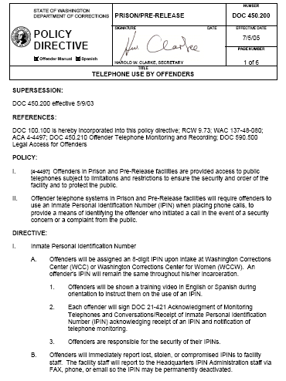
DOC Policy 450.200

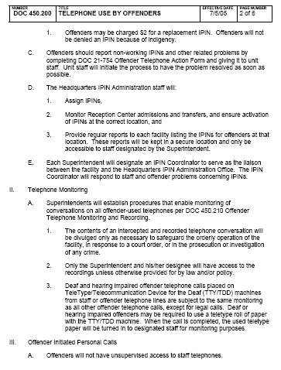
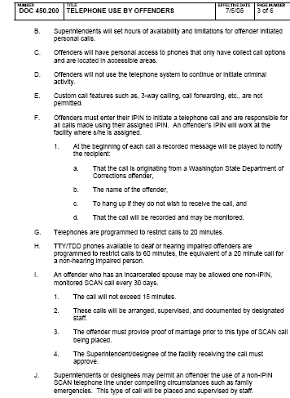

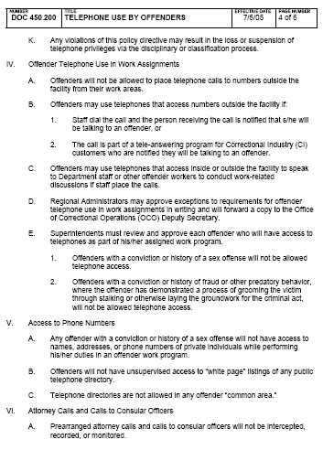

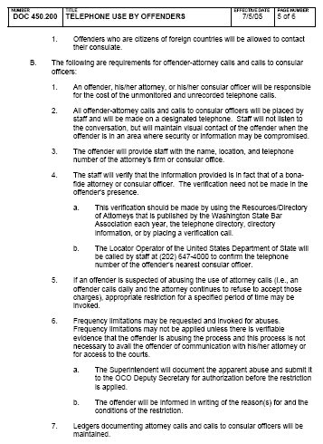

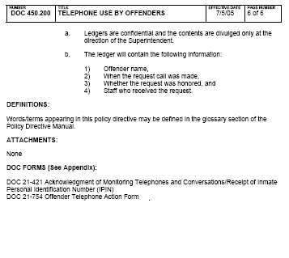

Exhibit F

DOC Policy 450.210

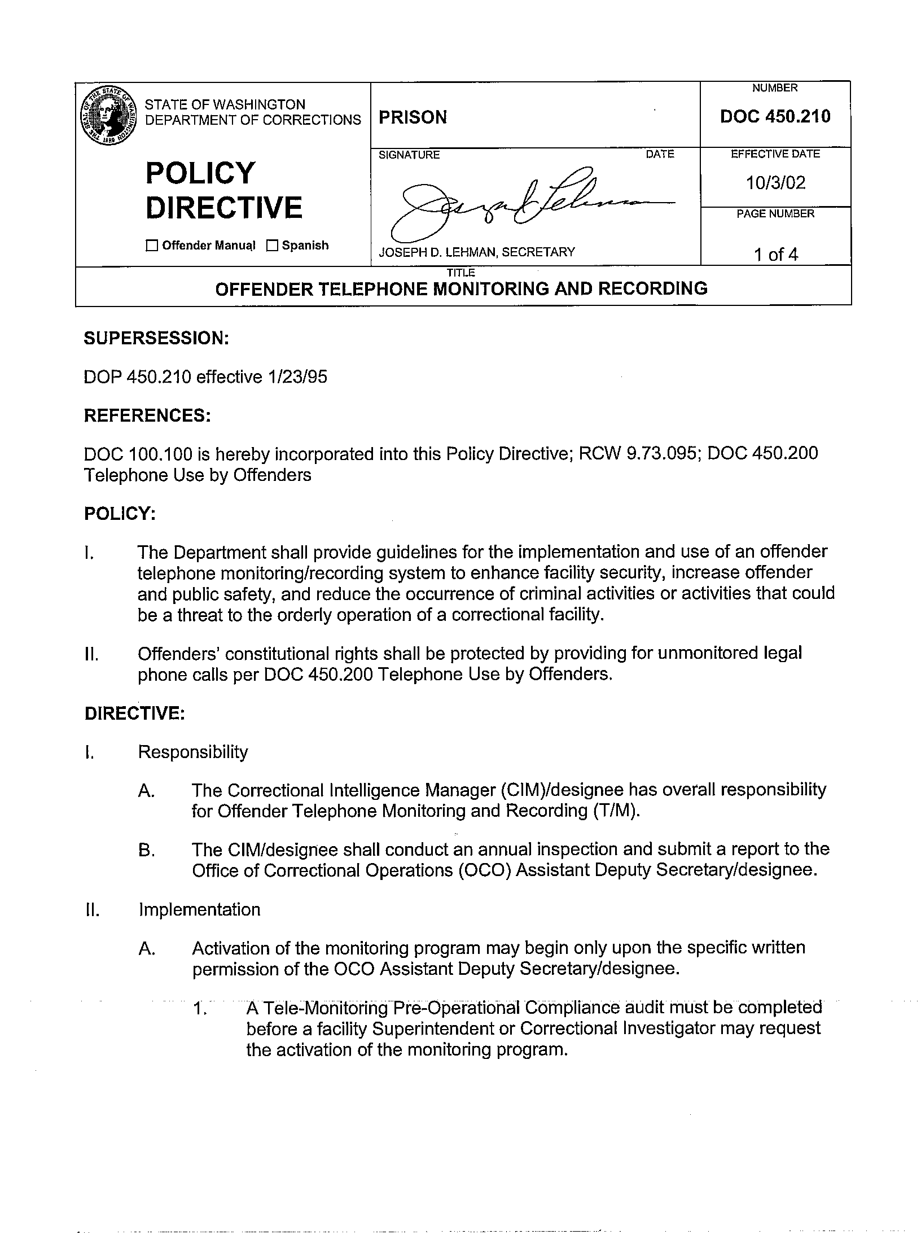

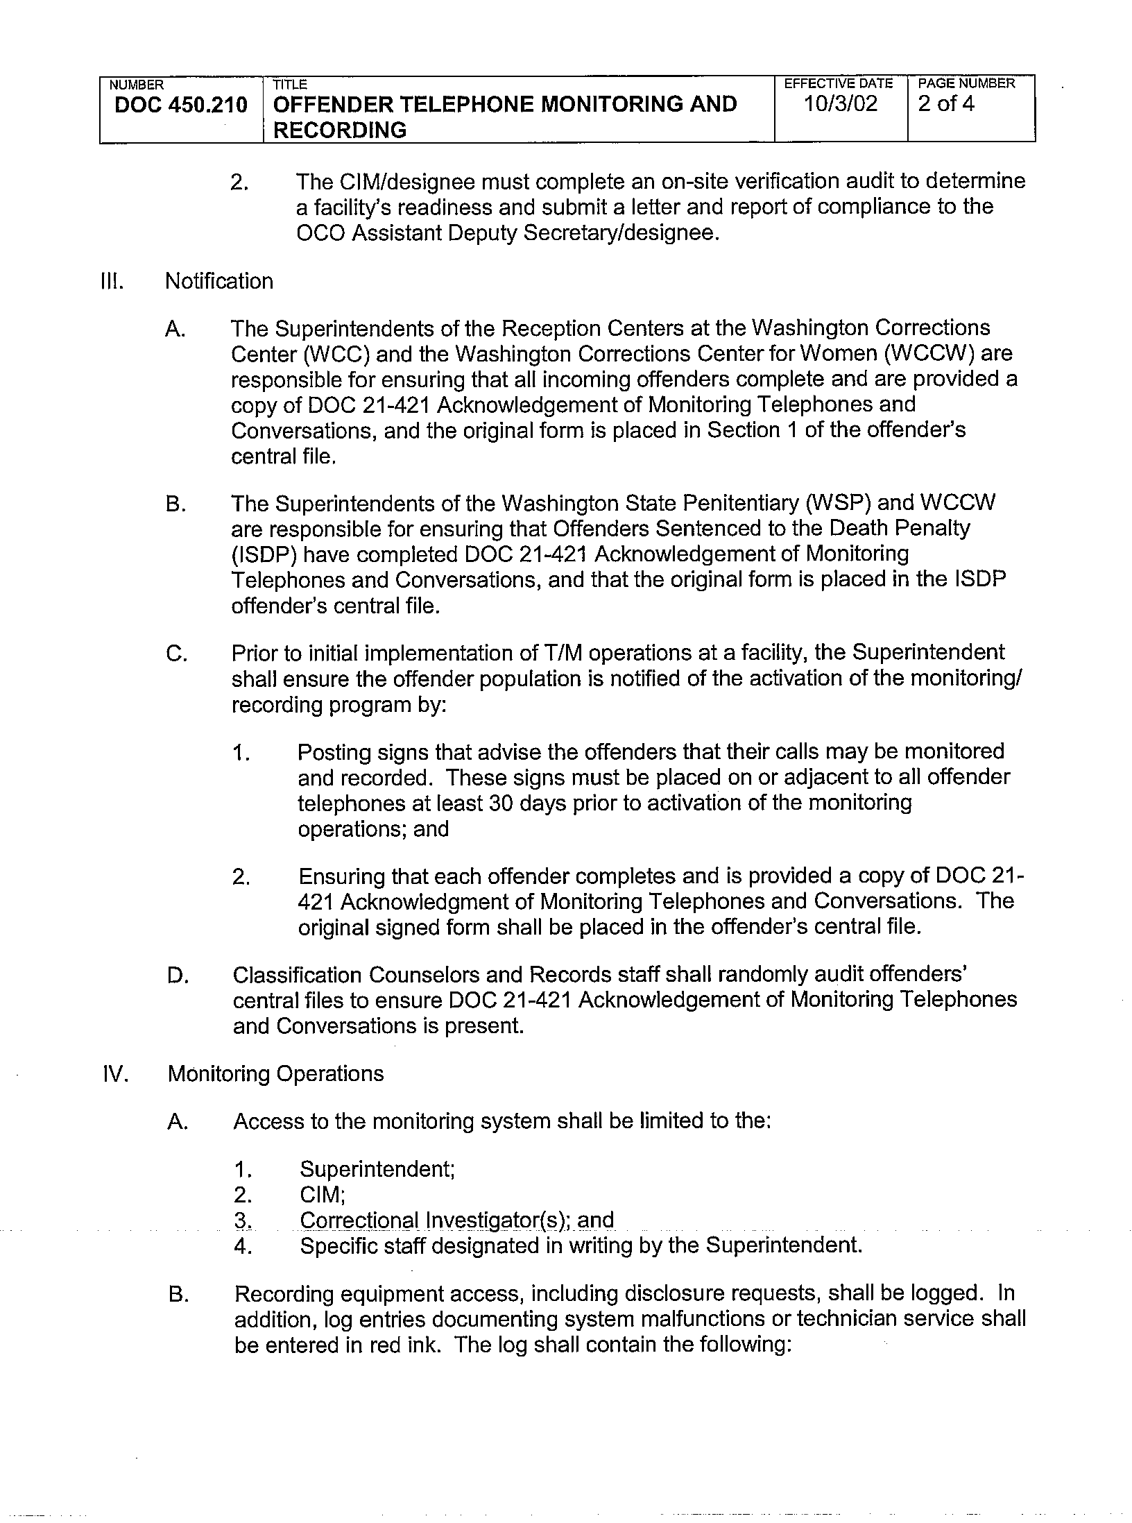

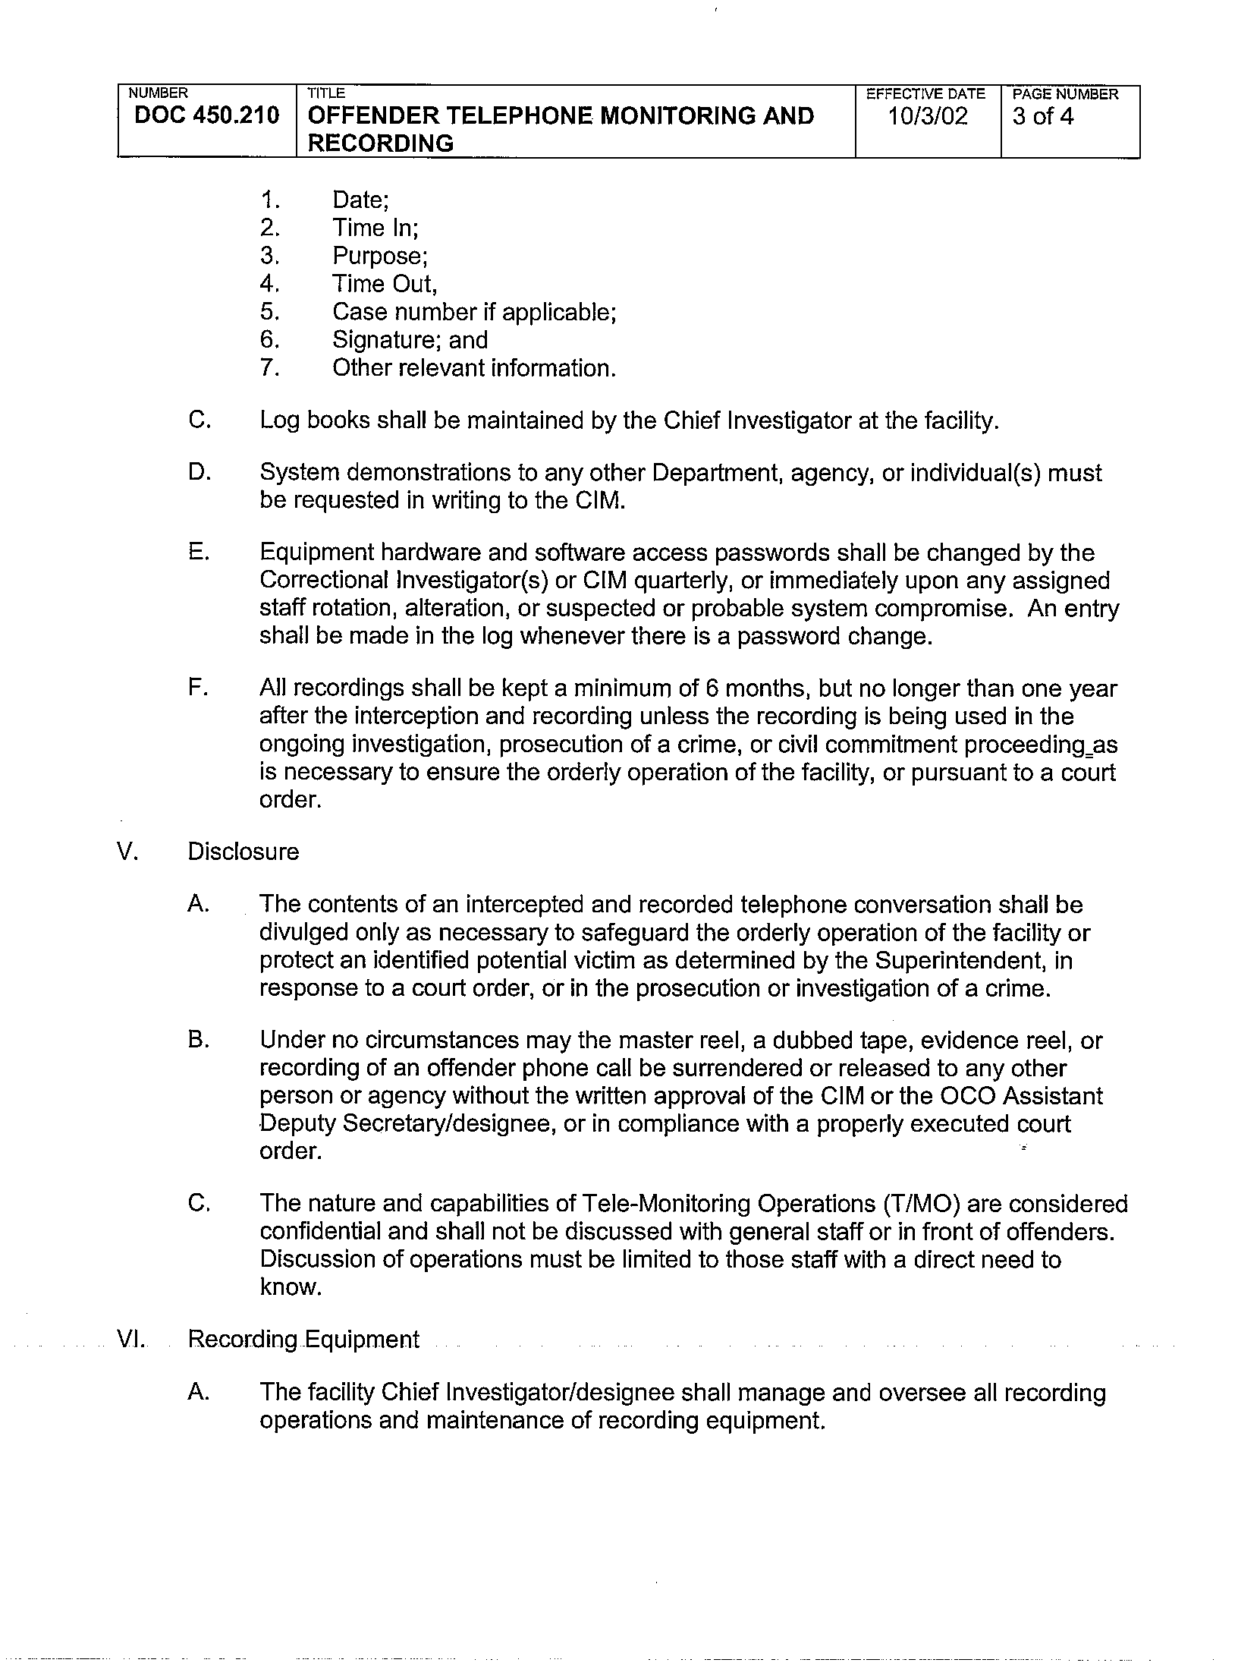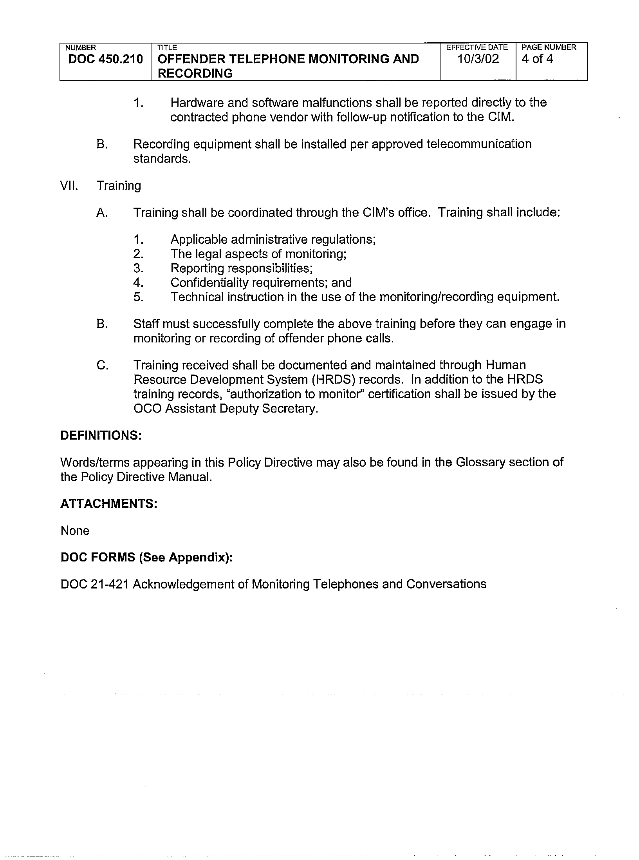

Exhibit G

RESPONSIVENESS CHECKLIST
CRFP6446

Submitted by: _________________________________________________

______ Proposal submitted by or before 4:00 PM on September 19, 2005.

______ Proposals submitted in five parts to include the following sections:

_____ Submittal letter and envelope - 1 copy (See Subsection 4.3.1)

_____ 4.3.2 Certifications and Assurances, Exhibit A

_____ Implementation Plan – 4 copies (See Subsection 2.2.2)

_____ Technical Proposal - 4 copies (See Subsection 4.4)

_____ Demonstration Video (See Subsection 5.1.10.)

_____ Qualifications Proposal - 4 copies (See Subsection 4.5)

_____ Cost Proposal - 4 copies (See Subsection 4.6)

_____ Five (5) Vendor references included (See Subsection 6.7.1.1)

NOTE: “Yes” Answers must be given in each element for the proposal to be considered responsive.

