March 21, 2006

Washington Utilities & Transportation Commission
Attn: Mr. Mike Sommerville, Records Management
1300 S. Evergreen Park Dr. SW
Olympia, WA 98504-7250

Re: Notice for Request of Intervention in Docket UG-060256 – Cascade Natural Gas General Rate Case

Dear: Mr. Mike Sommerville:

Mint Farm Energy Center LLC (“MFEC”) is a partially constructed 285 MW gas-fired combined cycle generation station in Longview, Washington, which may elect to take natural gas distribution service from Cascade Natural. MFEC and Cascade have communicated and in fact at one time executed a contract for service, which has since been terminated due to uncertainty related to the distribution rate and commercial completion of the MFEC project.

The proposed rate change by Cascade in Docket UG-060256 detrimentally impacts the economic completion and commercial operation of MFEC. MFEC agrees with the actions taken by the Commission in this Docket in Order 01 on the basis that Cascade has failed to demonstrate the calculation for fair and reasonable rates. Specifically, MFEC is not certain that Cascade has appropriately calculated the revenue and revenue requirement stated in their filing. Furthermore, Cascade has failed to propose a mechanism to track changes to revenue that may actually reduce rates.

The Commission has acted properly in requesting a careful examination into the books and records of Cascade for justification of their proposed rate increase. Customers behind Cascade’s distribution system will already incur rate increases due to recently proposed increases on Northwest Pipelines interstate gas transportation system and substantially higher natural gas commodity prices.

MFEC sites that the distribution throughput, revenue and revenue requirement calculations are directly related to the rate filing in this docket and as such requests intervention as an interested and impacted party o this proceeding.

The contact for MFEC is: Mint Farm Energy Center LLC
Attn. Mr. Scott Magie, Project Director
1200 Prudential Boulevard
Longview, WA
(605) 359-0200 Telephone
(605) 336-1014 Facsimile

Respectfully Submitted,
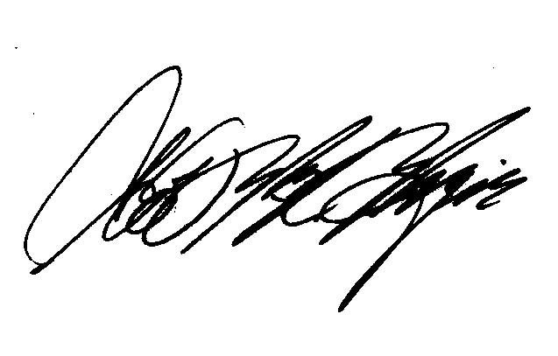
Scott M. Magie
Project Director
Mint Farm Energy Center LLC

