STAFF INVESTIGATION
INTO THE BUSINESS PRACTICES OF

EXCEL TELECOMMUNICATIONS, INC.
Docket No. UT-050713

Prepared by:
Betty Young
Compliance Specialist
Business Practices Investigations

June 2005

TABLE OF CONTENTS

Purpose, Scope & Authority 3

Executive Summary 4

Background 5

Response to Commission-Referred Complaints 6

Changes in Local Exchange and Intrastate Toll Services 9

Discontinuing Service – Company Initiated 11

Company Business Practices 12

Appendices 15

PURPOSE, SCOPE, AND AUTHORITY

Purpose
The purpose of this investigation is a review of the business practices of Excel Telecommunications, Inc. (Excel), as evidenced in customer complaints filed with the Washington Utilities and Transportation Commission (Commission).

Scope
The scope of the investigation focuses on informal complaints filed with the Consumer Affairs section of the Commission by customers of Excel from January 2004 through April 2005.

Authority
Staff undertakes this investigation under the authority of the Revised Code of Washington (RCW) 80.01.040, which directs the Commission to regulate telecommunications companies in the public interest, and to adopt such rules and regulations as may be necessary to do so. In addition, RCW 80.04.070 makes it clear that the Commission is authorized to conduct such an investigation. Appendix A includes copies of the appropriate laws and rules.

EXECUTIVE SUMMARY

The Commission’s Business Practices Investigations Staff has reviewed customer complaints and investigated business practice issues with Excel for several years. During the course of these investigations, Staff has provided Excel ongoing technical assistance in an effort to help the company obtain compliance with Commission rules.

This investigation finds the company in violation of the following Commission rules:

- WAC 480-120-166 – Commission-referred complaints, which describes the actions a company must take when Commission Staff refers an informal complaint to the company and outlines the required timeframes for responses to Staff.

- WAC 480-120-147 – Changes in local exchange and intrastate toll services, which describes the process telephone companies must follow in order to process change orders for local and/or long distance services.

- WAC 480-120-172 – Discontinuing service – Company initiated, which describes the specific procedures required when a telephone company discontinues a customer’s service.

While this investigation report gives Excel clear technical assistance on how to comply with Commission rules, Staff recommends that where Excel has previously been given technical assistance and the company has continued to violate that same rule, a penalty for continuing non-compliance be issued.

The following is Staff’s recommendation for the issuance of penalties:

Staff recommends a $100 penalty each for 26 violations of WAC 480-120-166. Total recommended penalty = $2,600.

BACKGROUND

Company Information
In May 1991, the Commission issued an order in Docket UT-910017, classifying Excel as a competitive telecommunications company. For 2004, Excel reported gross intrastate operating revenues of $3.8 million.

Previous Investigations
Staff of the Business Practices Investigations section have investigated Excel on two previous occasions. In 2003, Staff conducted two separate investigations into the company’s business practices: one relating to responses to Commission-referred complaints and one relating to electronic letters of agency. In each investigation, the Commission provided Excel with technical assistance on complying with Commission rules.

Background
This investigation was prompted by 28 customer complaints filed against Excel in 2004 where 61 violations were cited. Staff cited violations on a variety of issues including not responding to Commission-referred complaints in a timely manner and changing a customer’s phone service without proof of authorization. Staff noted that while the number of complaints filed against Excel has remained approximately the same over the last four years, the number of violations cited against the company has increased almost sixty-fold.

During the course of the investigation, Staff also reviewed the seven complaints filed to date in 2005. No violations were cited in these complaints; however, Staff is concerned with the company’s business practices in several of the complaints.

RESPONSE TO COMMISSION-REFERRED COMPLAINTS

WAC 480-120-166 describes the actions a company must take when Commission Staff refers an informal complaint to the company and outlines the required timeframes for responses to Staff.

Background
In July 2003, revised rules governing telephone companies became effective. The Commission sent copies of the new rules to all registered telephone companies, including Excel.

Also in July 2003, Business Practices Investigations staff conducted a review of complaints filed by customers of Excel. Information in the complaints indicated that the company had not responded timely to Staff on numerous occasions. As a result, the Commission sent a letter to Excel to provide additional technical assistance on the requirements in WAC 480-120-166. The letter stated that future late responses in complaints would be cited as violations of the rule and that the Commission could impose penalties of up to $1,000 per day for each violation of its rules.

Analysis of Informal Complaints and Notification of Response Violations
For the purpose of this investigation, Staff reviewed the 28 complaints filed with the Commission by customers of Excel in 2004 and the seven complaints filed to date in 2005. In four of the 2004 complaints, Staff cited a total of 38 violations of WAC 480-120-166(6) through (8).

Consumer Affairs Staff, who work with complaints on a daily basis, are clearly aware of the requirements of WAC 480-120-166. Staff provides technical assistance to companies, including Excel, by informing the company of the rule requirements within the text of an informal complaint. In addition, Staff provides technical assistance to companies by informing the company, again within the text of an informal complaint, when Staff records an alleged violation of Commission rules. In the 2004 complaints, Staff provided technical assistance to Excel on the requirements of WAC 480-120-166 and noted violations in the following four complaints:

- In May 2004 in complaint 87463, Consumer Affairs Staff Diana Jones-Suits notified company representative Nicole Mizell by electronic mail that a violation of WAC 480-120-166(7) had been cited because Excel failed to

respond to the Commission within five business days.

- In September 2004 in complaint 90209, Consumer Affairs Staff Diana Jones-Suits notified company representative Monica Rodriguez by electronic mail that 26 violations of WAC 480-120-166(8) had been cited for failure to respond to the complaint within three business days. Excel disputed these violations, indicating that it had been waiting for more information from Staff.

- In September 2004 in complaint 90484, Consumer Affairs Staff Diana Otto notified company representative Monica Rodriguez by electronic mail that a violation of WAC 480-120-166(6) had been cited because Excel failed to respond to a service-affecting complaint within two days. In addition, Ms. Otto cited nine violations of WAC 480-120-166(8) because Excel failed to respond with additional requested information within three business days.

- In December 2004 in complaint 91531, Consumer Affairs Staff Roger Kouchi notified company representative Monica Rodriguez by electronic mail that a violation of WAC 480-120-166(8) had been cited because Excel failed to respond to the Commission with requested information within three business days.

When Consumer Affairs Staff cites violations of WAC 480-120-166 in an informal complaint, the violation does not necessarily include the actual number of days a response is late. Staff may cite only one violation of the rule regardless of how late the response is. Or, as staff advised Excel on several occasions during the course of informal complaints, staff may cite daily violations until a complete response is received from the company.

In terms of assessing penalties, the Commission is authorized to assess penalties for each day the company is not in compliance with a rule. The Commission also advised Excel of this in its July 1, 2003, letter. The letter stated, in part, “…The Commission may
impose penalties of up to $1,000 per day for each violation of Commission rules.”

The chart below indicates the actual number of days Excel was late in responding to Staff in three of the four complaints where violations were noted. (Staff acknowledges that in complaint 90209, there appears to have been a misunderstanding between Excel and Consumer Affairs staff. Excel disputed the violations noted in the complaint, stating it was waiting for clarification from Staff prior to proceeding; therefore, these violations are not noted in the chart below.)

Excel’s Late Responses to Commission Complaints - 2004
 | Complaint # | Date Opened or Date Information Requested | Date Company Was Required to Respond | Date Company  Responded | # of Days Beyond Response Required Due Date
1. | 87463 | 1/28/04 | 2/5/04 | 2/6/04 | 1
2. | 90484 | 9/1/04  11/2/04  11/17/04 | 9/6/04  11/5/04  11/22/04 | 9/8/04  11/9/04  11/30/04 | 2  2  6
3. | 91531 | 11/17/04 | 11/22/04 | 12/13/04 | 15
 |  |  |  | Total | 26

Findings
The Commission has provided clear technical assistance to Excel on several occasions regarding the requirements of WAC 480-120-166 and has advised Excel that violations could result in the Commission assessing penalties. Consumer Affairs Staff has continued to inform Excel of the requirements of WAC 480-120-166 through customer complaints.

Despite the fact that Staff has repeatedly reminded the company of these requirements, in three of 28 complaints filed in 2004, Excel did not respond within the two-day, three-day, or five-day requirement.

Recommendation
Staff recommends a $100 penalty each for 26 violations of WAC 480-120-166. Total recommended penalty = $2,600.

CHANGES IN LOCAL EXCHANGE AND INTRASTATE TOLL SERVICES

WAC 480-120-147(1) - Verification of Orders, describes the process telephone companies must follow in order to process change orders for local and/or long distance services. A company may not change a customer’s telephone service without verifying the customer’s authorization to change that service. Changing a customer’s service without authorization, or without verification of that authorization, is also referred to as “slamming.” This section of the rule also specifically outlines the requirements for the types of verification a company may use, including letters of agency (LOA) and third party verifications.
Background
Business Practices Investigations Staff conducted an investigation of Excel’s electronic LOA as provided on the company’s website in July 2003. Staff found the electronic LOA out of compliance with certain rule requirements and advised Excel of the findings in a letter dated July 24, 2003. Staff also provided technical assistance on the requirements of WAC 480-120-147(1). Excel was asked to respond and describe how the LOA would be revised to comply with the rules. Excel responded in August 2003, stating that it was revising the electronic LOA to comply with the rules and would be in compliance by October 2003.

Analysis of Informal Complaints and Notification of Slamming Violations
In eight of the 28 complaints filed in 2004, Consumer Affairs Staff cited a total of nine violations of WAC 480-120-147:
- In complaint 88205, Excel could not provide any verification that the customer had authorized the switch in service.
- In complaint 88503, the third party verification tape submitted by the company was inaudible. The company switched the customer’s local, intra-, and inter-lata services without verifying that it had the proper authorization, so Staff cited three separate violations.
- In complaint 89518, Excel could not provide any verification that the customer had authorized the switch in service.
- In five complaints (87319, 88515, 88863, 89021, 91108), Excel could not provide a valid copy of an electronic letter of agency (ELOA). Violations were cited in four of the five complaints.

In the complaints where Excel could not provide a valid copy of an electronic LOA, the company provided staff with a copy of a “Customer Service Online Order Tracking” form, then provided copies of blank “web forms” which a customer fills in to sign up for service with Excel. Staff maintained that the two documents did not constitute an electronic LOA as required by WAC 480-120-147 and cited a violation of the rule.

Findings
The documents provided by Excel as electronic LOAs do not meet the requirements in the rule. The “web forms,” while they appear to meet the rule requirements, are essentially a copy of what anyone could locate on the company’s website. The forms show what a customer may have completed, but there is no evidence that the specific customer actually completed them. The “Customer Service Online Tracking Form” is the company’s assertion of what was ordered, but doesn’t contain the required language in the rule or a customer signature. WAC 480-120-147 requires that the LOA, whether written or electronic, be signed and dated by the customer requesting the preferred carrier change. As Excel was told in Staff’s July 24, 2003 letter, the customer must enter his or her own name and the date on the LOA for it to be valid. Without some sort of record showing this and the other required information, we have no evidence that the customer entered it.

Recommendation
Excel must revise its electronic LOA process and be able to reproduce and provide a valid copy of an electronic LOA containing all of the elements required in WAC 480-120-147.

DISCONTINUING SERVICE – COMPANY INITIATED

WAC 480-120-172 describes the specific procedures required when a telephone company discontinues a customer’s service. The rule also defines that the company must not discontinue or restrict service while a customer is pursuing remedy or appeal.

Analysis of Informal Complaints and Notification of Violations
In one of the 28 complaints filed in 2004, Staff cited a total of twelve violations of WAC 480-120-172.
- In complaint 90484, Staff cited 11 violations of WAC 480-120-172(8), because Excel disconnected customer's dial tone one way while the complaint was under investigation. Additionally, Staff cited one violation of WAC 480-120-172(12) because Excel disconnected the customer's long distance service during complaint.

Recommendation

Excel must review its disconnection practices and WAC 480-120-172 to ensure it does not discontinue or restrict a customer’s service while the customer is pursuing remedy or appeal.

COMPANY BUSINESS PRACTICES

In four complaints filed in 2004 and in four complaints filed in 2005, Excel cited an “internal processing error” or a “system processing error” as a reason for problems in customer complaints. These errors involved serious issues such as switching the customer’s telephone service without authorization or continuing to bill customers after the customer canceled service. No violations were noted, but the company was clearly in violation of Commission rule in several cases. The chart below includes portions of complaint text where Excel references the problems in the complaint and the company’s errors (emphasis added):

Excel Telecommunications, Inc. - “Internal/System Processing Errors”
Complaint | Type | Complaint Text – Excel’s Response to Staff
88205 | Slamming  Consumer Upheld | “…Internal records reveal that the local telephone company for the above-noted telephone number provided the Company with an update of the billing name and address for telephone number.. …Due to an internal processing error, this generated an electronic request from Excel to the local telephone company for the aforementioned telephone number to change the primary long distance service provider for telephone number …. Pursuant to this request, the Company became the primary long distance service provider for the above-referenced telephone number…”
90708 | Customer Service  Consumer Upheld | “…Additional records reveal that the customer requested disconnection of the aforementioned telephone numbers on August 26, 2004; however, due to a system processing error,…’ request was delayed…” (Request processed Sept. 1, 2004)
91531 | Disputed Bill  Consumer Upheld | “…The Company has investigated this matter and has determined that due to an internal processing error, the account for telephone number … was assessed incorrect rates for Excel’s long distance service from February 18, 2004 through April 17, 2004…”
91540 | Disputed Bill  Consumer Upheld | “…However, Excel indicated in correspondence forwarded to the Commission on March 31, 2004 that said account would be adjusted to a zero balance and held from collection actions. The Company has investigated this matter and determined that due to a system processing error, the long distance account for telephone number … was not recalled from the outside collection agency. ..” (Recalled from collections November 2, 2004)
92178 | Customer Service  Consumer Upheld | “…The Company has investigated this matter and has confirmed that the above-noted telephone number was converted to Qwest on December 3, 2004. However, due to an internal processing error, telephone number … was not deactivated within Excel’s billing database until December 28, 2004…  …Internal records indicate that Excel advised … in correspondence dated January 7, 2005 that the Company had issued a check in the amount of $37.79 to fully refund the payment remitted to the account for telephone number … for local service charges assessed for the period of December 4, 2004 through December 24, 2004. Excel has investigated this matter and has determined that due to an internal processing error, said check in the amount of $37.79 was not forwarded to the complainant’s attention until February 2, 2005…”
92670 | Disputed Bill  Consumer Upheld | “…The complainant canceled local and long distance service for telephone number … on November 3, 2003; however, Excel assessed local service charges to the account after said cancellation date. In addition, (customer) indicated that she has contacted the Company to resolve this issue; however, Excel has forwarded the account for telephone number … to an outside collection agency for processing. Internal records indicate that (customer) contacted the Company on November 5, 2003 to disconnect telephone number …; however, due to an internal processing error, said disconnection was delayed until January 16, 2004…”
92803 | Disputed Bill  Consumer Upheld | “…The complainant indicated in her communication with the Commission that the Company assessed $104.91 in local service charges to the account for telephone numbers … after she canceled Excel’s local telephone services in December 2004 and February 2005. In addition, (customer) indicated that the Company has referred the aforementioned account to an outside collection agency. Internal records indicate that Excel was removed as the local and long distance service provider for telephone numbers …on December 13, 2004; however, due to an internal processing error, the billing account for the aforementioned telephone numbers was not deactivated until January 20, 2005. Additional records reveal that the Company was removed as the local and long distance service provider for telephone number … on January 6, 2005; however, due to a notification delay, the billing account for the above-referenced telephone number was deactivated on January 7, 2005…”
92821 | Slamming  Consumer Upheld | “…Internal records reveal that the local telephone company for the above-noted telephone number provided Excel with an update of the billing name and address for telephone number … on October 8, 2004. Due to an internal processing error, this generated an electronic request from Excel to the local telephone company for the aforementioned telephone number to change the primary long distance service provider for telephone number... Pursuant to this request, the Company became the primary long distance service provider for the above-referenced telephone number on October 9, 2004. Please note that as of February 21, 2005, Excel is no longer the primary long distance service provider for telephone number…”

Findings
While processing errors can and do occur, Staff is concerned with the serious nature of the errors in these customer complaints. If these sorts of errors continue, violations will be noted as appropriate and the Commission may consider enforcement action.

Recommendation
Staff recommends Excel review the reported internal and system processing errors and revise its practices to comply with Commission rules.

Appendix A

RCW 80.01.040
General powers and duties of commission.
The utilities and transportation commission shall:
(1) Exercise all the powers and perform all the duties prescribed therefore by this title and by Title 81 RCW, or by any other law.
(2) Regulate in the public interest, as provided by the public service laws, the rates, services, facilities, and practices of all persons engaging in the transportation by whatever means of persons or property within this state for compensation, and related activities; including, but not limited to, air transportation companies, auto transportation companies, express companies, freight and freight line companies, motor freight companies, motor transportation agents, private car companies, railway companies, sleeping car companies, steamboat companies, street railway companies, toll bridge companies, storage warehousemen, and wharfingers and warehousemen.
(3) Regulate in the public interest, as provided by the public service laws, the rates, services, facilities, and practices of all persons engaging within this state in the business of supplying any utility service or commodity to the public for compensation, and related activities; including, but not limited to, electrical companies, gas companies, irrigation companies, telecommunications companies, and water companies.
(4) Make such rules and regulations as may be necessary to carry out its other powers and duties.
[1985 c 450 § 10; 1961 c 14 § 80.01.040. Prior: (i) 1949 c 117 § 3; Rem. Supp. 1949 § 10964-115-3. (ii) 1945 c 267 § 5; Rem. Supp. 1945 § 10459-5. (iii) 1945 c 267 § 6; Rem. Supp. 1945 § 10459-6. Formerly RCW 43.53.050.]

RCW 80.04.070
Inspection of books, papers, and documents.
The commission and each commissioner, or any person employed by the commission, shall have the right, at any and all times, to inspect the accounts, books, papers and documents of any public service company, and the commission, or any commissioner, may examine under oath any officer, agent or employee of such public service company in relation thereto, and with reference to the affairs of such company: PROVIDED, That any person other than a commissioner who shall make any such demand shall produce his authority from the commission to make such inspection.
[1961 c 14 § 80.04.070. Prior: 1911 c 117 § 77; RRS § 10415.]
WAC 480-120-147 Changes in local exchange and intrastate toll services. For the purpose of this section "subscriber" is any one of the following: The party identified in the account records of a common carrier as responsible for payment of the telephone bill; any adult person authorized by such party to change telecommunications services or to charge services to the account; or any person contractually or otherwise lawfully authorized to represent such party.
(1) Verification of orders. A local exchange or intrastate toll company that requests on behalf of a subscriber that the subscriber's company be changed, and that seeks to provide retail services to the subscriber (submitting company), may not submit a change-order for local exchange or intrastate toll service until the order is confirmed in accordance with one of the procedures in (a) through (c) of this subsection:
(a) The company has obtained the subscriber's written or electronic authorization to submit the order (letter of agency). The letter of agency must be a separate electronic form, located on a separate screen or web page, or a separate written document (or easily separable document) containing only the authorizing language described in (a)(i) through (vi) of this subsection, having the sole purpose of authorizing a telecommunications company to initiate a preferred company change. The letter of agency, whether written or electronic, must be signed and dated by the subscriber of the telephone line(s) requesting the preferred company change. The letter of agency must not be combined on the same document or on the same screen or web page with inducements of any kind; however, it may be combined with checks that contain only the required letter of agency language as prescribed in (a)(i) through (vi) of this subsection, and the necessary information to make the check a negotiable instrument. The check may not contain any promotional language or material. It must contain, in easily readable, boldface type on the front of the check, a notice that the subscriber is authorizing a preferred company change by signing the check. Letter-of-agency language must be placed near the signature line on the back of the check. Any company designated in a letter of agency as a preferred company must be the company directly setting the rates for the subscriber. If any portion of a letter of agency is translated into another language, then all portions must be translated into that language, as well as any promotional materials, oral descriptions or instructions provided with the letter of agency. The letter of agency must confirm the following information from the subscriber:
(i) The subscriber billing name, billing telephone number and billing address and each telephone number to be covered by the change order;
(ii) The decision to change;
(iii) The subscriber's understanding of the change fee;
(iv) That the subscriber designates (name of company) to act as the subscriber's agent for the preferred company change;
(v) That the subscriber understands that only one telecommunications company may be designated as the subscriber's intraLATA preferred company; that only one telecommunications company may be designated as the subscriber's interLATA preferred company; and that only one telecommunications company may be designated as the subscriber's local exchange provider, for any one telephone number. The letter of agency must contain a separate statement regarding the subscriber's choice for each preferred company, although a separate letter of agency for each choice is not necessary; and
(vi) Letters of agency may not suggest or require that a subscriber take some action in order to retain the current preferred company.
(b) The submitting company has obtained the subscriber's authorization, as described in (a) of this subsection, electronically, by use of an automated, electronic telephone menu system. This authorization must be placed from the telephone number(s) for which the preferred company is to be changed and must confirm the information required in (a)(i) through (vi) of this subsection.
Telecommunications companies electing to confirm the preferred company change electronically must establish one or more toll free telephone numbers exclusively for that purpose.
Calls to the number(s) must connect a subscriber to a voice response unit, or similar device, that records the required information regarding the change, including recording the originating automatic number identification (ANI).
(c) An appropriately qualified and independent third party operating in a location physically separate from the telemarketing representative has obtained the subscriber's oral authorization to submit the

change order that confirms and includes appropriate verification data (e.g., the subscriber's date of birth). A company or a company's sales representative initiating a three-way conference call or a call through an automated verification system must drop off the call once the three-way connection with the third-party verifier has been established. The independent third party must not be owned, managed, controlled or directed by the company or the company's marketing agent; and must not have any financial incentive to confirm preferred company change orders for the company or the company's marketing agent. The content of the verification must include clear and unambiguous confirmation that the subscriber has authorized a preferred company change.
(2) Where a telecommunications company is selling more than one type of telecommunications service (e.g., local exchange, intraLATA toll, and interLATA toll) that company must obtain separate authorization, and separate verification, from the subscriber for each service sold, although the authorizations may be made within the same solicitation.
(3) The documentation regarding a subscriber's authorization for a preferred company change must be retained by the submitting company, at a minimum, for two years to serve as verification of the subscriber's authorization to change his or her telecommunications company. The documentation must be made available to the subscriber and to the commission upon request and at no charge. Documentation includes, but is not limited to, entire third-party-verification conversations and, for written verifications, the entire verification document.
(4) Implementing order changes. An executing company may not verify directly with the subscriber the submission of a change in a subscriber's selection of a provider received from a submitting company. The executing company must comply promptly, without any unreasonable delay, with a requested change that is complete and received from a submitting company. An executing company is any telecommunications company that affects a request that a subscriber's company be changed. Except as provided by contract, a telecommunications company must submit a preferred company change order on behalf of a subscriber within no more than sixty days of obtaining authorization.
This section does not prohibit any company from investigating and responding to any subscriber-initiated inquiry or complaint.
(5) Preferred carrier freezes. A preferred carrier freeze prevents a change in a subscriber's preferred company selection unless the subscriber gives the company from whom the freeze was requested express consent. Express consent means direct, written, electronic, or oral direction by the subscriber. All local exchange companies (LECs) must offer preferred carrier freezes. Such freezes must be offered on a nondiscriminatory basis to all subscribers. Offers or solicitations for such freezes must clearly distinguish among telecommunications services subject to a freeze (e.g., local exchange, intraLATA toll, and interLATA toll). The carrier offering the freeze must obtain separate authorization for each service for which a preferred carrier freeze is requested. Separate authorizations may be contained within a single document.
(a) All LECs must notify all subscribers of the availability of a preferred carrier freeze, no later than the subscriber's first telephone bill, and once per year must notify all local exchange service subscribers of such availability on an individual subscriber basis (e.g., bill insert, bill message, or direct mailing).
(b) All company-provided solicitation and other materials regarding freezes must include an explanation, in clear and neutral language, of what a preferred carrier freeze is, and what services may be subject to a freeze; a description of the specific procedures to lift a preferred carrier freeze; an explanation that the subscriber will be unable to make a change in company selection unless he or she lifts the freeze; and an explanation of any charges incurred for implementing or lifting a preferred carrier freeze.
(c) No local exchange company may implement a preferred carrier freeze unless the subscriber's request to impose a freeze has first been confirmed in accordance with the procedures outlined for confirming a change in preferred company, as described in subsections (1) and (2) of this section.
(d) All LECs must offer subscribers, at a minimum, the following procedures for lifting a preferred

carrier freeze:
(i) A subscriber's written or electronic authorization stating the subscriber's intent to lift the freeze;
(ii) A subscriber's oral authorization to lift the freeze. This option must include a mechanism that allows a submitting company to conduct a three-way conference call with the executing company and the subscriber in order to lift the freeze. When engaged in oral authorization to lift a freeze, the executing company must confirm appropriate verification data (e.g., the subscriber's date of birth), and the subscriber's intent to lift the freeze.
(iii) The LEC must lift the freeze within three business days of the subscriber request.
(e) A LEC may not change a subscriber's preferred company if the subscriber has a freeze in place, unless the subscriber has lifted the freeze in accordance with this subsection.
(6) Remedies. In addition to any other penalties provided by law, a submitting company that requests a change in a subscriber's company without proper verification as described in this rule must receive no payment for service provided as a result of the unauthorized change and must promptly refund any amounts collected as a result of the unauthorized change. The subscriber may be charged, after receipt of the refund, for such service at a rate no greater than what would have been charged by its authorized telecommunications company, and any such payment must be remitted to the subscriber's authorized telecommunications company.
(7) Exceptions. Companies transferring subscribers as a result of a merger, purchase of the company, or purchase of a specific subscriber base are exempt from subsections (1) through (6) of this section if the companies comply with the following conditions and procedures:
(a) The acquiring company must provide a notice to each affected subscriber at least thirty days before the date of transfer. Such notice must include the following information:
(i) The date on which the acquiring company will become the subscriber's new provider;
(ii) The rates, terms, and conditions of the service(s) to be provided upon transfer, and the means by which the acquiring company will notify the subscriber of any change(s) to those rates, terms, and conditions;
(iii) That the acquiring company will be responsible for any company change charges associated with the transfer;
(iv) The subscriber's right to select a different company to provide the service(s);
(v) That the subscriber will be transferred even if the subscriber has selected a "freeze" on his/her company choices, unless the subscriber chooses another company before the transfer date;
(vi) That, if the subscriber has a "freeze" on company choices, the freeze will be lifted at the time of transfer and the subscriber must "refreeze" company choices;
(vii) How the subscriber may make a complaint prior to or during the transfer; and
(viii) The toll-free customer service telephone number of the acquiring company.
(b) The acquiring company must provide a notice to the commission at least thirty days before the date of the transfer. Such notice must include the following information:
(i) The names of the parties to the transaction;
(ii) The types of services affected;
(iii) The date of the transfer; and
(iv) That the company has provided advance notice to affected subscribers, including a copy of such notice.
(c) If after filing notice with the commission any material changes develop, the acquiring company must file written notice of those changes with the commission no more than ten days after the transfer date announced in the prior notice. The commission may, at that time, require the company to provide additional notice to affected subscribers regarding such changes.
[Statutory Authority: RCW 80.01.040 and 80.04.160. 05-03-031 (Docket No. UT 040015, General Order No.

R-516), § 480-120-147, filed 1/10/05, effective 2/10/05. Statutory Authority: RCW 80.01.040, 80.04.160, 81.04.160, and 34.05.353. 03-22-046 (Docket No. A-030832, General Order No. R-509), § 480-120-147, filed 10/29/03, effective 11/29/03. Statutory Authority: RCW 80.01.040 and 80.04.160. 03-01-065 (Docket No. UT-990146, General Order No. R-507), § 480-120-147, filed 12/12/02, effective 7/1/03.]

WAC 480-120-166 Commission-referred complaints. (1) Each company must keep a record of all complaints concerning service or rates for at least two years and, on request, make them readily available for commission review. The records must contain complainant's name and address, date and the nature of the complaint, action taken, and final result.
(2) Each company must have personnel available during regular business days to respond to commission staff.
(3) Applicants, customers, or their authorized representatives, may file with the commission an informal complaint as described in WAC 480-07-910 (Informal complaints) or a formal complaint against a company when there are alleged violations of statutes, administrative rules, or tariffs as provided by WAC 480-07-370 (Pleadings -- General).
(4) When the commission staff refers an informal complaint to a company, the company must:
(a) Stop any pending action involving the issues raised in the complaint provided any amounts not in dispute are paid when due (e.g., if the complaint involves a disconnect threat or collection action, the disconnect or collection must be stopped);
(b) Thoroughly investigate all issues raised in the complaint and provide a complete report of the results of its investigation to the commission, including, if applicable, information that demonstrates that the company's action was in compliance with commission rules; and
(c) Take corrective action, if warranted, as soon as appropriate under the circumstances.
(5) Commission staff will ask the customer filing the informal complaint whether the customer wishes to speak directly to the company during the course of the complaint, and will relay the customer's preference to the company at the time staff opens the complaint.
(6) Unless another time is specified in this rule or unless commission staff specifies a later date, the company must report the results of its investigation of service-affecting informal complaints to commission staff within two business days from the date commission staff passes the complaint to the company. Service-affecting complaints include, but are not limited to, nonfunctioning or impaired services (i.e., disconnected services or those not functioning properly).
(7) Unless another time is specified in this rule or unless commission staff specifies a later date, the company must report the results of its investigation of nonservice-affecting informal complaints to commission staff within five business days from the date commission staff passes the complaint to the company. Nonservice-affecting complaints include, but are not limited to, billing disputes and rate quotes.
(8) Unless another time is specified in this rule or unless commission staff specifies a later date, the company must provide complete responses to requests from commission staff for additional information on pending informal complaints within three business days.
(9) The company must keep commission staff informed when relevant changes occur in what has been previously communicated to the commission and when there is final resolution of the informal complaint.
(10) An informal complaint opened with the company by commission staff may not be considered closed until commission staff informs the company that the complaint is closed.
[Statutory Authority: RCW 80.01.040 and 80.04.160. 05-03-031 (Docket No. UT 040015, General Order No. R-516), § 480-120-166, filed 1/10/05, effective 2/10/05; 03-24-028 (General Order R-510, Docket No. A-010648), § 480-120-166, filed 11/24/03, effective 1/1/04; 03-01-065 (Docket No. UT-990146, General Order

No. R-507), § 480-120-166, filed 12/12/02, effective 7/1/03.]

WAC 480-120-172 Discontinuing service -- Company initiated. (1) A company may discontinue service without notice or without further notice when after conducting a thorough investigation, it finds the customer has performed a deceptive practice by:
(a) Tampering with the company's property;
(b) Using service through an illegal connection;
(c) Unlawfully using service or using service for unlawful purposes; or
(d) Obtaining service in another false or deceptive manner.
(2)(a) A company may discontinue service without notice or without further notice when after conducting a thorough investigation, it determines the customer has:
(i) Vacated the premises without informing the company;
(ii) Paid a delinquent balance in response to a delinquency notice as described in subsection (7) of this section with a check or electronic payment that is subsequently dishonored by the bank or other financial institution; or
(iii) Failed to keep payment arrangements agreed upon in response to a delinquency notice as described in subsection (7) of this section.
(b) The company must restore service once the customer has corrected the reason for discontinuance as described in subsection (2)(a) of this section.
(c) The company may require a deposit from a customer that it has disconnected due to the reasons described in subsection (2)(a) of this section.
(3) A company may discontinue service after providing proper notice, or may issue a discontinuation notice, if, and only if, in one or more of the following circumstances:
(a) The company determines the customer has violated a rule, statute, service agreement, filed tariff, or price list;
(b) The company determines the customer has used customer-owned equipment that adversely affects the company's service to its other customers;
(c) The company determines the customer has not paid regulated charges or has not paid a deposit as provided in the tariff or price list of the company or another company with which it has a billing and collection agreement, except for nonpayment of charges incurred from information delivery services as provided for in WAC 480-120-254 or disputed third party-billed charges;
(d) The company is unable to substantiate the identity of the individual requesting service:
(i) Companies must allow the applicant to substantiate identity with one piece of identification chosen from a list, provided by the company, of at least four sources of identification. The list must include a current driver's license or other picture identification;
(ii) Company business offices and payment agencies, required under WAC 480-120-132 and 480-120-162, must provide a means for applicants to provide identification at no charge to the applicant;
(e) The company determines the customer has received service from the company by providing false information, including false statements of credit references or employment, false statement of premises address, use of an alias or false name with intent to deceive, or rotation of service among roommates or persons living together for the purpose of avoiding the debts of one or more persons;
(f) The company determines the customer is receiving service at an address where a former customer is known to reside with an overdue, unpaid prior obligation to the same company for the same class of service at that address and there is evidence that the applicant lived at the address while the overdue, unpaid prior obligation was incurred and helped incur the obligations. However, a company may not

deny service if a former customer with an overdue, unpaid prior obligation has permanently vacated the address.
(4) Except as provided in subsections (1), (2), and (3) of this section, a company may discontinue or restrict services only under the following circumstances:
(a) A company may discontinue basic service only for nonpayment of basic service charges;
(b) A company may discontinue ancillary services only for nonpayment of ancillary charges or if the company properly discontinues basic service;
(c) A company may discontinue interexchange access only for nonpayment of interexchange charges or if the company properly discontinues basic service:
(i) At its discretion, the company may permit access to toll-free numbers while a customer's interexchange access service is discontinued or restricted;
(ii) The company may not charge fees for toll restriction when it has discontinued or restricted the customer's interexchange access service under this section;
(d) Companies may not shift a rate plan as a discontinuation method.
(5) When a company discontinues service to a customer, it must also discontinue billing for service as of the date of the discontinuation.
(6) Medical emergencies.
(a) When a local exchange company (LEC) has cause to discontinue residential basic service or has discontinued service, it must postpone total service discontinuation or reinstate toll-restricted basic service that permits both making and receiving calls and access to E911 for a grace period of five business days after receiving either oral or written notice of the existence of a medical emergency, as described in (b) of this subsection. The LEC must reinstate service during the same day if the customer contacts the LEC prior to the close of the business day and requests a same-day reconnection. Otherwise, the LEC must restore service by 12:00 p.m. the next business day. When service is reinstated, the LEC cannot require payment of a reconnection charge or deposit before reinstating service but may bill the charges at a later date.
(b) The LEC may require that the customer submit written certification from a qualified medical professional, within five business days, stating that the discontinuation of basic service or restricted basic service would endanger the physical health of a resident of the household. "Qualified medical professional" means a licensed physician, nurse practitioner, or physician's assistant authorized to diagnose and treat the medical condition without supervision of a physician. Nothing in this subsection precludes a company from accepting other forms of certification, but the maximum the company can require is written certification. If the company requires written certification, it may not require more than the following information:
(i) The address of the residence;
(ii) An explanation of how discontinuation of basic service or restricted basic service would endanger the physical health of the resident;
(iii) A statement of how long the condition is expected to last; and
(iv) The title, signature, and telephone number of the person certifying the condition.
(c) The medical certification is valid only for the length of time the medical professional certifies the resident's health would be endangered, but no longer than ninety days unless renewed.
(d) A medical emergency does not excuse a customer from paying delinquent and ongoing charges. The company may require that, within the five-day grace period, the customer pay a minimum of twenty-five percent of the delinquent basic service balance or ten dollars, whichever is greater, and enter into an agreement to pay the remaining delinquent basic service balance within ninety days, and agree to pay subsequent bills when due.
Nothing in this subsection precludes the company from agreeing to an alternate payment plan, but the company must not require the customer to pay more than this section prescribes and must send a notice

to the customer confirming the payment arrangements within two business days.
(e) The company may discontinue basic service or restrict basic service without further notice if, within the five-day grace period, the customer fails to provide an acceptable medical certificate or pay the amount required under (d) of this subsection. The company may discontinue basic service or restrict basic service, without further notice, if the customer fails to abide by the terms of the payment agreement.
(f) The company must ensure that the records of medical emergencies are used or disclosed only for the purposes provided for in this section.
(7) Discontinuation notice requirements. The company must provide the customer notice before discontinuing service except as described in subsection (1) of this section, as follows:
(a) Each company must provide a written discontinuation notice to the customer either by first class mail, personal delivery to the customer's service address, or electronically delivered when the company has the technical capability and the customer consents to this delivery method. A company must provide delivered notice by handing the notice to a person of apparent competence in the residence; to a person employed at the place of business of the customer if it is a business account; or attached to the primary door of the residential unit or business office where service is provided if no person is available to receive notice. A company must include the following information, at a minimum, in a discontinuation notice:
(i) A discontinuation date that is not less than eight business days after the date the notice is mailed, transmitted electronically, or personally delivered;
(ii) The amount(s) owing for the service(s) that is subject to discontinuation or restriction;
(iii) A statement that clearly indicates the amount a customer must pay to maintain basic service or restricted basic service, regardless of the full amount owed by the customer;
(iv) Instructions on how to correct the problem to avoid the discontinuation;
(v) Information about any discontinuation or restoration charges that may be assessed;
(vi) Information about how a customer can avoid disconnection under the medical emergency rules described in subsection (6) of this section; and
(vii) The company's name, address, toll-free number, and TTY number where the customer may contact the company to discuss the pending discontinuation of service.
(b) If the company discovers that the information provided on the notice failed to meet the requirements of (a) of this subsection, or if it discovers it provided incorrect information on the notice, the company must restore service and issue a second notice with accurate information as described in this section.
(c) If the company has not discontinued service within ten business days of the first day the discontinuation may be implemented, the discontinuation notice is void, unless the customer and the company have entered into a mutually acceptable payment agreement with payment dates that exceed the ten-day period. Upon a void notice, the company must provide a new discontinuation notice to the customer if it intends to discontinue service at a later date.
(8) In addition to the notice required in subsection (7) of this section, a company must attempt to make personal contact with a customer prior to discontinuing service. Any of the following methods will satisfy the personal contact requirement:
(a) Delivered notice. A company must provide delivered notice handing the notice to a person of apparent competence in the residence; to a person employed at the place of business of the customer if it is a business account; or attached to the primary door of the residential unit or business office where service is provided if no person is available to receive notice. The notice must state a scheduled discontinuation date that is not earlier than 5:00 p.m. of the next business day after the date of delivery;
(b) Electronically issued notice. If the company has the technical capability to provide electronic notice and the customer has agreed to receive notice in electronic form, the notice sent by the company must state a scheduled discontinuation date that is not earlier than 5:00 p.m. of the second business day

after the date of delivery;
(c) Mailed notice. The notice mailed by the company may not include a scheduled discontinuation date that is earlier than 5:00 p.m. of the third business day after the date of mailing. The date of mailing is not the first day of the notice period; or
(d) Telephone notice. The company must attempt at least two times to contact the customer during regular business hours. If the company is unable to reach the customer on the first attempt, the company must attempt to contact the customer using any business or message number provided by the customer as a contact number. The company must keep a log or record of the calls for a minimum of ninety calendar days showing the telephone number called, the time of the call, and details of the results of each attempted call.
(e) A company need not attempt personal contact as provided for in (a) through (d) of this subsection when the company has had cause, in any two previous billing periods during a consecutive twelve-month period, to attempt such contact and the company has notified the customer in writing that such contact will not be attempted in the future before effecting a discontinuation of services.
(9) Except in case of danger to life or property, companies may not discontinue service on days that it is not fully staffed to discuss discontinuation and reestablish service to the customer on the same or the following day.
(10) When the company has reasonable grounds to believe that service is to other than the party of record, the company must take reasonable efforts to inform the occupants at the service address of the impending discontinuation. Upon request of one or more service users, the company must allow a minimum period of five business days to permit the service user to arrange for continued service.
The company is not required to allow the additional five days when a thorough investigation indicates there is deceptive activity at the service address.
(11) LECs must provide notice of pending local service discontinuation to the secretary, Washington state department of social and health services, and to the customer, where it provides service to a facility with resident patients including, but not limited to, hospitals, medical clinics, or nursing homes. Upon request from the secretary or a designee, the company must allow a delay in discontinuation of no less than five business days from the date of notice so that the department may take whatever steps are necessary in its view to protect the interests of patients living within the facilities.
(12) Remedy and appeals. The company must not discontinue or restrict service while a customer is pursuing any remedy or appeal provided for by these rules, if the customer pays any amounts not in dispute when due and the customer corrects any conditions posing a danger to health, safety, or property. The company must inform the customer of these provisions when the customer is referred to a company's supervisor or the commission.
During a dispute a company may, upon authorization from commission staff, discontinue service when a customer's toll charges substantially exceed the amount of any deposit or customary use and it appears the customer may incur excessive, uncollectible toll charges while an appeal is being pursued. A customer whose service is subject to discontinuation may maintain service pending resolution of any dispute upon payment of outstanding toll charges subject to refund if the dispute is resolved in the customer's favor.
(13) Payment at a payment agency. Payment of any past-due amounts to a designated payment agency of the company constitutes payment to the company when the customer informs the company of the payment and the company verifies the payment.
[Statutory Authority: RCW 80.01.040 and 80.04.160. 03-01-065 (Docket No. UT-990146, General Order No. R-507), § 480-120-172, filed 12/12/02, effective 7/1/03.]

Appendix B

2004 Complaints with Violations – Excel Telecommunications, Inc.
Total Complaints for 2004 = 28 Total Violations for 2004 = 61

Complaint | Complaint Type | Violations | Comments
87319 | Slamming  Consumer Upheld | 1 - 480-120-147(1)(a)(iii) | LOA did not comply w/rules
88205 | Slamming  Consumer Upheld | 0 -None noted | Company stated that due to an “internal error,” customer’s service was switched without authorization.
88503 | Slamming  Consumer Upheld | 3 - 480-120-147 | TPV inaudible – 3 violations noted for switch w/o proper authorization (local, intra- & inter-lata)
88515 | Slamming  Consumer Upheld | 1 – 480-120-147 | Company could not supply actual electronic LOA.
88863 | Slamming  Consumer Upheld | 1 – 480-120-147 | Company could not supply actual electronic LOA.
89021 | Slamming  Consumer Upheld | 1 – 480-120-147(1)(a)(i) | Customer’s name/address not correct on electronic LOA.
89518 | Slamming  Consumer Upheld | 1 – 480-120-147 | No customer authorization for switch.
91108 | Slamming  Consumer Upheld | 1 – 480-120-147(a) | Company could not provide complete electronic LOA.
90209 | Disputed Bill  Consumer Upheld | 1 – 480-120-166(5)  1 – 480-120-166(3)(a)  26 – 480-120-166(7) | Company contacted consumer while complaint was open, threatening collection action.  Company pursued collection on amount in dispute.  Response violations. (Company disputed)
91531 | Disputed Bill  Consumer Upheld | 1 – 480-120-166(8) | Response time
87463 | Slamming  Company Upheld w/Arrangements | 1 - 480-120-166(7) | Company failed to respond in 5 business days.
90484 | Quality of Service  Consumer Upheld | 1 - 480-120-166(6)  9 – 480-120-166(8)  11 – 480-120-172(8)  1 – 480-120-172(12) | Failing to respond in 2 business days  Response time violations  Company disconnected customer's dial-tone one-way while the complaint was under investigation (one violation for disconnecting one-way and one violation for each day that it was not restored after notification of the error for a total of 11 violations)  Company disconnected customer's long distance service during complaint.

Appendix C

 | 2001 | 2002 | 2003 | 2004
# of Complaints Filed | 25 | 26 | 24 | 28
# of Violations Noted | 1 | 11 | 41 | 61

Source: CCS Database

Appendix D

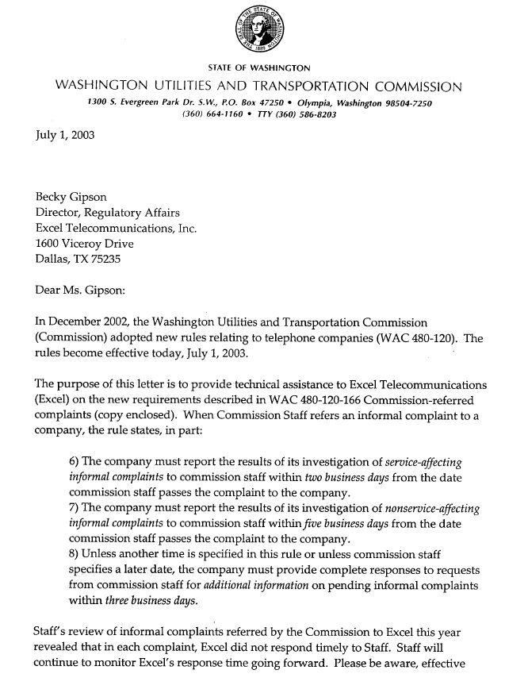
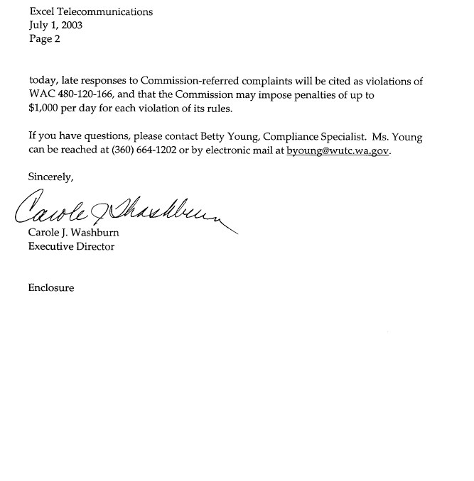
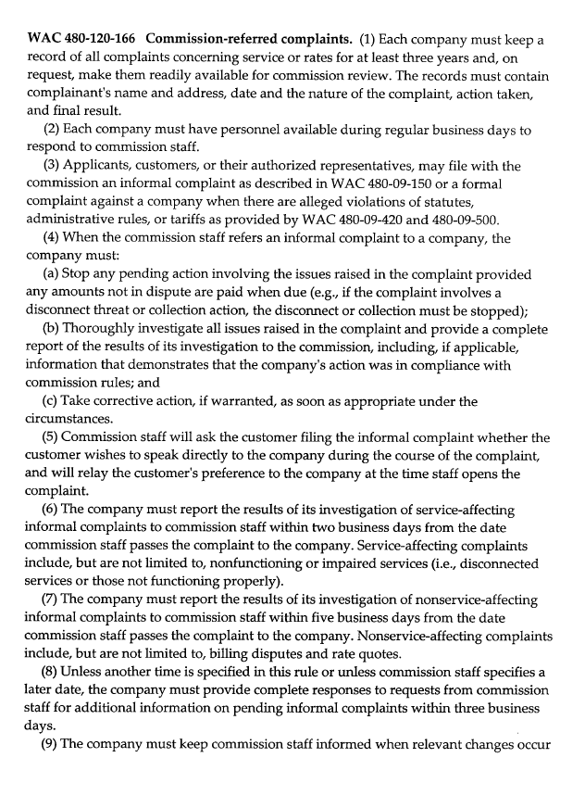
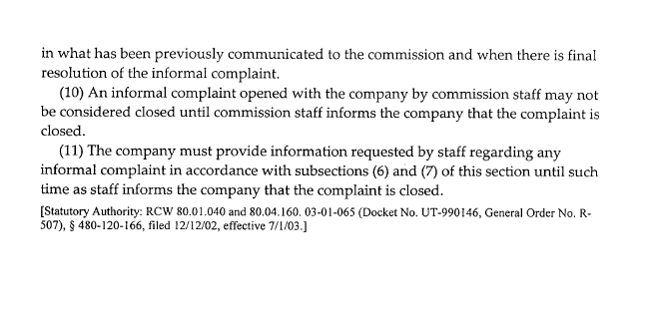
Appendix E

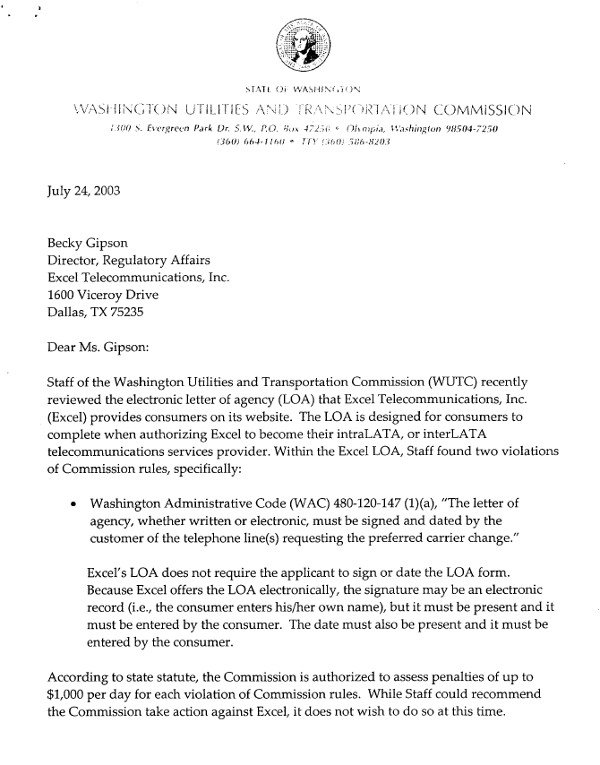
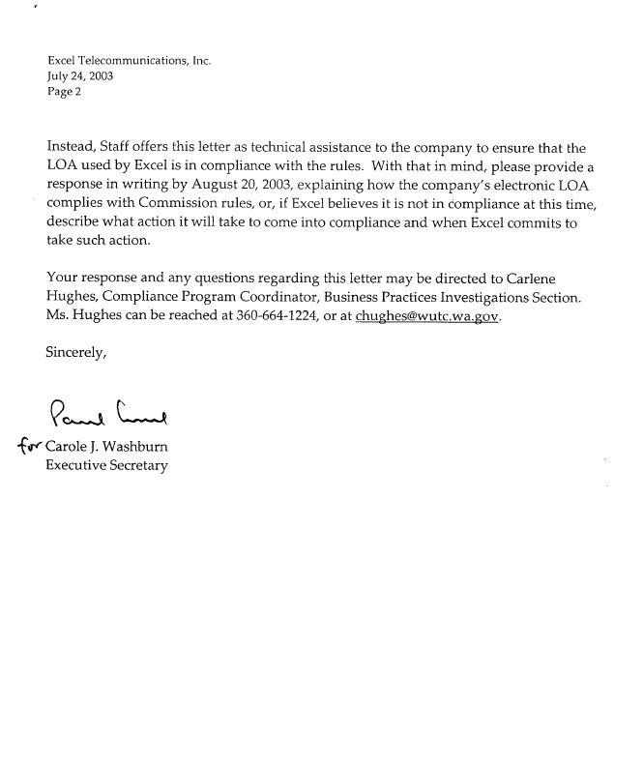

Appendix F
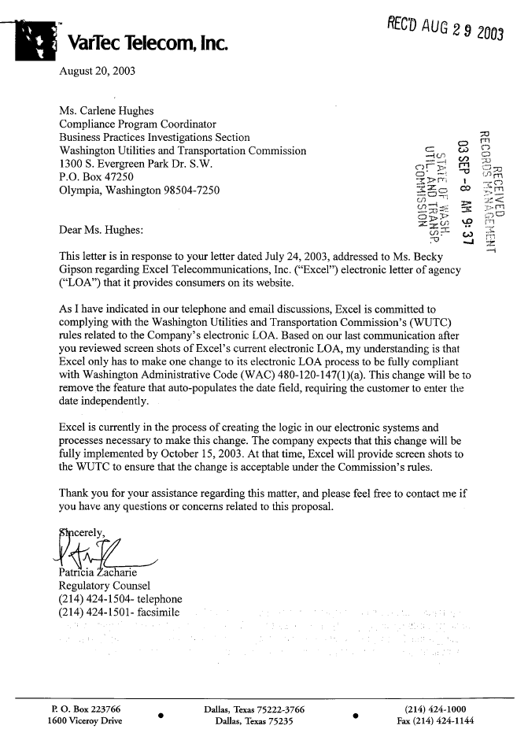

Appendix G

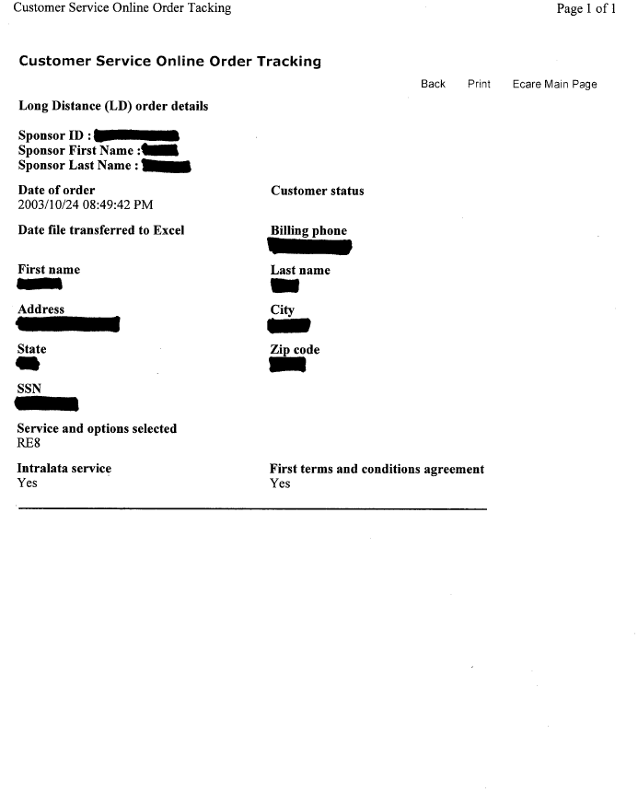
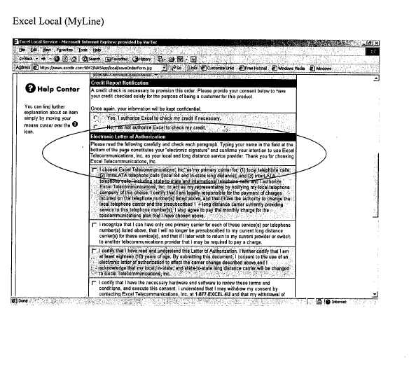
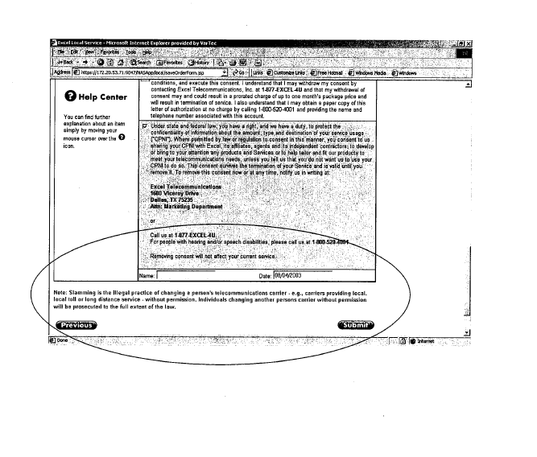

A summary of 2004 complaints where violations were cited is included as Appendix B.
See chart in Appendix C.
See letter at Appendix D.
See letter at Appendix E.
See company’s response at Appendix F.
See forms at Appendix G.
This is a typographical error within the complaint. The violation should reference WAC 480-120-172(12). One violation was cited for disconnecting the customer’s one-way service and one violation for each day that it was not restored after notification of the error for a total of 11 violations.

