CenturyLink

1600 7th Avenue, Room 1506

Seattle, Washington 98191

(206) 345-1568

Facsimile (206) 343-4040

Mark S. Reynolds

VP Regulatory & Legislative Affairs

Western Region

March 18, 2014

Re: Docket UT-130477 (Do Not Re-Docket)
Advice No. WA 14-01A for CenturyTel of Washington, CenturyTel of Inter Island and CenturyTel of Cowiche d/b/a CenturyLink

Steven King
Executive Director and Secretary
1300 S. Evergreen Park Dr. S.W.
P.O. Box 47250
Olympia, Washington 98504-7250

Dear Mr. King:

Pursuant to conversations with Staff, enclosed is a complete replacement of Access Service Tariff WN U-9. Access Service Tariff WN U-9 is being replaced in its entirety by Access Service Tariff WN U-12 with the only change being the change in the tariff number. This revised Tariff is being submitted with the same effective date as the original, April 1, 2014 and is in compliance with the Stipulated Plan for Alternative Form of Regulation (AFOR) in Docket No. UT-130477.

If you have questions concerning this filing, please contact Mark Brinton – Regulatory Operations on (303) 992-5832.

Sincerely,

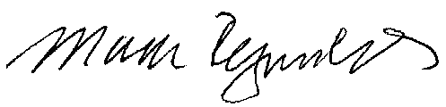

Mark Reynolds

cc: Lisa Anderl
John Felz

