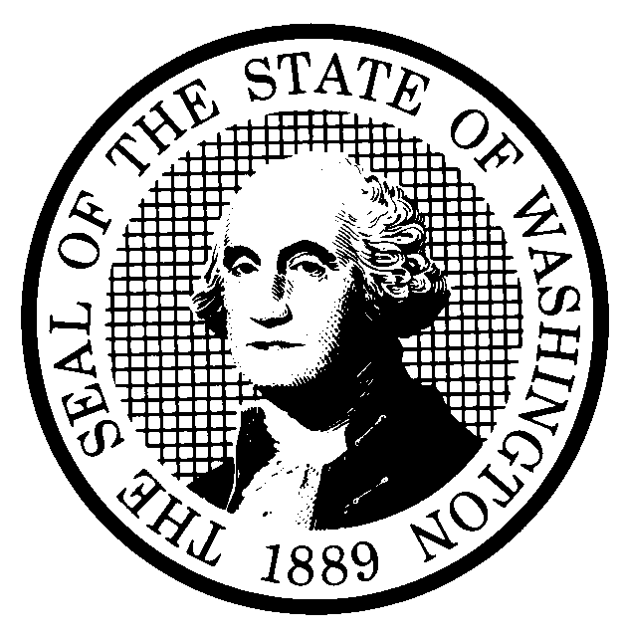 | PROPOSED RULE MAKING |  |  |  |  | CR-102 (June 2004)  (Implements RCW 34.05.320)  Do NOT use for expedited rule making
Agency: Washington Utilities and Transportation Commission
Preproposal Statement of Inquiry was filed as WSR #05-15-091 ; or  Expedited Rule Making--Proposed notice was filed as WSR ; or  Proposal is exempt under RCW 34.05.310(4). |  |  |  |  |  |  | Original Notice  Supplemental Notice to WSR #06-08-058 Continuance of WSR
Title of rule and other identifying information: Chapter 480-07 WAC – Procedural Rules

This supplemental proposal notices possible changes to WAC 480-07-700(3) relating to settlement conferences, which were not included in the proposal filed at WSR #06-08-058, and Qwest’s proposed amendment to WAC 480-07-650(1)(c), that would require a petitioner to file its petition within 30 days of service of the 10-day notice of intent to file a petition. Provisions previously noticed in WSR 06-08-058 are not affected by this supplemental notice.

Docket No. A-050802
Hearing location(s):  Commission Hearing Room  Second Floor, Chandler Plaza,  1300 S. Evergreen Park Drive SW  Olympia, WA 98504-7250 |  |  |  | Name: Carole J. Washburn,  Address: Washington State Utilities and Transportation Commission  P.O. Box 47250  Olympia, WA 98504-7250  e-mail: records@wutc.wa.gov. Please, include: “Docket No. A-050802” in your comments.  Fax: (360) 586-1150 by (date) June 19, 2006
Date: June 28, 2006 Time: 1:30 P.M. |  |  |  | Assistance for persons with disabilities: Contact  Mary De Young by June 26, 2006  TTY (360) 586-8203 or (360) 664-1133
Date of intended adoption: June 28, 2006
(Note: This is NOT the effective date)
Purpose of the proposal and its anticipated effects, including any changes in existing rules:
This supplemental proposal would revise WAC 480-07-700(3), by setting forth a process for settlement conferences that includes notice to all parties. The amended language is intended to ensure that all parties have an opportunity to participate in settlement conferences.

This supplemental proposal would also revise WAC 480-07-650(1)(c) concerning the prefiling notice of petitions for enforcement of interconnection agreements. The amended language would require that companies that send a 10-day notice of intent to file a petition for enforcement must file the petition within 30 days after serving the 10-day notice. The inclusion of the 30-day window in which to file the petition is intended to avoid the situation of a petitioner filing a 10-day notice of intent to file a petition, and then waiting several months to file the petition.

The detailed changes are shown in legislative format on the commission’s Web site at www.wutc.wa.gov/050802.

Reasons supporting proposal: See above.
Statutory authority for adoption:  RCW 80.01.040 and RCW 80.04.160 |  |  |  | Statute being implemented: N/A
Is rule necessary because of a:  Federal Law?  Federal Court Decision?  State Court Decision?  If yes, CITATION: |  | Yes  Yes  Yes | No  No  No |  | CODE REVISER USE ONLY  Filed with the Code Reviser’s Office  May 11, 2006, 9:53 a.m.  WSR 06-11-047
DATE
May 11, 2006
NAME (type or print)
Carole J. Washburn
SIGNATURE
TITLE Executive Secretary

(COMPLETE REVERSE SIDE)
Agency comments or recommendations, if any, as to statutory language, implementation, enforcement, and fiscal matters:

Name of proponent: (person or organization) Washington State Utilities and Transportation Commission |  |  | Private  Public  Governmental
Name of agency personnel responsible for:
 | Name | Office Location | Phone
Drafting............... Ann Rendahl |  | 1300 S. Evergreen Pk Drive SW, Olympia, WA 98504 | (360) 664-1144
Implementation.... Carole Washburn |  | 1300 S. Evergreen Pk Drive SW, Olympia, WA 98504 | (360) 664-1174
Enforcement.........Carole Washburn |  | 1300 S. Evergreen Pk Drive SW, Olympia, WA 98504 | (360) 664-1174
Has a small business economic impact statement been prepared under chapter 19.85 RCW?
Yes. Attach copy of small business economic impact statement.

A copy of the statement may be obtained by contacting:
Name:
Address:

phone ( )
fax ( )
e-mail
No. Explain why no statement was prepared.

The proposed rules will not result in or impose an increase in costs. Because there will not be any increase in costs resulting from the proposed rule changes, an SBEIS is not required under RCW 19.85.030 (1)

Is a cost-benefit analysis required under RCW 34.05.328?

Yes A preliminary cost-benefit analysis may be obtained by contacting:
Name:
Address:

phone ( )
fax ( )
e-mail

No: Please explain: The proposed rules are not significant legislative rules of the sort referenced in RCW 34.05.328 (5).

