CenturyLink

931 14th Street, Suite 1230

Denver, Colorado 80202

303-992-5832

May 18, 2018

Advice No. 3725T

Steven V. King
Executive Director and Secretary
1300 S. Evergreen Park Dr. S.W.
P.O. Box 47250
Olympia, Washington 98504-7250

Dear Mr. King:

Qwest Corporation d/b/a CenturyLink QC is forwarding for filing the sheets listed on Attachment A.

This filing is the seventh step in implementing the Terminating Switched End Office Access Service reductions mandated in the Federal Communications Commission's November 18, 2011 Report and Order and Further Notice of Proposed Rulemaking in WC Docket Nos. 10-90, etc. (FCC 11-161) (Transformation Order). When a CenturyLink Price Cap ILEC owns the tandem and a CenturyLink Price Cap ILEC or affiliate owns the terminating End Office Switch, the tandem switched rates will be considered “Tandem-to-End Office” and will transition to bill-and-keep (not to exceed $0.0000/MOU) as required by 47 C.F.R. §51.907(h), which addresses changes beginning July 1, 2018. All other tandem traffic that traverses a CenturyLink Price Cap ILEC-owned tandem and does not terminate to an end user served by a CenturyLink Price Cap ILEC end office will be considered “Tandem-to-3rd Party” and will continue to be billed at the current Interstate rates, including tandem traffic traversing a CenturyLink Price-Cap ILEC-owned tandem to an affiliated CenturyLink CLEC end office. Tandem-Switched Transport charges associated with traffic traversing a non-CenturyLink Price Cap ILEC-owned tandem, but terminating to a CenturyLink-owned end office will also remain at current Interstate rates.

On April 5, 2018, the FCC released an order (WC Docket No. 18-100 DA 18-355) granting a limited waiver of the July 1 effective date for the 2018 annual access filings specifically including §51.907(h) and setting July 3, 2018 as the effective date for the 2018 rate changes required by its Transformation Order. The intrastate rate changes proposed under this filing mirror the effective date of the interstate rate changes.

Also enclosed is CenturyLink’s certification that the company is not seeking duplicative recovery in the state jurisdiction for any Eligible Recovery subject to the recovery mechanism established by the Transformation Order.

Page 2

As part of this filing CenturyLink is also removing the direct dial coin feature on smart public access lines provided by CenturyLink. The direct dial coin feature is no longer supportable due to the age of the technology and the inability to secure technical support and knowledge on how to make the feature work with the new SIP signaling and difficulty securing sites to complete viable testing. CenturyLink will continue to support 0+ or 0- intraLATA calling. 1+ interLATA calling will continue to be provided by FGD (long-distance service providers).

CenturyLink QC respectfully requests that these proposed changes become effective July 3, 2018.
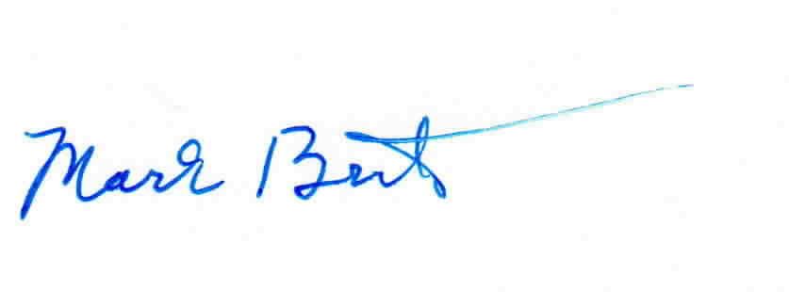
Sincerely,

Mark Brinton
Manager Regulatory Operations
Office: (303) 992-5832
e-mail: Mark.Brinton@CenturyLink.com

Attachments

Attachment A
Advice No. 3725T

ACCESS SERVICE
WN U-48

SECTION | SHEET | REVISION
2 | 58.2 | 1st
6 | 45 | 1st
6 | 46 | 2nd
6 | 139.1 | 1st

