Qwest Corporation d/b/a CenturyLink QC
Section 2
WN U-48 1st Revised Sheet 55
Access Service Cancels Original Sheet 55
Washington

2. General Regulations  2.4 Payment Arrangements And Credit Allowances  2.4.7 Ordering, Rating And Billing Of Access Services Where More Than One Exchange Telephone Company Is Involved (Cont'd)  C. The billing percentages will be agreed upon by the Exchange Telephone Companies involved.  D. When jointly provisioned Switched Access Service is provided between the Company and another Exchange Telephone Company, the appropriate Switched Access recurring rates will be applied based on the type of Switched Transport provided, Tandem-Switched Transport (TST) or Direct-Trunked Transport (DTT). Tandem 3rd Party rates apply to Terminating Traffic Types between the Company and another Exchange Telephone Company that is not a CenturyLink Operating Company (CLOC) ILEC.  For Switched Access Service provisioned as TST, the appropriate Switched Access recurring rates for Terminating – Tandem 3rd Party or Originating will be applied as follows: 1) multiply the Tandem Transmission fixed rate by the minutes of use (MOU) by the billing percentage (BP), 2) multiply the Tandem Transmission per-mile rate by the number of miles, by the MOU by the BP, and 3) all other appropriate Switched Access recurring rate elements at 100 percent, if applicable.  For Switched Access Service provisioned as DTT, the recurring rates will be applied as follows: 1) multiply the monthly Transport Channel fixed rate by the BP, 2) multiply the monthly Transport Channel per-mile rate by the number of miles, by the BP, and 3) all other appropriate Switched Access recurring rate elements at 100 percent, if applicable.  The Exchange Telephone Company that owns the access tandem will assess the appropriate access tandem Terminating – Tandem 3rd Party or Originating recurring rates at 100 percent. The Exchange Telephone Company that owns the end office will assess the appropriate end office recurring rates at 100 percent.  (M) Material moved to Page 55.1 | (C)  (C)  (C)  (C)  (C)  (M)  (M)

Advice No. 3722T
Issued by Qwest Corporation d/b/a CenturyLink QC Effective: July 1, 2017
By Phil Grate, Director – Washington (T)

Qwest Corporation d/b/a CenturyLink QC
Section 2
WN U-48 Original Sheet 55.1
Access Service
Washington

2. General Regulations  2.4 Payment Arrangements And Credit Allowances  2.4.7 Ordering, Rating And Billing Of Access Services Where More Than One Exchange Telephone Company Is Involved (Cont'd)  E. When jointly provisioned Switched Access Service is provided and the Company is the intermediate non-terminating carrier, only the recurring Tandem Transmission per-mile rate for Terminating – Tandem 3rd Party or Originating or DTT per-mile rate for Switched Access Service will apply. The Tandem Transmission Originating per-mile rate or Tandem Transmission Terminating– Tandem 3rd Party per-mile rate or DTT per-mile rate will be determined by multiplying the appropriate rate by the MOU by the number of miles, by the BP. The DTT per-mile rate will be determined by multiplying the appropriate DTT per-mile monthly rate by the number of miles by the BP. If the Company provides the access tandem, all appropriate access tandem 3rd Party recurring rates will apply at 100 percent.  F. When jointly provisioned Access Service is provided between the Company and another Exchange Telephone Company, or when the Company is the intermediate non-terminating carrier, the appropriate nonrecurring charges shall apply. The BP is not applied to nonrecurring charges.  (M) Material moved from Page 55. | (M)  (C-M)  (M)  (C-M)  (C-M)  (M)  (C-M)  (M)  (M)

Advice No. 3722T
Issued by Qwest Corporation d/b/a CenturyLink QC Effective: July 1, 2017
By Phil Grate, Director – Washington (T)

Qwest Corporation d/b/a CenturyLink QC
Section 2
WN U-48 1st Revised Sheet 56
Access Service Cancels Original Sheet 56
Washington

2. General Regulations  2.4 Payment Arrangements And Credit Allowances  2.4.7 Ordering, Rating And Billing Of Access Services Where More Than One Exchange Telephone Company Is Involved (Cont'd)  G. Examples - Switched Access provisioned by Direct-Trunked Transport and Tandem-Switched Transport  Feature Group D Access Service Ordered  Example 1 – Originating Switched Access  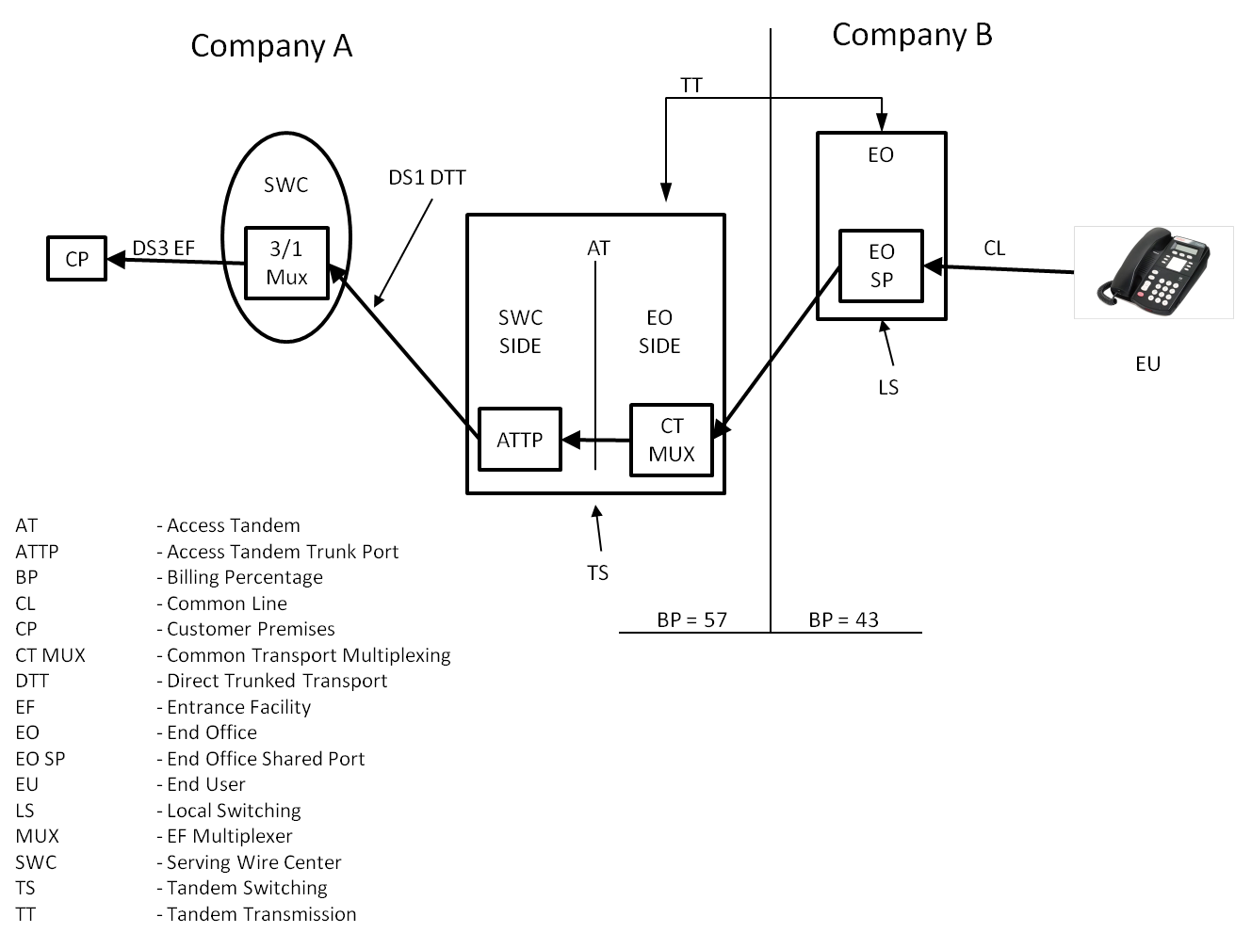 | (T)  (N)  (C)  (C)

Advice No. 3722T
Issued by Qwest Corporation d/b/a CenturyLink QC Effective: July 1, 2017
By Phil Grate, Director – Washington (T)

Qwest Corporation d/b/a CenturyLink QC
Section 2
WN U-48 1st Revised Sheet 57
Access Service Cancels Original Sheet 57
Washington

2. General Regulations  2.4 Payment Arrangements And Credit Allowances  2.4.7 Ordering, Rating And Billing Of Access Services Where More Than One Exchange Telephone Company Is Involved  G. Examples - Switched Access provisioned by Direct-Trunked Transport and Tandem-Switched Transport (Cont’d)  1. Example 1 Layout – Originating Switched Access  a. Originating Feature Group D Switched Access is ordered to an end office via DTT and TST. Originating rates would apply.  b. The premises of ordering customer, the serving wire center (SWC) of that premises, and the access tandem are in operating territory of Company A.  c. The customer orders a DS3 Entrance Facility from the customer’s premises to the SWC with a 3/1 MUX in the SWC.  d. The customer orders a DS1 DTT to the AT.  e. The BP for TT is 57 for Company A.  f. The end office is in the operating territory of Company B.  g. The BP for transport is 43 for Company B. | (T)  (C)  (C)  (C)  (C)  (C)  (C)

Advice No. 3722T
Issued by Qwest Corporation d/b/a CenturyLink QC Effective: July 1, 2017
By Phil Grate, Director – Washington (T)

Qwest Corporation d/b/a CenturyLink QC
Section 2
WN U-48 1st Revised Sheet 58
Access Service Cancels Original Sheet 58
Washington

2. General Regulations  2.4 Payment Arrangements And Credit Allowances  2.4.7 Ordering, Rating And Billing Of Access Services Where More Than One Exchange Telephone Company Is Involved  G. Examples - Switched Access provisioned by Direct-Trunked Transport and Tandem-Switched Transport (Cont’d)  2. Rate elements assessed per Company  a. Company A  Entrance Facility - 100% of DS3 monthly Entrance Facility rate and 3/1 MUX  DS1 DTT - 100% of DS1 monthly DTT rate  ATTP - 100% of ATTP monthly rate  Tandem Switching - MOU rate X MOU  Common Transport MUX - MOU rate X MOU  Tandem Transmission - Fixed rate X MOU X BP  Tandem Transmission - Per-mile rate X number of miles X MOU X BP  b. Company B  Tandem Transport - Transport rate X MOU X BP  Local Switching - MOU rate X MOU  End Office Shared Port - MOU rate X MOU | (C)  (C)  (C)

Advice No. 3722T
Issued by Qwest Corporation d/b/a CenturyLink QC Effective: July 1, 2017
By Phil Grate, Director – Washington (T)

Qwest Corporation d/b/a CenturyLink QC
Section 2
WN U-48 Original Sheet 58.1
Access Service
Washington

2. General Regulations  2.4 Payment Arrangements And Credit Allowances  2.4.7 Ordering, Rating And Billing Of Access Services Where More Than One Exchange Telephone Company Is Involved  G. Examples - Switched Access provisioned by Direct-Trunked Transport and Tandem-Switched Transport (Cont’d)  Feature Group D Access Service Ordered  Example 2 – Terminating Switched Access Tandem 3rd Party  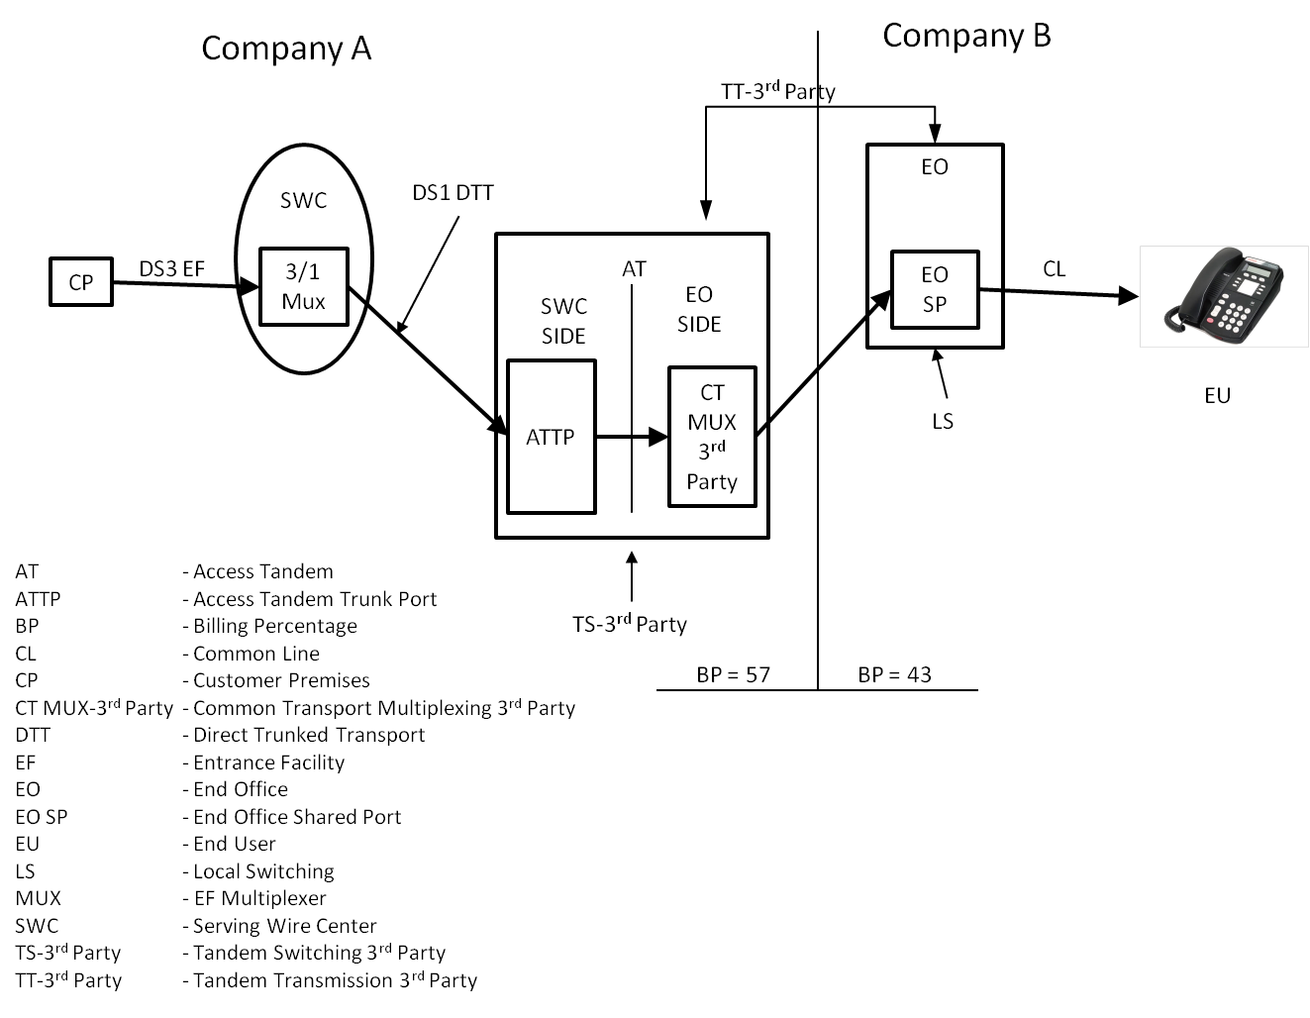 | (N)  (N)

Advice No. 3722T
Issued by Qwest Corporation d/b/a CenturyLink QC Effective: July 1, 2017
By Phil Grate, Director – Washington (T)

Qwest Corporation d/b/a CenturyLink QC
Section 2
WN U-48 Original Sheet 58.2
Access Service
Washington

2. General Regulations  2.4 Payment Arrangements And Credit Allowances  2.4.7 Ordering, Rating And Billing Of Access Services Where More Than One Exchange Telephone Company Is Involved  G. Examples - Switched Access provisioned by Direct-Trunked Transport and Tandem-Switched Transport (Cont’d)  3. Example 2 Layout – Terminating Switched Access, Tandem 3rd Party  a. Terminating Feature Group D Switched Access is ordered to an end office via DTT & TST. Terminating – Tandem 3rd Party rates would appl.  b. The premises of ordering customer, the serving wire center (SWC) of that premises, and the access tandem are in operating territory of Company A.  c. The customer orders a DS3 Entrance Facility from the customer's premises to the SWC with a 3/1 Mux in the SWC.  .  d. The customer orders a DS1 DTT to the AT.  e. The BP for TT is 57 for Company A.  f. Company B is not a CLOC ILEC.  g. The end office is in the operating territory of Company B.  h. The BP for transport is 43 for Company B. | (N)  (N)

Advice No. 3722T
Issued by Qwest Corporation d/b/a CenturyLink QC Effective: July 1, 2017
By Phil Grate, Director – Washington (T)

Qwest Corporation d/b/a CenturyLink QC
Section 2
WN U-48 Original Sheet 58.3
Access Service
Washington

2. General Regulations  2.4 Payment Arrangements And Credit Allowances  2.4.7 Ordering, Rating And Billing Of Access Services Where More Than One Exchange Telephone Company Is Involved  G. Examples - Switched Access provisioned by Direct-Trunked Transport and Tandem-Switched Transport (Cont’d)  Feature Group D Access Service Ordered  Example 3 – Tandem Switched Access, Tandem End Office  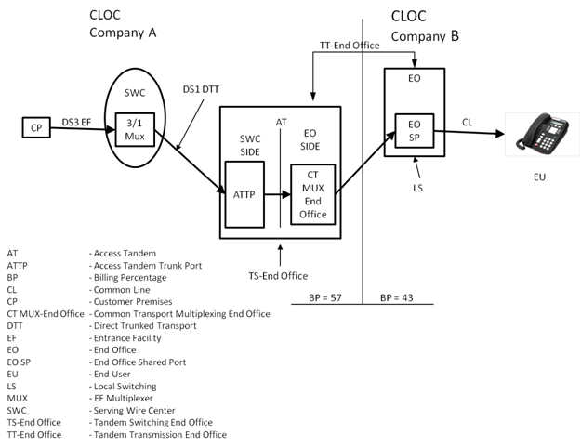 | (N)  (N)

Advice No. 3722T
Issued by Qwest Corporation d/b/a CenturyLink QC Effective: July 1, 2017
By Phil Grate, Director – Washington (T)

Qwest Corporation d/b/a CenturyLink QC
Section 2
WN U-48 Original Sheet 58.4
Access Service
Washington

2. General Regulations  2.4 Payment Arrangements And Credit Allowances  2.4.7 Ordering, Rating And Billing Of Access Services Where More Than One Exchange Telephone Company Is Involved  G. Examples - Switched Access provisioned by Direct-Trunked Transport and Tandem-Switched Transport (Cont’d)  4. Example 3 Layout – Terminating Switched Access, Tandem End Office  a. Terminating Feature Group D Switched Access is ordered to an end office via DTT & TST. Terminating – Tandem End Office rates would apply  b. The premises of ordering customer, the serving wire center (SWC) of that premises, and the access tandem are in operating territory of Company A.  c. The customer orders a DS3 Entrance Facility from the customer's premises to the SWC with a 3/1 Mux in the SWC.  .  d. The customer orders a DS1 DTT to the AT.  e. The BP for TT is 57 for Company A.  f. Company B is a CLOC ILEC.  g. The end office is in the operating territory of Company B.  h. The BP for transport is 43 for Company B. | (N)  (N)

Advice No. 3722T
Issued by Qwest Corporation d/b/a CenturyLink QC Effective: July 1, 2017
By Phil Grate, Director – Washington (T)

Qwest Corporation d/b/a CenturyLink QC
Section 2
WN U-48 1st Revised Sheet 59
Access Service Cancels Original Sheet 59
Washington

2. General Regulations  2.4 Payment Arrangements And Credit Allowances (Cont'd)  2.4.8 Ordering, Rating And Billing Of Switched Access Service Provided In Conjunction With A Commercial Mobile Radio Service Provider  When Switched Access Service is ordered by a customer in conjunction with a Commercial Mobile Radio Service provider, the Company will provide its portion of the Switched Access Service based on the regulations, rates and charges contained in this Tariff, subject to the following rules.  If the Company and the Commercial Mobile Radio Service provider have agreed to jointly provide the Switched Access Service, the Meet Point Billing provisions as set forth in 2.4.7, preceding, shall determine the ordering, rating and billing for access services.  If the Company and the Commercial Mobile Radio Service provider have not agreed to jointly provide the Switched Access Service under the provisions of Meet Point Billing, the Company shall provide the Switched Access Service to the carrier subject to the following rules.  • If the Company provides the Switched Transport and provides end office local switching functions, the customer will be assessed all applicable Switched Access Service rates (i.e., Switched Transport and Local Switching).  • If the Company provides the Switched Transport and does not provide end office local switching functions, the Company will assess all applicable Switched Access charges, including the Switched Transport Tandem 3rd Party charges. Local Switching rates will not be assessed by the Company.  The mileage to be used to determine the Switched Transport rate is calculated as set forth in 6.7.11, following. | (C)  (C)

Advice No. 3722T
Issued by Qwest Corporation d/b/a CenturyLink QC Effective: July 1, 2017
By Phil Grate, Director – Washington (T)

Qwest Corporation d/b/a CenturyLink QC
Section 6
WN U-48 1st Revised Sheet 14
Access Service Cancels Original Sheet 14
Washington

6. Switched Access Service  6.1 General  6.1.2 Rate Categories  A.1. (Cont'd)  c. Switched Transport TST Rate Category  TST provides the transmission facilities between an access tandem and end offices subtending that tandem utilizing tandem switching functions. TST is not available from or to a Company Hub. TST consists of circuits used in common by multiple customers from the access tandem to an end office. For TST, the Company will determine the type of facilities to the end office(s) based on the customer’s order for service on a per-trunk basis. For examples of Tandem Switched Transport see Section 2.4.7.G., preceding.  The TST rate category is composed of the rate elements set forth in (1) through (4), following. Rates and charges are set forth in 6.8, following.  (1) Tandem Transmission  Tandem Transmission is composed of a fixed per-MOU rate and per-mile/per-MOU rate. The fixed rate provides for the circuit equipment at the end of the interoffice transmission paths. The per-mile rate provides for the transmission facilities, including intermediate transmission circuit equipment between the end points of the interoffice circuit. For purposes of determining the per-mile rate, mileage will be measured as airline mileage using the V & H coordinates method. Mileage measurement rules are set forth in 6.7.11, following.  (2) Tandem Switching  Tandem Switching is a per-MOU rate assessed for utilizing tandem switching functions when tandem routing is requested for trunkside services. Tandem Switching is not assessed to FGA services.  (3) Access Tandem Trunk Port  An access tandem trunk port (ATTP) is provided for each trunk terminated on the SWC side of the access tandem when the customer has requested tandem routing. The ATTP rate is assessed monthly per Feature Group trunk (excludes FGA). | (C)  (C)

Advice No. 3722T
Issued by Qwest Corporation d/b/a CenturyLink QC Effective: July 1, 2017
By Phil Grate, Director – Washington (T)

Qwest Corporation d/b/a CenturyLink QC
Section 6
WN U-48 3rd Revised Sheet 139
Access Service Cancels 2nd Revised Sheet 139
Washington

6. Switched Access Service  6.8 Rates And Charges  6.8.1 Switched Transport (Cont'd)  C. Tandem-Switched Transport Usage Rates  Rate Per Access Minute  Mileage Bands Fixed Per Mile  1. Tandem Transmission  • Originating  • 0 $0.000000 $0.000000  • Over 0 to 8 0.000199 0.000020  • Over 8 to 25 0.000255 0.000022  • Over 25 to 50 0.000263 0.000023  • Over 50 0.000265 0.000023  • Terminating – Tandem 3rd Party  0 0.000000 0.000000  Over 0 to 8 0.000240 0.000030  Over 8 to 25 0.000240 0.000030  Over 25 to 50 0.000240 0.000030  Over 50 0.000240 0.000030  • Terminating – Tandem End Office  0 0.000000 0.000000  Over 0 to 8 0.000000 0.000000  Over 8 to 25 0.000000 0.000000  Over 25 to 50 0.000000 0.000000  Over 50 0.000000 0.000000  (M) Material moved to Page 139.1. | (C)  (N)  (N)  (M)

Advice No. 3722T
Issued by Qwest Corporation d/b/a CenturyLink QC Effective: July 1, 2017
By Phil Grate, Director – Washington (T)

Qwest Corporation d/b/a CenturyLink QC
Section 6
WN U-48 Original Sheet 139.1
Access Service
Washington

6. Switched Access Service  6.8 Rates And Charges  6.8.1 Switched Transport  C. Tandem-Switched Transport Usage Rates (Cont’d)  Rate Per Access Minute  2. Tandem Switching Charge:  Originating $0.003306  Terminating – Tandem 3rd Party 0.002252  Terminating – Tandem End Office 0.000700  3. Common Transport Multiplexing:  Originating 0.000198  Terminating – Tandem 3rd Party 0.000036  Terminating – Tandem End Office 0.000000  Monthly  Rate  4. Access Tandem Trunk Port Charge,  per port $6.00  (M) Material moved from Page 139. | (M)  (C-M)  (N)  (M)  (C-M)  (N)  (M)  (M)

Advice No. 3722T
Issued by Qwest Corporation d/b/a CenturyLink QC Effective: July 1, 2017
By Phil Grate, Director – Washington (T)

Qwest Corporation d/b/a CenturyLink QC
Section 6
WN U-48 7th Revised Sheet 146
Access Service Cancels 6th Revised Sheet 146
Washington

6. Switched Access Service

6.8 Rates And Charges (Cont'd)

6.8.2 Local Switching

A. Local End Office Switching

Rate Per Access Minute

1. Local Switching

• Originating $0.014441
• Terminating 0.000000 (R)

• End Office Shared Port
Originating 0.000590
Terminating 0.000000

Monthly
Rate

• End Office Dedicated Trunk Port,[1]
per trunk $3.00

[1] The End Office Dedicated Trunk Port rate was calculated based upon a 50/50 split between originating and terminating traffic using this flat-rated port. The FCC in their FCC 11-161 ICC Transformation order in section 51.907(d)(1) allowed Price Cap Carriers to use an equal split to divide the charge between originating and terminating elements. When the terminating portion of the rate is reduced and then combined with the originating portion of the rate a single flat rate is generated for billing purposes. The Originating portion of the charge is $3.00.

Advice No. 3722T
Issued by Qwest Corporation d/b/a CenturyLink QC Effective: July 1, 2017
By Phil Grate, Director – Washington (T)

