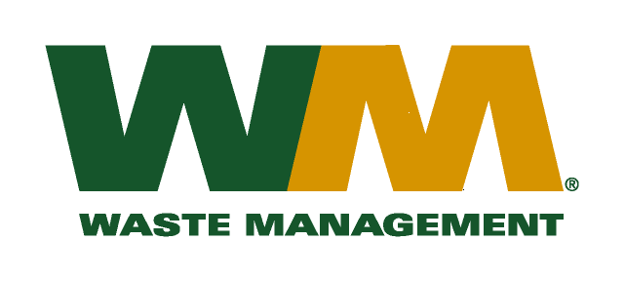
July 30, 2026
Washington Utilities and Transportation Commission
Chandler Plaza Building
1300 S. Evergreen Park Drive SW
P.O. Box 47250
Olympia, WA. 98504-7250
Dear Sirs:
Subject: Waste Management of Spokane, a division of Waste Management of Washington, Inc. (G-237); Tariff # 18
Enclosed are revised pages 2, 22, and 26 to the above-referenced tariff. The purpose of these tariff revisions is to reflect the change in the commodity credits for residential and multi-family customers receiving recycling collection services. The changes are due to a clerical error in TG-106815 that was discovered subsequent to approval of this docket. This clerical error resulted in an incorrect rebate to residential and multi-family customers. Accordingly, with this filing we are correcting this error. The tariff revisions reflect a decrease of the current commodity credit from $1.78 to $1.06 per month for residential customers and a decrease to the rebate of $0.28 per yard to $0.18 per yard for multi-family customers. We request that the effective date of these tariff revisions be approved on October 1, 2016 in accordance with our less than statutory notice (LSN) request.
Enclosed for your review are our corrected accounting work papers and our request for LSN treatment. Customers will be notified of the change in their commodity credit adjustment on their next regularly scheduled billing after the approval of the Commission. In addition, the county has been notified of these proposed tariff changes.
If you have any questions or need additional information, please contact me at (425) 814-7840.
Very truly yours,

Michael A. Weinstein
Senior Pricing Manager, Pacific Northwest Market Area

cc: Jesse Granado
Tami Yager
Clerk of the Board, Spokane County Chair

