Pipeline Replacement Program Plan
Cascade Natural Gas Corporation
2015

in accordance with
Policy Statement in Docket No. UG-120715

Required Contents: Checklist and Table of Contents

Policy Statement |  | Section/Page
The pipe replacement program plan should consist of three parts:  (1) a “master” plan for replacing all pipes with an elevated risk of failure; | In support of its pipe replacement program plan, each gas company should demonstrate that the type of pipe to be replaced under its program presents an elevated risk of cracking, leakage, breakage or other failure. The gas company should explain why the particular type(s) of pipe presents an elevated risk, such as the physical qualities of the pipe as manufactured (e.g., low ductile plastic pipe), the condition of the pipe as installed (e.g., poor soil conditions) or as maintained (e.g., no cathodic protection), the age of the pipe, etc.  The gas company should also provide detailed analysis and explanation demonstrating why the pipe it seeks to replace is appropriate for replacement, compared to other pipe. To the extent practical, the gas company should quantify and explain the degree to which risk of failure is elevated for such pipe, compared to other pipe. | Section 1 – Master Plan  Page 3
(2) a two-year plan that specifically identifies the pipe replacement program goals for the upcoming two year period; | The first pipe replacement program plan shall be filed by June 1, 2015, covering planned pipe replacement through October 2016. | Section 2 – Two-Year Plan  Page 5
and (3) if applicable, a plan for identifying the location of pipe that presents elevated risk of failure. | - A prudent pipe replacement program should contain a plan for identifying the location of elevated risk pipe; to the extent the gas company does not presently know the location. The plan should include a timetable under which the gas company will know the location of its elevated risk pipe.  The Commission will not require a gas company to know the location of all of its elevated risk pipe as a prerequisite for having a pipe replacement program consistent with the policy statement. A pipe replacement program may focus initially on pipe for which the gas company knows the location. | Section 3 – Identification Plan  Page 6

Introduction

On December 31, 2012, the Washington Utilities and Transportation Commission issued a policy statement in Docket UG-120715 for the accelerated replacement of natural gas pipeline facilities with elevated risk. This policy statement requires each gas company requesting a special pipe replacement cost recovery mechanism (CRM) to file with the Commission a pipe replacement program plan containing the following elements:

- A “master” plan for replacing all pipes with an elevated risk of failure
- A two-year plan that specifically identifies the pipe replacement goals for the upcoming two year period
- A plan for identifying the location of pipe that presents elevated risk of failure

Section 1 -Master Plan
This Master Plan will serve as the guide that Cascade Natural Gas Corporation (Cascade) will use to determine which pipelines should be replaced as part of the Pipe Replacement Program. This Master Plan will describe the possible risks that can be associated with a pipeline, how the pipelines are analyzed to assess and quantify risks, how the pipelines to be replaced are identified, and how information for identified and new risks is obtained. The Master Plan will also describe the role that Cascade’s Distribution Integrity Management Plan (DIMP) plays in the Pipe Replacement Program.
Possible Risks
Cascade operates pipelines that are classified as Pre-CNG piping systems. Pre-CNG pipelines are distribution systems that were constructed to distribute manufactured gas. These pipelines were originally installed, owned, operated, and maintained by others prior to 1955, before natural gas was introduced to the Pacific Northwest. Cascade acquired a number of these systems in the late 1950s and throughout the 1960s. The condition of the pre-CNG pipe is bare steel or coal tar wrapped. This pipe is of concern since it is at least 60 years old and lacked cathodic protection until the early 1970s, leaving the pipe suspect to corrosion risk. The extent of this pipe varies throughout Cascade systems and depends on the history of the system and how it was acquired by Cascade. Gas distribution systems in Washington where the majority of this pre-CNG pipe resides are in the towns of Longview, Anacortes, and Shelton.
In addition to the risks inherent with Pre-CNG pipelines, Cascade’s pipelines are exposed to risks due to the following factors:
- Corrosion
- Natural Forces
- Excavation Damage
- Other Outside Force Damage
- Material, Weld, or Joint Failure
- Equipment Failure
- Incorrect Operation
- Missing Data
- Other – Forces unique to a particular area on the system

Cascade’s DIMP describes these risks in greater detail. Cascade’s DIMP is on file with the Commission’s Pipeline Safety Division.
Analysis and Quantification
As part of Cascade’s DIMP, a GIS-based model has been created and is maintained. Information collected as part of DIMP is input into the model, where it is analyzed to find areas of concern and also trends. This allows Cascade to quantify the risk associated with each pipeline based on factors that are pertinent to this Pipe Replacement Program. Cascade’s DIMP contains a more detailed explanation of this process.
Identification of Pipelines for Replacement
DIMP model results, modified to remove weighting factors that increase risk due to factors that do not apply to the intent of the Pipe Replacement Program (i.e. – excavation damage and natural forces) are used to identify the locations of pipelines that should be considered for replacement. Samples of the DIMP model outputs for the areas identified in Section 2 of this document are included in Appendix A. Once replacement locations are identified, specific projects within these areas are planned and prioritized based on coordination with district and on-site personnel considered to be Subject Matter Experts (SMEs). This helps ensure the replacement of the higher risk pipelines within the identified areas.
Obtaining New Information
Cascade obtains new information for their DIMP model and Pipe Replacement Plan through the following methods:
- Observing trending on DIMP – the DIMP model is analyzed on a yearly basis. As part of this analysis trends are identified and the plan and/or model are modified as needed.
- Company forms that gather information on exposed pipelines – every time a Cascade pipeline is exposed an Integrity Management Dig Report – Form 625 is completed. Additionally, all leaks are documented with a Leak Investigation – Form 293. Information from these forms is input into the DIMP model.
- Continuing Subject Matter Expert (SME) panel meetings – SME panel meetings are held on an as appropriate basis, at least once annually. Information from the panel meetings is used to validate the DIMP model and new information is input into the DIMP model.
- Updating model annually – Cascade’s DIMP model is updated annually. Results of the model analysis are used to prioritize pipeline replacement projects.

Cascade’s DIMP describes these methods in greater detail.
Section 2 - Two Year Plan
Cascade’s two year plan has been divided into three separate time periods. The time periods and the projects that are proposed for each are listed below.
November 1, 2014 – October 31, 2015
These projects were identified through Cascade’s DIMP model and are both intermediate pressure (IP) (<60 psig) and high pressure (HP).
November 1, 2015 – October 31, 2016
These projects were also identified through Cascade’s DIMP model. The majority are intermediate pressure (IP) (<60 psig) pipelines and all are pre-CNG.
The projects listed in these tentative schedules are based on the best information available at this time. As more information becomes available and the DIMP model is updated, the prioritization of the projects may change.
The projects identified above are anticipated to have no more than an annual 1% increase to rates in the accompanying annual Cost Recovery Mechanism (CRM). Unknown or unanticipated future projects that are subsequently identified via the application of the DIMP model will impact annual recovery requests.
Section 3 - Plan for Identifying the Location of Pipe that Presents Elevated Risk of Failure
Cascade identifies the location of pipe that presents an elevated risk of failure through the DIMP plan and model. The plan calls for information to be gathered on exposed pipe, leaks to be tracked, and SME knowledge to be incorporated into the plan. In addition, the plan has sufficient flexibility to identify and adjust to trends and new sources of information. Yearly analyses are performed that quantify the risks on each pipeline.
As outlined in Cascade’s DIMP, additional or accelerated (A/A) actions are implemented when existing compliance activities and procedures need to be supplemented to address risk identified to the integrity of Cascade’s distribution system. A/A actions that may be implemented to mitigate risk are outlined in Cascade’s DIMP, as well as the requirements for implementation and documentation.
APPENDIX A
DIMP MODEL OUTPUT
LONGVIEW/KELSO, WA
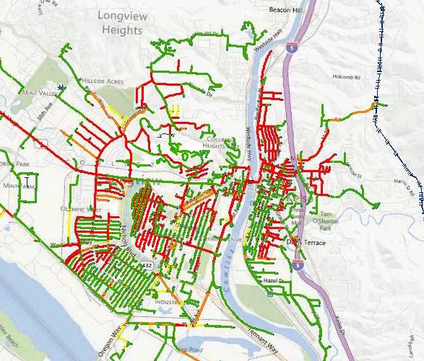
*Areas in red represent highest risk areas.
ANACORTES, WA

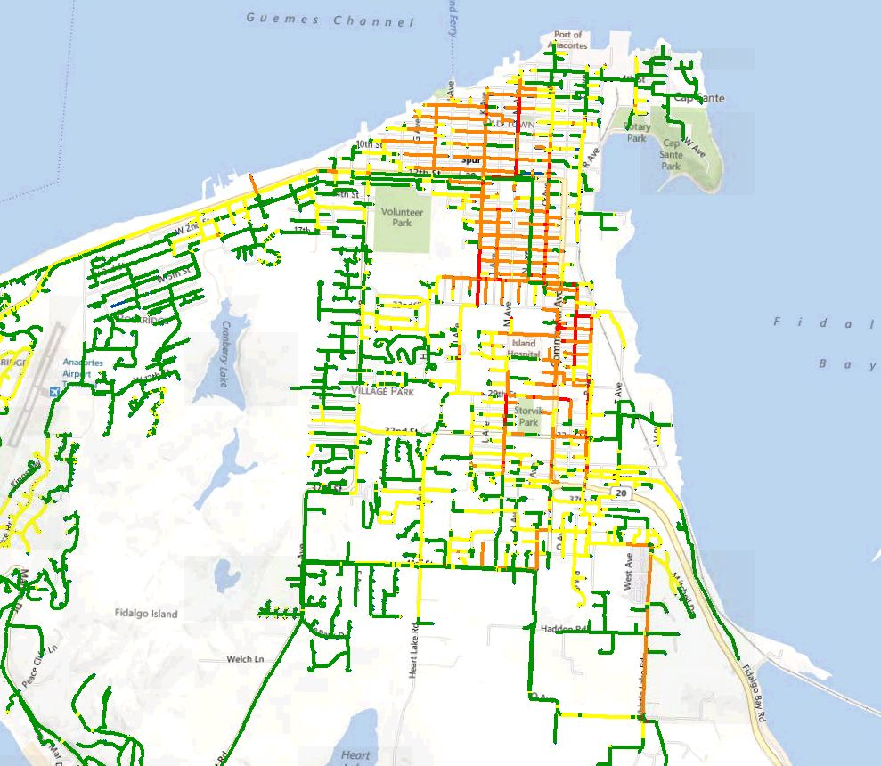

*Areas in red represent highest risk areas.
SHELTON, WA
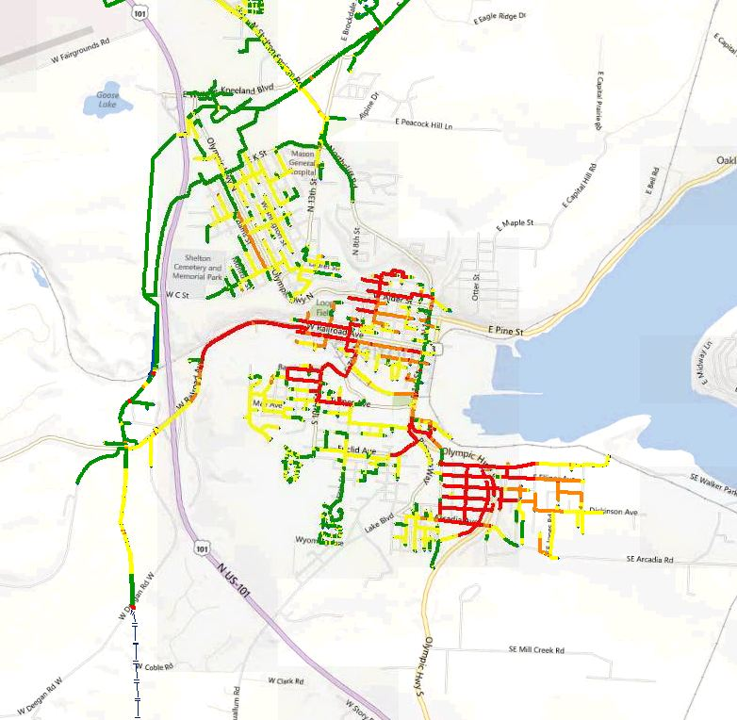
*Areas in red represent highest risk areas.
WENATCHEE, WA

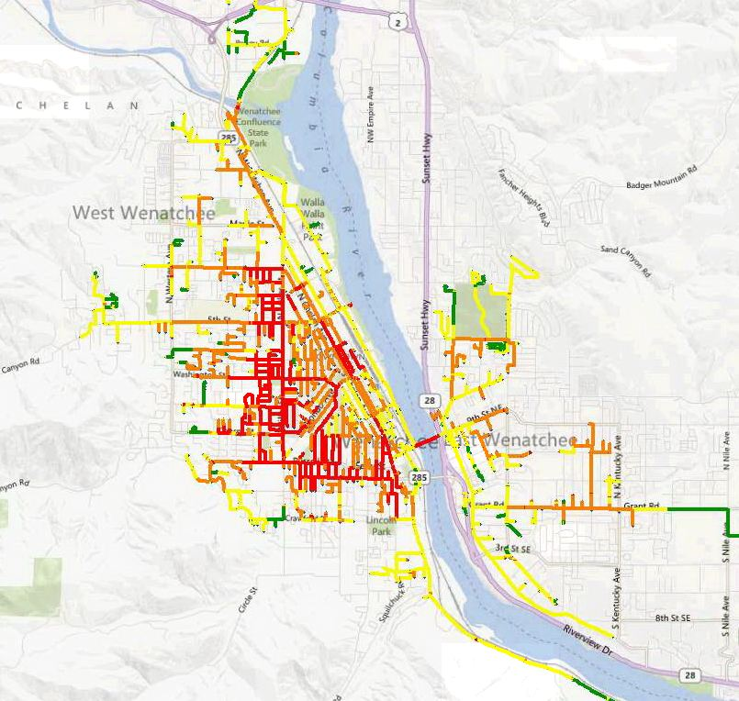

*Areas in red represent highest risk areas.
ZILLAH, WA

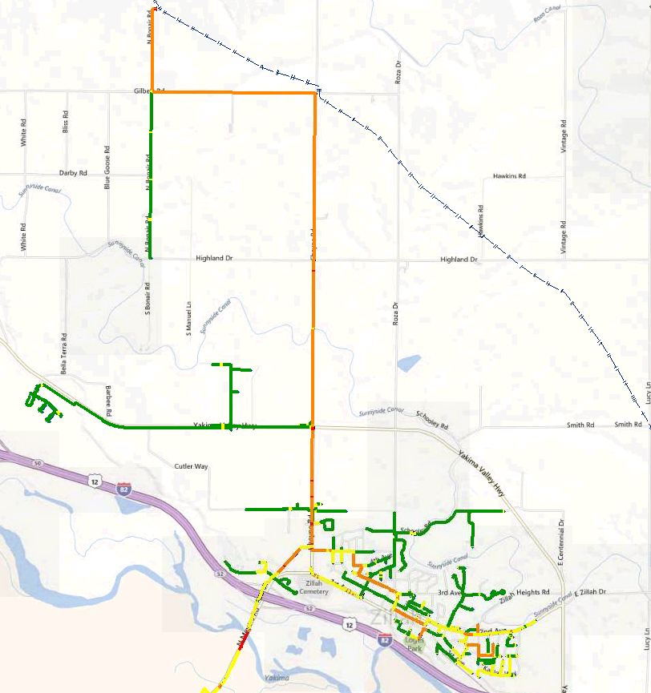

*Areas in red represent highest risk areas.
MOSES LAKE, WA

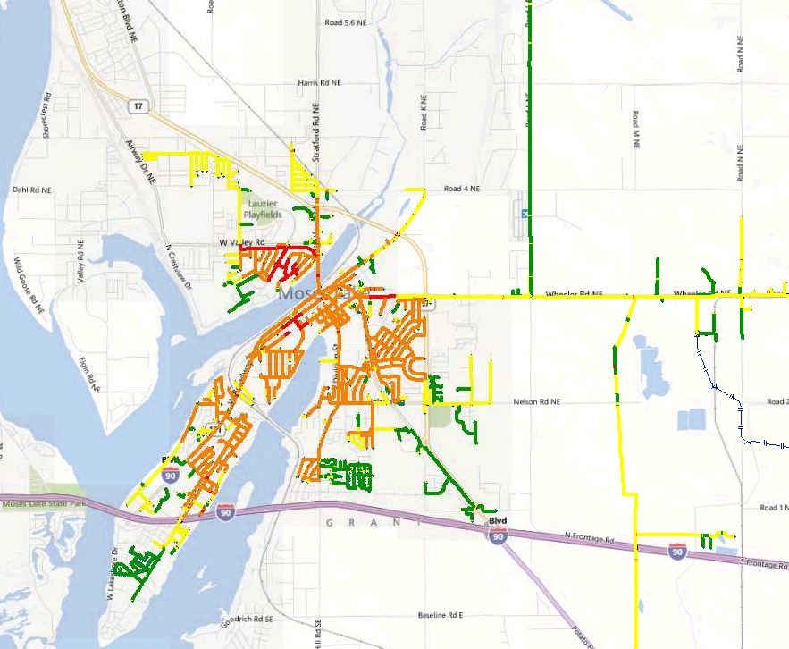

*Areas in red represent highest risk areas.
MT. VERNON, WA

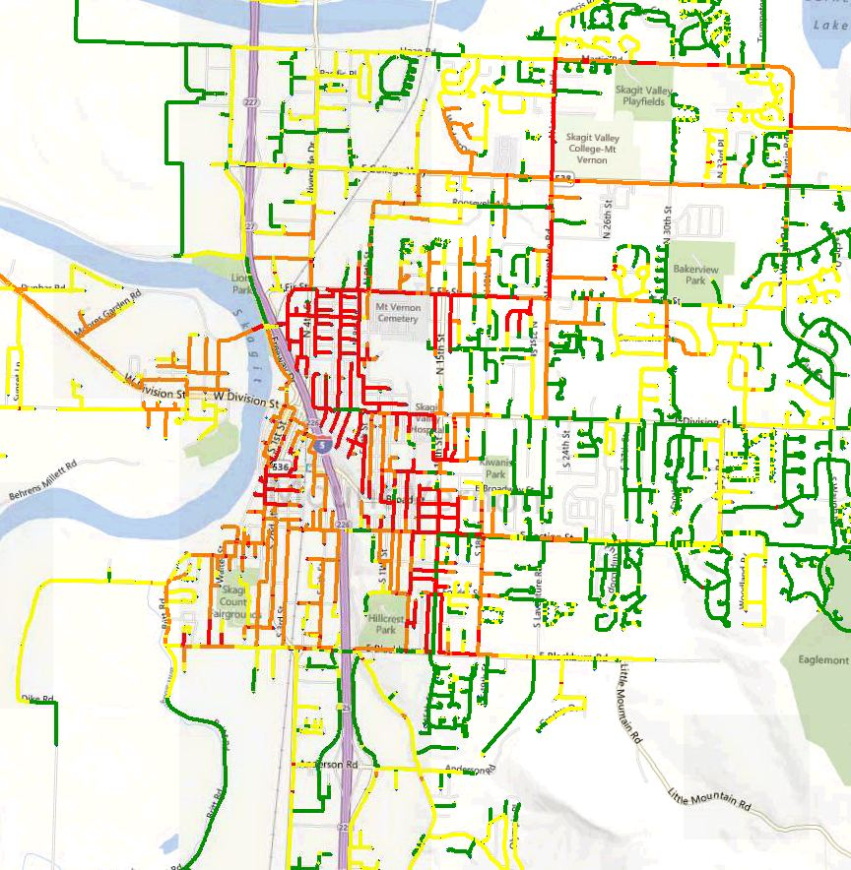

*Areas in red represent highest risk areas.
YAKIMA, WA

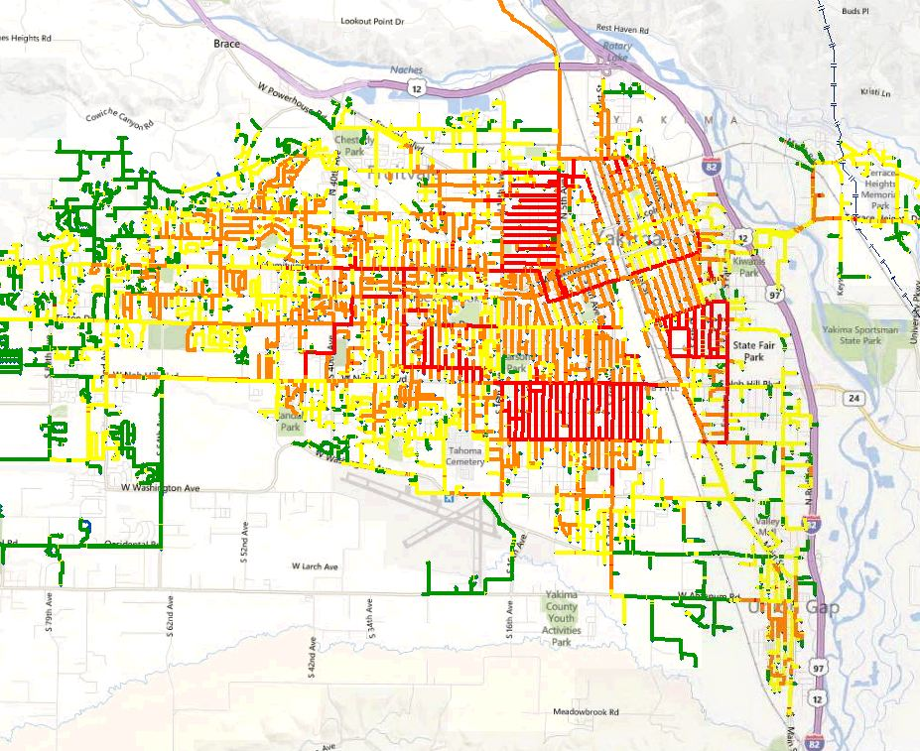

*Areas in red represent highest risk areas.

