§54.313(f)(2) – Milestone Certification

5 Year Plan Milestone Annual Certification

Dale Merten | Chief Operating Officer | The Toledo Telephone Company, Inc.
Printed Name of Officer | Title of Officer | Company Name

I am authorized to provide this certification on behalf of the Company. I hereby certify that the Company has taken reasonable steps upon reasonable request to provide broadband service. In fact, during calendar year 2015 there were no unfulfilled requests for broadband service and 100% of subscribers in our SAC are now served by fiber optic facilities.

Executed on | 06/13/2016
 | Date
Signature | 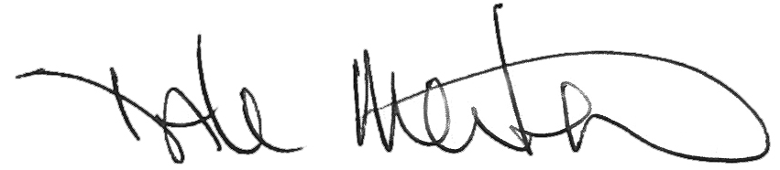
Printed/Typed Name | Dale Merten

