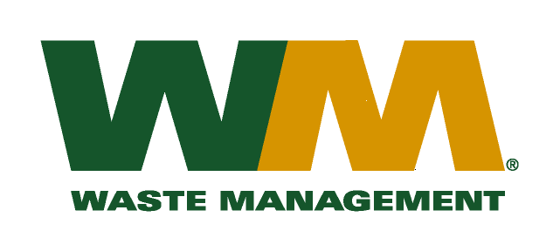
July 30, 2026
Washington Utilities and Transportation Commission
Chandler Plaza Building
1300 S. Evergreen Park Drive SW
P.O. Box 47250
Olympia, WA. 98504-7250

Subject: Waste Management – Brem-Air, a division of Waste Management of Washington, Inc.(G-237); Tariff #20
Dear Sirs:
Enclosed herein, please find revised pages, 2, 22, 23, 27, 32, 33, 34, and 35 to the above-referenced tariff. These proposed revised tariff pages contain increased rates for residential and commercial garbage collection services. The requested rate increase is necessary in order to recover increased disposal costs at the Olympic View Transfer Station (OVTS). The Kitsap County Board of Commissioners approved the increase in disposal fees from $65.00 to $68.00 per ton to become effective on January 1, 2015. The increased rates, if approved by the commission, would approximately increase Company revenue by $205,000, and residential and commercial garbage rates by 1.4% and 2.0%, respectively. The effective date of these proposed tariff revisions is January 1, 2015.
Enclosed for your review are our accounting work papers, which reflect the results of operations from our last general rate filing approved in TG-121822 and as adjusted by the 2013 disposal fee increase in TG-130596. There have been no significant changes in the operations of Waste Management – Brem-Air since this prior case. In addition, a copy of the letter from the Kitsap County Department of Public Works notifying us of the increase in disposal fees is enclosed for your review. Upon approval by the Commission of this filing, affected customers will be notified of this rate increase on their next regularly scheduled billing.
If you have any questions or need additional information, please contact me at (425) 814-7840.
Very truly yours,
Michael A. Weinstein
Senior Pricing Manager, Pacific Northwest Market Area

cc: Dean Boening
Clerk of the Board, Kitsap County Chair

