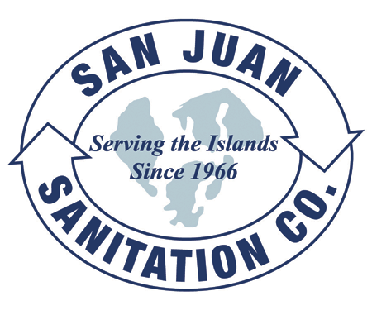
Steven King, Executive Secretary
Washington Utilities and Transportation Commission
1300 South Evergreen Park Drive SW
P.O. Box 47250
Olympia, WA 98504-7250 August 5, 2014

Dear Secretary King,

We are submitting this transmittal letter and a request for a disposal-only rate increase for San Juan Sanitation Inc., permit G-144. Enclosed please find revised tariff pages and the required work papers. This is an adjustment to Solid Waste Tariff Number 7, with an Effective Date of September 20, 2014.

Orcas Recycling Services, now operating the Orcas Island Transfer Station, has given notice that they are increasing our disposal fees by 26% to a new rate of $195.00 per ton beginning September 20, 2014. The requested increase affects all residential and commercial garbage service rates related to disposal. If approved by the Commission as filed, these requested rates would result increase company revenues by $111,264 or 7.7%, and residential and commercial rates would go up by approximately 10%.

We are requesting an exemption for this submittal from the requirement to file work papers as outlined in WAC 480-07-520(4). We believe San Juan Sanitation qualifies for this exemption, as our last general rate request was approved for rates effective July 1, 2010 (Docket TG 100828). Since that time, no material changes have taken place, customer counts are the same, and fuel and other expenses are very similar to those contained in that filing. We believe that granting this exemption from the filing requirements in WAC 480-70-520(4) would be consistent with public interest as required in WAC 480-70-051 and WAC 480-07-110.

Customer notices will be mailed with the first bill after commission approval as outlined in WAC 480-70-271(2). A copy of this transmittal letter will be mailed to the San Juan County Council.

The contact person for this submittal is: Calvin Den Hartog
P.O. Box 267, Lynden, WA 98264
Phone: (360) 354-3400 Fax: (360) 354-3288
Email: Calvin_NVD@msn.com

Sincerely,

Calvin Den Hartog
General Manager

CC: San Juan County Council
San Juan County Public Works

