STAFF INVESTIGATION

OF

MEEKER SOUTHERN RAILROAD
DOCKET TR-110221

Prepared by:
Betty Young, Compliance Investigator
Transportation Safety
March 2011

TABLE OF CONTENTS

Purpose, Scope & Authority 3

Background 4

Investigation 9

Discussion and Findings 15

Appendices 17

PURPOSE, SCOPE, AND AUTHORITY

Purpose
The purpose of this investigation is to determine if the operating practices of Meeker Southern Railroad (Meeker Southern) violated a Washington Utilities and Transportation Commission (commission) order in Docket TR-100036.

Scope
The scope of this investigation, as directed by the commission, includes the operations of Meeker Southern related to the railroad crossing at 134th Avenue East in Pierce County.

Authority
Staff undertakes this investigation under the authority of the Revised Code of Washington (RCW) 80.01.040(2) and 81.01.010. RCW 81.04.070 makes it clear that the commission is authorized to conduct such an investigation. RCW 81.04.380 and 81.04.405 authorize the commission to assess penalties against companies for violation of the statutes, rules, orders, decisions, or directives of the Legislature or the commission. Appendix A includes copies the appropriate laws and rules.

BACKGROUND

Petition to Modify Highway-Rail Grade Crossing
On January 4, 2010, Meeker Southern filed a “Petition to Modify an Existing Highway-Rail Grade Crossing” with the commission in Docket TR-100036. The petition sought approval to modify a railroad-highway grade crossing and upgrade warning devices at 134th Avenue East in Pierce County. The US Dept. of Transportation number assigned to this crossing is 085536R.

The materials filed with Meeker Southern’s petition included an overview and details of the crossing and the proposed modifications, expected characteristics of the crossing after the modification, current highway traffic information, sight distance considerations and proposed warning signals and devices.

The petition outlined Meeker Southern’s proposal to add a spur track to its existing main line track located north of Pioneer Way East. The purpose of the spur track was to provide rail access to industrial properties. The existing railroad warning devices at the crossing consisted of cross bucks, advance warning signs and pavement markings. 134th Avenue East is classified as a collector arterial with two-lane, two-way traffic and a posted vehicle speed limit of 35 miles per hour. Average annual daily traffic through the crossing is estimated at 2,525 vehicles, including eight school bus trips.

Based on consultations with Pierce County Public Works and commission staff, Meeker Southern proposed to upgrade the existing passive warning devices to shoulder-mounted flashing lights. Motion sensitive train detection would be installed to detect approaching trains. Each assembly mast would have three pairs of 12-inch flashing LED light signals, a pedestrian bell, a cross buck sign, a “2 Tracks” sign and a “Stop Here When Flashing” sign. The signal equipment bungalow would contain a back-up power supply, power-on indicator light and an emergency notification sign.

According to its design drawings submitted with the petition, Meeker Southern proposed to install advance warning signs, pavement markings and stop lines. Meeker Southern also proposed trimming and maintaining existing brush within the sight distance triangles shown in the design drawings. The existing crossing surface would also be upgraded from plank to asphalt and the new spur track crossing surface would also be asphalt.

The petition specifically stated:

“All work for the proposed spur track and the Phase 1 Service Siding shown on the accompanying civil engineering design drawings shall be completed to the reasonable satisfaction of Pierce County Public Works and Utilities prior to the Petitioner starting its operation of the spur line and the Phase 1 Service Siding.”

The petition was signed by Byron D. Cole, Managing Member of Meeker Southern. Pierce County Public Works and Utilities also signed the petition, waiving a hearing and stating that the agency had investigated the conditions at the crossing proposed for modification. The county further stated that it was satisfied that the conditions were the same as described by Meeker Southern in the petition and agreed that the crossing should be modified.

The commission must grant approval prior to a railroad company constructing multiple railroad tracks at a crossing. The commission must also grant approval prior to a railroad company adding active crossing signal warning devices at public railroad-highway grade crossings within the state.

On January 12, 2010, the commission issued an order granting Meeker Southern’s petition to modify the crossing at 134th Avenue, subject to the following conditions:

- The modifications must conform to those described and attached to the petition and set forth on the five-sheet set of civil engineering design drawings. The drawings are identified by December 29, 2009, and October 20, 2009, approval signatures by Brian D. Stacy, P.E., on behalf of Pierce County Public Works Director.
- Traffic control devices must comply with all applicable standards specified in the U.S. Department of Transportation Manual on Uniform Traffic Control Devices.
- All work for the proposed spur track and the Phase 1 Service Siding shown on the design drawings shall be completed to the reasonable satisfaction of Commission Staff and Pierce County Public Works and Utilities Staff prior to the Petitioner starting operation of the spur line and Phase 1 Service Siding.

Operations on Spur Track
In November 2010, Kathy Hunter, commission Deputy Assistant Director for Transportation Safety, contacted Byron Cole by email regarding a new spur track at the 134th Avenue crossing. Within that email, Ms. Hunter stated her understanding that the spur track had been installed and the main crossing surface repaved as part of the crossing surface modification. Ms. Hunter questioned when active warning devices would be installed and reminded Meeker Southern that according to condition three from the commission’s order, all work for the proposed spur track had to be completed to the satisfaction of Pierce County and commission staff prior to operational use of the track. Ms. Hunter stated that the county and commission staff should be notified when all modifications to the crossing were complete and prior to operations beginning on the spur line.

Mr. Cole responded on December 1, 2010, and provided information about the progress at the 134th Avenue crossing, stating, “We are keeping a close eye on the stability of the newly constructed spur subgrade and grade, and our customers retaining wall, by operating a test train about once a week. The conductor hand flags the crossing as needed.”

Compliance Letter/Company Response
On December 7, 2010, the commission sent Mr. Cole a letter outlining its concerns about the situation at the 134th Avenue crossing. The letter stated commission staff’s understanding that the spur track was constructed but the flashing light signals and other warning devices had not been installed in compliance with Commission Order 01. The letter communicated staff’s concerns that the crossing did not have the appropriate level of protection for highway users and that the company’s operations presented an unacceptable and unnecessary risk to public safety that must be remedied immediately.

The letter required Meeker Southern to submit a plan for full compliance with the commission’s order by December 20, 2010, and outlined specifically what the plan should include. The letter also provided Meeker Southern with official notice that commission staff considered any commercial use of the spur track as configured to be a violation of the commission’s order. The letter explained that if staff found any material violation of the commission’s order, staff intended to initiate enforcement action which could result in an emergency cease and desist or abatement order and monetary penalties up to $1,000 per violation.

On December 20, 2010, David L. Halinen, attorney for Meeker Southern, responded to the commission’s compliance letter. Mr. Halinen filed a motion to amend the commission’s order, as well as a proposed amended order, to address the items raised in the commission’s December 7 letter. The motion and amended order included a proposed timeline for Meeker Southern to fully conform with the conditions in the proposed amended order and specific steps Meeker Southern proposed to take to protect the public until the signals and other safety devices were installed and fully operational. The motion stated that the spur track had been recently installed and that roadway pavement improvements were made to the crossing. The motion also argued that the commission’s order should be amended to allow “immediate and continued use of the spur track.”
Pierce County filed a response on December 30, 2010, opposing Meeker Southern’s motion to modify the commission’s order unless Meeker Southern agreed to four specific conditions. These conditions would require Meeker Southern to:
- Remove specific language in the proposed amended order.
- Obtain required county permits prior to working within the county right-of-way.
- Submit bi-weekly certified payroll reports as proof that flaggers are on site when the spur track is in use.
- Obtain a performance bond or assignment of funds to guarantee the remaining work is completely timely and properly.

Commission staff filed its response on January 4, 2011, supporting the amendments requested by Meeker Southern, subject to specific conditions and corrections to the proposed amended order. Staff’s conditions included:
- That Meeker Southern be required to file reports with the commission on the 1st and 15th of each month, describing Meeker Southern’s progress in completing the work described in Table 1 of the proposed amended order.
- That Meeker Southern be required to file with the commission notice that revisions to engineering design drawings had been made, along with any revised design drawings, within seven days of the completion of any revisions.
- That the commission include Pierce County’s request for bond as a condition in its order.
- That Meeker Southern report bi-monthly with specific information related to traffic flagging and operations over the spur track, verifying compliance with the conditions in Table 2 of the proposed amended order.

Commission staff also requested that certain factual inaccuracies be corrected in the proposed amended order and outlined its intentions to pursue enforcement action if Meeker Southern did not meet the conditions.

On January 6, 2011, Meeker Southern filed a letter explaining that Pierce County Public Works and commission staff had negotiated some conditions for Meeker Southern’s operation on the spur track. On January 13, 2011, Meeker Southern filed a report on its use of the spur track between December 19, 2010, and January 8, 2011, in accordance with the conditions described in the January 6 letter.

Show Cause Proceeding
On January 19, 2011, the commission issued a “Notice of Hearing and Order to Show Cause Why Meeker Southern Railroad Should Not be Fined for Violating Commission Order 01,” setting a hearing date of January 26, 2011.

During that proceeding, Meeker Southern testified that it had begun operational use of the spur track on or around October 17, 2010.

At the conclusion of the hearing, the administrative law judge stated that commission staff should follow up with an investigation to determine prior non-compliance with the commission order of January 2010 and a recommendation for penalties if appropriate.

The administrative law judge also issued Order 03 amending the January 2010 order in Docket TR-100036.
INVESTIGATION

Staff Information Request
On February 2, 2011, commission staff sent a letter to Mr. Halinen requesting specific information from Meeker Southern regarding its operations. The letter requested the following information by February 15, 2011:

- Specific information related to each Meeker Southern/Sound Delivery train movement over the 134th Avenue crossing from October 17, 2010, through December 18, 2010, including:
- Date
- Time
- Track (main or spur)
- Direction
- Destination
- Length of train in feet
- Type and number of train cars
- Whether the movement was a test train or a load hauled for compensation
- How the crossing was protected during train movements

- Meeker Southern’s explanation, including any mitigating factors, of why the company modified the 134th Avenue crossing and commenced operational use of the new spur track prior to satisfying the conditions in the commission’s Order 01 in Docket TR-100036.

- Spreadsheet of all Meeker Southern train movements from October 1, 2010, thru January 30, 2011.

Company Response
Mr. Halinen provided a written response with exhibits to staff’s information request on behalf of Meeker Southern on February 15, 2011.

Item 1 – Meeker Southern/Sound Delivery train movements: In response to Item 1 in staff’s request, Meeker Southern provided the following specific information related to train crossings for Sound Delivery Service from October 17 through December 18, 2010:
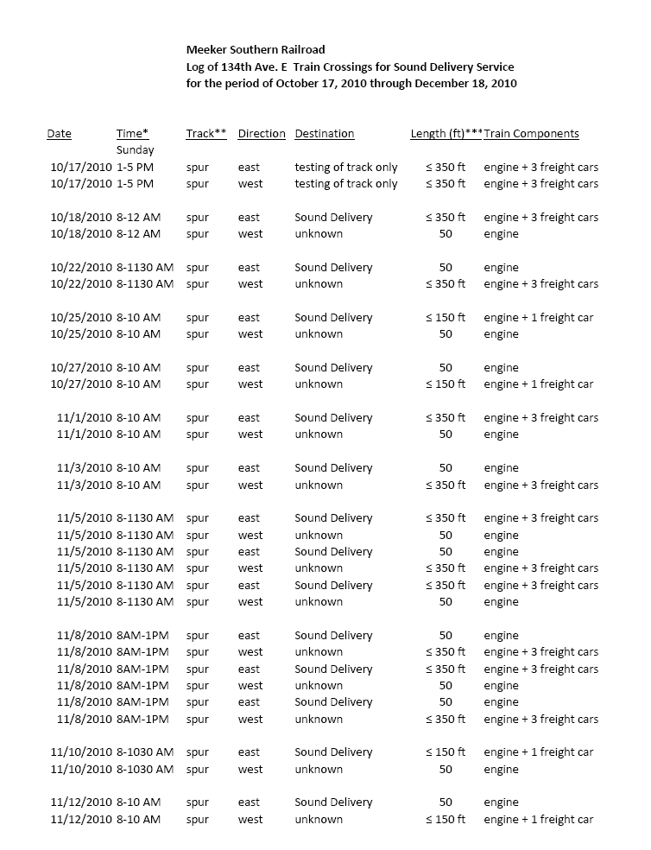
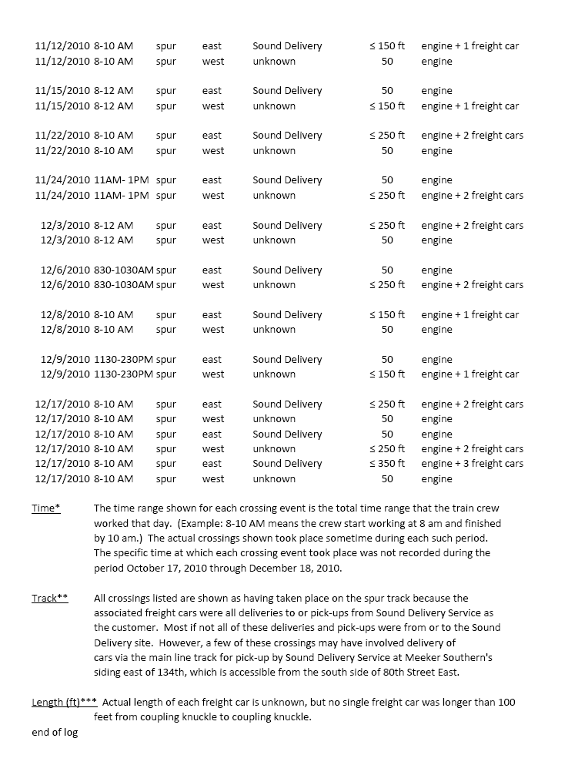
Analysis: Based on the information Mr. Halinen submitted in response to staff’s request, and on the information contained in Meeker Southern’s Report #1 submitted in Docket TR-100036, it appears Meeker Southern conducted operations on the spur track over the 134th Avenue crossing on two occasions for the purposes of testing the track and on 50 occasions for the purposes of delivering or picking up freight cars from Sound Delivery Service between October 17, 2010, and December 20, 2010. Commission staff believes these operations constitute a direct violation of the commission’s Order 01 in Docket TR-100036.

Item 2 – Explanation of why Meeker Southern modified the crossing and commenced operations prior to satisfying the conditions in the commission’s order in TR-100036, including mitigating factors:
In its response, Meeker Southern provided the following four reasons and/or mitigating factors for commencing operational use of the new spur track prior to satisfying the commission’s order:
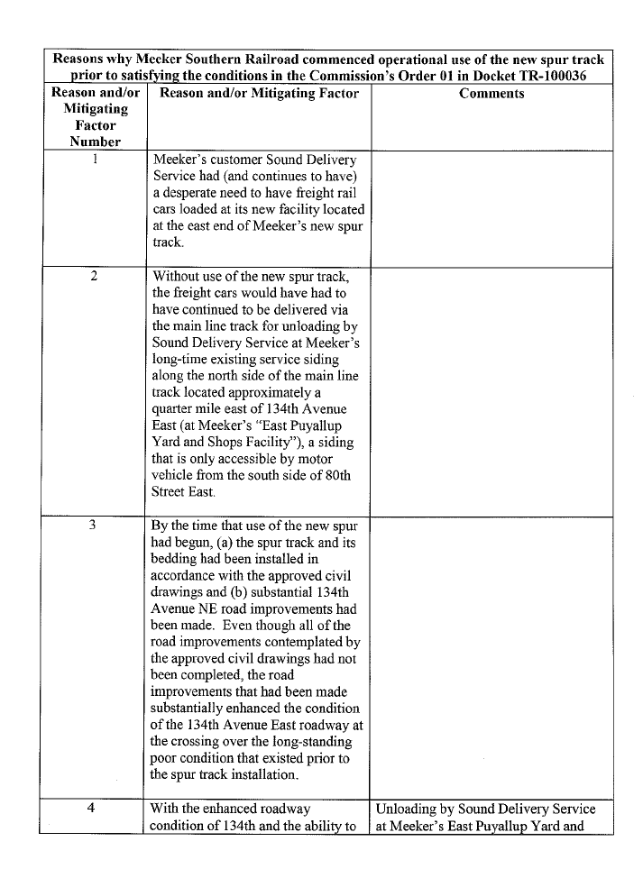
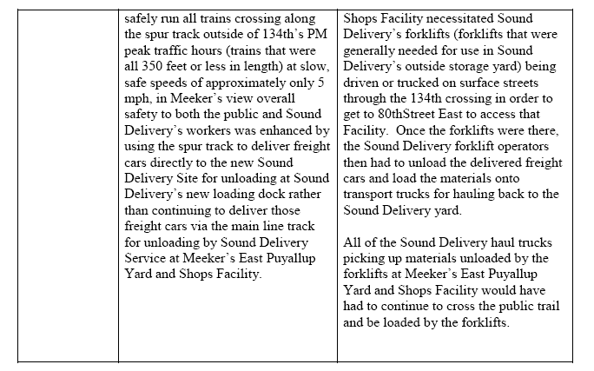

Analysis: When Meeker Southern submitted its petition to modify the crossing, the company proposed that all work for the proposed spur track and the Phase 1 Service Siding be completed to the reasonable satisfaction of Pierce County prior to Meeker Southern starting its operation of the spur line and the service siding. The commission accepted this proposal and stated it as a condition in its order, adding that the work be completed to the reasonable satisfaction of commission staff as well.

Commission staff rejects Meeker Southern’s assertion that the safety of the public was somehow enhanced by Meeker Southern operating in contravention to the commission’s order. While Meeker Southern’s reasons for installing the spur track and commencing operational use prior to satisfying the conditions in the commission’s order may be persuasive, at no point did Meeker Southern contact the commission to discuss these matters. In fact, Meeker Southern did not file the petition to modify the commission’s order until after commission staff discovered that the company had already commenced operations.

Commission staff maintains that the operations conducted over the spur crossing between October 17, 2010, and December 20, 2010, the date Meeker Southern filed its motion to amend Order 01, directly violated the commission’s Order 01 in Docket TR-100036.

Item 3 – Spreadsheet of all Meeker Southern train movements from October 1, 2010, through January 30, 2011. In response to Item 3 in staff’s request, Meeker Southern provided a spreadsheet showing monthly rail car logs for the four-month period from October 2010 through January 30, 2011.

Analysis: The information provided appears to correspond with the testimony given by Meeker Southern and Sound Delivery Service during the January 26, 2011, hearing. In early October 2010, the logs appear to show service to Sound Delivery Service prior to the installation of the spur track. As indicated in testimony, Meeker Southern used its main line and storage yard to facilitate these deliveries.

On February 28, 2011, under separate cover, Mr. Halinen sent staff a letter titled, “Arguments as to Why, in View of Mitigating Circumstances and the Functional Equivalent of a Civil Penalty that Meeker Has Already Incurred, Civil Penalties Should Not Be Imposed Upon Meeker.” This letter is provided within this report for informational purposes only. Staff will respond to arguments contained in the letter through testimony if the commission schedules a hearing regarding penalties in this docket.

DISCUSSION AND FINDINGS

Commission staff has determined that Meeker Southern violated Commission Order 01 in Docket TR-100036 when it commenced operation on the spur track and Phase 1 Service Siding prior to all proposed work shown on the design drawings being completed to the reasonable satisfaction of commission staff and Pierce County Public Works and Utilities Staff. Meeker Southern conducted operations on the spur track over the 134th Avenue crossing on two occasions for the purposes of testing the track and on 50 occasions for the purposes of delivering or picking up freight cars from Sound Delivery Service between October 17, 2010, and December 20, 2010.

RCW 81.04.010(11) states that a common carrier “… includes … railroads, railroad companies…”

RCW 81.04.010(16) states that a public service company “… includes every common carrier.”

RCW 81.04.380 Penalties – Violations by public service companies states, in part:
“Every public service company … shall obey, observe and comply with every order, rule, direction or requirement made by the commission under authority of this title …. Any public service company which shall violate or fail to comply with any provision of this title, or which fails, omits or neglects to obey, observe or comply with any order, rule, or any direction, demand or requirement of the commission, shall be subject to a penalty of not to exceed the sum of one thousand dollars for each and every offense …”

Recommendations
Commission staff recommends the commission file a complaint on its own motion setting forth any act or omission by Meeker Southern that violates any law, or any order or rule of the commission, as provided by RCW 81.04.110. In addition, staff recommends that the commission impose penalties of up to $1,000 each for 50 violations of Order 01 in Docket TR-100036, as provided by RCW 81.04.380.

Commission staff does not recommend penalties for Meeker Southern’s use of the spur track for the two test train runs conducted on October 17, 2010. Condition three of Order 01 required Meeker Southern to complete all work before starting “operation” of the spur line. Staff does not view testing of the track as “operation.” Staff also does not recommend penalties for Meeker Southern’s use of the spur track between December 20, 2010, the date that Meeker Southern filed its motion to amend Order 01 in Docket TR-100036, and January 26, 2011, the date that the administrative law judge granted that motion. Between December 20, 2010, and January 26, 2011, it appears that Meeker Southern sought to comply with the conditions that the administrative law judge approved on January 26, 2011.

Petition to Modify Railroad-Highway Grade Crossing at page 3, #7 at Appendix B.
WAC 480-62-150(1)(f).
WAC 480-62-150(2)(b).
Commission Order 01 in Docket TR-100036 at Appendix C.
Kathy Hunter email dated November 1, 2010, at Appendix D.
Byron Cole email dated December 1, 2010, at Appendix E.
Commission letter dated December 7, 2010, signed by David Danner, at Appendix F.
Letter and Motion to Amend Order from Mr. Halinen dated December 20, 2010, at Appendix G.
Pierce County’s response to Motion to Amend dated December 30, 2010, at Appendix H.
Commission staff’s response to Motion to Amend dated January 4, 2011, at Appendix I.
Letter from Mr. Halinen dated January 6, 2011, at Appendix J.
Letter from Mr. Halinen dated January 12, 2011, at Appendix K.
Commission’s Notice of Hearing dated January 19, 2011, at Appendix L.
TR-100036 Hearing Transcript, page 10, at Appendix M.
TR-100036 Hearing Transcript, pages 53-54, at Appendix N.
TR-100036 Order Amending Order 01, dated January 26, 2011, at Appendix O.
Commission staff’s February 2, 2011, information request at Appendix P.
Mr. Halinen’s February 15, 2011, response to staff’s information request at Appendix Q.
Exhibit A to letter from Mr. Halinen dated February 15, 2011, at Appendix Q.
Letter from Mr. Halinen dated January 12, 2011, at Appendix K.
Meeker filed its motion to amend Order 01 in Docket TR-100036 on December 20, 2010.
Exhibit B to letter from Mr. Halinen dated February 15, 2011, at Appendix Q.
Exhibit C to letter from Mr. Halinen dated February 15, 2011, at Appendix Q.
Letter from Mr. Halinen dated February 28, 2011, at Appendix R.

