

October 7, 2009

Mr. David W. Danner, Executive Director and Secretary
Washington Utilities and Transportation Commission
P.O. Box 47250
1300 S. Evergreen Park Drive SW
Olympia, WA 98504-7250

Re: Advice No. WA for CenturyTel Long Distance LLC

Dear Mr. Danner:

Enclosed for electronic filing is a copy of CenturyTel Long Distance LLC’s filing with the Secretary of State’s office registering the trade name CenturyLink Long Distance LLC. The company intends to discontinue the use of its current trade name, CenturyTel and replace it with the new name, CenturyLink beginning October 8, 2009.

With the conclusion of the CenturyLink merger, I will continue to be the primary regulatory contact for both the legacy CenturyTel and Embarq properties in the state of Washington. My title has changed to Regulatory Government Relations Manager but my contact information remains as follows:

Mailing address: 219 Legion Way SW, Suite 203-D, Olympia WA 98501
Office: 360-943-6996
Fax: 360-943-2114
Cell: 360-951-6309.

Please feel free to contact me should you have any questions.

Sincerely,
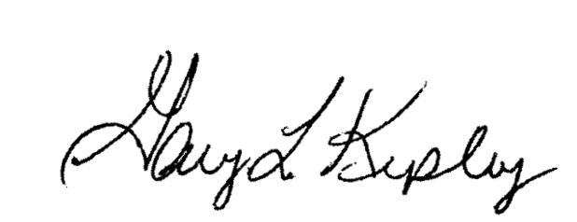

Mary M. Taylor
Regulatory Government Relations Manager
CenturyTel

Attachments

