

WASHINGTON
SERVICE QUALITY 
REVIEW

January 1 – December 31, 2008

Annual Report

TABLE OF CONTENTS

TABLE OF CONTENTS 2

EXECUTIVE SUMMARY 3

1 Service Standards Program Summary 3

1.1 PacifiCorp Customer Guarantees 4

1.2 PacifiCorp Performance Standards 5

1.3 Reliability Definitions and Service Territory 6

2 CUSTOMER GUARANTEES SUMMARY 9

3 PERFORMANCE STANDARDS 10

3.1 System Average Interruption Duration Index (SAIDI) 10

3.2 System Average Interruption Frequency Index (SAIFI) 11

3.3 Operating Area Metrics 12

3.4 Cause Code Analysis 13

3.5 Areas of Greatest Concern 16

3.6 Reduce CPI for Worst Performing Circuits by 20% 17

3.7 Restore Service to 80% of Customers within 3 Hours (across 3 years) 18

3.8 Telephone Service and Response to Commission Complaints 18

4 CUSTOMER RELIABILITY COMMUNICATIONS 19

4.1 Reliability Complaint Process Overview 19

4.2 Customer Complaint Tracking 20

4.3 Customer Complaints Recorded During the Period 20

5 WASHINGTON RELIABILITY RESULTS DURING 2008 21

5.1 State Reliability 22

5.2 Operating Area Reliability-Sunnyside and Yakima 23

5.3 Operating Area Reliability-Walla Walla 24

5.4 Reliability Areas of Greatest Concern 25

5.4.1 5W118: Boyer Feeder 25

5.4.2 5W4: Mount View Feeder 26

5.4.3 5Y382: Occidental Feeder 27

5.4.4 5W2: Memorial Feeder 28

5.4.5 5W102: 13th Street Feeder 29

EXECUTIVE SUMMARY
During January 1 through December 31, 2008, PacifiCorp continued to deliver excellent reliable service to its Washington customers. The Customer Guarantee program continued to deliver high quality results (in fact, well above 99%) consistent with the prior year’s performance. While PacifiCorp’s reliability results delivered to its Washington customers during 2008 were slightly off the company’s operating plan targets for the year, the service delivered across PacifiCorp’s six state service territory ranks very high when compared across the industry.

The company’s service reliability is impacted by uncontrollable interference events, such as car-hit-pole accidents, and by significant events that exceed the normal underlying level of interruptions but that do not reach the qualifying major event threshold for exclusion from the company’s performance metrics. To provide a perspective on their impact this year, the significant events experienced during 2008 are listed in Section 2.1 and 2.2.

Service Standards Program Summary
PacifiCorp has a Service Standards Program comprised of a number of Customer Guarantees and Performance Standards. Regular status reports regarding the program’s performance are provided both internally and externally. These reports detail measures of performance that are reflective of PacifiCorp's reliability in service delivery (of both personnel and the network) to its customers. The company developed these measures after evaluating company and industry standards and practices for delivering, collecting, and reporting performance data. In certain cases, the company chose to adopt a level of performance higher than the industry norm. In other cases, PacifiCorp developed metrics and targets based upon its history of delivery of these measures. The measures are useful in evaluating historical performance and in setting future targets for performance. In its entirety, these measures comply with WAC 480-100-393 and 398 requirements for routine reliability reporting.

In UE-042131, the company applied for, and received approval, to extend the core program through March 31, 2008. During the MidAmerican acquisition of PacifiCorp, in UE-051090, the program was extended again through 2011. During Fiscal Year 2006, from April 1, 2005 through March 31, 2006 the company successfully delivered on both its outage duration and outage frequency targets consistent with the commitment made. At the close of March 31, 2008, the company also accomplished its 3-Hour Outage Restoration Target goal (PS4). Further, the company continues to target improvements to its underperforming circuits, resulting in meeting this commitment also.

PacifiCorp Customer Guarantees
Customer Guarantee 1:  Restoring Supply After an Outage | The company will restore supply after an outage within 24 hours of notification from the customer with certain exceptions as described in Rule 25.
Customer Guarantee 2:  Appointments | The company will keep mutually agreed upon appointments which will be scheduled within a two-hour time window.
Customer Guarantee 3:  Switching on Power | The company will switch on power within 24 hours of the customer or applicant’s request, provided no construction is required, all government inspections are met and communicated to the company and required payments are made. Disconnection for nonpayment, subterfuge or theft/diversion of service are excluded.
Customer Guarantee 4:  Estimates For New Supply | The company will provide an estimate for new supply to the applicant or customer within 15 working days after the initial meeting and all necessary information is provided to the company.
Customer Guarantee 5:  Respond To Billing Inquiries | The company will respond to most billing inquiries at the time of the initial contact. For those that require further investigation, the company will investigate and respond to the Customer within 10 working days.
Customer Guarantee 6:  Resolving Meter Problems | The company will investigate and respond to reported problems with a meter or conduct a meter test and report results to the customer within 10 working days.
Customer Guarantee 7:  Notification of Planned Interruptions | The company will provide the customer with at least two days notice prior to turning off power for planned interruptions.

Note: See Rules for a complete description of terms and conditions for the Customer Guarantee Program.

PacifiCorp Performance Standards
Network Performance Standard 1:  Improve System Average Interruption Duration Index (SAIDI) | The company will achieve its SAIDI commitment target during the 3 year period through March 31, 2008.
Network Performance Standard 2:  Improve System Average Interruption Frequency Index (SAIFI) | The company will achieve its SAIFI commitment target during the 3 year period through March 31, 2008.
Network Performance Standard 3:  Improve Under Performing Circuits | The company will reduce by 20% the circuit performance indicator (CPI) for a maximum of five under performing circuits on an annual basis within five years after selection.
Network Performance Standard 4:  Supply Restoration | The company will restore power outages due to loss of supply or damage to the distribution system on average to 80% of customers within three hours.
Customer Service Performance Standard 5: Telephone Service Level | The company will answer 80% of telephone calls within 30 seconds. The company will monitor customer satisfaction with the company’s Customer Service Associates and quality of response received by customers through the company’s eQuality monitoring system.
Customer Service Performance Standard 6:  Commission Complaint Response/Resolution | The company will a) respond to at least 95% of non-disconnect Commission complaints within three working days and will b) respond to at least 95% of disconnect Commission complaints within four working hours. The company will c) resolve 95% of informal Commission complaints within 30 days.

Note: Performance Standards 1, 2 & 4 are for underlying performance days, excluding days classified as Major Events.

Reliability Definitions and Service Territory
This section will define the various terms used when referring to interruption types, performance metrics and the internal measures developed to meet performance plans. A map of PacifiCorp’s service territory is included.
Interruption Types
Sustained Outage
A sustained outage is defined as an outage of equal to or greater than 5 minutes in duration.
Momentary Outage
A momentary outage is defined as an outage of less than 5 minutes in duration. PacifiCorp has historically captured this data using substation breaker fault counts.

Reliability Indices
SAIDI
SAIDI (system average interruption duration index) is an industry-defined term to define the average duration summed for all sustained outages a customer experiences in a given period. It is calculated by summing all customer minutes lost for sustained outages (those exceeding 5 minutes) and dividing by all customers served within the study area. When not explicitly stated otherwise, this value can be assumed to be for a one-year period.
Daily SAIDI
In order to evaluate trends during a year and to establish Major Event Thresholds, a daily SAIDI value is often used as a measure. This concept was introduced in IEEE Standard P1366-2003. This is the day’s total customer minutes out of service divided by the static customer count for the year. It is the total average outage duration customers experienced for that given day. When these daily values are accumulated through the year, it yields the year’s SAIDI results.
SAIFI
SAIFI (system average interruption frequency index) is an industry-defined term that attempts to identify the frequency of all sustained outages that the average customer experiences during a given period. It is calculated by summing all customer interruptions for sustained outages (those exceeding 5 minutes in duration) and dividing by all customers served within the study area.
CAIDI
CAIDI (customer average interruption duration index) is an industry-defined term that is the result of dividing the duration of the average customer’s sustained outages by the frequency of outages for that average customer. While the Company did not originally specify this metric under the umbrella of the Performance Standards Program within the context of the Service Standards Commitments, it has since been determined to be valuable for reporting purposes. It is derived by dividing PS1 (SAIDI) by PS2 (SAIFI).
CEMI
CEMI is an acronym for Customers Experiencing Multiple (Sustained and Momentary) Interruptions. This index depicts repetition of outages across the period being reported and can be an indicator of recent portions of the system that have experienced reliability challenges. This metric is used to evaluate customer-specific reliability in Section 4. Customer Reliability Communications.

CPI99
CPI99 is an acronym for Circuit Performance Indicator, which uses key reliability metrics (such as SAIDI and SAIFI) to identify underperforming circuits. It excluded Major Event and Loss of Supply or Transmission outages.
CPI05
CPI05 is an acronym for Circuit Performance Indicator, which uses key reliability metrics (such as SAIDI and SAIFI) to identify underperforming circuits. Unlike CPI99 it includes Major Event and Loss of Supply or Transmission outages.

Performance Types & Commitments
PacifiCorp recognizes two categories of performance: underlying performance and major events. Major events represent the atypical, with extraordinary numbers and durations for outages beyond the usual. Ordinary outages are incorporated within underlying performance. These types of events are further defined below.
Major Events
A Major Event is defined as a 24-hour period where SAIDI exceeds a statistically-derived threshold value, as detailed in IEEE Distribution Reliability Standard 1366-2003.
Underlying Events
Within the industry, there has been a great need to develop methodologies to evaluate year-on-year performance. This has led to the development of methods for segregating outlier days, via the approaches described above. Those days which fall below the statistically-derived threshold represent “underlying” performance, and are valid (with some minor considerations for changes in reporting practices) for establishing and evaluating meaningful performance trends over time.
Commitment Targets
Because of the benefits that the company and its customers and regulators experienced from the Service Standards Program, the company filed and received approval to continue the program through 3/31/2008. From a reliability perspective, the company continues to develop stretch goals that will deliver important improvements to its customers. For Washington customers, the company committed that it would deliver outage duration (SAIDI) and outage frequency (SAIFI) results within the 3-year period that met its prior commitment targets, as filed in UE-042131. At mid-year the Company filed demonstrating it successful delivered on each of the commitments made.

Service Territory Map

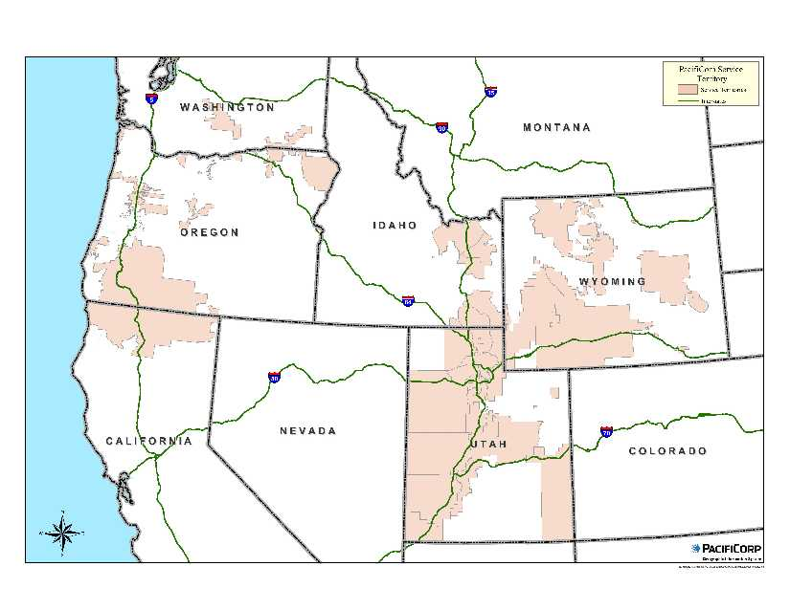

CUSTOMER GUARANTEES SUMMARY

Overall guarantee performance remains well above 99%, demonstrating PacifiCorp’s continued commitment to customer satisfaction.

Customer Communications: The Customer Guarantee program was highlighted throughout the year in customer communications as follows:
A campaign of radio advertisements launched in April.
Performance reports are included in all billing statements beginning in June 2008.
Performance reports were also highlighted in Voices, the company's newsletter.
PacifiCorp’s website features the program.
Each new customer is sent a welcome aboard packet that features the program and describes how to file a claim.
(Major Events are excluded from the Customer Guarantees program.)

PERFORMANCE STANDARDS

System Average Interruption Duration Index (SAIDI)
During the reporting period, the company delivered reliability results considerably higher than its internal targets. As seen in the following charts, events early in the year strayed from performance targets, and continued to stray further off target throughout the period. There were fourteen separate dates throughout the year with a daily underlying SAIDI of greater than 3 minutes - totaling 46 SAIDI minutes. The two most noteworthy of these 14 significant events (which did not reach the company’s Washington major event threshold) accounted for 11 SAIDI minutes, and are shown in the table below. For these 14 days, only 12% of the customer minutes interrupted were considered “controllable”. The remaining events were largely associated with loss of supply and wind. Two major events (on January 4 and September 4) were filed with commission staff for exclusion from performance results.

During the period, the customer average interruption duration index (CAIDI) was 98 minutes, meaning the average outage was restored in 98 minutes.

 | January 1 through December 31, 2008
 | SAIDI Actual | SAIDI Internal Goal
Washington | 131 | 98

System Average Interruption Frequency Index (SAIFI)
As stated previously, the company delivered reliability results off plan during the year. As seen in the following chart, a February 1 loss of supply event started an up-tick which was continued on May 14 because of a loss of feed from supply event. Through the remainder of the year these gains were unable to be compensated for, particularly during the winter storm activity the Company experienced.

 | January 1 through December 31, 2008
 | SAIFI Actual | SAIFI Internal Goal
Washington | 1.331 | 0.778

Operating Area Metrics

Washington operating area performance for the reporting period is listed in the table below.

Jan – Dec 2008 | Including Major Events |  |  | Excluding Major Events
Operating Area | SAIDI | SAIFI | CAIDI | SAIDI | SAIFI | CAIDI
SUNNYSIDE | 109 | 1.82 | 60 | 109 | 1.82 | 60
WALLA WALLA | 1180 | 2.63 | 449 | 145 | 1.41 | 103
YAKIMA | 162 | 1.51 | 108 | 141 | 1.21 | 116

Cause Code Analysis
The table and charts below show number of incidents, customer hours lost, and sustained interruptions by cause. Customer hours lost is directly related to SAIDI (average outage duration) while sustained interruptions is directly related to SAIFI (average outage frequency). Certain types of outages typically result in high duration, but are infrequent, such as Loss of Supply outages. Others tend to be more frequent, but are generally shorter duration.

Cause Category | Description and Examples
Environment | Contamination or Airborne Deposit (i.e., salt, trona ash, other chemical dust, sawdust, etc.); corrosive environment; flooding due to rivers, broken water main, etc.; fire/smoke related to forest, brush or building fires (not including fires due to faults or lightning).
Weather | Wind (excluding windborne material); snow, sleet or blizzard; ice; freezing fog; frost; lightning.
Equipment Failure | Structural deterioration due to age (incl. pole rot); electrical load above limits; failure for no apparent reason; conditions resulting in a pole/cross arm fire due to reduced insulation qualities; equipment affected by fault on nearby equipment (i.e. broken conductor hits another line).
Interference | Willful damage, interference or theft; such as gun shots, rock throwing, etc; customer, contractor or other utility dig-in; contact by outside utility, contractor or other third-party individual; vehicle accident, including car, truck, tractor, aircraft, manned balloon; other interfering object such as straw, shoes, string, balloon.
Animals and Birds | Any problem nest that requires removal, relocation, trimming, etc; any birds, squirrels or other animals, whether or not remains found.
Operational | Accidental Contact by PacifiCorp or PacifiCorp’s Contractors (including live-line work); switching error; testing or commissioning error; relay setting error, including wrong fuse size, equipment by-passed; incorrect circuit records or identification; faulty installation or construction; operational or safety restriction.
Loss of Supply | Failure of supply from Generator or Transmission system; failure of distribution substation equipment.
Planned | Transmission requested, affects distribution sub and distribution circuits; company outage taken to make repairs after storm damage, car hit pole, etc.; construction work, regardless if notice is given; rolling blackouts.
Trees | Growing or falling trees.
Other | Cause Unknown.

Areas of Greatest Concern
During 2008, reliability continues to focus on improved system hardening and protection, including replacement of hydraulic reclosers, upgrades of substation breakers and/or relays and coordination of circuit protection devices, such as fuses and reclosers. The company has found substantial improvements in performance by focusing on circuits that do not appear to be well coordinated. Additionally, it has continued its circuit hardening efforts by strategic deployment of circuit inspection, pole and/or crossarm replacement and vegetation hot spotting. Along with circuit hardening and protection efforts, it has reviewed opportunities for localized activities such as feeder ties and cable replacement activities. Further, the company has piloted additional circuit hardening technologies that are radio frequency-based. This technology complements circuit hardening inspections performed via the company’s Saving SAIDI program. While conclusive evidence has not been obtained, it appears use of key tools may improve the quality of delivered circuit hardening activities.

See Appendix A for graphical depictions of outage frequency and duration for the state, operating areas and selected circuits during the reporting period.

The table below lists reliability projects currently underway for Washington’s Areas of Greatest Concern.

Circuit | Actions | Status | Target Date
5W1 Plaza  5W2 Memorial  5W102 Thirteenth St | Evaluate feeder tie between Bowman and Central subs, large wire tie; 5W1, 5W2, 5W102; provides for additional downtown Walla Walla source | Evaluation Underway | 12/31/2009
5W102  Thirteenth St | Conduct circuit hardening inspection & correct found conditions | Inspection Underway | 12/31/2009
5W118  Boyer | Coordinate circuit protection, replace or install new fuses, modify breaker settings as needed | Coordination plan prepared; in progress | 12/31/2009
Central substation | Animal guard last half of Central Sub | Pending | 12/31/2009
5W4  Mount View | Coordinate circuit protection, replace or install new fuses, modify breaker settings as needed | Coordination plan prepared; in progress | 12/31/2009

Reduce CPI for Worst Performing Circuits by 20%
On a routine basis, the company reviews circuits for performance. One of the measures that it uses is called circuit performance indicator (CPI), which is a blended weighting of key reliability metrics covering a three-year time frame. The higher the number, the poorer the blended performance the circuit is delivering. As part of the company’s Performance Standards Program, it annually selects a set of Worst Performing Circuits for target improvement. The improvements are to be completed within two years of selection. Within five years of selection, the average performance must improve by at least 20% (as measured by comparing current performance against baseline performance). Circuit selections for Program Years 1 through 5 have previously met their targets (as filed and approved) and are thus removed from the tracking table below.

WASHINGTON WORST PERFORMING CIRCUITS | BASELINE | Performance 12/31/2008
Circuit Performance Indicator 2005 (CPI05)
PROGRAM YEAR 9:
Garden 5W154 | 109 | 127
Hay 5Y131 | 166 | 120
Rivard 5Y148 | 81 | 89
Franklin 5Y448 | 82 | 78
Boulevard 5Y610 | 41 | 58
TARGET SCORE = 77 | 96 | 94
PROGRAM YEAR 8:
Zillah 5Y245 | 114 | 173
Gurley 5Y358 | 87 | 97
Stone Creek 5W19 | 135 | 132
Nile 4Y1 | 760 | 604
Highland 5Y93 | 247 | 184
TARGET SCORE = 215 | 269 | 238
PROGRAM YEAR 7:
West 5Y149 | 210 | 119
Granger 5Y357 | 116 | 284
Russell Creek 5W121 | 149 | 85
Tampico 5Y380 | 140 | 118
Gore 5Y100 | 56 | 76
TARGET SCORE = 107 | 134 | 136
PROGRAM YEAR 6:
Nile 4Y1 | 383 | 604
Forney 5Y94 | 246 | 150
Harrah 5Y202 | 220 | 82
Windward 4W22 | 233 | 119
Ferndale 5W106 | 227 | 155
TARGET SCORE = 210 | 262 | 222

Restore Service to 80% of Customers within 3 Hours (across 3 years)

WASHINGTON RESTORATIONS WITHIN 3 HOURS
3-Year Program to Date = 86%
January 1 through December 31, 2008 = 86%
January | February | March | April | May | June
82% | 96% | 89% | 94% | 88% | 81%
July | August | September | October | November | December
82% | 62% | 89% | 83% | 77% | 87%

Telephone Service and Response to Commission Complaints

COMMITMENT | GOAL | PERFORMANCE
PS5-Answer calls within 30 seconds | 80% | 85%
PS6a) Respond to commission complaints within 3 days | 95% | 100%
PS6b) Respond to commission complaints regarding service disconnects within 4 hours | 95% | 100%
PS6c) Resolve commission complaints within 30 days | 95% | 98%

CUSTOMER RELIABILITY COMMUNICATIONS

Reliability Complaint Process Overview
The company’s process for managing customers’ concerns about reliability are to provide opportunities to hear customer concerns, respond to those concerns, and where necessary, provide customers an opportunity to elevate those concerns.

Customer Complaint Tracking
Listed below are the various avenues available to a customer to resolve concerns about reliability performance.
- Customer Reliability Inquiry
The company records customer inquiries about reliability as Outage Power Quality transactions in its customer service system, referred to as “OPQ” transactions.
- Customer Complaint
If a customer’s reliability concerns are not met through the process associated with the OPQ transaction, a customer can register a 1-800 complaint with the company. This is recorded in a complaint repository from which regular reports are prepared and circulated for resolution.
- Commission Complaint
If a customer’s reliability concerns are not met through the process associated with a 1-800 complaint, a customer can register a complaint with the Commission. This is recorded by the Commission staff and also by the company in a complaint repository. Regular reports are prepared and circulated for resolution of these items.

Customer Complaints Recorded During the Period
Listed below are the complaints recorded during the year, by the receipt point.
- Informal Complaints (1-800 or Customer Assistance Line - CAL)

Received | City | Circuit | Summary
6/16/2008 | Yakima | 5Y441 East Valley | regarding frequency of outages
7/11/2008 | Sunnyside | 5Y314 Sheller | regarding timeframe for getting a bad cable replaced

- Commission Complaints

Received | City | Circuit | Summary
1/7/2008 | Walla Walla | 5W1 Plaza | requesting restoration information for major event
7/28/2008 | Walla Walla | 5W106 Ferndale | regarding frequency of power outages
8/6/2008 | Walla Walla | 5W106 Ferndale | regarding frequency of outages
8/11/2008 | Walla Walla | 5W106 Ferndale | regarding frequency of outages
8/13/2008 | Walla Walla | 5W106 Ferndale | regarding frequency of power outages
8/25/2008 | Yakima | 5Y134 Gleed | regarding frequent outages in the area
8/26/2008 | Wapato | 5Y184 Cambell | regarding planned interruption

WASHINGTON RELIABILITY RESULTS DURING 2008
To geospatially display reliability results, the Company has developed its GREAT tool which blends circuit topology with outage history and uses a variety of industry metrics (differentiated by color) to indicate areas where reliability analysis should be targeted. In the subsequent plots, two important reliability indicators are depicted. First, plots with customers experiencing multiple interruptions (CEMI) are shown. This measure shows how many sustained and momentary outages a given service transformer has experienced. The greater the color intensity, with red as the most severe, the more interruptions the transformer has had. Second, service transformer-level SAIDI is shown. While technically SAIDI is a “system-level” metric, the local application of this metric can be revealing in determining service transformers that have had long cumulative durations of outages during the period. As explained previously, the greater the color intensity, the longer the outage duration during the period. (Major events, customer requested and prearranged outages are excluded from underlying results.)
Finally, these graphics superimpose customer reliability inquiries and complaints. When this data is graphically overlaid with transformer performance data, trends can be surfaced that warrant prompt action.

State Reliability
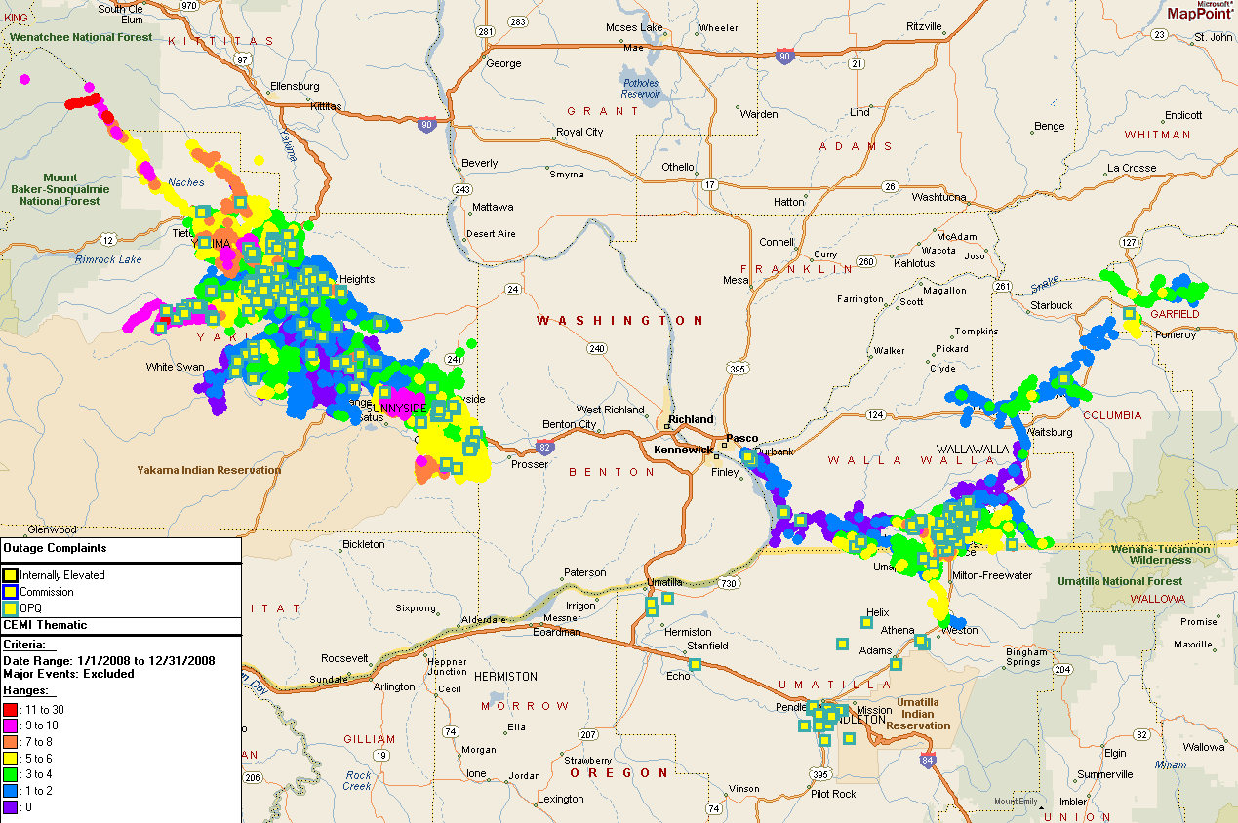

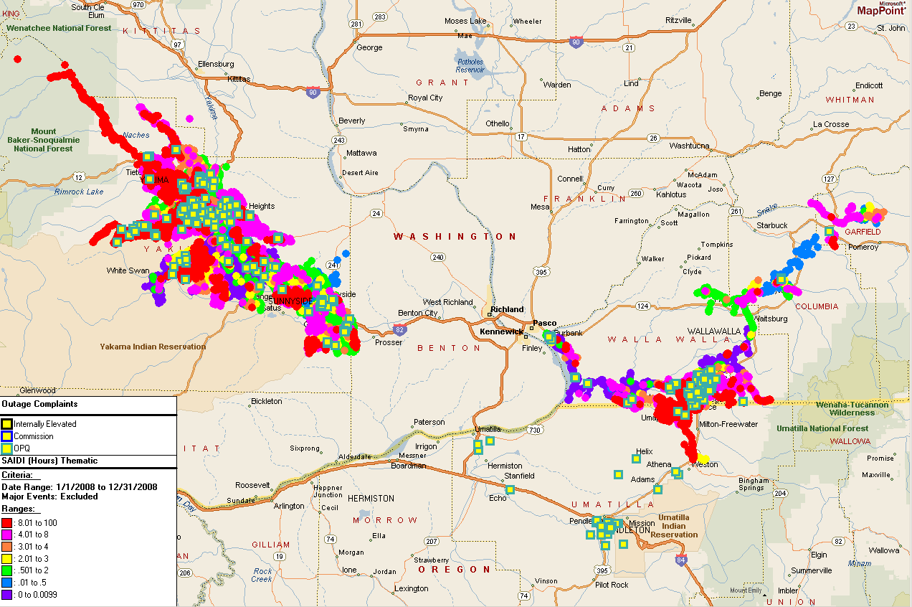

Operating Area Reliability-Sunnyside and Yakima
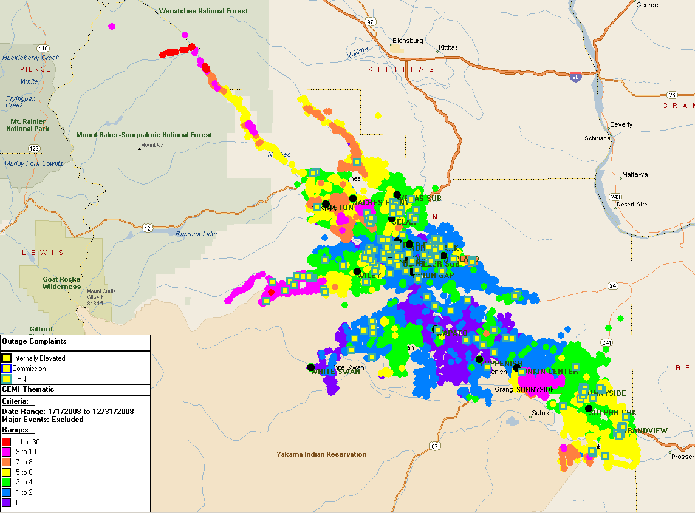
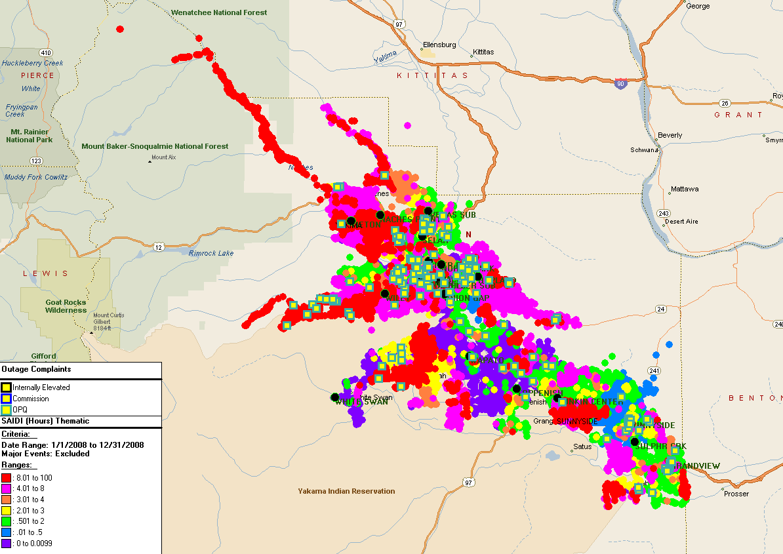

Operating Area Reliability-Walla Walla
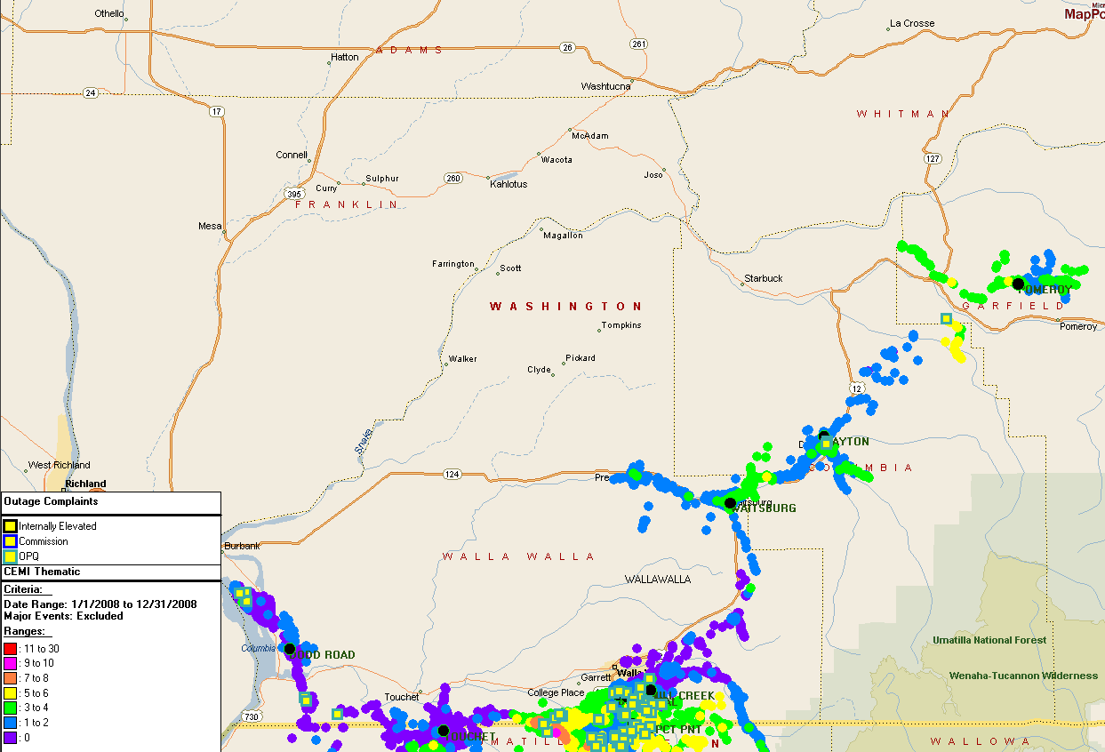
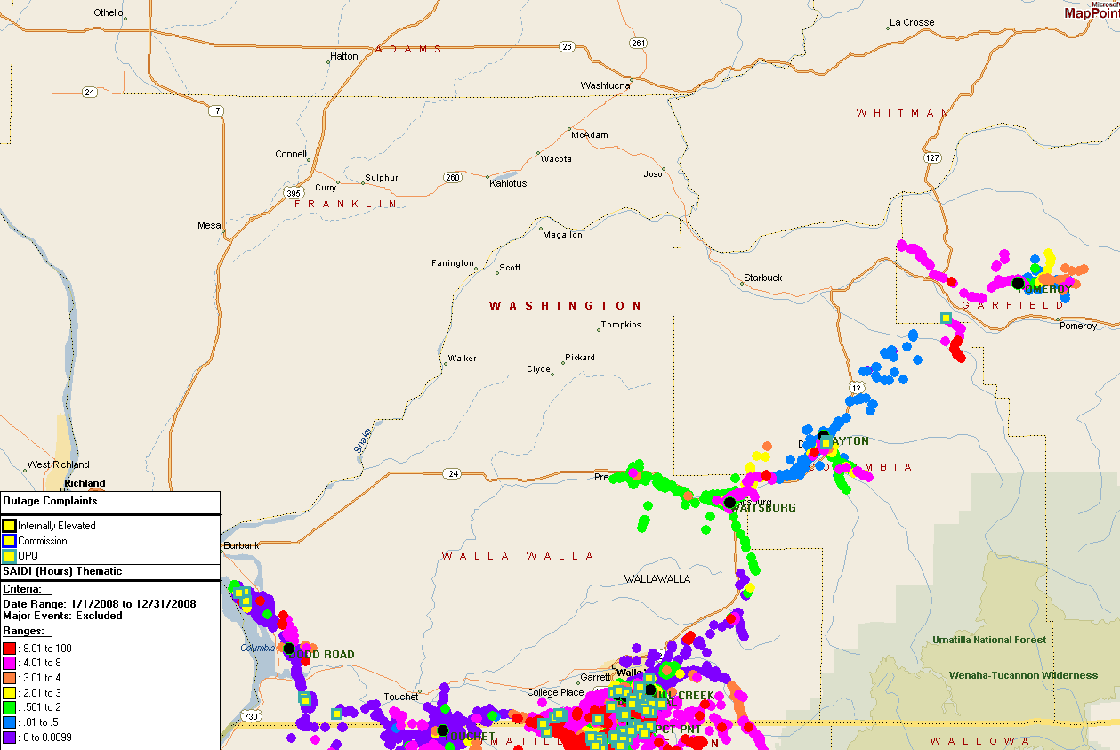

Reliability Areas of Greatest Concern

5W118: Boyer Feeder
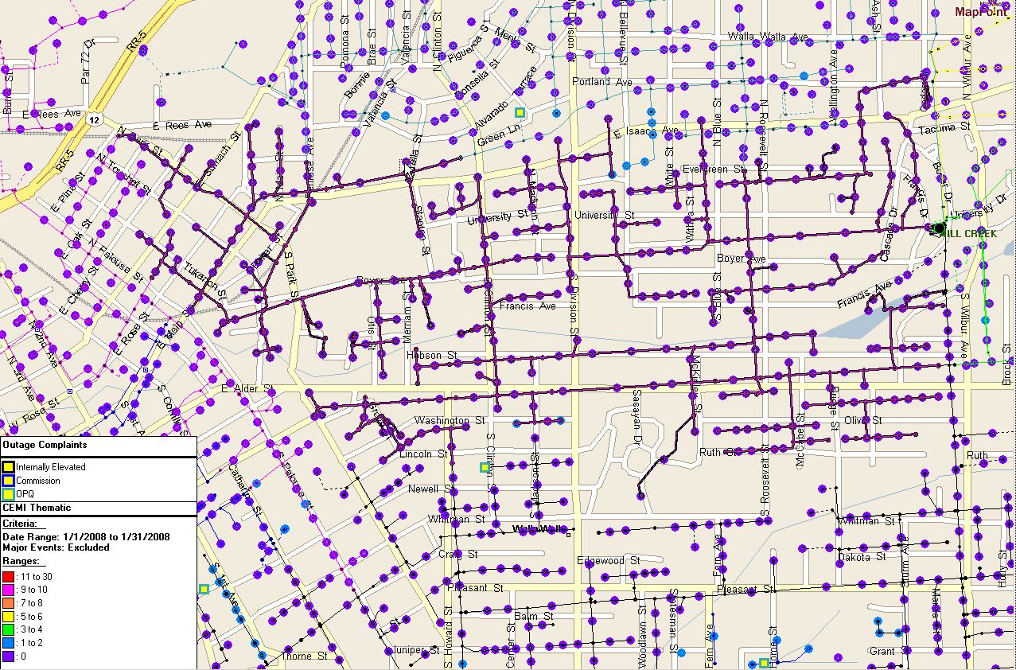

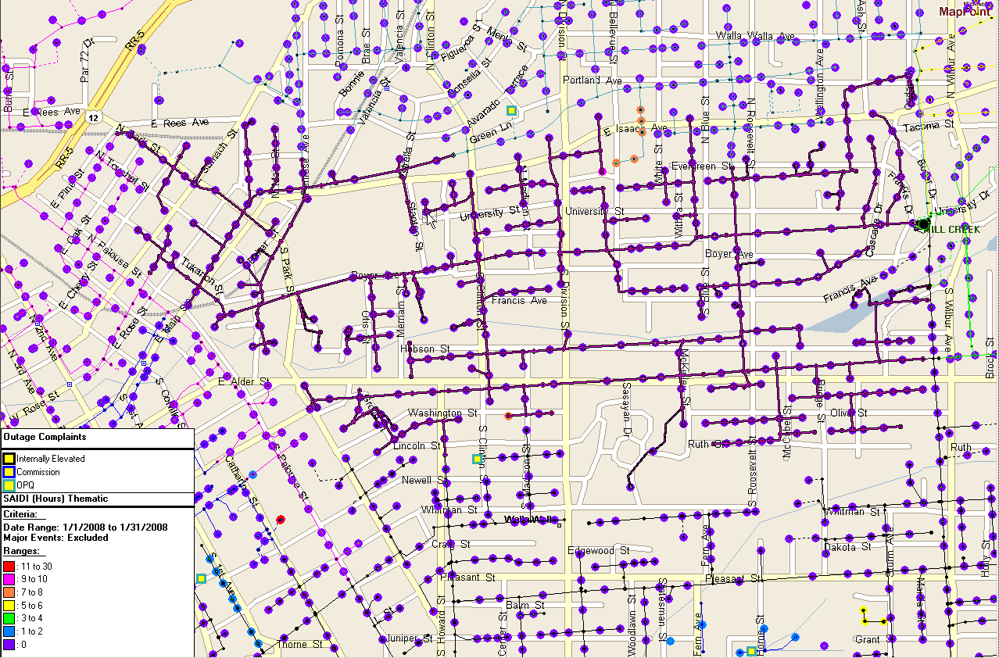

5W4: Mount View Feeder
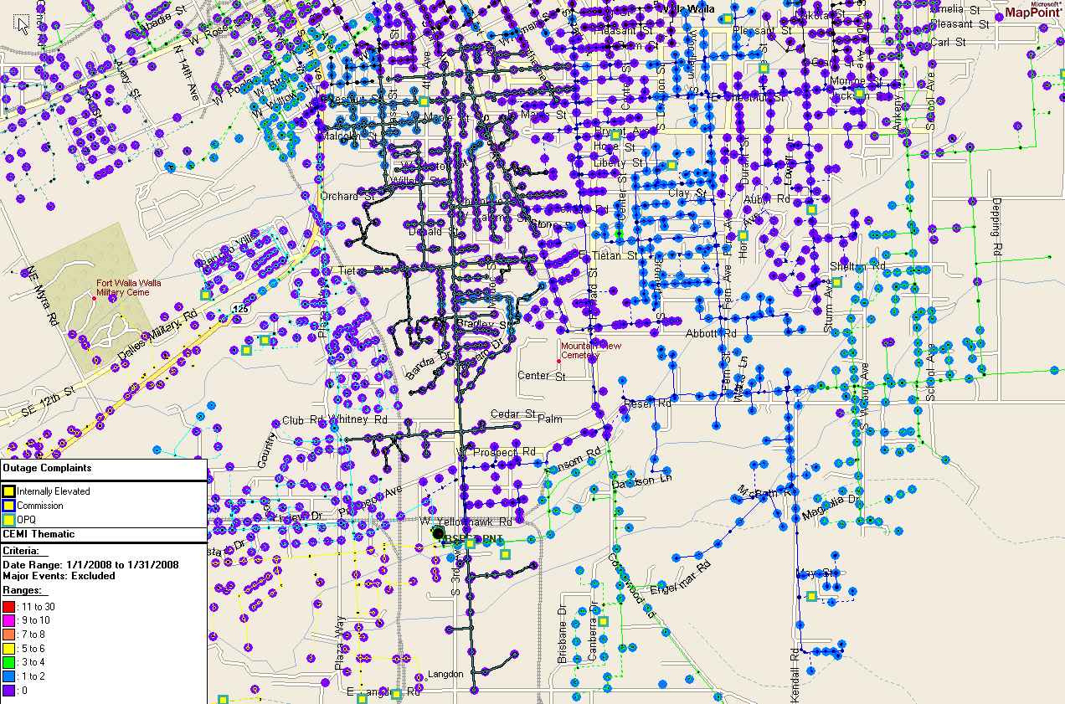

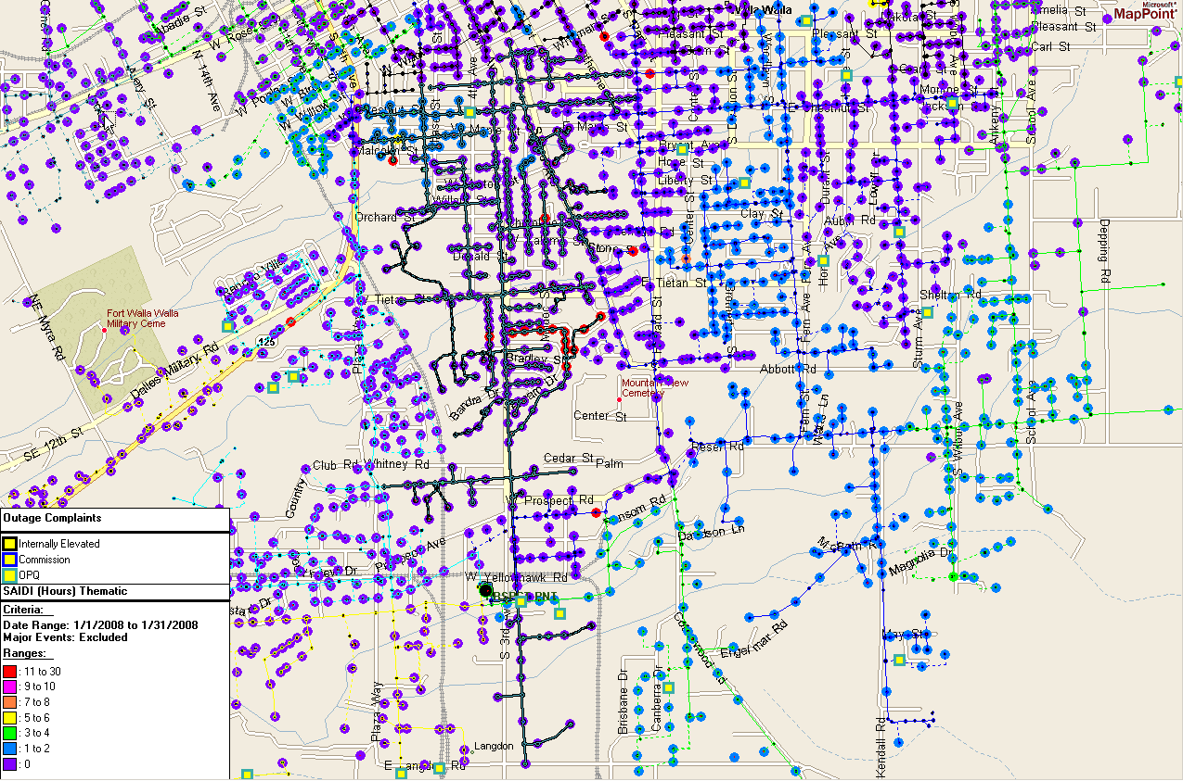

5Y382: Occidental Feeder

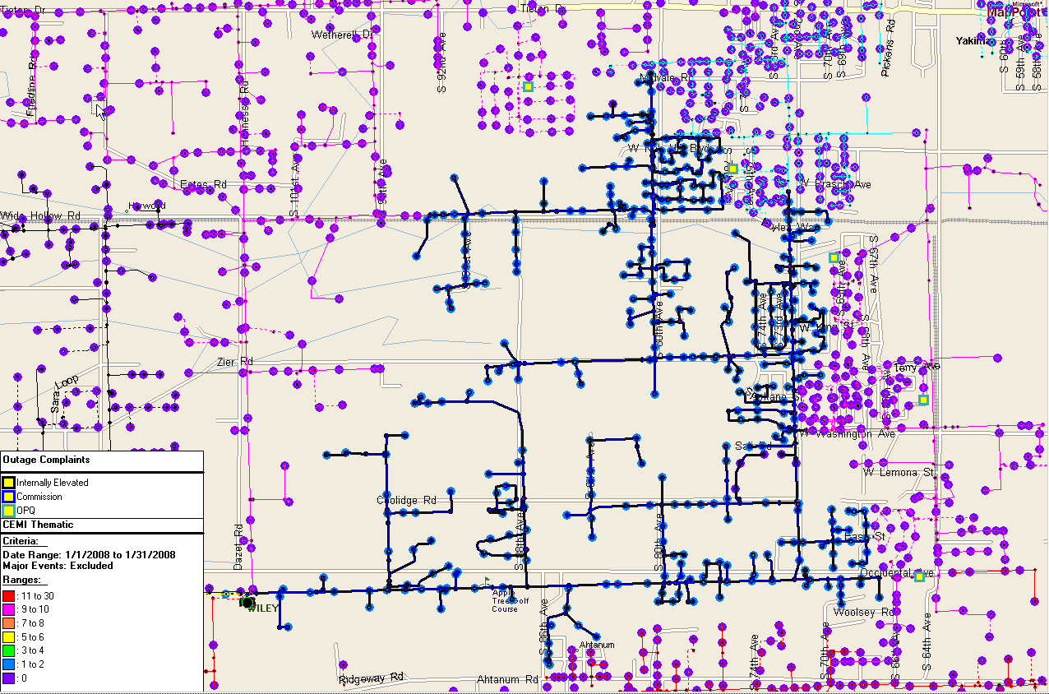

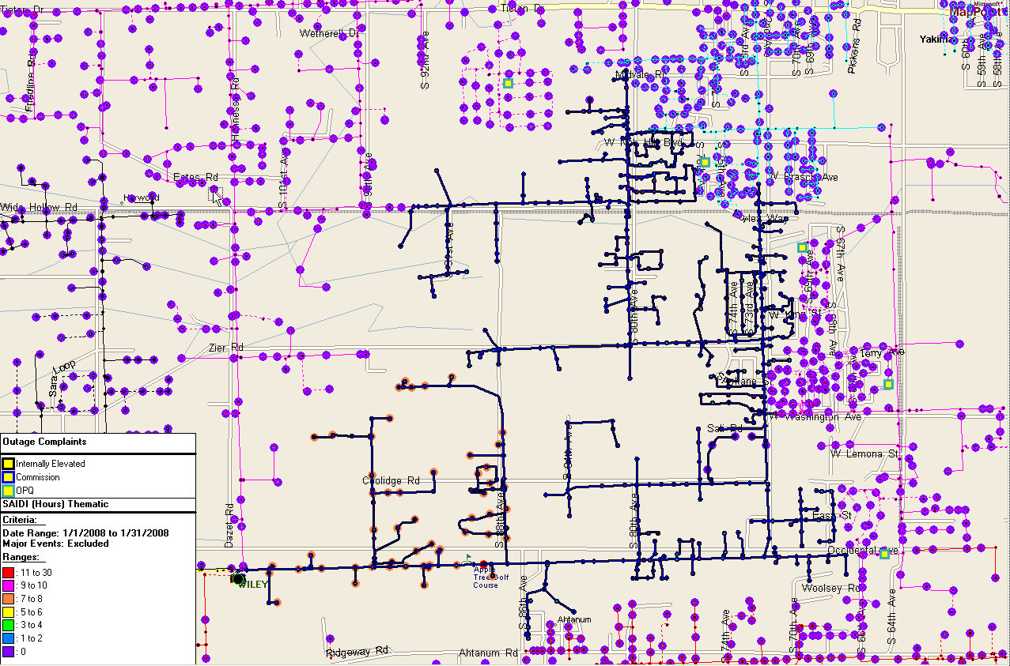

5W2: Memorial Feeder
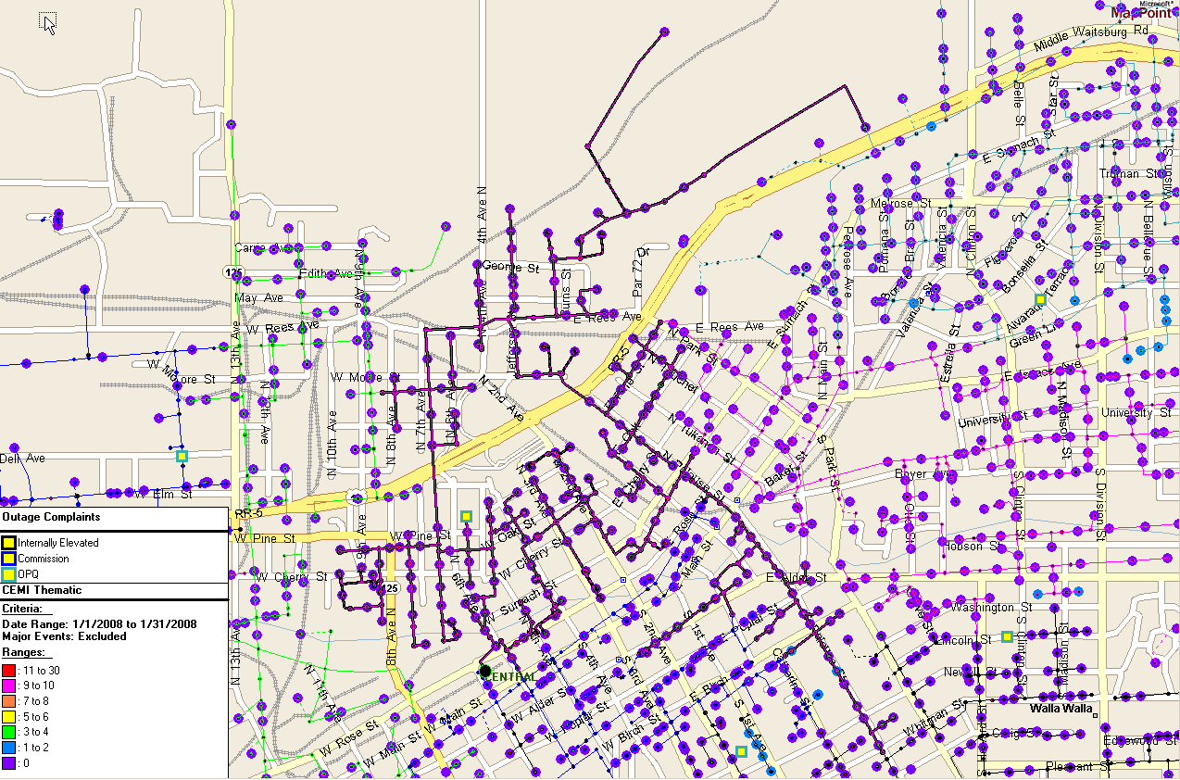

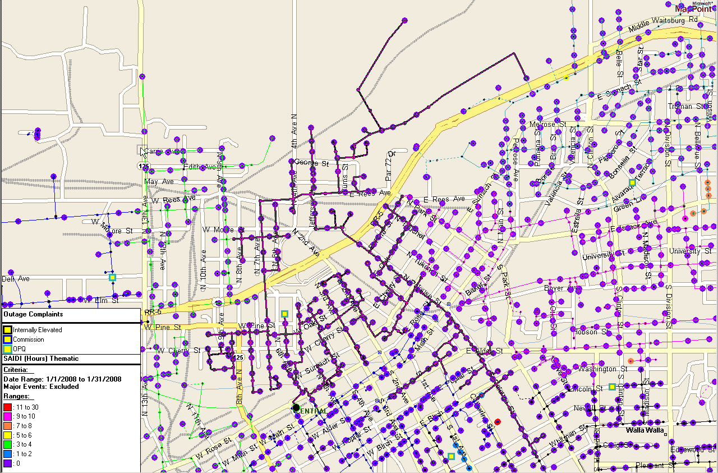

5W102: 13th Street Feeder
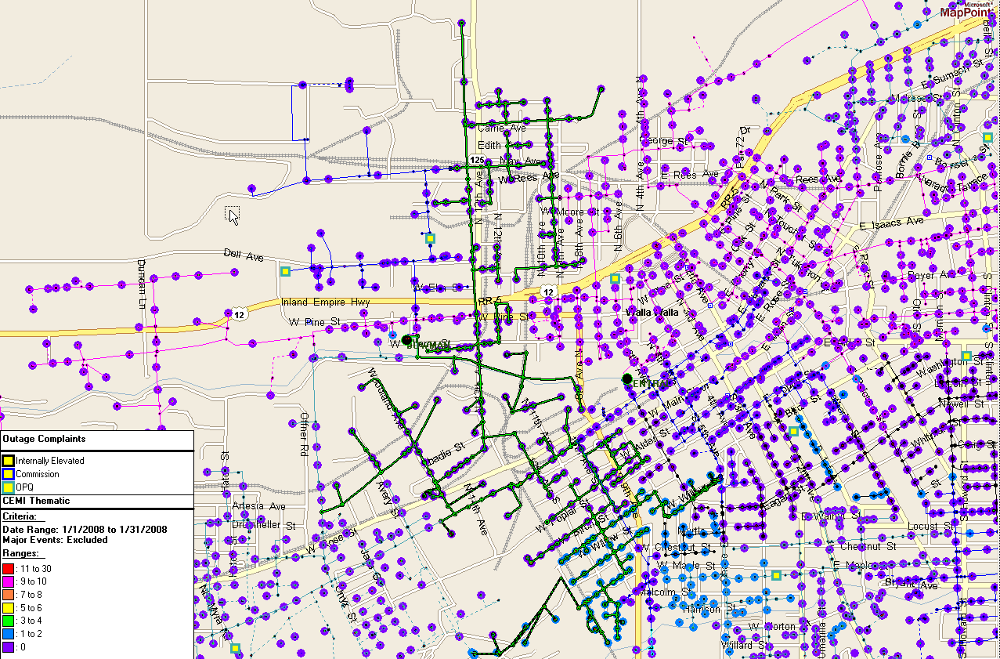

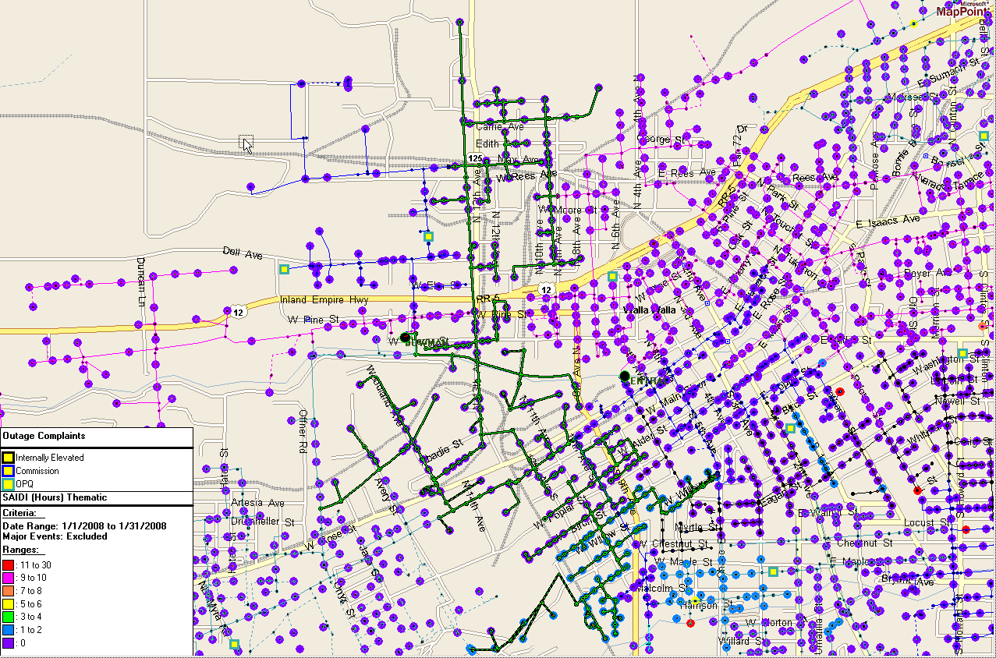

The Company has proposed a minor modification to its Service Standards Program to recognize that many of the outages experienced are beyond the Company’s control, except as to its response. Thus, the frequency of these types of outages may render year-to-year comparisons of service delivered by the Company inappropriate. The use of Controllable Distribution and Non-Controllable Distribution Outage Causes is intended to remedy this anomaly. This proposed modification is under review by Commission Staff.
Customer Service Standards address individual customer transaction performance, while Performance Standards address system-level performance for the average PacifiCorp Washington customer.
Commitment 45 states that “MEHC and PacifiCorp commit to continue customer service guarantees and performance standards as established in each jurisdiction, provided that MEHC and PacifiCorp reserve the right to request modifications of the guarantees and standards after March 31, 2008, and the right to request termination (as well as modification) of one or more guarantees or standards after 2011. The guarantees and standards will not be eliminated or modified without Commission approval.”
The Company has filed proposed modifications to its Service Standards Program, wherein Network Performance Improvement Targets would be developed based upon Controllable Distribution causes, and extend through December 31, 2011. The Commission must approve any modifications made to the program.
P1366-2003 was adopted by the IEEE Commissioners on December 23, 2003. The definitions and methodology detailed therein are now industry standards.
During calendar 2008, the calculated threshold for a major event is 11.69 minutes.

