DEPARTMENT OF THE AIR FORCE
HQ 38th ENGINEERING INSTALLATION GROUP (AFMC)
TINKER AIR FORCE BASE OKLAHOMA 73145-2713

MEMORANDUM FOR MCI COMMUNICATIONS SERVICES INC. 7 Jun 07
Dba VERIZON BUSINESS SERVICES
ATTN: PAMELA MUNFORD
1945 OLD GALLOWS ROAD 6050
VIENNA VA 22182-33131

FROM: 38 EIG/PKK
4001 HILLTOP ROAD
TINKER AFB OK 73145-2713

SUBJECT: FA8773-07-C-0061, Communication Service Authorization (CSA) Award Documents for
Camp Murray – Everett WA Site

1. Attached are the award documents for the above referenced CSA. The SF1449 must be signed in black ink by an official with contractual authority. This individual’s name and title, along with the date of signature, must be typed or printed in Blocks 30a, b, and c.

2. One copy is to be retained for your files. Please return the signed document to 38 EIG/PKK, Attention: Emily Gregg no later than 12 Jun 07.

3. CAUTION: The execution of this document by your company does not constitute a contract. The document is not binding until a fully executed copy, signed by the Contracting Officer, is received by your company.

4. In the event the above stated suspense date cannot be met, please promptly notify the undersigned. If you find the terms to be unacceptable, immediately return documents unsigned, with a letter specifying any objections to the address listed above.

5. We look forward to working with you in the future.

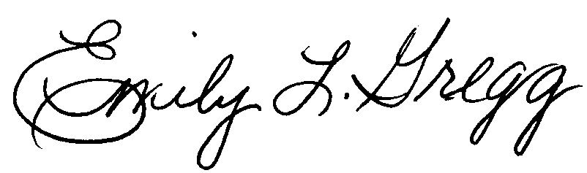

EMILY L. GREGG
Contracting Officer

Attachments:
1. Award
2. Schedule B
3. Statement of Work

