 |  |  |  |  |  |  |  | Commission Docket No.
 |  |  |  |  |  |  |  | Agenda Date Assigned
BEFORE THE WASHINGTON UTILITIES AND TRANSPORTATION COMMISSION

LESS THAN STATUTORY NOTICE AND WAIVER OF CUSTOMER NOTICE RULES REQUESTED BY:
(Utility Name) Verizon Northwest Inc. |  |  |  |  |  |  |  |  |  |  |  |  |  | (Utility UBI Number) 313-013-420
(Utility d/b/a if different than registered name)
Utility proposes to change |  |  | Local Network Access Services, Collocation Services |  |  |  |  |  |  |  |  |  |  | Number |  | WN U-20
 | (tariff title, price list title, etc.)
Present provisions are: Changes to terms and conditions approved in Docket UT-031731 expire on August 26, 2006.
Proposed changes are: Changes to terms and conditions approved in Docket UT-031731 remain in effect until March 1, 2007.
Indicate below, or attach, an explanation of the reason the company requests permission to file the proposed provisions with less than statutory notice and to provide notification to customers on less than required notice.

The current provision expired on August 26, 2006. The requested effective date of September 1, 2006 will reinstate the terms and conditions for collocation intervals that have been effective for the last three years, at the earliest possible date.

 |  |  |  | is authorized to issue and file tariffs on behalf of
(Name and title of issuing agent) |  |  |  |  |  |  |  |  |  |  |  |  |  |  | (Name of Utility)
Signature and Title of Company Officer
I request these provisions become effective on |  |  |  |  | September 1, 2006
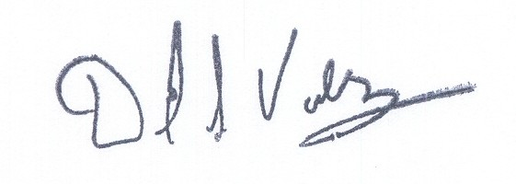 |  |  |  |  |  |  |  |  |  | (Date)
 |  |  |  |  |  |  |  |  |  | Senior Vice President
(Signature of Authorized Agent) |  |  |  |  |  |  |  |  |  | (Title)
David S. Valdez
(Print Name)
( 425 ) 261-5691 |  |  |  |  |  | ( 425 ) 261-5262 |  |  |  |  |  |  | David.s.valdez@verizon.com
(Telephone Number) |  |  |  |  |  | (Fax Number) |  |  |  |  |  |  | (E-Mail Address)
1800 41st St |  |  |  |  |  | Everett |  |  |  |  |  |  | WA |  |  |  | 98201
(Mailing Address) |  |  |  |  |  | (City) |  |  |  |  |  |  | (State) |  |  |  | (Zip Code)
WASHINGTON UTILITIES AND TRANSPORTATION COMMISSION

O R D E R
The Commissioners, having determined this order is consistent with the public interest, directed the Secretary to enter this order granting the provisions requested above.
DATED and signed at Olympia, Washington, this |  |  |  |  |  |  |  |  | Day of
 |  |  |  |  |  |  |  |  |  | (Month and Year)
 |  |  |  |  |  |  |  |  |  | Secretary
Util LSN Form 02/24/04

