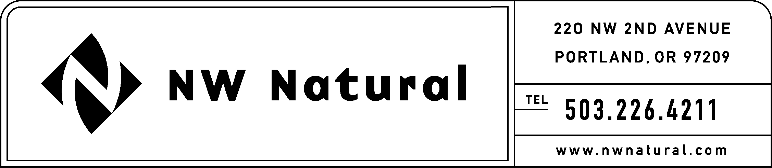

Rates and Regulatory Affairs
Facsimile: 503.721.2532

November 15, 2005 NWN Advice No. WUTC 05-10

VIA ELECTRONIC FILING

Ms. Carole J. Washburn, Executive Secretary
Washington Utilities and Transportation
Commission
1300 Evergreen Park Drive, S.W.
P. O. Box 47250
Olympia, Washington 98504-7250

Re: UG-051683: Special Contract Related to Rate Schedule 42: Large Volume Non-Residential Sales and Transportation Service

Northwest Natural Gas Company, dba NW Natural (NW Natural, or Company), files electronically the following three (3) Special Contracts:

“Agreement between Northwest Natural Gas Company and Great Western Malting Company Regarding Gas Supply and Costs for Sales Service During Interim Period;”

“Agreement between Northwest Natural Gas Company and SEH America, Inc. Regarding Gas Supply and Costs for Sales Service During Interim Period,” and;

“Agreement between Northwest Natural Gas Company and Exterior Wood, Inc. Regarding Gas Supply and Costs for Sales Service During Interim Period.”

At a special public meeting held on November 7, 2005, the Commission accepted the recommendation of Washington Utilities & Transportation Commission (WUTC) Staff Joelle Steward and James M. Russell to authorize the secretary to issue orders approving, with less than required notice, special contracts filed by November 15, 2005 between NW Natural and any of its Schedule 42 customers, if those contracts have the same provisions as the proposed substitute agreement submitted in Docket UG-051683. The three (3) Special Contracts filed herewith, as listed above, are the same as the proposed substitute agreements submitted in Docket UG-051683.

The Company respectfully requests that these Special Contracts be approved effective November 15, 2005 on “less than required notice” basis, pursuant to the Commission’s November 7, 2005 decision.

Copies of this letter and the attached filing are available in the company’s offices in Vancouver, Washington and The Dalles, Oregon.

As required by WAC 480-80-103(4)(a), I certify that I have authority to issue tariff revisions on behalf of NW Natural.

Please address correspondence on this matter to me with copies to the following:

Kelley Miller
Staff Assistant
Rates & Regulatory Affairs
220 NW Second Avenue
Portland, Oregon 97209
Telecopier: (503) 721-2532
Telephone: (503) 226-4211, ext. 3589
E-mail: kelley.miller@nwnatural.com

Please call if you have questions.

Sincerely,

/s/ Onita R. King

Onita R. King, Manager
Tariffs & Regulatory Compliance

enclosures

