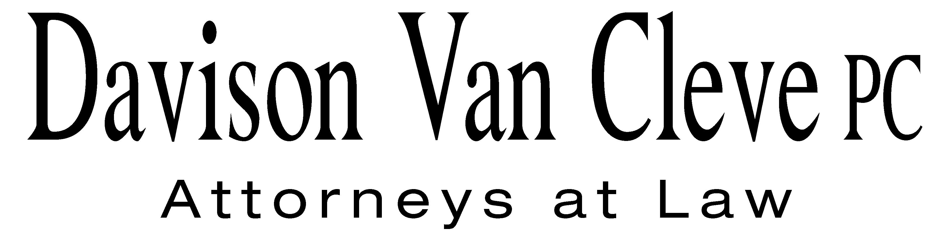
TEL (503) 241-7242 ● FAX (503) 241-8160 ● mail@dvclaw.com
Suite 400
333 S.W. Taylor
Portland, OR 97204

November 8, 2010

Via Electronic and US Mail

Executive Director and Secretary
Washington Utilities and Transportation Commission
PO Box 47250
1300 S. Evergreen Park Drive, SW
Olympia, WA 98504-7250

Re: In the Matter of the General Rate Increase to Recover Increased Electric Cost.

Docket No. UE-100467

Dear Executive Director:

Enclosed please find the Response to Bench Request for Information on behalf of the Industrial Customers of Northwest Utilities.

Thank you for your assistance.

Sincerely yours,

/s/ Sarah A. Kohler
Sarah A. Kohler

Enclosures

