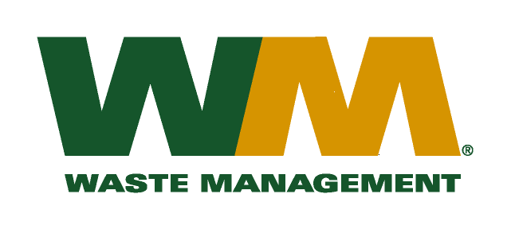

July 2, 2015

Washington Utilities and Transportation Commission
Chandler Plaza Building
1300 S. Evergreen Park Drive SW
P.O. Box 47250
Olympia, WA. 98504-7250

Subject: Waste Management – North Sound and Waste Management - Marysville, divisions of Waste Management of Washington, Inc. (G-237); Tariff No. 19.
Enclosed herein, you will find our new Tariff No.19 for the above-referenced company. This tariff replaces Waste Management – Northwest Tariff No.18, and puts it in the Company’s current and proper trade names that were approved by the Commission following approval of the most recent rate request last year. In this new tariff, we are requesting adjustments to our rates attributed to increased recyclable and yard waste processing, maintenance, labor, and other operating and administrative costs since our last general rate increase. This company received its last general rate increase on January 1, 2014. This new tariff, if approved by the commission, would increase Company revenue by approximately $2,273,000 (3.7%) and collectively, residential and commercial rates by 4.1%. This new tariff is being filed with a proposed effective date of September 1, 2015.
Enclosed for your review are an original and twelve copies of general rate increase materials, including proposed tariff sheets, customer notices, and a rate-case checklist, and two CD’s with all of the rate case information copied on them. We are also submitting workpapers related to the rate filing, including a legend for the tabs that clearly identifies where various financial analyses are located to facilitate the auditor’s review. The enclosed rate case checklist confirming compliance with the requirements of WAC 480-07-520 is also included in the workpapers. In addition, along with our tariff filing is a “Petition for Rule Exemption”, seeking the Commission’s approval to file workpapers that vary from a strict interpretation of the general rate filing regulations. This request seeks an exemption for workpapers similar to that which has been approved by the Commission under exemptions granted to Waste Management of Washington, Inc. in its eleven most recent general rate increase filings.
Please note that our filing includes certain documents that contain valuable commercial information and is therefore being submitted in accordance with the procedures established in WAC 480-07-160. It is presented in two separate submittals to the web portal, both of which clearly identify electronic versions of confidential and redacted documents. One includes electronic versions of confidential materials (in PDF and excel), with the first page of the file, and each page that contains confidential information marked appropriately. The second, separate web portal filing contains all nonconfidential materials in PDF and native format, except the fully redacted nonconfidential materials are in PDF format only. In addition, paper copies of the confidential and redacted workpapers will be submitted as well, with the unredacted workpapers printed on yellow paper with the confidential information clearly designated, and contained in a sealed and labeled envelope.
Sample customer notices are also enclosed. Customer notices will be mailed on or before August 1, 2015. In addition, a copy of this transmittal letter was mailed to King and Snohomish County on August 1, 2015.
A standing letter granting me authority to file on behalf of Waste Management of Washington, Inc. is on file with the Commission. If you have any questions or need additional information, please contact me at:
Address: 13225 NE 122nd Place, Kirkland, WA 98034
Telephone /Fax #: (425) 814-7840 / (425) 814-7866
e-mail: mweinstein@wm.com
Respectfully,

Michael A. Weinstein
Senior Pricing Manager, Pacific Northwest Market Area

cc: Jason Rose
Adam Winston
Jeff McMahon
Clerks of the Board, King County and Snohomish County

