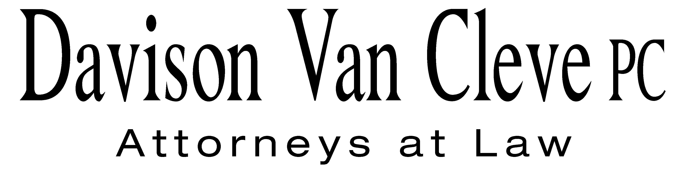
TEL (503) 241-7242 ● FAX (503) 241-8160 ● mail@dvclaw.com
Suite 400
333 SW Taylor
Portland, OR 97204

April 4, 2013

Via Email and Federal Express

Mr. Steven V. King
Acting Executive Director
Washington Utilities & Transportation Commission
1300 S. Evergreen Pk. Dr. S.W.
P. O. Box 47250
Olympia, WA 98504-7250

Re: In the Matter of PUGET SOUND ENERGY and NW ENERGY COALITION’S Petition for an Order Authorizing PSE to Implement Electric and Natural Gas Decoupling Mechanisms and to Record Accounting Entries Associated with the Mechanisms
Docket Nos. UE-121697/UG-121705

Dear Mr. King:

Enclosed please find an original and sixteen (16) copies of the Response to Public Counsel Objection to Order 02 Schedule of the Industrial Customers of Northwest Utilities.

Thank you for your assistance.

Sincerely yours,

/s/ Jesse Gorsuch
Jesse Gorsuch
Enclosures

cc: Service List

CERTIFICATE OF SERVICE

I hereby certify that I have this day served the foregoing Response to Public Counsel Objection to Order 02 Schedule upon all parties of record in this proceeding by mailing a copy thereof in a sealed, first-class postage prepaid envelope to each individual’s last-known address, as listed below.
DATED this 4th day of April, 2013.
Davison Van Cleve, P.C.

/s/ Jesse Gorsuch
Jesse Gorsuch

PUGET SOUND ENERGY  KEN JOHNSON  PO BOX 97034 PSE-08N  BELLEVUE WA 98009-9734 | PERKINS COIE  SHEREE CARSON  10885 N.E. FOURTH STREET STE 700 BELLEVUE WA 98004-5579
NW ENERGY COALITION  Nancy Hirsh  811 1st Ave STE 305  Seattle, WA 98104 | CHAD STOKES  Cable Huston Benedick Haagensen & Lloyd, LLP  1001 SW 5th Avenue STE 2000  Portland, OR 97204
NORTHWEST INDUSTRIAL GAS USERS  ED FINKLEA  326 Fifth Street  Lake Oswego, OR 97034  efinklea@nwigu.org | THE KROGER CO.  1014 Vine Street  Cincinnati, OH 45202
KURT J BOEHM  Boehm, Kurtz & Lowry  36 E. Seventh St. STE 1510  Cincinnati, OH 45202  kboehm@BKLlawfirm.com | SALLY BROWN  Assistant Attorney General  WUTC  PO Box 40128  Olympia, WA 98504-0128
FRED MEYER STORES, INC.  3800 Southeast 2nd Street  Portland, OR 99202 | Ronald L Roseman  Attorney At Law  2011 - 14th Avenue East  Seattle, WA 98112
Simon ffitch  Office of the Attorney General  800 Fifth Avenue STE 2000  Seattle, WA 98104-3188 | Ken Johnson  Director, Rates & Regulatory Affairs  Puget Sound Energy (E012)  PO BOX 97034, PSE-08N  Bellevue, WA 98009-9734
John Carr  Industrial Customers of Northwest Utilities  818 SW 3rd Avenue # 266  Portland, OR 97204 | Norman Furuta,  Associate Counsel  Department of the Navy  1455 Market Street STE 1744  San Francisco, CA 94103-1399
Charles M Eberdt,
Manager
The Energy Project
3406 Redwood Ave
Bellingham, WA 98225

