CenturyLink

1600 7th Avenue, Room 1506

Seattle, Washington 98191

(206) 345-1568

Facsimile (206) 343-4040

Mark S. Reynolds

VP Regulatory & Legislative Affairs

Western Region

February 28, 2014

Re: Advice No. WA 14-01A for CenturyTel of Washington, CenturyTel of Inter Island and CenturyTel of Cowiche d/b/a CenturyLink

Steven King
Executive Director and Secretary
1300 S. Evergreen Park Dr. S.W.
P.O. Box 47250
Olympia, Washington 98504-7250

Dear Mr. King:

CenturyTel of Washington, CenturyTel of Inter Island and CenturyTel of Cowiche d/b/a CenturyLink is forwarding for filing a new Access Services Tariff, WN U-9.

This filing implements certain aspects of Docket UT-130477 which became effective on January 9, 2014. Specifically, Docket UT-130477 allows CenturyTel of Washington, CenturyTel of Inter Island and CenturyTel of Cowiche d/b/a CenturyLink to provide intrastate special access and private line services under a catalog rather than through a tariff. Consequently this new tariff, WN U-9, reflects the removal of these services and replaces WN U-8 in its entirety.

Customers were notified of the pending removal of intrastate special access and private line services from the WN U-8 tariff and posting of the applicable rates, terms and conditions for these services to a catalog in February. The change will be seamless and transparent to, and have no effect on customers. The rates, terms and conditions of service are not changing at this time.

CenturyLink respectfully requests that the new tariff which contain the remaining access services that will remain under tariff, become effective on April 1, 2014. If you have questions concerning this filing, please contact Mark Brinton – Regulatory Operations on (303) 992-5832.

Sincerely,

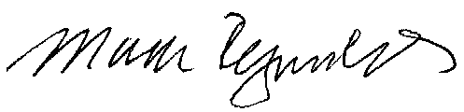

Mark Reynolds

