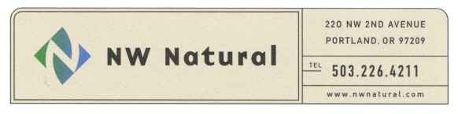
Shawn M. Filippi

Vice President, Chief Compliance Officer and

Corporate Secretary

Tel: 503.220.2435

Fax: 503.220.2584

Toll Free: 1.800.422.4012

e-mail: shawn.filippi@nwnatural.com

February 2, 2017

Dave Danner, Secretary and Executive Director
Washington Utilities and
Transportation Commission
1300 S. Evergreen Park Drive, S.W.
P. O. Box 47250
Olympia, WA 98504-7250

Ladies and Gentlemen:

Re: Docket UG-161218

Pursuant to WAC 480-90-242(6) and the Commission’s Order No. 01, in Docket UG-161218, we enclose herewith the Initial Report of Securities Issued, and Disposition of Proceeds, for the December 2016 issuance and sale of $150,000,000 aggregate principal amount of first mortgage bonds. Please note that the Company is not able to submit a native (WORD) version of Exhibit A (Pricing Supplement) because such document was filed through the Securities and Exchange Commission’s EDGAR filing system.

Sincerely,

/s/ Shawn M. Filippi

Shawn M. Filippi

SMF:amp
Encl.

