Avista Corp.
1411 East Mission P.O. Box 3727
Spokane, Washington 99220-0500
Telephone 509-489-0500
Toll Free 800-727-9170

VIA: UTC Web Portal

April 30, 2018

Steven V. King
Executive Director and Secretary
Washington Utilities & Transportation Commission
1300 S. Evergreen Park Drive S. W.
P.O. Box 47250
Olympia, Washington 98504-7250

Re: Docket No. UE-160071 & UG-160072 – Avista Utilities Q1 2018 Fee-Free Payment Program Report

Dear Mr. King,

Attached for filing with the Commission is an electronic copy of Avista Corporation’s, dba Avista Utilities (“Avista” or “the Company”) Q1 2018 Fee-Free Payment Program Report.

On March 24, 2016 the Commission issued Order 01 in Docket UE-160071 and UG-160072 approving Avista’s petition for an order authorizing accounting and ratemaking treatment of its residential fee-free payment program. In its petition, the Company sought to defer the costs associated with offering the fee-free payment for up to 36 months from the time the program went into effect. The fee-free payment program was successfully launched on February 19, 2017.

In its petition, the Company agreed to provide updates to the Commission every three months about the program’s progress. For purposes of reporting, the Company will be providing updates that coincide with the quarters of the calendar year.

Avista’s residential fee-free payment program encompasses previous methods of payments that were assessed a fee or not available. The program includes the following payment methods and channels:
- Credit and debit card payments made through a Customer Service Representative (CSR), through the Company’s Integrated Voice Recognition (IVR) system, through its website as a one-time guest payment, through its website as an authenticated user, and for Automatic Payment Service (APS) payments.
- Automated Clearing House (ACH) payments made through a CSR, through the Company’s IVR system, and through its website as a one-time guest payment.

Prior to the launch of the new program, customers could make payments free of charge by ACH when making an electronic payment through the Company’s website as an authenticated user, or when signed up for APS payments, in which payments are automatically deducted from their checking or savings account. Also, prior to the launch of the program APS payments were limited to only ACH payment methods.

The following tables represents the residential payment information for the Company’s Washington customers by month for 2017 and 2018:
Table No. 1 - 2017
Payments | January | February | March | April | May | June | July | August | September | October | November | December | Total
Total Payments | 211,354 | 194,987 | 219,215 | 197,679 | 208,013 | 196,544 | 200,998 | 205,075 | 187,450 | 219,641 | 205,123 | 186,759 | 2,432,838
Fiserv Payments | - | 28,610 | 99,256 | 91,667 | 98,866 | 90,153 | 96,994 | 97,249 | 90,974 | 107,186 | 102,804 | 94,414 | 998,173
Fee-Free Fiserv | - | 8,147 | 25,058 | 23,182 | 25,473 | 26,890 | 30,169 | 31,210 | 31,661 | 37,449 | 38,424 | 37,027 | 314,690
Kubra Fee-Free Equivalent* | 18,542 | 11,493 | 3 | 2 | 1 | - | - | - | - | - | - | - | 30,041
Total Fee-Free | 18,542 | 19,640 | 25,061 | 23,184 | 25,474 | 26,890 | 30,169 | 31,210 | 31,661 | 37,449 | 38,424 | 37,027 | 344,731
Fee-Free Payments as % of Total | 8.8% | 10.1% | 11.4% | 11.7% | 12.2% | 13.7% | 15.0% | 15.2% | 16.9% | 17.1% | 18.7% | 19.8% | 14.2%
*Kubra Fee-Free Equivalent – these payments represent the Kubra payments received from February 1st – 18th that would have come through the fee-free payment program. Kubra did not process APS payments, which Fiserv now does, including the ability for customers to sign up for APS by credit or debit card.

Table No. 2 - 2018
Payments | January | February | March | April | May | June | July | August | September | October | November | December | Total
Total Payments | 224,159 | 198,759 | 211,550 |  |  |  |  |  |  |  |  |  | 634,468
Fiserv Payments | 116,532 | 105,518 | 110,133 |  |  |  |  |  |  |  |  |  | 332,183
Fee-Free Fiserv | 48,525 | 45,028 | 47,517 |  |  |  |  |  |  |  |  |  | 141,070
Fee-Free Payments as % of Total | 21.6% | 22.7% | 22.5% |  |  |  |  |  |  |  |  |  | 22.2%

Table Nos. 3 and 4 below includes additional detail on certain payment channels. This information is highlighted to monitor trends in customers’ payment behavior. Note that the data in Table No. 2 will not subtotal to the data in Table No. 1 as there is overlap in payment information by channel (i.e., “Total Card Payments” includes card payments made through APS, CSRs, the IVR, and web).

Table No. 3 - 2017
Payment Method | January | February | March | April | May | June | July | August | September | October | November | December | Total
APS by ACH | 27,456 | 28,895 | 33,613 | 31,742 | 36,812 | 30,780 | 33,448 | 34,535 | 29,606 | 36,957 | 34,094 | 29,167 | 387,105
APS by Debit or Credit Card | - | 31 | 464 | 939 | 1,669 | 1,903 | 2,610 | 3,254 | 3,407 | 4,731 | 4,844 | 4,654 | 28,506
Total APS Payments | 27,456 | 28,926 | 34,077 | 32,681 | 38,481 | 32,683 | 36,058 | 37,789 | 33,013 | 41,688 | 38,938 | 33,821 | 415,611
Total Card Payments | 17,364 | 18,209 | 22,947 | 21,339 | 23,462 | 24,437 | 27,557 | 28,689 | 29,275 | 37,702 | 35,921 | 34,473 | 318,375
CSR Payments | 4,450 | 5,204 | 6,707 | 5,215 | 5,328 | 5,472 | 5,427 | 5,430 | 5,200 | 5,741 | 5,043 | 4,799 | 64,016
IVR Payments | 6,113 | 6,240 | 7,364 | 6,579 | 6,955 | 7,609 | 8,042 | 7,556 | 7,518 | 8,095 | 7,953 | 7,439 | 87,463
Bank Bill Payments | 42,536 | 38,619 | 42,104 | 38,586 | 40,587 | 38,773 | 38,682 | 39,138 | 34,928 | 42,163 | 35,936 | 33,513 | 465,565
Mailed & Lobby Payments | 60,295 | 51,786 | 60,708 | 53,136 | 53,757 | 55,138 | 52,975 | 56,434 | 50,207 | 57,570 | 52,210 | 46,705 | 650,921
Pay Station Payments | 12,119 | 10,988 | 11,882 | 10,390 | 10,361 | 9,883 | 10,171 | 10,122 | 9,475 | 10,563 | 9,363 | 8,291 | 123,608
Web Based Payments | 54,456 | 49,343 | 51,011 | 47,122 | 48,023 | 44,311 | 47,388 | 46,393 | 45,140 | 51,597 | 50,778 | 48,269 | 583,831

Table No. 4 - 2018
Payment Method | January | February | March | April | May | June | July | August | September | October | November | December | Total
APS by ACH | 34,077 | 30,429 | 31,617
APS by Debit or Credit Card | 5,785 | 5,708 | 6,399
Total APS Payments | 39,682 | 36,137 | 38,016
Total Card Payments | 45,399 | 42,115 | 44,545
CSR Payments | 6,309 | 5,895 | 6,035
IVR Payments | 9,412 | 8,588 | 8,911
Bank Bill Payments | 37,400 | 33,131 | 35,244
Mailed & Lobby Payments | 55,826 | 46,883 | 51,367
Pay Station Payments | 9,958 | 8,676 | 9,006
Web Based Payments | 60,846 | 54,780 | 57,046

For historical comparison purposes, Table No. 3 displays residential payment data from 2015 and 2016. The column labeled “Payments Subject to Convenience Fee” represents the payments that were previously charged a fee and no longer do through the Company’s fee-free payment program.

Table No. 3
Year | # of Residential Payments | Payments Subject to Convenience Fee | % of Total
2015 | 2,435,536 | 163,570 | 6.72%
2016 | 2,474,632 | 191,720 | 7.75%

Chart No. 2 graphically shows the trend in fee-free payments in 2017 compared to the historical annual average in 2015 and 2016.
Chart No. 2
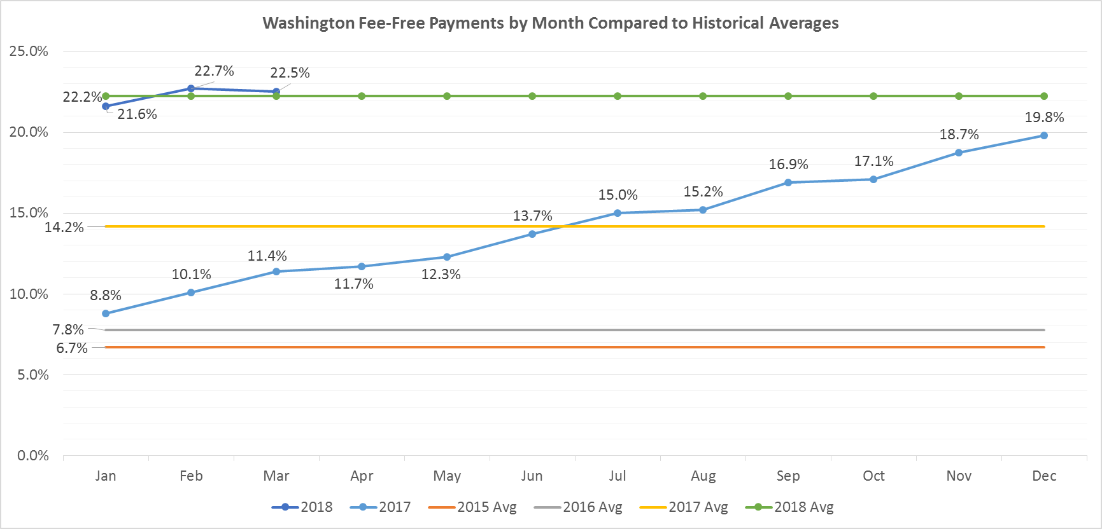

To date the Company has paid invoices through February 2018, of which $611,285 has been deferred for customer transactions through the fee-free payment program.

Please direct any questions regarding this report to Joel Anderson at 509-495-2811 or shawn.bonfield@avistacorp.com or myself at 509-495-4975 or linda.gervais@avistacorp.com

Sincerely,

Linda Gervais

Sr. Manager Regulatory Policy
Avista Utilities

