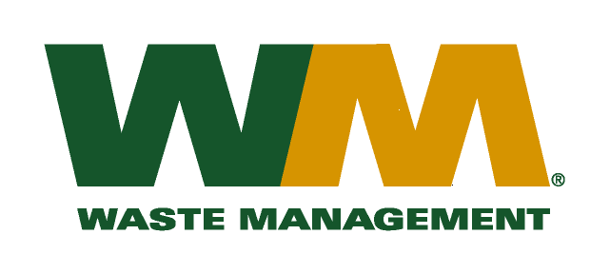
July 29, 2026
Washington Utilities and Transportation Commission
Chandler Plaza Building
1300 S. Evergreen Park Drive SW
P.O. Box 47250
Olympia, WA 98504-7250

Subject: Waste Management – Sno-King, a division of Waste Management of Washington, Inc. (G-237); Tariff # 15 – TG-090760
Dear Sirs:
Enclosed is our Revenue Sharing Report for the plan year 2009 – 2010 that reflects the amount of the revenue retained, the amount of money spent on the activities identified in the Revenue Sharing Plan and the effect the activities had on increasing recycling. This report is being submitted in accordance with the order in TG-090760.
If you have any questions or need additional information, please contact me at (425) 814-7840.
Very truly yours,

Mike Weinstein
Senior Pricing Manager, Pacific Northwest Market Area

cc: Dean Kattler
Jeff McMahon
Bill Reed, King County Solid Waste Division
Jeff Gaisford, King County Solid Waste Division

