

Verizon Northwest Inc.
1800 – 41st Street WA0105RA
P. O. Box 1003
Everett, WA 98206

May 27, 2009

Ms. Carole J. Washburn, Executive Secretary

Washington Utilities and Transportation Commission

1300 S. Evergreen Park Drive SW

P.O. Box 47250

Olympia, Washington 98504-7250

Dear Ms. Washburn:

Subject: Contract No. 1394ICB (Renewal in Docket UT-030727)

Verizon Northwest Inc. submits Contract No. 1394ICB, a renewal of Synchronized Optical Networking (SONET) OC-12 Multi-Protocol Hubbing Service for a term of six months for the period June 12, 2009 – December 11, 2009. Customer has the option to extend the Agreement for one additional six month term after the Extension term, by providing Verizon with sixty (60) days advanced written notice of customer’s intent to extend the Agreement term for another six months. SONET provides a fiber-based, self-healing, fully redundant facility in a ring architecture. This service is provided under contract because it is not available under tariff and has limited demand. The customer currently receives this service under Contract No. 1328ICB, effective October 12, 2006 for a term of twenty-four months. The original agreement was filed under Contract No. 1252 effective June 15, 2003. Amendment No. 1 was effective January 28, 2006 to correct Exhibit A to remove rates specified in the Agreement which were included in error and which represent a Service configuration which was not utilized in provisioning the Service. No interoffice transport mileage charges apply to this arrangement. The purpose of Amendment No. 2 is to extend the term, no changes to rates or other terms or conditions are included in Amendment No. 2.

Verizon requests approval on less than required notice with an effective date of June 12, 2009. If this amendment is not approved effective prior to the expiration date of the current effective agreement, service will have to be disconnected which will have a negative impact on the customer. The LRN form is attached to this filing.

Verizon submits the documentation required in Section 7 of WAC 480-80-142 as an attachment to this filing. Verizon considers the contract and all cost computations required under sub-Section 7 (b) (iii) of WAC 480-80-142 to be confidential and protected under the provisions of WAC 480-07-160. Verizon considers this cost documentation to also be

Carole J. Washburn
Executive Secretary
Page 2

protected under the exemption from disclosure requirements per the Public Records Act, Chapter 42.56 RCW. The cost documentation is marked "Confidential per WAC 480-07-160". The company, for commercial reasons, may be harmed if this information is not considered confidential.

With regards to the contract, Verizon will comply with any applicable resale obligations required by RCW 80.36.170 and 80.36.180.

Please direct questions to Lin Fogg at 425-261-6380.

Very truly yours,

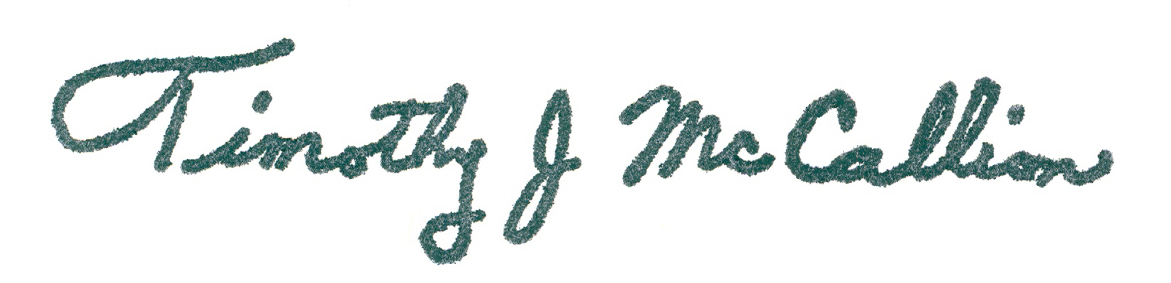

Timothy McCallion
President West Region – Public Affairs, Policy and Communications

Attachments (2009-480297)

TM/LF
ESSENTIAL TERMS AND CONDITIONS
PER WAC 480-80-142

Contract No. 1394ICB New _____ Renewal _____ Amendment __X___

Effective Date: June 12, 2009

Expiration Date: December 11, 2009

Renewal Options: Customer shall have the option to extend the Agreement for one additional six month term after the Extension Term, by providing Verizon with sixty (60) days advanced written notice of Customers intent to extend the Agreement term for another six months.

Duration of Contract: Six Months

Description of Service: SONET provides a fiber-based, self-healing, fully redundant facility in a ring architecture.

Number of Units: 2 OC12 Customer Premise (CP) Nodes
1 OC12 Central Office (CO) Node
Gig E 10 Mb/100Mb Port per Node (month to month)
Gig E 24 1000 Mb Port per Node (month to month)
DS1 Port per Node (month-to-month)
DS3 Port per Node (month-to-month)

Monthly Recurring Charge: $5,125.00

Non-Recurring Charge: Applicable tariff service ordering charges in the WN U-16, Section 5 for Optical/Electrical Drops ordered on a month-to-month basis.

Location: Marysville

Contract No. 1394ICB New ____ Renewal ______ Amendment __X___

7(b)(iv) Summarize the basis of the charge(s) proposed in the contract and explain the derivation of the proposed charge(s) including al cost computations involved;

Nonrecurring (NRC) Charges

Applicable tariff service ordering charges in the WN U-16, Section 5 for Optical
Electrical Drops ordered on a month-to-month basis.

Termination Liability

Termination liability applies to all Services under this Agreement with the exception of
the Optical / Electrical Drops (which are provided on a month-to-month basis). For the
OC12 CP Nodes and CO Node, if Customer cancels this Agreement in whole or in part
or terminates any Services prior to the expiration of the Service Period, Customer shall
pay to Verizon a termination charge equal to twenty-five (25%) of the applicable monthly
rate for the terminated Service multiplied by the number of months remaining in the
unexpired portion of the Service Period. Termination liability will not apply to a
Customer upgrade (change to a higher capacity Dedicated SONET Ring (DSR)
service), if all of the following conditions are met: (a) A new commitment period
commences with the upgrade, b) The new expiration date extends beyond the
discontinued plan date, c) The new DSR service has at least one Customer Premise
Node and one Central Office Node in common with the discontinued service(s).

Monthly Charges

The average monthly charge is $5,125.00.

Contract No. 1394ICB New ____ Renewal ______ Amendment __X___

7(b) (iii) Demonstrate, at a minimum, that the contract charges cover the company’s cost of providing the service. Costs will be determined under a long-run incremental cost analysis, including as part of the incremental cost, the price charged by the offering company to other telecommunications companies for any essential function used to provide the service, or any other commission-approved cost method.

This is an Amendment to renew a term for an additional six months. The attached confidential cost documentation demonstrates such charges covers the company’s cost of providing the service. This Amendment does not impact the rates filed under the original agreement.

Cost computations and explanations required by WAC 480-80-142 are attached. They have been stamped confidential and are protected pursuant to WAC 480-07-160 for commercial reasons.

Contract No. 1394ICB New ____ Renewal ______ Amendment __X___

7(b)(iv)

Summarize the basis of the charge(s) proposed in the contract and explain the derivation of the proposed charge(s) including all cost computations involved.

The underlying costs of the individual component elements are identified in the confidential cost documentation filed with this contract. See Exhibit B to the original contract document for the detailed list of the services and rates subscribed to under the agreement.

Cost computations and explanations required by WAC 480-80-142 are attached. They have been stamped confidential and are protected pursuant to WAC 480-07-160 for commercial reasons.

Contract No. 1394ICB New ____ Renewal ______ Amendment __X___

7 (v) Indicate the basis for using a contract rather than a filed tariff for the specific service involved.

Verizon is offering this service on a contract basis because the service is not available under tariff and has limited demand.

Contract No. 1394ICB New _____ Renewal _____ Amendment __X___

- Duration of contract. All contracts shall be for a stated time period.

The term for this contract is six months.

