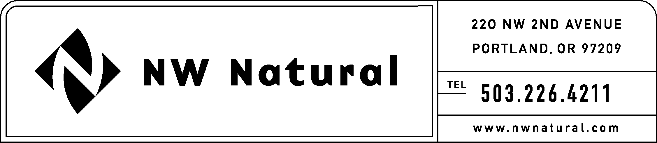

TARIFFS AND REGULATORY COMPLIANCE
RATES AND REGULATORY AFFAIRS

PLEASE DO NOT REDOCKET

NWN Advice No: WUTC 04-1A

June 30, 2004

Ms. Carole Washburn, Secretary
Washington Utilities and Transportation
Commission
1300 S. Evergreen Park Drive, S.W.
P. O. Box 47250
Olympia, Washington 98504-7250

Re: Docket UG-031885 General Rate Increase Compliance Filing – Replacement Sheets

Dear Ms. Washburn:

Northwest Natural Gas Company (“NW Natural” or “company”) files herewith an original and twelve (12) paper copies, plus one electronic copy of the tariff schedules listed below bearing the issue date of June 30, 2004, and stated to become effective with service on and after July 1, 2004.

The submission of 12 paper copies instead of the 20 copies stated in WAC 480-09-330(1) is made pursuant to e-mail dated November 17, 2003 received from the Administrative Law Division of the Washington Utilities & Transportation Commission.

The company requests that the tariff sheets filed herewith be permitted to become effective with service on and after July 1, 2004:

Second Revision of Sheet 110.1,
Schedule 10,
Charges for Special Metering Equipment, Rental Meters and Metering Services (continued);

Original Sheet 200.1,
Schedule 200,
Summary of Adjustments (continued);

Original Sheet 200.2,
Schedule 200,
Summary of Adjustments, and;

Eighth Revision of Sheet 201.1,
Schedule 201,
Temporary (Technical) Adjustments to Rates.

The company hereby withdraws the following tariff sheets, submitted under NWN Advice No. WUTC 04-1, dated June 28, 2004:

Second Revision of Sheet 110.1,
Schedule 10,
Charges for Special Metering Equipment, Rental Meters and Metering Services (continued);

Original Sheet 200.1,
Schedule 200,
Summary of Adjustments (continued);

Original Sheet 200.2,
Schedule 200,
Summary of Adjustments, and;

Eighth Revision of Sheet 201.1,
Schedule 201,
Temporary (Technical) Adjustments to Rates.

All other Sheets filed with NWN Advice No. WUTC 04-1, dated June 28, 2004, are requested to become effective as originally filed. Copies of this letter and the attached filing are available in the company’s offices in Vancouver, Washington and The Dalles, Oregon.

As required by WAC 480-80-103(4)(a), I certify that I have authority to issue tariff revisions on behalf of NW Natural.

Please address correspondence on this matter to me with copies to the following:

Chérie M. Taylor

Administrative Rates Specialist

Rates & Regulatory Affairs
NW Natural
220 NW Second Avenue
Portland, Oregon 97209
Telephone: (503) 226-4211, ext. 3590
Telecopier: (503) 721-2532
Email: cherie.taylor@nwn.com

Please do not hesitate to contact me if you have any questions.

Sincerely,

Onita R. King, Manager
Tariffs and Regulatory Compliance

cc: UG-031885 Service List
File

