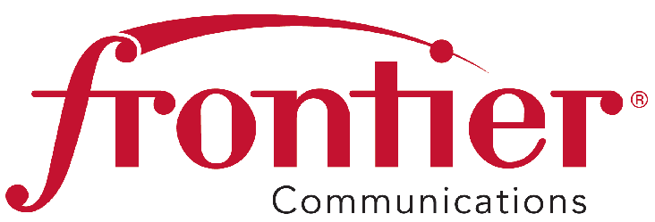
805 Central Expressway South
Suite 200
Allen, Texas 75013
Phone 972-908-4415
Fax 214-383-2737
Email: kimberly.a.douglass@ftr.com

January 25, 2016

Mr. Steven V. King
Executive Director and Secretary
Washington Utilities and Transportation Commission
1300 S. Evergreen Park Drive SW
P.O. Box 47250
Olympia, WA 98504-7250

RE: Docket No. UT-160028 - Annual Eligibility Re-Certification of Lifeline Subscribers

Dear Mr. King:

Frontier Communications Northwest Inc. (Study Area Codes 522449 and 522416) hereby provides a copy of its Annual Lifeline Eligible Telecommunications Carrier Certification FCC Form 555 in compliance with 47 CFR 54.416 as adopted by the Federal Communication Commission (FCC) in its Lifeline Reform Order, FCC 12-11, released February 6, 2012.

Section 54.4 16(b) requires eligible telecommunication carriers (ETCs) to annually provide the results of their re-certification efforts performed pursuant to Section 54.4 10 (f) to the FCC and the Universal Service Administrative Company (USAC). ETCs are also required to provide the results of their re-certification efforts to state commissions and relevant tribal governments.

Please call me at (972) 908-4415 if you have any questions.

Sincerely,
Kim Douglass
Manager
Compliance – Regulatory Affairs
Attachments
cc: Cathy Dahlquist, Frontier

