 |  |  |  |  |  |  | Commission Docket No. |  |  |  |  |  |  |  | 050454
 |  |  |  |  |  |  | Agenda Date Assigned
BEFORE THE WASHINGTON UTILITIES AND TRANSPORTATION COMMISSION

LESS THAN REQUIRED NOTICE REQUESTED BY:

Verizon Northwest Inc. 313-013-420
(Utility Name) |  |  |  |  |  |  |  |  |  |  |  |  | (Utility UBI Number)
Utility proposes |  | Verizon Northwest Inc. Service Agreement |  |  |  |  |  |  |  |  |  |  | Number |  | Contract No. 1362ICB
(Contract Title)
Indicate below, or attach, an explanation of the reason the company requests permission to file the proposed provisions with less than required notice.

Verizon Northwest respectfully requests this ICB contract become effective June 29, 2008. Amendment No. 1 extends the term of the current agreement for 36 months. If the amendment is not effective upon the expiration of the current term, which is June 29, 2008, the company will have to revert the customer’s DS1 Special Access Line Service to higher rates under the tariff. Customer executed the renewal agreement on 6/11/08. LRN is required to have renewal agreement made effective prior to expiration of current agreement. Customer is currently receiving this service under Contract No. 1299ICB, effective 4/30/05 in Docket No. UT-050454.

David S. Valdez-SR. VP Public Affairs, Policy and Communications  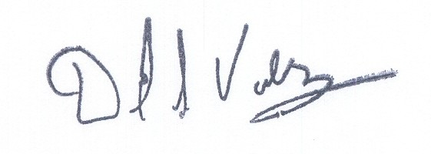 |  |  | is authorized to make filings on behalf of |  |  |  |  |  |  |  |  |  |  | Verizon Northwest Inc.
Signature and Title of Company Officer
I request these provisions become effective on |  |  |  | June 29, 2008
 |  |  |  |  |  |  |  |  | (Date)
(Signature of Authorized Agent) |  |  |  |  |  |  |  |  | (Title)
David S. Valdez
(Print Name)
( 425 ) 261-5691 |  |  |  |  | (425 ) 261-5262 |  |  |  |  |  |  | David.s.valdez@verizon.com
(Telephone Number) |  |  |  |  | (Fax Number) |  |  |  |  |  |  | (E-Mail Address)
1800 41st St. MC: WA0105RA |  |  |  |  | Everett |  |  |  |  |  |  | WA |  |  |  | 98201
(Mailing Address) |  |  |  |  | (City) |  |  |  |  |  |  | (State) |  |  |  | (Zip Code)
WASHINGTON UTILITIES AND TRANSPORTATION COMMISSION

O R D E R
The Commissioners, having determined this order is consistent with the public interest, directed the Secretary to enter this order granting the provisions requested above.
DATED and signed at Olympia, Washington, this |  |  |  |  |  |  |  | Day of
 |  |  |  |  |  |  |  |  | (Month and Year)
 |  |  |  |  |  |  |  |  | Secretary
Util LRN Form 05/16/05

